Name: Etuk Esther Emmanuel
Matric no.: 17/mhs01/124
Department: Medicine and Surgery
College: Medicine and Health Sciences
Assignment Title: Cerebellum And Its Connections
Course Title: Neuroanatomy
Course Code: ANA 303
Question
1. Write a concise review on the developmental genetics of the cerebellum and highlight the genetic bases of known cerebellar disorders.
N/B: As usual, observe every research/scholarly writing rule.
Assignment
The Developmental Genetics of Cerebellum and Genetic Bases of its Disorder
The cerebellum develops from the dorsolateral part of the alar lamina of the metencephalon (Fig. 7.5A). Obviously, there are at first two primordia of the cerebellum, right and left. These extend medially in the roof plate of the metencephalon to eventually fuse across the midline (Figs. 7.5B, C). As the cerebellum increases in size, fissures appear on its surface. The lateral lobes and vermis can soon be distinguished, as a result of differential growth.
The developing cerebellum can be divided into: (a) an intraventricular part that bulges into the cavity of the developing fourth ventricle, and (b) an extraventricular part that is seen as a bulging on the surface (Fig. 7.5C). At first the intraventricular part is the larger of the two, but at a later stage, the extraventricular part becomes much larger than the intraventricular part and constitutes almost the whole of the organ (Fig. 7.5D).
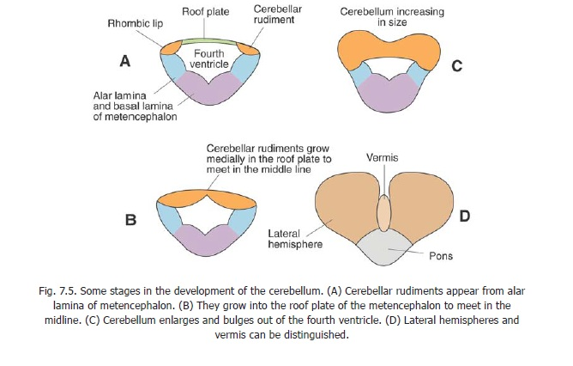
The cerebellum, at first, consists of the usual matrix cell, mantle and marginal layers. Some cells of the mantle layer migrate into the marginal layer to form the cerebellar cortex. The cells of the mantle layer that do not migrate into the cortex, develop into the dentate, emboliform, globose and fastigalnuclei.
The superior cerebellar peduncle is formed chiefly by the axons growing out of the dentate nucleus. The middle cerebellar peduncle is formed by axons growing into the cerebellum from the cells of the pontine nuclei, while the inferior cerebellar peduncleis formed by fibres that grow into the cerebellum from the spinal cord and medulla.

Disorders of the Cerebellum
- Ataxia
- Nystagmus

- Ataxia: Ataxia is a degenerative disease of the nervous system that describes a lack of muscle control or coordination of voluntary movements, such as walking or picking up objects. Hereditary ataxias may be autosomal recessive or autosomal dominant. Autosomal recessive ataxias include Friedreich ataxia (the most prevalent), ataxia-telangiectasia, abetalipoproteinemia, ataxia with isolated vitamin E deficiency, and cerebrotendinous xanthomatosis.
a). Friedreich ataxia results from a gene mutation causing abnormal repetition of the DNA sequence GAA in the FXN gene on the long arm of chromosome 9; the FXN gene codes for the mitochondrial protein frataxin. The GAA sequence is repeated 5 to 38 times within the FXN gene in people who do not have Friedreich ataxia; however, in people with Friedreich ataxia, the GAA sequence may be repeated 70 to > 1000 times (1). Inheritance is autosomal recessive. Decreased frataxin levels lead to mitochondrial iron overload and impaired mitochondrial function.
In Friedreich ataxia, gait unsteadiness begins between ages 5 and 15; it is followed by upper-extremity ataxia, dysarthria, and paresis, particularly of the lower extremities. Mental function often declines. Tremor, if present, is slight. Reflexes and vibration and position senses are lost. Talipes equinovarus (clubfoot), scoliosis, and progressive cardiomyopathy are common. By their late 20s, patients may be confined to a wheelchair. Death, often due to arrhythmia or heart failure, usually occurs by middle age.
b).Spinocerebellar ataxias (SCAs) are the main autosomal dominant ataxias. Classification of these ataxias has been revised many times recently as knowledge about genetics increases. Currently, at least 43 different gene loci are recognized; about 10 involve expanded DNA sequence repeats. Some involve a repetition of the DNA sequence CAG that codes for the amino acid glutamine, similar to that in Huntington disease.
Manifestations of SCAs vary. Some of the most common SCAs affect multiple areas in the central and peripheral nervous systems; neuropathy, pyramidal signs, and restless leg syndrome, as well as ataxia, are common. Some SCAs usually cause only cerebellar ataxia.
SCA type 3, formerly known as Machado-Joseph disease, may be the most common dominantly inherited SCA worldwide. Symptoms include ataxia, parkinsonism, and possibly dystonia, facial twitching, ophthalmoplegia, and peculiar bulging eyes.

2. Nystagmus: Nystagmus is a vision condition in which the eyes make repetitive, uncontrolled movements. These movements often result in reduced vision and depth perception and can affect balance and coordination.
These involuntary eye movements can occur from side to side, up and down, or in a circular pattern. As a result, both eyes are unable to steadily view objects. People with nystagmus might nod and hold their heads in unusual positions to compensate for the condition.
Mutations in the FRMD7gene cause X-linked infantile nystagmus(X-linked congenital nystagmus). The FRMD7 gene provides instructions for making a protein whose exact function is unknown. This protein is found mostly in areas of the brain that control eye movement and in the light-sensitive tissue at the back of the eye (retina). Research suggests that FRMD7 gene mutations cause nystagmus by disrupting the development of certain nerve cells in the brain and retina.
In some people with X-linked infantile nystagmus, no mutation in the FRMD7 gene has been found. The genetic cause of the disorder is unknown in these individuals. Researchers believe that mutations in at least one other gene, which has not been identified, can cause this disorder.

References
1. Anatomy of the cerebellum by wikipedia https://en.wikipedia.org/wiki/Anatomy_of_the_cerebellum#Development
2. Cerebellar Disorders By By Hector A. Gonzalez-Usigli , MD, HE UMAE Centro Médico Nacional de Occidente https://www.msdmanuals.com/professional/neurologic-disorders/movement-and-cerebellar-disorders/cerebellar-disorders
3. x-linked infantile nystagmus by genetic home reference https://ghr.nlm.nih.gov/condition/x-linked-infantile-nystagmus#synonyms

