NAME: SOJI-OYE IREOLUWA FAITH

MATRIC NO: 17/ MHS05/019

DEPARTMENT: MEDICINE AND SURGERY

LEVEL: 300

COURSE TITLE: NEUROANATOMY

The cerebellum is derived from dorsal rhombomere , which comprises the most anterior aspect of the hindbrain. Expression of the homeobox genes Otx2 and Gbx2 are essential for the development of the midbrain and hindbrain. During development, these two genes are expressed in abutting domains where they antagonize each other to establish the mid/hindbrain boundary and formation of an isthmic organizer (IsO). The IsO functions as a classic signaling center by secreting fibroblast growth factor 8 (FGF8), which maintains the posterior border of Otx2 expression and is crucial for normal cerebellar development. FGF expression is strongly controlled during hindbrain development and its loss results in the absence of the midbrain and cerebellum. Accordingly, FGF expression is required for cell survival and to regulate gene expression in the mid/hindbrain region.
Different mediolateral and anteroposterior regions of the midbrain and cerebellum require varying levels and durations of FGF signaling for proper
development. For instance, a slight reduction in FGF8 signaling results in a specific loss of posterior midbrain and the vermis. Moreover, the different
isoforms of FGF8 that are expressed in the IsO have specific receptor affinities and their ectopic expression causes distinct developmental disruptions with mis-expression of FGF8b causing a deletion of the midbrain and gain of cerebellar territory whereas FGF8a promotes an increase in midbrain tissue. The ability of FGF8 to induce distinct structures depends not only on the strength of the signal but also on its duration. For example, transient Fgf8 expression
between E8.5 and E10 is sufficient to induce the formation of the lateral cerebellum but not the vermis. A number of other genes cooperate with Fgf8 to control cerebellar development. Among these are the homeobox genes engrailed 1 (En1) and engrailed 2 (En2), and the paired box genes Pax2 and Pax5. Pax2 induces Fgf8 expression while En1 and En2 are necessary for its maintenance. Interestingly, notch signaling may be upstream of all the above-mentioned genes during the establishment of the IsO. Although a great deal of attention has been given to Fgf8, other members of the Fgf family are also crucial for cerebellar
development (e.g., Fgf17 and Fgf18) and several of the mRNAs that encode FGF signaling molecules exhibit a patterned expression postnatally.

CELL LINEAGE SPECIFICATION
Cell birth in the cerebellum begins during embryonic development and continues well into the second postnatal week. Cerebellar cells are born and migrate sequentially from two germinal zones: the ventricular zone, which produces inhibitory GABAergic neurons and the rhombic lip, which generates excitatory glutamatergic neurons. However, Golgi cells, which are inhibitory, may be derived from both germinal zones. Ventricular zone and rhombic lip-derived cells are apparently produced from multipotent radial glial progenitor cells. Proper proliferation of ventricular zone progenitor cells is initially reliant upon wingless (WNT) signaling. Thereafter, their proliferation requires the expression
of sonic hedgehog (SHH), which is not endogenous in the cerebellum before E17 but instead may be delivered to the cerebellum by the cerebrospinal fluid in the fourth ventricle. In contrast, after E17, SHH is secreted from Purkinje cells and plays a key role in the proliferation of granule cell precursors. As in other regions of the brain and spinal cord, cellular fate in the cerebellum is determined by the differential expression of genes that encode key transcription factors. Studies in mice have shown that GABAergic neurons are derived from progenitors
that express pancreas specific transcription factor 1a (Ptf1a). Accordingly, loss of Ptf1a results in the absence of GABAergic neurons in the cerebellum.
Moreover, conditional removal of Ptf1a causes cells that are normally fated to become GABAergic neurons to incorrectly adopt a glutamatergic phenotype. However, the finding that development of inferior olivary neurons, the source of excitatory climbing fibers to Purkinje cells, is dependent on Ptf1a provides
evidence that within an individual circuit Ptf1a can have context-specific functions in fate determination. Atonal homolog 1 (Atoh1, formerly known
as Math1)-expressing progenitors give rise to the glutamatergic cells that arise from the rhombic lip. Among these are the granule cells, UBCs, and the
excitatory cells of the cerebellar nuclei. Loss of Atoh1 results in the absence of glutamatergic cells in the cerebellum. Although Ptf1a and Atoh1 contribute to the
general identities of inhibitory and excitatory cells in the cerebellum, there is evidence in mice that the germinal zones are genetically divided into different
populations by transcription factor expression. A complex combinatorial genetic code may partition the ventricular neuroepithelium into distinct domains
that can be distinguished based on their expression of Lhx1, Lhx5, and Lmx1a; Neurog1, Neurog2, Ascl1, and Pax2; and KIRREL2 and CDH1. There
is also evidence that the rhombic lip may be genetically compartmentalized. Lineage tracing of Atoh1 and Lmx1a-expressing granule cell progenitors and the analysis of mouse chimera suggest that granule cells have distinct developmental origins within the rhombic lip.

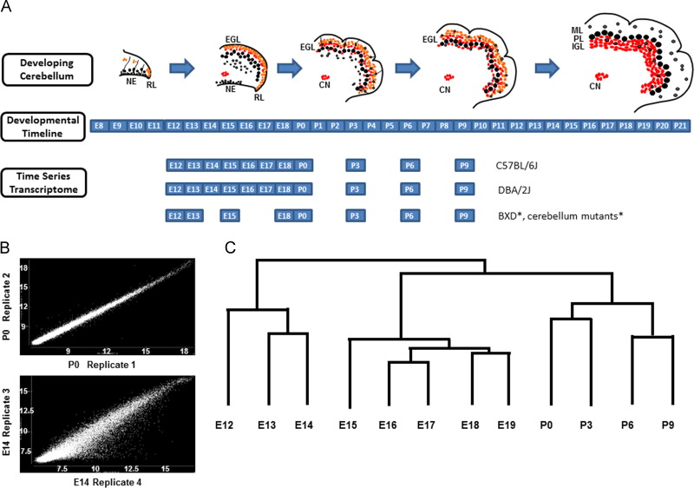
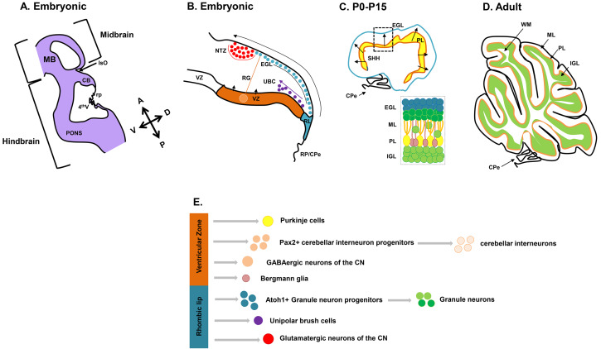

CEREBELLAR DISORDER
ATAXIA: Ataxia-telangiectasia is a rare inherited disorder that affects the nervous system, immune system, and other body systems. This disorder is characterized by progressive dificulty with coordinating movements (ataxia) beginning in early childhood, usually before age 5. It is caused by mutations in the ATM gene cause ataxia-telangiectasia. The ATM gene provides
instructions for making a protein that helps control cell division and is involved in DNA repair. This protein plays an important role in
the normal development and activity of several body systems, including the nervous system and immune system.
Mutations in the ATM gene reduce or eliminate the function of the ATM protein. Without this protein, cells become unstable and die. Cells in the part of the brain involved in coordinating movements (the cerebellum) are particularly affected by loss of the ATM protein. Mutations in the ATM gene also prevent cells from responding correctly to DNA damage, which allows breaks in DNA strands to accumulate and can lead to the formation of cancerous tumors.

Inheritance Pattern: Ataxia-telangiectasia is inherited in an autosomal recessive pattern , which means both copies of the ATM gene in each cell have mutations. Most often, the parents of an individual with an autosomal recessive condition each carry one copy of the
mutated gene, but do not show signs and symptoms of the condition.

HUNTINGTON DISEASE: huntington disease is a progressive brain
disorder that causes uncontrolled movements, emotional problems, and loss
of thinking ability (cognition). Mutations in the HTT gene causes Huntington
disease. The HTT gene provides instructions for making a protein called huntington. Although the function of this protein is unknown, it appears to play an important role in nerve cells (neurons) in the brain. The HTT mutation that causes Huntington disease involves a DNA segment known as a
CAG trinucleotide repeat . This segment is made up of a series of three DNA building blocks (cytosine, adenine, and guanine) that appear multiple times in a row. Normally, the CAG segment is repeated 10 to 35 times within the gene. In people with Huntington disease, the CAG segment is repeated 36 to more than 120 times. People with 36 to 39 CAG repeats may or may not develop the signs and symptoms of Huntington disease, while people with 40 or more repeats almost always develop the disorder.

Inheritance Pattern: This condition is inherited in an autosomal dominant pattern , which means one copy of the altered gene in each cell is sufficient
to cause the disorder. An affected person usually inherits the altered gene from one affected parent. In rare cases, an individual with Huntington disease does not have a parent with the disorder.

JOUBERT’S SYNDROME: Joubert syndrome is a disorder that affects many parts of the body. The signs and symptoms of this condition vary among affected individuals, even among members of the same family.
The characteristic feature of Joubert syndrome is a combination of brain abnormalities that together are known as the molar tooth sign , which can be seen on brain imaging studies such as magnetic resonance imaging (MRI). Joubert syndrome from theabnormal development of structures near the back of the brain, including the cerebellar vermis and the brainstem.
Joubert syndrome can be caused by mutations in more than 30 genes. The proteins produced from these genes are known or suspected to play roles in cell structures called primary cilia. Primary cilia are microscopic, finger-like projections that stick out from the surface of cells and are involved in sensing the physical environment and in chemical signaling. Primary cilia are important for the structure and function of many types of cells, including brain cells (neurons) and certain cells in the kidneys and liver.
Defects in these cell structures can disrupt important chemical signaling pathways during development. Although researchers believe that defective primary cilia are responsible for most of the features of these disorders, it is not completely understood how they lead to specific developmental abnormalities.
Mutations in these genes known to be associated with Joubert syndrome account
for about 60 to 90 percent of all cases of this condition. In the remaining cases, the genetic cause is unknown.

Inheritance Pattern: Joubert syndrome typically has an autosomal recessive pattern of inheritance, which means both copies of a gene in each cell have mutations. The parents of an individual with an autosomal recessive condition each carry one copy of the mutated gene, but they usually do not show signs and symptoms of the condition.
Rare cases of Joubert syndrome are inherited in an X-linked recessive pattern .
In these cases, the causative gene is located on the X chromosome, which is one of the two sex chromosomes . In males (who have only one X chromosome), one altered copy of the gene in each cell is sufficient to cause the condition. In females (who have two X chromosomes), a mutation would have to occur in both copies of the gene to cause the disorder. Because it is unlikely that females will have two altered copies of this gene, males are affected by X-linked recessive disorders much more frequently than females. A characteristic of X-linked
inheritance is that fathers cannot pass X-linked traits to their sons.
LEIGH SYNDROME: Leigh syndrome can be caused by mutations in one of more than 75 different genes. In humans, most genes are found in DNA in the cell's nucleus , called nuclear DNA. However, some genes are found in DNA in mitochondria . This type of DNA is known as mitochondrial DNA (mtDNA). While most people with Leigh syndrome have a mutation in nuclear DNA, about 20 percent have a mutation in mtDNA.
The most common mtDNA mutation in Leigh syndrome affects the MT-ATP6 gene,
which provides instructions for making a piece of complex V, also known as the ATP synthase protein complex . Using the energy provided by the other protein
complexes, the ATP synthase complex generates ATP. MT-ATP6 gene mutations,
found in approximately 10 percent of people with Leigh syndrome, block the generation of ATP.
Other mtDNA mutations associated with Leigh syndrome decrease the activity of other oxidative phosphorylation protein complexes or lead to reduced formation of mitochondrial proteins, all of which impair mitochondrial energy production.

Inheritance Pattern: Leigh syndrome can have different inheritance patterns. It is most commonly inherited in an autosomal recessive pattern , which means both copies of the gene in each cell have mutations. This pattern of inheritance applies to most of the Leigh syndrome-associated genes contained in nuclear DNA, including SURF1. The parents of an individual with an autosomal recessive condition each carry one copy of the mutated gene, but they typically do not
show signs and symptoms of the condition.

