FOLASHADE JEGEDE
300 LEVEL
MEDICINE AND SURGERY
17/MHS01/168
NEUROANATOMY

Assignment
Write a concise review on the developmental genetics of the cerebellum and highlight the genetic bases of known cerebellar disorders.
Answer
Introduction: The cerebellum also known as ‘little brain’, resides at the anterior end of the hindbrain and is classically defined by its role in sensory-motor processing. It is also involved in some cognitive functions, such as attention and language, and probably in some emotional functions, such as the regulation of fear and pleasure responses In amniotes, it represents one of the most architecturally elaborate regions of the central nervous system (CNS), and in humans it contains over half of the mature neurons in the adult brain. The adult cerebellum anatomy consists of three parts, the vermis (median) and the two hemispheres (lateral), which are continuous with each other. The morphological complexity belies histological simplicity: the cerebellar cortex is composed of a very basic structure comprising a monolayer of inhibitory Purkinje cells sandwiched between a dense layer of excitatory granule cells and a sub-pial molecular layer of granule cell axons and Purkinje cell dendritic trees. Granule cells receive inputs from outside the cerebellum and project to the Purkinje cells, the majority of which then project to a variety of cerebellar nuclei in the white matter. A less well-defined complement of locally interacting inhibitory interneuron cell types and glutamatergic unipolar brush cells complete the circuit, which famously promised to be the first of any vertebrate neural network to be fully comprehended.

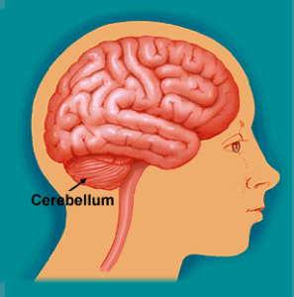

Developmental Genetics of Cerebellum
Two primary germinal zones generate the cells that make up the cerebellum. Each zone expresses a specific set of genes that establish the cell lineages within the cerebellar anlage. Then, cohorts of differentiated projection neurons and interneuron progenitors migrate into the developing cerebellum. Thereafter, a number of remarkable patterning events occur including transformation of the smooth cerebellar surface into an intricately patterned series of folds, formation of three distinct cellular layers, and the demarcation of parasagittal gene expression domains. Together, these structural and molecular organizations are thought to support the proper connectivity between incoming afferent projections and their target cells. After birth, genetic programs and neural activity repattern synaptic connections into topographic neural networks called modules, which are organized around a longitudinal zone plan and are defined by their molecular, anatomic, and functional properties.
The cerebellum is developed in the roof of the anterior part of the hind-brain. It is one of the first structures in the brain to begin to differentiate, but one of the last to mature. The alar laminæ of this region become thickened to form two lateral plates which soon fuse in the middle line and produce a thick lamina which roofs in the upper part of the cavity of the hind-brain vesicle; this constitutes the rudiment of the cerebellum, the outer surface of which is originally smooth and convex. The cerebellar hemisphere and the vermis, which form the roof of the fourth ventricle, grow rapidly.
The fissures of the cerebellum appear first in the vermis and floccular region, and traces of them are found during the third month; the fissures on the cerebellar hemispheres do not appear until the fifth month. The primitive fissures are not developed in the order of their relative size in the adult, thus the horizontal sulcus in the fifth month is merely a shallow groove. The best marked of the early fissures are: (a) the fissura prima between the developing culmen and declive, and (b) the fissura secunda between the future pyramid and uvula. The flocculus and nodule are developed from the rhombic lip, and are therefore recognizable as separate portions before any of the other cerebellar lobules. The groove produced by the bending over of the rhombic lip is here known as the floccular fissure; when the two lateral walls fuse, the right and left floccular fissures join in the middle line and their central part becomes the post-nodular fissure.

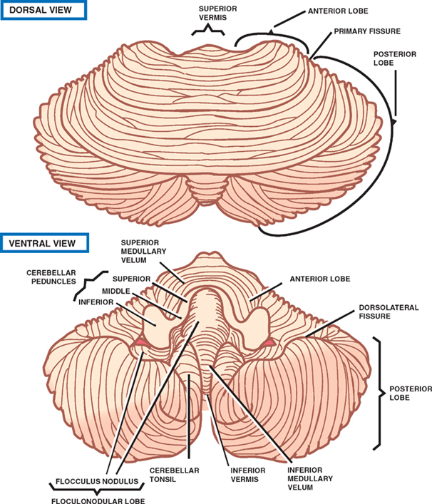

Genetic Basis of Cerebellar Disorders
Genetics has recently enabled the identification of genes causing human pontocerebellar hypoplasia, Joubert syndrome, and Dandy–Walker malformation (DWM). In conjunction with advances in imaging techniques, this allows patients to be diagnosed with malformations at early post-natal or even fetal stages.
Some of the cerebellar disorders are;
Dandy-Walker Syndrome: Dandy-Walker Syndrome/Malformation (DWS) is a cerebellar hypoplasia and upward rotation of the cerebellar vermis with ventricular enlargement (cystic dilation of the fourth ventricle). Genetic Basis: Mendelian inheritance for Dandy-Walker Syndrome is rare, and the genetics are likely oligogenic. Dandy-Walker malformation has also been associated with many chromosomal abnormalities. This condition can be a feature of some conditions in which there is an extra copy of one chromosome in each cell (trisomy). It mostly occurs in people with trisomy 18 (an extra copy of chromosome 18), but can also occur in people with trisomy 13, trisomy 21, or trisomy 9. This condition can also be associated with missing or copied pieces of certain chromosomes. It can also be a feature of genetic syndromes that are caused by mutations in specific genes.
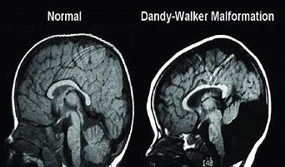

Joubert syndrome: It is also known as Joubert-Boltshauser syndrome, cerebelloparenchymal disorder 4 and cerebellar vermis agenesis. It is a rare disease of the cerebellum. It is identified as a ciliopathy, characterized by the absence or underdevelopment of the cerebellar vermis. There is also malformation of the stem, connecting the brain and spinal cord. Genetic Basis: Rare cases of Joubert syndrome are inherited in an X-linked recessive pattern. In these cases, the causative gene is located on the X chromosome, which is one of the two sex chromosomes. It can be caused by mutations in more than 30 genes, for example mutation in the OFD1 gene on the X chromosome-linked recessive conditions usually occur in males, who only have one X chromosome (and one Y chromosome). Females have two X chromosomes, so if they have a mutation on one X chromosome, they still have a working copy of the gene on their other X chromosome and are typically unaffected. While females can have an X-linked recessive condition, it is very rare.
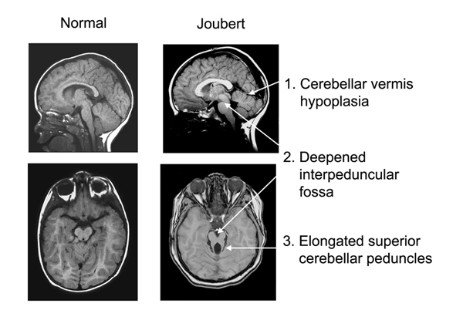
Pontocerebellar Hypoplasia: Pontocerebellar Hypoplasia (PCH) are very rare, inherited progressive neurodegenerative disorders with prenatal onset The major features are: hypoplasia or atrophy of cerebellum and pons, progressive microcephaly, and variable cerebral involvement. There is a further classification of different subtypes. Genetic Basis: Pontocerebellar hypoplasia can result from mutations in several genes. About half of all cases of PCH1 are caused by mutations in the EXOSC3 gene. PCH1 can also result from mutations in several other genes, including TSEN54, RARS2, and VRK1. PCH2 is caused by mutations in the TSEN54, TSEN2, TSEN34, or SEPSECS gene. In addition to causing PCH1 and PCH2, mutations in the TSEN54 gene can cause PCH4 and PCH5. Mutations in the RARS2 gene, in addition to causing PCH1, can result in PCH6. PCH8 is caused by mutations in the CHMP1A gene. The remaining types of pontocerebellar hypoplasia are caused by mutations in other genes. In some cases, the genetic cause of pontocerebellar hypoplasia is unknown, specific genes that cause PCH3 and PCH7 have not yet been identified.
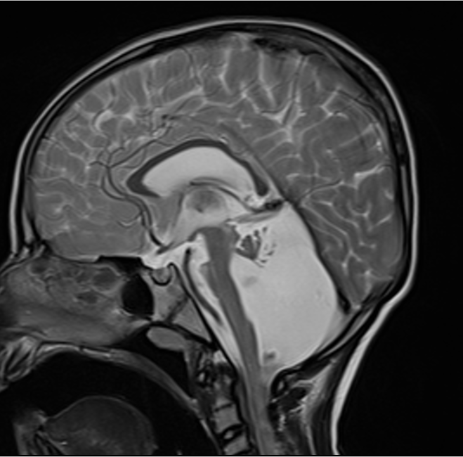

Medulloblastomas: These are the most common childhood primary central nervous system tumour. They are thought to arise in the developing cerebellum from the precursors of the granule cell. Genetic Basis: The genome of the WNT tumors is relatively stable compared with that of the other groups. Copy number aberration and single nucleotide variants in this molecular variant include deletion of one copy of chromosome 6 (monosomy 6, almost all cases), mutations in the DEAD-box RNA helicase gene (DDX3X, 50%) which enhances cell proliferation by increasing the transactivating capacity of beta-catenin, SMARCA4 (26%), TP53 mutations (16%, not associated with a corresponding germ line mutation and does not affect the excellent prognosis associated with this subgroup), and MLL2 mutation (12%). Tetraploidy is present in about 14% of cases and might be an early event in tumorigenesis.
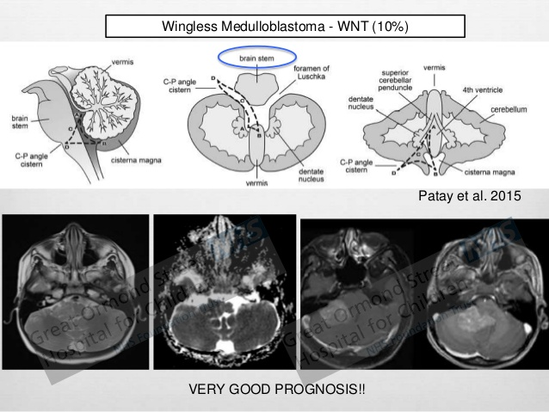

Rhombencephalosynapsis: It is a unique cerebellar malformation characterized by fusion of the cerebellar hemispheres with partial or complete absence of a recognizable cerebellar vermis. Genetic Basis: Most patients with rhombencephalosynapsis are sporadic, suggesting de novo autosomal dominant mutations are the likely cause. A mutation of the ZIC2 gene as a cause of or predisposing factor to partial RES associated with HPE.
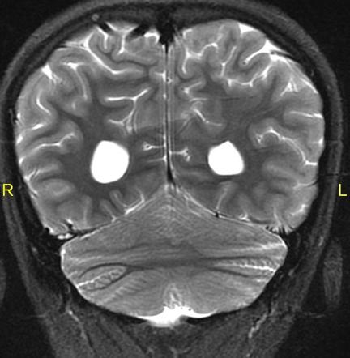

Friedreich ataxia: It is a rare genetic disease that affects the nervous system and causes movement problems. Genetic Basis: Friedreich ataxia results from a gene mutation causing abnormal repetition of the DNA sequence GAA in the FXN gene on the long arm of chromosome 9; the FXN gene codes for the mitochondrial protein frataxin. The GAA sequence is repeated 5 to 38 times within the FXN gene in people who do not have Friedreich ataxia; however, in people with Friedreich ataxia, the GAA sequence may be repeated 70 to > 1000 times. Inheritance is autosomal recessive. Decreased frataxin levels lead to mitochondrial iron overload and impaired mitochondrial function.

References
1) The Company of Biologists (2014) The Company of Biologists corporate website, viewed 9 July 2020 https://dev.biologists.org/content/141/21/4031#ref-161
2) White, J. J., & Sillitoe, R. V. (2013). Development of the cerebellum: from gene expression patterns to circuit maps. Wiley interdisciplinary reviews. Developmental biology, 2(1), 149–164. https://pubmed.ncbi.nlm.nih.gov/23799634/
3) Embryology (2020) Embryology official website, viewed on 10 July 2020 https://embryology.med.unsw.edu.au/embryology/index.php/Neural_-_Cerebellum_Development
4) MSD Manual (2020) MSD Manual official website, viewed 10 July 2020 https://www.msdmanuals.com/professional/neurologic-disorders/movement-and-cerebellar-disorders/cerebellar-disorders#v48481082
5) National Library of Medicine (2020) National Library of Medicine official website, viewed 10 July 2020 https://ghr.nlm.nih.gov/condition/pontocerebellar-hypoplasia#genes
6) Genetic and Rare Diseases Information Center (2020) Genetic and Rare Diseases Information Center official website, viewed on 10 July 2020 https://rarediseases.info.nih.gov/diseases/
7) Human Molecular Genetics (2005) Human Molecular Genetics official website, viewed 10 July 2020 https://academic.oup.com/hmg/article/14/suppl_2/R235/663262
8) National Center for Biotechnology Information (2014) National Center for Biotechnology Information official website, viewed 10 July 2020 https://www.ncbi.nlm.nih.gov/pmc/articles/PMC3921827/#!po=0.925926

