NAME: ADEBARA FAITH INUMIDUN
MATRICULATION NUMBER: 17/SCI05/001
DEPARTMENT: MEDICINE AND SURGERY
COLLEGE: MEDICINE AND HEALTH SCIENCES
LEVEL: 300

COURSE TITLE: NEUROANATOMY
COURSE CODE: ANA 303

ASSIGNMENT TITLE: Cerebellum and its connections
QUESTION: Write a concise review on the developmental genetics of the cerebellum and highlight the genetic basis of known cerebellar disorders. (N/B as usual, observe every research/scholarly writing rule)
DATE: 12TH July, 2020
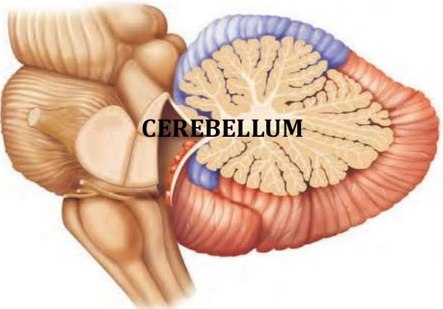
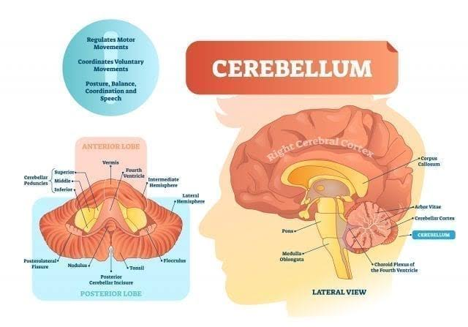
REVIEW ON THE DEVELOPMENTAL GENETICS OF THE CEREBELLUM
ABSTRACT:
The cerebellum is one of the first brain structures to begin to differentiate, yet it is one of the last to achieve maturity — the cellular organization of the cerebellum continues to change for many months after birth. This protracted developmental process creates a special susceptibility to disruptions during embryogenesis and makes the cerebellum highly amenable to study. Over the past few years, genetic research has provided a great deal of information about the molecular events directing the formation of the cerebellum. (Vincent Y. Wang, Huda Y. Zoghbi, 2001)

INTRODUCTION:
The cerebellum represents 10% of the brain's total volume, but contains more than half of our neurons. It acts as a coordination centre, using sensory inputs from the periphery to fine-tune our movement and balance. It is one of the first structures in the brain to begin to differentiate, but one of the last to mature, and its cellular organization continues to change for many months after birth. The study of mouse homologues of Drosophila genes has provided valuable insights into the molecular basis of cerebellar development. (Vincent Y. Wang, Huda Y. Zoghbi, 2001).
The internal structure of the cerebellum reflects an intriguing paradox; its cytoarchitecture is relatively simple and repeated throughout, yet the connections between its neurons are wired into a complex array of gene expression domains and functional circuits. The developmental mechanisms that coordinate the establishment of cerebellar structure and circuitry provide a powerful model for understanding how functional brain networks are formed. (Joshua J. White & Roy V. Sillitoe, 2013)
In humans, the cerebellum develops from the dorsal region of the posterior neural tube, and its cells arise from two primary germinal zones – the Ventricular Zone (VZ) and the Rhombic lip (RL). Each zone expresses a specific set of genes that establish the cell lineages within the cerebellar anlage. (Joshua J. White & Roy V. Sillitoe, 2013). Most cells are derived from the ventricular zone, but the granule neurons come from the specialized germinal matrix called the rhombic lip. (Vincent Y. Wang, Huda Y. Zoghbi, 2001).
Then, cohorts of differentiated projection neurons and interneuron progenitors migrate into the developing cerebellum. Thereafter, a number of remarkable patterning events occur including transformation of the smooth cerebellar surface into an intricately patterned series of folds, formation of three distinct cellular layers, and the demarcation of parasagittal gene expression domains. Together, these structural and molecular organizations are thought to support the proper connectivity between incoming afferent projections and their target cells. After birth, genetic programs and neural activity re-pattern synaptic connections into topographic neural networks called modules, which are organized around a longitudinal zone plan and are defined by their molecular, anatomic, and functional properties (Joshua J. White & Roy V. Sillitoe, 2013)
The list of genes that when mutated cause disruptions in cerebellar development is rapidly increasing. Improvements in brain imaging, such as magnetic resonance imaging (MRI) and the emergence of better classification schemes for human cerebellar malformations, have recently led to the identification of a number of genes which cause human cerebellar disorders. In this review we argue that synergistic approaches combining classical molecular techniques, genomics, and mouse models of human malformations will be essential to fuel additional discoveries of cerebellar developmental genes and mechanisms. (Samin A. Sajan, Kathryn E. Waimey, & Kathleen J. Millen, 2010)

DISCUSSION:
The cerebellum arises from both the mesencephalic and metencephalic vesicles of the neural tube and develops over a relatively long period of time between early embryogenesis and late childhood. (Carrie M. Louie & Joseph G. Gleeson, 2005)
Development of the cerebellum can be described in four basic stages:
- FIRST STAGE
In the ﬁrst stage, characterization of cerebellar territory occurs at the midbrain–hindbrain boundary. Transplantation studies in chicken and mouse have found that the patterning and specification of these two regions (the mesencephalon and metencephalon) depends on signals from the isthmus organizer (IsO), a region corresponding to the midbrain– hindbrain boundary expression. Hence, cerebellar development is dependent on IsO signaling. (Martinez, 2015), (Carrie M. Louie & Joseph G. Gleeson, 2005)
Otx2 and Gbx2 are central to IsO development. Otx2 is expressed in the mesencephalon, with a posterior boundary at the rostral metencephalon; Gbx2 is expressed in the metencephalon, and its anterior boundary abuts the Otx2 boundary. (Vincent Y. Wang, Huda Y. Zoghbi, 2001).
The molecular nature of the IsO signal has been identified as a member of the fibroblast growth factor (FGF) family, FGF8, which is highly expressed in the most anterior hindbrain. Indeed, beads containing FGF8 protein mimic the activity of the IsO tissue when ectopically transplanted. (Figure 1). (Martinez, 2015).
In the avian embryo at Hamburger and Hamilton (HH) stage 8, an Otx2 and Gbx2 negative neuroepithelial gap separates these domains, but by HH9 they come to overlap across the prospective mid-hindbrain boundary. Then, Fgf8 expression is activated (at HH9 in chick and at embryonic day (E) 8.5 in mice) at the interface of the OTX2- and GBX2-positive neuroepithelial domains. The co-expression of Otx2 and Gbx2 in the IsO territory essentially disappears by HH11–12(chick) and E10 (mouse), and both domains become thereafter mutually excluded and complementary. The limit determined by Otx2 and Gbx2 marks the mid-hindbrain molecular boundary (MHB). (Figure 1). (Martinez, 2015)
- At the isthmus, restricted expression of secreted factors, such as ﬁbroblast growth factor 8, FGF8 and Wnt1, the mammalian homolog of Drosophila wingless gene, as well as homeobox proteins En1 and En2 and the paired box genes Pax2 and Pax5 and the Hox families are required for early speciﬁcation of midbrain and hindbrain structures. (Carrie M. Louie & Joseph G. Gleeson, 2005), (Vincent Y. Wang, Huda Y. Zoghbi, 2001)

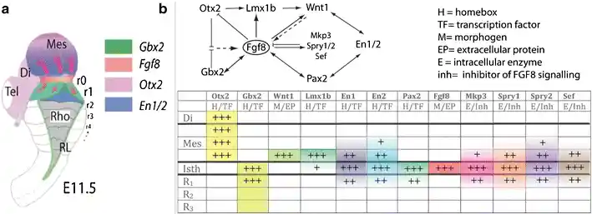
Figure 1 Topographical location of the mid-hindbrain boundary in the E11.5mouse embryo.
a. Dorsal view of an E11.5 mouse embryo illustrating the isthmic constriction (isth) located between the mesencephalon and rhombomere 1 (r1). Rhombomeres r0 and r1, which give rise to the cerebellum, are highlighted in (a). The different color codes depict the expression pattern of the most important genes related to the morphogenetic activity and the capacity of the IsO.
b. Functional interactions (induction/inhibition) of genes that, together with Fgf8, are involved in the molecular maintenance of the isthmic region at E9.5. The table summarizes the expression intensity and expression range of genes along the AP axis of the neural tube, focusing on the isthmus: the level of RNAm expression for each gene is represented by the number of (+) and the color signifies the region of expression and the expression pattern (homogeneous or gradient),extending rostrally or caudally from the isthmus. (Martinez, 2015)

- SECOND STAGE
In the second stage, two compartments for cell proliferation are formed.
Purkinje cells, Golgi neurons, Stellate and Basket cells, and cells of the deep cerebellar nuclei are generated in the roof of the fourth ventricle, while, granule cell precursors, as well as cells of the pre-cerebellar nuclei are formed in the rhombic lip.
- Purkinje cells, golgi neurons, stellate and basket cells and cells of the deep cerebellar nuclei all arise from the ventricular neuroepithelium. The development of Purkinje cells is not well understood. (Vincent Y. Wang, Huda Y. Zoghbi, 2001) (Carrie M. Louie & Joseph G. Gleeson, 2005)
- Purkinje cells are born around embryonic day 13, and they migrate along radial glial fibres to reach their final positions (the cerebellar anlage). During their final maturation phase, purkinje cells develop extensive dendritic arbors and synapse onto granule neurons. This depends on granule neuron signals, Math1 gene, RU49/Zipro1, Zic1, Zic2 and Zic3 ad probably including Wnt3, Bmp4. (Figure 2)
- Various growth factors are required for purkinje cells survival, including nerve growth factor, acetylcholine, neurotrophin 4/5, brain-derived neurotrophic factor and ciliary neurotrophic factor.
- Purkinje cells might release a diffusible factor such as sonic hedgehog (Shh), and Zic1 could control cell proliferation by indirectly regulating the Shh pathway. Hence, sonic hedgehog regulates proliferation of granule cells.

- The rhombic lip, located between the fourth ventricle and the metencephalic roof plate, gives rise to granule neurons. (Vincent Y. Wang, Huda Y. Zoghbi, 2001) (Carrie M. Louie & Joseph G. Gleeson, 2005)
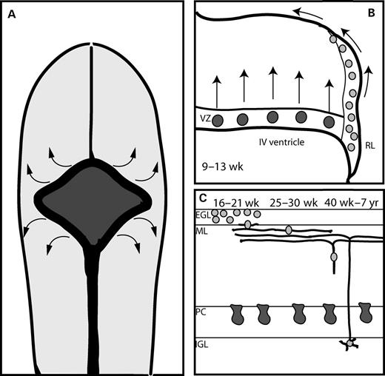
- Proliferation in its germinal epithelium is governed by the Math1 gene. Rhombic lip cells migrate over the surface of the developing cerebellum to the cerebellar anlage and settle on its periphery to form the external granule layer (EGL), another zone of proliferation. As the cells begin to migrate, the granule neuron precursors express a number of markers that include RU49/Zipro1, Zic1, Zic2 and Zic3. These markers are thought to be involved in cell proliferation, which requires interaction with purkinje cells. (Figure 2)
Figure 2. Schematic overview of cerebellar development.
(A) Diagram of dorsal view of cerebellar anlage showing migration from the rhombic lip over the surface of the neural tube. Granule neuron precursors migrate rostrally, whereas precursors of precerebellar nuclei migrate ventrally.
(B) Diagram of cross-section through the anlage showing radial migration of Purkinje cell precursors from the ventricular zone (VZ) and tangential migration of granule cells from the rhombic lip (RL).
(C) ‘Time-lapse’ diagram of granule neuron migration. Granule cell precursors proliferate in the outer EGL. Postmitotic cells move into the inner EGL and extend parallel axons and a descending process prior to migration through the molecular layer (ML) along ﬁbers of Bergman glia (data not shown), until settlement in the IGL. Human developmental time point indicated by wk (refers to prenatal) or yr (refers to postnatal)
- THIRD STAGE
In the third stage, cells of the external granule layer (EGL) migrate inward along the processes of Bergman glia to their ﬁnal position in the internal granular layer (IGL). (Carrie M. Louie & Joseph G. Gleeson, 2005).
The final stage of granule neuron maturation occurs after precursor cell migration into the inner granule layer. (Vincent Y. Wang, Huda Y. Zoghbi, 2001)
- FOURTH STAGE
Finally, cerebellar circuitry is established and further differentiation occurs. The lower portion of the rhombic lip also gives rise to cells of the pre-cerebellar nuclei such as the inferior olivary nuclei, which migrate to positions in the brainstem. (Carrie M. Louie & Joseph G. Gleeson, 2005)

GENETIC BASIS OF KNOWN CEREBLLAR DISORDERS
Numerous cerebellar malformations have been described in humans, primarily classified by MRI studies, and can occur in isolation or as part of a broader malformation syndrome involving multiple systems. Cerebellar development in humans begins around the ninth gestational week and continues beyond birth. This protracted developmental timeline makes the human cerebellum particularly vulnerable to insult, especially during 24– 40 weeks of gestation, when massive neurogenesis in the EGL causes a fivefold increase in size of the cerebellum. Thus, while several malformations have a genetic basis, inflammation, fetal hemorrhage, and prematurity are often contributing factors. (William B. Dobyns, Parthiv Haldipur, Kathleen J. Millen, 2015)
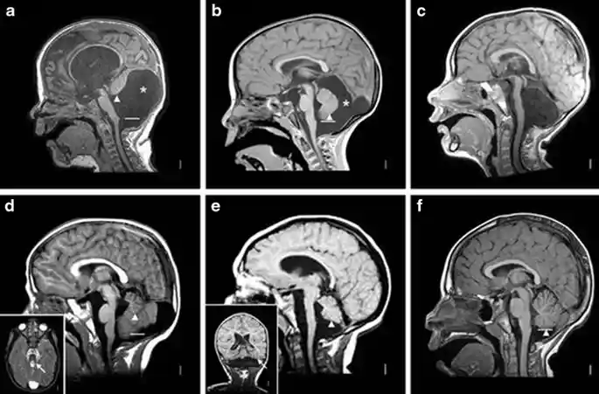
Figure 3. Brain imaging in mid-hindbrain malformations.
- T1-weighted midline sagittal magnetic resonance images show the key features of classic DWM
- Cerebellar vermis hypoplasia with mega-cisterns magna
- Complete cerebellar agenesis
- Molar tooth malformation seen in JSRD
- Ponto-cerebellar hypoplasia
- Normal.
The solid white lines in most images mark the level of the obex, while the arrowheads point to the lower edge of the vermis (both landmarks are absent). The asterisk denotes an enlarged posterior fossa
In(a), the vermis is small and rotated far upwards, the fourth ventricle is enlarged into a cyst-like structure, and the posterior fossa is greatly enlarged causing an elevated tentorium
In(b), the vermis is small but located in the anatomic position, but the posterior fossa is again greatly enlarged. A posterior extension of the cyst appears to scallop the inner table of the skull
In(c), the brainstem is thin without any landmarks other than the tectum and no cerebellum is seen.
In (d), the vermis is very small but located in the correct anatomic position, with portions of the cerebellar hemispheres seen beneath. The inset shows the associated “molar tooth” sign (arrow).
In (e), the brainstem is thin but the obex can just be seen, and the vermis is moderately small. The even more “pancake-like” flattening of the hemispheres is shown in the inset (arrow)

- Dandy Walker Malformation (DWM)
(William B. Dobyns, Parthiv Haldipur, Kathleen J. Millen, 2015)
DWM is the most common human cerebellar malformation with an estimated incidence of 1/3000 live births. DWM is an imaging diagnosis characterized by an enlarged posterior fossa, cerebellar vermis hypoplasia, and an enlarged fourth ventricle. See Figure 3a. It can occur in association with agenesis of the corpus callosum, but more often occurs as an isolated finding on MRI scans.
Its clinical features are variable. Patients may exhibit symptoms ranging from intellectual disability to autism or they may be completely unaware of any deficits until diagnosed as adults for unrelated reasons.
The genetic causes of DWM remain largely unknown. However, recent studies indicate that deletions in FOXC1 and ZIC1/4 are responsible for a small subset of DWM cases. Research in animal models has led to the hypothesis that disruptions of posterior fossa signaling from the mesenchyme surrounding the brain to the underlying embryonic cerebellum are key. Signaling disruptions cause dramatic reductions in cerebellar anlage neuronal progenitor proliferation, as well as abnormal migration of both rhombic lip (RL)- and neuroepithelium of the ventricular zone (VZ) of the 4th ventricle derived cells. This ultimately leads to foliation and lamination defects.
Prenatal cerebellar hemorrhage however can also cause DWM, which may also be associated with genetic risk factors; however, these are yet to be determined.

- Joubert Syndrome and Related Disorders (JSRD)
(William B. Dobyns, Parthiv Haldipur, Kathleen J. Millen, 2015), (Carrie M. Louie & Joseph G. Gleeson, 2005)
JSRD is a group of disorders with an incidence of 1 in 80,000–100,000 live births. JSRD is an autosomal recessive neurodevelopmental disorder, which is characterized by the molar tooth malformation (MTM), a complex brainstem malformation that reﬂects aplasia or marked hypoplasia of the cerebellar vermis, thickened and elongated superior cerebellar peduncles and a deepened interpeduncular fossa that is apparent on axial MRI at the midbrain–hindbrain junction. Figure 3d
Patients with JSRD exhibit variable neurological symptoms such as ataxia, developmental delay, abnormal eye movements, and altered breathing patterns.
To date, ~23 genes have been identified as causative for JSRD. Most have been linked to the primary cilia and its function, bringing JSRD under the umbrella of a highly heterogeneous group of disorders called ciliopathies. Studies in animal models as well as human fetal tissue from JSRD patients indicate reduced granule cells proliferation suggesting impaired SHH signaling. Additionally, the primary cilia also play a role in the mediation of signaling pathways involving WNT and platelet-derived growth factor which can impact cerebellar anlage fusion earlier in fetal development.

- Cerebellar Hypoplasia (CH)
(William B. Dobyns, Parthiv Haldipur, Kathleen J. Millen, 2015)
Cerebellar hypoplasia refers to underdevelopment of the cerebellum. This category of cerebellar malformation is distinct from Dandy Walker Malformation, as it does not involve a concomitant enlargement of the posterior fossa.
CH is also an extremely heterogeneous group of disorders, and often, other central nervous system (CNS) abnormalities are observed, including lissencephaly, microcephaly, and cortical heterotopia. CH may be unilateral, global, vermian, or pontocerebellar, where in addition to the cerebellum, the volume of the pons is also reduced likely reflecting the common developmental origin of granule cells and pontine nuclei neurons in the cerebellar rhombic lip. (Figure 3b, e). In contrast to DWM, almost all individuals exhibit cognitive and motor impairments.
Several genes have been associated with CH including mutations in CASK, DAB1, OPHN1, RELN, CHD7, several tubulin genes, and several TSEN genes. Each cause developmental defects in a multitude of cerebellar developmental programs, including progenitor proliferation and neuronal migration and even developmental cell survival.
Notably, CH can also occur due to a variety of non-genetic causes such as perinatal cytomegalovirus infection and perinatal exposure to alcohol and drugs such as cocaine.

- Cerebellar Agenesis
(William B. Dobyns, Parthiv Haldipur, Kathleen J. Millen, 2015)
Cerebellar agenesis is an extremely rare anomaly distinguished by a complete or near-complete absence of the cerebellum( Figure 3c). Individuals show a number of neurological deficits particularly related to movement and speech, but can be otherwise surprisingly unaffected.
Homozygous mutations in PTF1A have been associated cerebellar agenesis in humans. In mice, Ptf1a is required for the generation of all VZ-derived GABAergic cerebellar neurons. Failure to generate these neurons means that RL-derived cells have no trophic support and these too are therefore lost, resulting in cerebellar agenesis in neonates.
Fetal hemorrhages that completely disrupt the early cerebellar anlage have also been predicted to cause cerebellar agenesis.
- Medulloblastoma (MB)
(Silvia Marino, Thomas O. Millner)
It is a cancerous (malignant) brain tumor that starts in the cerebellum. It tends to spread through cerebrospinal fluid (CSF) to other areas around the brain and spinal cord. This tumor rarely spreads to other parts of the body.
It is also called cerebellar primitive neuroectodermal tumor (PNET), because it is a tumor that starts in the fetal cells in the brain. MB is the most common pediatric brain tumor and is the most common cause of pediatric death from cancer.
Histologically, cases are classified into classic, nodular/desmoplastic, and large cell/anaplastic subtype, and prognosis is performed by combining histological subtype, clinical markers, namely, age, metastatic stage, and level of resection, as well as selected molecular markers.
Morphologically, MB cells closely resemble granule cells and granule cells progenitors; hence, it has been long postulated that a link exists between these tumors and the normal development of the cerebellum.
Evidence gained from candidate gene approaches in mouse models and more recently “-omics” screening of large tumor series has shown deregulation of specific developmental pathways in subgroups of these tumors.
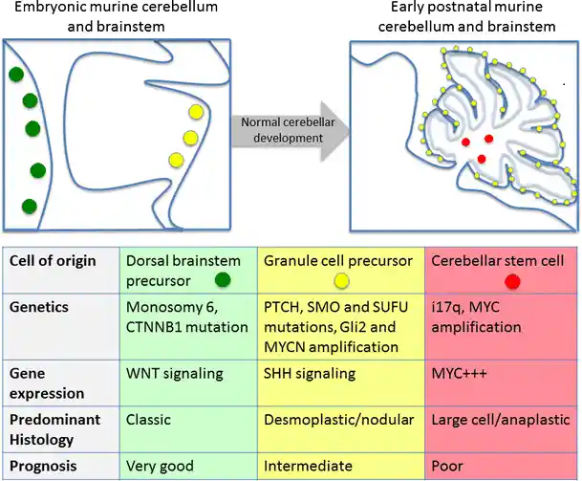
Figure 4.Medulloblastoma subgroups and their cells of origin.
The schematic shows the embryonic and early postnatal murine cerebellum and brainstem with the spatial and temporal locations of likely cells of origin of MB subgroups (green dots represent dorsal brainstem precursor cells, yellow dots represent GCPs, red dots represent cerebellar stem cells).
The table shows the genetics, gene expression profile, predominant histology, and prognosis of the MB subgroups for each of these cells of origin
The current consensus is that MB can be sub-classified based on genetic, epigenetic, and transcriptomic characteristics into four distinct subgroups (Figure 4): WNT, SHH, Group 3, and Group 4.
- The WNT and SHH subgroups have been associated with constitutive activation of the WNT/β-catenin and SHH pathways.
- Group 3 and Group 4 MBs are less well characterized.
Each of these subgroups have defining demographic, clinical, genetic, and epigenetic profiles, and emerging evidence links their origin to different cerebellar progenitor cells at different developmental time points.
SHH subgroup
Granular cell progenitors (GCPs) are the main cell of origin of SHH-MB, as shown in mouse models in which Ptch1 is conditionally inactivated in GCPs. Importantly, constitutive activation of SHH signaling induces neoplastic transformation of more undifferentiated progenitor cells only upon commitment toward a GC lineage. Pre-neoplastic lesions expressed Atho1, a marker of the GC lineage, and showed activation of Gli1, Cyclin D1, and MycN, which are SHH target genes. Their gene expression profiles were more similar (differing by 34 genes) to tumor cells than GCPs (differing by 75 genes).
SHH-MBs have also been shown to originate from cells located in the cochlear nuclei of the brainstem. SHH tumors are mainly detected within the cerebellar hemispheres consistent with a GCP cell origin.
Human Shh MBs have a 1:1male-to-female ratio and a bimodal age distribution (very frequently seen in infants and adults), with a good prognosis in infants but an intermediate prognosis in other age groups.
All histological nodular/desmoplastic MBs are likely SHHMBs, but 50 % of SHH-MBs are of other morphology.
WNT subgroup
Mouse models have shown that WNT-MBs, characterized by activating mutations in the Wnt pathway effector CTNNB1, arise from cells outside the cerebellum, in the embryonic dorsal brainstem. These studies also showed that the genes characterizing human WNT-MBs are more often expressed in the lower RL and embryonic dorsal brainstem than in the upper RL of the developing cerebellum. In addition, transcriptome analysis showed that the MBs arising in these mice matched human WNT-MBs.
MRI studies in patients have shown that WNT tumors are often found within the fourth ventricle (cerebellar peduncle/ cerebellopontine angle cistern) and infiltrated the dorsal brainstem, with the majority of them being continuous with the cuneate nucleus.
Human WNT-MBs have a 1:1 male-to-female ratio and occur at all ages (uncommon in infants). They have a very good long-term prognosis in comparison to the other subgroups of MB (survival rate likely exceeds 90 % with current treatment). The large majority of WNT-MBs investigated so far have classic histology.

- Cerebellar Ataxia
The cerebellar ataxias comprise a heterogeneous group of neurological disorders characterized by gait disturbances, motor incoordination and imbalance, dysarthria, and oculomotor deficits. The etiology of cerebellar ataxia is complex and includes acquired causes as well as a steadily growing number of inherited conditions. The genetic ataxias are usually progressive. For many of these disorders, pathologic changes in progenitor cells and a substantial loss of these neurons resulting in cerebellar atrophy are thought to cause the symptoms of the disease. However, accumulating evidence from cell- and animal-based models of cerebellar ataxia suggest that abnormal PC development and related early changes in PC physiology might contribute to the disease, thus challenging our view of cerebellar ataxias as pure neurodegenerative disorders. (Becker, 2015)
The following are some of the types of ataxias:
- Spinocerebellar ataxia type 1, 2 and 3 (SCA1, SCA2 and SCA3)
SCA1,2 & 3 are conditions characterized by progressive problems with movement.
People with these conditions initially experience ataxia. Other signs and symptoms include speech and swallowing difficulties, muscle stiffness (spasticity), and weakness in the muscles that control eye movement (ophthalmoplegia). Eye muscle weakness leads to rapid, involuntary eye movements (nystagmus). Individuals with SCA may have difficulty processing, learning, and remembering information (cognitive impairment).
Over time, individuals with SCA may develop numbness, tingling, or pain in the arms and legs (sensory neuropathy); uncontrolled muscle tensing (dystonia); muscle wasting (atrophy); and muscle twitches (fasciculations). Rarely, rigidity, tremors, and involuntary jerking movements (chorea) have been reported in people who have been affected for many years.
Signs and symptoms of the disorder typically begin in early adulthood but can appear anytime from childhood to late adulthood. People with SCA1, 2 and 3 typically survive 10 to 20 years after symptoms first appear.
Mutations in the ATXN1, ATXN2, ATXN3 gene cause SCA1, SCA2, SCA3 respectively.[1][2][3]
- Spinocerebellar ataxia type 36 (SCA36)
SCA36 is a condition characterized by progressive problems with movement that typically begin in mid-adulthood.
People with this condition initially experience (ataxia). Affected individuals often have exaggerated reflexes (hyperreflexia) and problems with speech (dysarthria). They also usually develop muscle twitches (fasciculations) of the tongue and over time, the muscles in the tongue waste away (atrophy). These tongue problems can cause difficulties swallowing liquids. As the condition progresses, individuals with SCA36 develop muscle atrophy in the legs, forearms, and hands. Another common feature of SCA36 is the atrophy of specialized nerve cells that control muscle movement (motor neurons), which can contribute to the tongue and limb muscle atrophy in affected individuals.
Some people with SCA36 have abnormalities of the eye muscles, which can lead to involuntary eye movements (nystagmus), rapid eye movements (saccades), trouble moving the eyes side-to-side (oculomotor apraxia), and droopy eyelids (ptosis). Sensorineural hearing loss, which is hearing loss caused by changes in the inner ear, may also occur in people with SCA36.
Brain imaging of people with SCA36 shows progressive atrophy of various parts of the brain, particularly within the cerebellum, which is the area of the brain involved in coordinating movements. Over time, the loss of cells in the cerebellum causes the movement problems characteristic of SCA36. In older affected individuals, the frontal lobes of the brain may show atrophy resulting in loss of executive function, which is the ability to plan and implement actions and develop problem-solving strategies.
Signs and symptoms of SCA36 typically begin in a person's forties or fifties but can appear anytime during adulthood. People with SCA36 have a normal lifespan and are usually mobile for 15 to 20 years after they are diagnosed.
SCA36 is caused by mutations in the NOP56 gene. The NOP56 gene provides instructions for making a protein called nucleolar protein 56, which is primarily found in the nucleus of nerve cells (neurons), particularly those in the cerebellum[4]
- Friedreich ataxia
Friedreich ataxia is a genetic condition that affects the nervous system and causes movement problems.
People with this condition develop impaired muscle coordination (ataxia) that worsens over time. Other features of this condition include the gradual loss of strength and sensation in the arms and legs; muscle stiffness (spasticity); and impaired speech, hearing, and vision. Individuals with Friedreich ataxia often have a form of heart disease called hypertrophic cardiomyopathy, which enlarges and weakens the heart muscle and can be life-threatening. Some affected individuals develop diabetes or an abnormal curvature of the spine (scoliosis).
Most people with Friedreich ataxia begin to experience the signs and symptoms of the disorder between ages 5 and 15. Poor coordination and balance are often the first noticeable features. Affected individuals typically require the use of a wheelchair about 10 years after signs and symptoms appear. About 25 percent of people with Friedreich ataxia have an atypical form in which signs and symptoms begin after age 25. Affected individuals who develop Friedreich ataxia between ages 26 and 39 are considered to have late-onset Friedreich ataxia (LOFA). When the signs and symptoms begin after age 40 the condition is called very late-onset Friedreich ataxia (VLOFA). LOFA and VLOFA usually progress more slowly than typical Friedreich ataxia.
Mutations in the FXN gene cause Friedreich ataxia. This gene provides instructions for making a protein called frataxin. Although its role is not fully understood, frataxin is important for the normal function of mitochondria, the energy-producing centers within cells.
This condition is inherited in an autosomal recessive pattern, which means both copies of the gene in each cell have mutations. The parents of an individual with an autosomal recessive condition each carry one copy of the mutated gene, but they typically do not show signs and symptoms of the condition.[5]
- Episodic ataxia
Episodic ataxia is a group of related conditions that affect the nervous system and cause problems with movement.
People with episodic ataxia have recurrent episodes of poor coordination and balance (ataxia). During these episodes, many people also experience dizziness (vertigo), nausea and vomiting, migraine headaches, blurred or double vision, slurred speech, and ringing in the ears (tinnitus). Seizures, muscle weakness, and paralysis affecting one side of the body (hemiplegia) may also occur during attacks. Additionally, some affected individuals have a muscle abnormality called myokymia during or between episodes. This abnormality can cause muscle cramping, stiffness, and continuous, fine muscle twitching that appears as rippling under the skin.
Episodes of ataxia and other symptoms can begin anytime from early childhood to adulthood. They can be triggered by environmental factors such as emotional stress, caffeine, alcohol, certain medications, physical activity, and illness. The frequency of attacks ranges from several per day to one or two per year. Between episodes, some affected individuals continue to experience ataxia, which may worsen over time, as well as involuntary eye movements called nystagmus.
Researchers have identified at least seven types of episodic ataxia, designated type 1 through type 7. The types are distinguished by their pattern of signs and symptoms, age of onset, length of attacks, and, when known, genetic cause.[6]
Episodic ataxia is uncommon, affecting less than 1 in 100,000 people. Only types 1 and 2 have been identified in more than one family, and type 2 is by far the most common form of the condition.
Episodic ataxia can be caused by mutations in several genes that play important roles in the nervous system. Three of these genes, KCNA1, CACNA1A, and CACNB4, provide instructions for making proteins that are involved in the transport of charged atoms (ions) across cell membranes. The movement of these ions is critical for normal signaling between nerve cells (neurons) in the brain and other parts of the nervous system. Mutations in the KCNA1, CACNA1A, and CACNB4 genes are responsible for episodic ataxia types 1, 2, and 5, respectively.
Mutations in the SLC1A3 gene have been found to cause episodic ataxia type 6. This gene provides instructions for making a protein that transports a brain chemical (neurotransmitter) called glutamate. Neurotransmitters, including glutamate, allow neurons to communicate by relaying chemical signals from one neuron to another.
Researchers believe that mutations in the KCNA1, CACNA1A, CACNB4, and SLC1A3 genes alter the transport of ions and glutamate in the brain, which causes certain neurons to become overexcited and disrupts normal communication between these cells. Although changes in chemical signaling in the brain underlie the recurrent attacks seen in people with episodic ataxia, it is unclear how mutations in these genes cause the specific features of the disorder.[6]
The genetic causes of episodic ataxia types 3, 4, and 7 have not been identified. Researchers are looking for additional genes that can cause episodic ataxia[6]

CONCLUSION:
The goal of this review paper is to provide an updated view of our current knowledge on cerebellar development, the genetic basis of cerebellar development and the genetic basis of known cerebellar disorders.
BIBLIOGRAPHY
- Becker, E. B. (2015). Abnormal purkinje cell development and cerebellar ataxia. Consensus Paper: Cerebellar Development, 789-828. doi:10.1007/s12311-015-0724-2
- Carrie M. Louie & Joseph G. Gleeson. (2005, October 15). Genetic basis of Joubert syndrome and related disorders of cerebellar developmen. Human Molecular Genetics, 14(2), R235-R242. doi:10.1093/hmg/ddi264
- Joshua J. White & Roy V. Sillitoe. (2013). Delopment of the cerebellum: from gene expression patterns to circuit maps. WIREs Developmental Biology, 2(1), 149-164. doi:10.1002/wdev.65
- Martinez, S. (2015). The molecular specification of the cerebellar anlage: The isthmic organizer. Consensus Paper: Cerebellar Development. doi:10.1007/s12311-015-0724-2
- Samin A. Sajan, Kathryn E. Waimey, & Kathleen J. Millen. (2010). Novel approaches to studying the genetic basis of cerebellar development. Cerebellum, 9(3), 272-283. doi:10.1007/s12311-010-0169-6
- Silvia Marino, Thomas O. Millner. (n.d.). Deregulated developmental pathways in medulloblastoma. Consensus Paper: Cerebellar Development. doi:10.1007/s12311-015-0724-2
- Vincent Y. Wang, Huda Y. Zoghbi. (2001). Genetic regulation of cerebellar development. Nature Reviews Neuroscience, 2, 484-491. doi:https://doi.org/10.1038/35081558
- William B. Dobyns, Parthiv Haldipur, Kathleen J. Millen. (2015). Neurodevelopmental disorders of the cerebellum. Consensus Paper: Cerebellar Development. doi:10.1007/s12311-015-0724-2
- [1] Condition, gene, or chromosome summary: National Library of Medicine (US). Genetics Home Reference [Internet]. Bethesda (MD): The Library; 2020 July 07. Spinocerebellar ataxia type 1; [reviewed 2011 Feb; cited 2020 July 12]. Available from: https://ghr.nlm.nih.gov/condition/spinocerebellar-ataxia-type-1
- [2] Condition, gene, or chromosome summary: National Library of Medicine (US). Genetics Home Reference [Internet]. Bethesda (MD): The Library; 2020 July 07. Spinocerebellar ataxia type 2; [reviewed 2019 Dec; cited 2020 July 12]. Available from: https://ghr.nlm.nih.gov/condition/spinocerebellar-ataxia-type-2
- [3] Condition, gene, or chromosome summary: National Library of Medicine (US). Genetics Home Reference [Internet]. Bethesda (MD): The Library; 2020 July 07. Spinocerebellar ataxia type 3; [reviewed 2019 Feb; cited 2020 July 12]. Available from: https://ghr.nlm.nih.gov/condition/spinocerebellar-ataxia-type-3
- [4] Condition, gene, or chromosome summary: National Library of Medicine (US). Genetics Home Reference [Internet]. Bethesda (MD): The Library; 2020 July 07. Spinocerebellar ataxia type 36; [reviewed 2014 Dec; cited 2020 July 12]. Available from: https://ghr.nlm.nih.gov/condition/spinocerebellar-ataxia-type-36
- [5] Condition, gene, or chromosome summary: National Library of Medicine (US). Genetics Home Reference [Internet]. Bethesda (MD): The Library; 2020 July 07. Friedreich ataxia; [reviewed 2016 June; cited 2020 July 12]. Available from: https://ghr.nlm.nih.gov/condition/friedrich-ataxia
- [6] Condition, gene, or chromosome summary: National Library of Medicine (US). Genetics Home Reference [Internet]. Bethesda (MD): The Library; 2020 July 07. Episodic ataxia; [reviewed 2008 Aug; cited 2020 July 12]. Available from: https://ghr.nlm.nih.gov/condition/episodic-ataxia

