17/MHS01/085
Bisi-Kazeem Abisayo Ameerah
MBBS
300L
Neuroanatomy

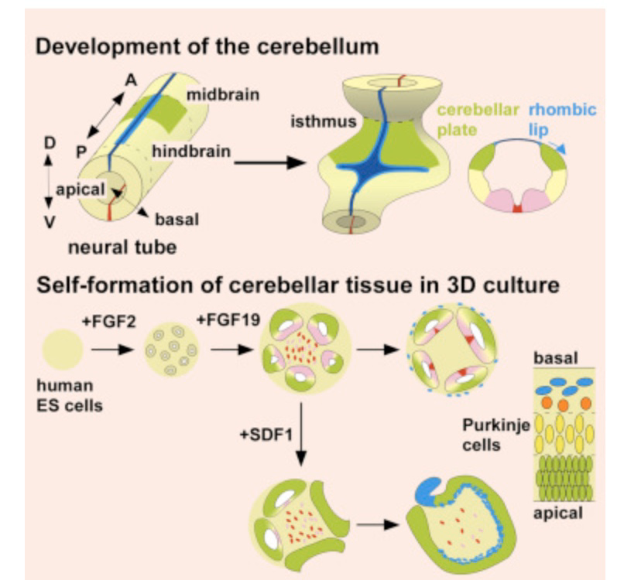
Write a concise review on the developmental genetics of the cerebellum and highlight the genetic basis of known cerebellar disorders.

The cerebellum is a very important structure in the nervous system which controls and regulates motor and non-motor functions. The cerebellum is in the posterior cranial fossa, beneath the occipital lobe and dorsal to the brainstem. It is involved in the regulation of posture, motor coordination, balance, and motor learning. More recently, it has been proposed that it plays a role in emotion and cognition. The cerebellum consists of a midline region referred to as the vermis, a narrow paravermal area immediately adjacent to the vermis, and large hemispheres on either side. Well-defined fissures divide the cerebellum into an anterior, posterior and flocculonodular lobe.
During prenatal development of the nervous system, the central nervous system originates from the area of the ectoderm known as the neural plate. Thee neural plate thickens as a result of cell proliferation and then begins to invaginate and thus forms the neural groove. The invagination of the neural groove continues until the lateral edges of the neural groove fuse to form the neural tube through a process called neurulation. As the edges of the neural groove fuse to form the neural tube, which detaches from the ectoderm, a population of neuroectodermal cells dissociate from the neural fold as neural crest cells. The rostral end of the neural tube develops into the prosencephalon, mesencephalon, and rhombencephalon. The cerebellum develops from the dorsal portion of the metencephalon and the neural folds. The alar plates of the rostral metencephalon undergo bilateral expansion in the dorsolateral region to form the rhombomere 1(r1). These rostral extensions of alar plate eventually join in the midline to form the vermis of the cerebellum, as the cerebellum begins to form, initially from the dorsal rhombomere 1 (r1), it rotates 90° before fusing at the midline as the vermis. This rotation of the dorsal r1 results in the conversion of rostral-caudal axis seen in the early neural tube, into the medial-lateral axis seen in the mature cerebellum. As the bilateral cerebellar primordia fuse, the midline vermis is derived from the rostro-medial ends while the cerebellar hemispheres are derived from the more caudo-lateral components of the rhombencephalon.

The cerebellum is a highly ordered brain structure related to motor functions with several distinct types of cells. Initially, the isthmic organizer, formed at the midbrain-hindbrain boundary (MHB), induces the cerebellar plate (CP) in the dorsal region (alar plate) of rhombomere 1 (r1). Cerebellar cells are generated in two distinct germinal zones in r1:
The ventricular zone (VZ) of the CP expresses the basic helix-loop-helix (bHLH) transcription factor Ptf1a. Ptf1a+ progenitors produce GABAergic neurons of the cerebellar cortex (Purkinje cells and interneurons) and of the deep cerebellar nuclei (DCN).
The rhombic lip (RL) at the dorsal margin of r1 expresses another bHLH factor, Atoh1 (also known as Math1). Atoh1+ progenitors generate glutamatergic neurons, including granule cells (GCs), unipolar brush cells, and large DCN projection neurons. Recent knowledge on the mechanism of cerebellar differentiation has promoted technical advancement for in vitro generation of cerebellar neurons from pluripotent stem cells. However, it remains unknown how the several cellular components are assembled to form the intricate structure of the cerebellum.

We found in vitro production of major cerebellar cell types. Of note, we demonstrated a set of electrophysiological analyses of human Purkinje cells. Moreover, two factors were identified; FGF19 and SDF1, that promote self-formation of ordered CP-like tissues in distinct manners. Here,it was demonstrated that the addition of FGF19 promotes spontaneous formation of hindbrain neural-tube-like NE structures with dorsal-ventral (D-V) polarity. Sequential addition of FGF19 and SDF1 induces the generation of continuous CPNE that differentiates into a multilayered structure as seen in the cerebellar ontogenesis. NE margins form distinct RL-like germinal zones. We discuss the self-organizing nature of hESC-derived cerebellar tissues with regard to spontaneous polarity formation in 3D stem cell culture.
During cerebellar development, the main portion of the cerebellar plate neuroepithelium gives birth to Purkinje cells and interneurons, whereas the rhombic lip, the germinal zone at its dorsal edge, generates granule cells and cerebellar nuclei neurons. However, it remains elusive how these components cooperate to form the intricate cerebellar structure. A polarized cerebellar structure self-organizes in embryonic stem cell (ESC) culture. The self-organized neuroepithelium differentiates into electrophysiologically functional Purkinje cells. The addition of fibroblast growth factor 19 (FGF19) promotes spontaneous generation of dorsoventrally polarized neural-tube-like structures at the level of the cerebellum. Furthermore, addition of SDF1 and FGF19 promotes the generation of a continuous cerebellar plate neuroepithelium with rhombic-lip-like structure at one end and a three-layer cytoatchitecture similar to the embryonic cerebellum.

GENETIC BASIS OF KNOWN CEREBELLAR DISORDERS
Trauma, hemorrhage, tumors and congenital diseases are some of the causes of cerebellar disorders.
1. HEREDITARY ATAXIAS
Hereditary ataxias may be autosomal recessive or autosomal dominant. Autosomal recessive ataxias include Friedreich ataxia (the most prevalent), ataxia-telangiectasia, abetalipoproteinemia, ataxia with isolated vitamin E deficiency, and cerebrotendinousxanthomatosis.
- Friedreich ataxia is a rare inherited disease that causes progressive damage to the nervous system. It is caused by a defect in the FXN gene that produces the protein frataxin. Frataxin controls important steps in mitochondrial iron metabolism and overall cell iron stability. Research suggests that cells that have a reduced level of frataxin produce energy less effectively, which may lead to a buildup of toxic byproducts. It results from a gene mutation causing abnormal repetition of the DNA sequence GAA in the FXN gene on the long arm of chromosome 9; the FXN gene codes for the mitochondrial protein frataxin. The GAA sequence is repeated 5 to 38 times within the FXN gene in people who do not have Friedreich ataxia; however, in people with Friedreich ataxia, the GAA sequence may be repeated 70 to > 1000 times. Inheritance is autosomal recessive. Decreased frataxin levels lead to mitochondrial iron overload and impaired mitochondrial function.In Friedreich ataxia, gait unsteadiness begins between ages 5 and 15; it is followed by upper-extremity ataxia, dysarthria, and paresis, particularly of the lower extremities. Mental function often declines. Tremor, if present, is slight. Reflexes and vibration and position senses are lost. Talipes equinovarus (clubfoot), scoliosis, and progressive cardiomyopathy are common. By their late 20s, patients may be confined to a wheelchair. Death, often due to arrhythmia or heart failure, usually occurs by middle age. Symptoms typically appear between ages 5 and 15 years but can begin in adulthood. Damage to the peripheral nerves and the cerebellum (part of the brain that coordinates balance and movement) results in awkward, unsteady movements and impaired muscle coordination (ataxia) that worsens and eventually spreads to the arms and the trunk of the body. Other symptoms include loss of sensory function, speech problems, and vision and hearing loss. Thinking and reasoning abilities are not affected. Many people with Friedreich ataxia develop scoliosis (a curving of the spine to one side), which, if severe, may impair breathing. Some individuals may develop diabetes.

- Spinocerebellar ataxia (SCA) is a term referring to a group of hereditary ataxias that are characterized by degenerative changes in the part of the brain related to the movement control (cerebellum), and sometimes in the spinal cord. There are many different types of SCA, and they are classified according to the mutated (altered) gene responsible for the specific type of SCA. Classification of these ataxias , currently, at least 43 different gene loci are recognized; about 10 involve expanded DNA sequence repeats. Some involve a repetition of the DNA sequence CAG that codes for the amino acid glutamine, similar to that in Huntington disease. Manifestations of SCAs vary. Some of the most common SCAs affect multiple areas in the central and peripheral nervous systems; neuropathy, pyramidal signs, and restless leg syndrome, as well as ataxia, are common. Some SCAs usually cause only cerebellar ataxia. The signs and symptoms may vary by type but are similar, and may include an uncoordinated walk (gait), poor hand-eye coordination, and abnormal speech (dysarthria). SCA is inherited in an autosomal dominant manner. However, the term "spinocerebellar" may be found with other diseases, such as the autosomal recessive spinocerebellar ataxias (SCAR). Treatment is supportive and based on the signs and symptoms present in the person with SCA.

- Ataxia-telangiectasia is a rare, childhood neurological disorder that causes degeneration in the part of the brain that controls motor movements and speech. The first signs of the disease are unsteady walking and slurred speech, usually occurring during the first five years of life. Telangiectasias (tiny, red "spider" veins), which appear in the corners of the eyes or on the surface of the ears and cheeks, are characteristic of the disease, but are not always present and generally do not appear in the first years of life. About 35 percent of those with A-T develop cancer, most frequently acute lymphocytic leukemia or lymphoma. The most unusual symptom is an acute sensitivity to ionizing radiation, such as X-rays or gamma rays. Many individuals with A-T have a weakened immune system, making them susceptible to recurrent respiratory infections. Other features of the disease may include mild diabetes mellitus, premature graying of the hair, difficulty swallowing, and delayed physical and sexual development. Children with A-T usually have normal or above normal intelligence.
2. DANDY-WALKER SYNDROME is a congenital brain malformation involving the cerebellum and the fluid-filled spaces around it. The key features of this syndrome are an enlargement of the fourth ventricle (a small channel that allows fluid to flow freely between the upper and lower areas of the brain and spinal cord), a partial or complete absence of the area of the brain between the two cerebellar hemispheres (cerebellar vermis), and cyst formation near the lowest part of the skull. An increase in the size and pressure of the fluid spaces surrounding the brain (hydrocephalus) may also be present. The syndrome can appear dramatically or develop unnoticed. Symptoms, which often occur in early infancy, include slow motor development and progressive enlargement of the skull. In older children, symptoms of increased intracranial pressure (pressure within the skull) such as irritability and vomiting, and signs of cerebellar dysfunction such as unsteadiness, lack of muscle coordination, or jerky movements of the eyes may occur. Other symptoms include increased head circumference, bulging at the back of the skull, abnormal breathing problems, and problems with the nerves that control the eyes, face and neck. Dandy-Walker Syndrome is sometimes associated with disorders of other areas of the central nervous system, including absence of the area made up of nerve fibers connecting the two cerebral hemispheres (corpus callosum) and malformations of the heart, face, limbs, fingers and toes. Dandy-Walker malformation most often occurs in people with trisomy 18 (an extra copy of chromosome 18) but can also occur in people with trisomy 13 and trisomy 21. This condition can also be associated with deletion or duplication of certain chromosomes. Some genes associated with this syndrome are: FOXC1, ZIC1,ZIC4. Most cases of this syndrome are sporadic i.e. they occur in people with no history of the disorder in their family. It does not have a clear pattern of inheritance.

3. OLIVOPONTOCEREBELLAR ATROPHY(OPCA): is a term used for a progressive condition characterized by the degeneration of nerve cells (neurons) in specific areas of the brain. OPCA can be viewed as a finding of several diseases, and indicates a form of progressive ataxia (abnormal or uncontrolled movements) distinguished by characteristic findings in brain imaging studies and at autopsy (pontine flattening and cerebellar atrophy). It was traditionally divided in hereditary or genetic OPCA and sporadic OPCA. Currently, most of the major forms of hereditary OPCA refer to disorders that overlap with spinocerebellar ataxia (SCA), which is a neurological disorder characterized by ataxia. The sporadic forms are considered now to be a form of multiple system atrophy (MSA). OPCA may also occur in people with prion disorders and inherited metabolic diseases. The main symptom is clumsiness that slowly gets worse. Other symptoms may include problems with balance; speech or swallowing problems; difficulty walking; abnormal eye movements; muscle spasms; and neuropathy. Whether OPCA is inherited (and the inheritance pattern) depends on the underlying cause, if known. There is no cure for OPCA, and management aims to treat symptoms and prevent complications.

4. JOUBERT SYNDROME is a rare brain malformation characterized by the absence or underdevelopment of the cerebellar vermis - an area of the brain that controls balance and coordination -- as well as a malformed brain stem (molar tooth sign). The most common features of Joubert syndrome in infants include abnormally rapid breathing (hyperpnea), decreased muscle tone (hypotonia), abnormal eye movements, impaired intellectual development, and the inability to coordinate voluntary muscle movements (ataxia). Physical deformities may be present, such as extra fingers and toes (polydactyly), cleft lip or palate, and tongue abnormalities. Kidney and liver abnormalities can develop, and seizures may also occur. Many cases of Joubert syndrome appear to be sporadic (not inherited). In most other cases, Joubert syndrome is inherited in an autosomal recessive manner (meaning both parents must have a copy of the mutation) via mutation in at least 10 different genes, including NPHP1, AHI1, and CEP290. Mutations in these genes leads to problems with the structure and function of the primary cilia(which is necessary for perception of sensory input). This syndrome has an autosomal recessive pattern of inheritance which means both copies of a gene in each cell have mutations. Rare cases are inherited in an X-linked recessive pattern which mostly affects males.

5. MACHADO-JOSEPH DISEASE which is also called spinocerebellar ataxia type 3, is a rare hereditary ataxia (ataxia is a medical term meaning lack of muscle control). The disease is characterized by slowly progressive clumsiness and weakness in the arms and legs, spasticity, a staggering lurching gait easily mistaken for drunkenness, difficulty with speech and swallowing, involuntary eye movements, double vision, and frequent urination. Some individuals also have dystonia (sustained muscle contractions that cause twisting of the body and limbs, repetitive movements, abnormal postures, and rigidity) or symptoms similar to those of Parkinson's disease. Others have twitching of the face or tongue, or peculiar bulging eyes. Almost all individuals with MJD experience vision problems, including double vision or blurred vision, loss of the ability to distinguish color and/or contrast, and inability to control eye movements. Machado-Joseph disease belongs to a class of genetic disorders called expanded repeat diseases. Mutations are abnormally long repeats of a normal repetition of three letters of the DNA genetic code. In the case of this disease, the code sequence “CAG” is repeated in the ATXN3 gene, which produces the disease protein called ataxin-3. This protein when mutated is prone to fold abnormally and acccumulate in the affected brain cells. They are located in the nucleus of the cell.

References

- Keiko Muguruma, Ayaka Nishiyama, Kouichi Hashimoto, Yoshiki Sasai. Self-Organization of Polarized Cerebellar Tissue in 3D culture of human pluripotent stem cells. January 29, 2015. Available from : www.sciencedirect.com/science/article/pii/S2211124714011048
- (ed.) Hassan Marzban. Development of the Cerebellum from Molecular Aspects to Diseases. Contemporary Clinical Neuroscience, 2627-535X.Gewerbestrasse 11, 6330 Cham, Switerland: Springer International Publishing AG; 2017
- National Institute of Neurological Disorders and Stroke. [Online]. Available from: www.ninds.nih.gov.
- National Center for Advancing Translational Services. Genetic and Rare Diseases Information Center. [Online]. Available from: https://rarediseases.info.nih.gov/
- National Library of Medicine. [Online]. Available from: https://ghr.nlm.nih.gov/

