NAME: SUOWARI OYINEBI PASCHELIA
MATRIC NUMBER: 17/MHS01/299
DEPARTMENT: MEDICINE AND SURGERY
NEUROANATOMY ASSIGNMENT
Write a concise review on the developmental genetics of the cerebellum and highlight the genetic bases of known cerebellar disorders.
ANSWER
- Developmental genetics of the cerebellum
The cerebellum is derived from dorsal rhombomere 1, which comprises the most anterior aspect of the hindbrain. Expression of the home box genes Otx2 and Gbx2 are essential for the development of the midbrain and hindbrain. During development, these two genes are expressed in abutting domains where they antagonize each other to establish the mid/hindbrain boundary and formation of an isthmic organizer (IsO). The IsO functions as a classic signalling center by secreting ﬁbroblast growth factor 8 (FGF8), which maintains the posterior border of Otx2 expression and is crucial for normal cerebellar development. FGF expression is strongly controlled during hindbrain development and its loss results in the absence of the midbrain and cerebellum. Accordingly, FGF expression is required for cell survival and to regulate gene expression in the mid/hindbrain region. Different mediolateral and anteroposterior regions of the midbrain and cerebellum require varying levels and durations of FGF signalling for proper development. For instance, a slight reduction in FGF8 signalling results in a speciﬁc loss of posterior midbrain and the vermis. Moreover, the different isoforms of FGF8 that are expressed in the IsO have speciﬁc receptor afﬁnities and their ectopic expression causes distinct developmental disruptions with miss-expression of FGF8b causing a deletion of the midbrain and gain of cerebellar territory whereas FGF8a promotes an increase in midbrain tissue. The ability of FGF8 to induce distinct structures depends not only on the strength of the signal but also on its duration. For example, transient Fgf8 expression between E8.5 and E10 is sufﬁcient to induce the formation of the lateral cerebellum but not the vermis. A number of other genes cooperate with Fgf8 to control cerebellar development. Among these are the home box genes engrailed 1(En1) and engrailed 2 (En2), and the paired box genes Pax2 and Pax5.Pax2 induces Fgf8 expression while En1 and En2 are necessary for its maintenance. Interestingly, notch signalling may be upstream of all the above-mentioned genes during the establishment of the IsO. Although a great deal of attention has been given to Fgf8, other members of the Fgf family are also crucial for cerebellar development (e.g., Fgf17 and Fgf18) and several of the mRNAs that encode FGF signalling molecules exhibit a patterned expression postnatally.
Cell birth in the cerebellum begins during embryonic development and continues well into the second postnatal week. Cerebellar cells are born and migrate sequentially from two germinal zones:
- the ventricular zone ,which produces inhibitory GABAergic neurons and
- The rhombic lip, which generates excitatory glutamatergic neurons.
However, Golgi cells, which are inhibitory, may be derived from both germinal zones. Ventricular zone and rhombic lip-derived cells are apparently produced from multipotent radial glial progenitor cells. Proper proliferation of ventricular zone progenitor cells is initially reliant upon wingless (WNT) signalling. Thereafter, their proliferation requires the expression of sonic hedgehog (SHH), which is not endogenous in the cerebellum before E17 but instead may be delivered to the cerebellum by the cerebrospinal ﬂuid in the fourth ventricle. In contrast, after E17, SHH is secreted from Purkinje cells and plays a key role in the proliferation of granule cell precursors.
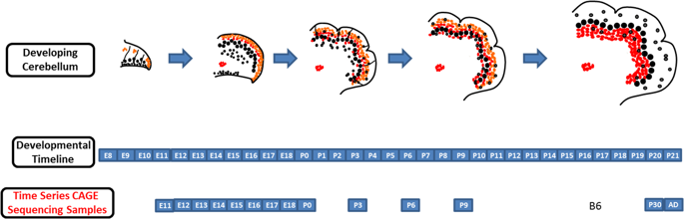
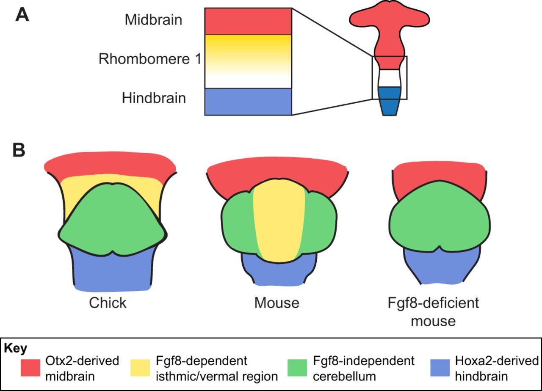

- Cerebellar Disorders
The cerebellum contains a lot of neurons; it contains about 80% of the neurons in the brain. So small in size yet large in number. The large neuron count probably is due to the more elaborate folding of the cerebellar cortex, as the neurons are mainly close to the periphery. Cerebellar disorders are rare and are often called "ataxias". According to Musselman et al (2014), the prevalence of childhood ataxia is 26/100,000 children. Ataxia is rare compared to cerebral palsy (211/100,00) and autism (620/100,000).Many cerebellar disorders are genetic in origin. In general, prevalence of genetic disorders and especially autosomal recessive disorders is much higher in populations where there is more consanguinity. There are also many acquired cerebellar disorders. For example, drinking too much alcohol for a long time causes a cerebellar disorder.
The main clinical features of cerebellar disorders include incoordination, imbalance, and troubles with stabilizing eye movements. There are two distinguishable cerebellar syndromes:
- Midline cerebellar syndromes are characterized by imbalance. Persons are unsteady, they are unable to stand in Romberg with eyes open or closed, and are unable to well perform tandem gait. Severe midline disturbance causes "truncal ataxia" a syndrome where a person is unable to sit on their bed without steadying themselves. Some persons have "titubation" or a bobbing motion of the head or trunk. Midline cerebellar disturbances also often affect eye movements. There may be nystagmus, ocular dysmetria and poor pursuit.
- Hemispheric cerebellar syndromes are characterized by incoordination of the limbs. There may be decomposition of movement, dysmetria, and rebound. Dysdiadochokinesis is the irregular performance of rapid alternating movements. Intention tremors may be present on an attempt to touch an object. A kinetic tremor may be present in motion. The finger-to-nose and heel-to-knee tests are classic tests of hemispheric cerebellar dysfunction. While reflexes may be depressed initially with hemispheric cerebellar syndromes, this cannot be counted on. Speech may be dysarthric, scanning, or have irregular emphasis on syllables.
Some causes of cerebellar disorders are:
- Vascular: stroke or transient ischaemic attack (TIA):
- Usually with other brainstem features.
- Infarction of the posterior inferior cerebellar artery causes lateral medullary syndrome with hemiataxia, vertigo, dysarthria, ptosis and miosis.
- Space-occupying: enlarging masses in the cerebellum may obstruct CSF flow, causing hydrocephalus and raised intracranial pressure. Coning of the cerebellar tonsils can occur rapidly (within hours), causing respiratory arrest, for example:
- Hydrocephalus.
- Posterior fossa tumours or abscess.
- Nutritional:
- Thiamine deficiency - Wernicke's encephalopathy; requires urgent thiamine treatment.
- Vitamin E deficiency (including a genetic form).
- Gluten sensitivity (gluten ataxia): neurological dysfunction can be the only manifestation of coeliac disease and, in this situation, typically presents as cerebellar ataxia, ± peripheral neuropathy. The neurological features may reverse with a gluten-free diet.
- Zinc deficiency (rarely).
- Infections:
- Bacterial: meningo-encephalitis or intracranial abscess.
- Viral: acute infections (e.g., varicella); chronic infections - e.g., human immunodeficiency virus (HIV); post-viral syndromes (e.g., post infective cerebellar syndrome in childhood).
- Parasitic infections (e.g., toxoplasma, falciparum malaria, Lyme disease).
- Genetic: there are a number of inherited cerebellar ataxias:
- Many of these present in adulthood, Examples are Friedreich's ataxia (the most common) and ataxia telangiectasia. Etc.
Some Cerebellar Disorders include:
- Ataxia-telangiectasia: Ataxia-telangiectasia is a rare inherited disorder that affects the nervous system, immune system, and other body systems. This disorder is characterized by progressive difficulty with coordinating movements (ataxia) beginning in early childhood, usually before age 5. Affected children typically develop difficulty walking, problems with balance and hand coordination, involuntary jerking movements (chorea), muscle twitches (myoclonus), and disturbances in nerve function (neuropathy). The movement problems typically cause people to require wheelchair assistance by adolescence. People with this disorder also have slurred speech and trouble moving their eyes to look side-to-side (oculomotor apraxia). Small clusters of enlarged blood vessels called telangiectasia, which occur in the eyes and on the surface of the skin, are also characteristic of this condition.
Mutations in the ATM gene cause ataxia-telangiectasia. The ATM gene provides instructions for making a protein that helps control cell division and is involved in DNA repair. This protein plays an important role in the normal development and activity of several body systems, including the nervous system and immune system. The ATM protein assists cells in recognizing damaged or broken DNA strands and coordinates DNA repair by activating enzymes that Qx the broken strands. Efficient repair of damaged DNA strands helps maintain the stability of the cell's genetic information. Mutations in the ATM gene reduce or eliminate the function of the ATM protein. Without this protein, cells become unstable and die. Cells in the part of the brain involved in coordinating movements (the cerebellum) are particularly affected by loss of the ATM protein. The loss of these brain cells causes some of the movement problems characteristic of ataxia-telangiectasia. Mutations in the ATM gene also prevent cells from responding correctly to DNA damage, which allows breaks in DNA strands to accumulate and can lead to the formation of cancerous tumours.
- Friedreich ataxia: Friedreich ataxia is a genetic condition that affects the nervous system and causes movement problems. People with this condition develop impaired muscle coordination (ataxia) that worsens over time. Other features of this condition include the gradual loss of strength and sensation in the arms and legs; muscle stiffness (spasticity); and impaired speech, hearing, and vision. Individuals with Friedreich ataxia often have a form of heart disease called hypertrophic cardiomyopathy, which enlarges and weakens the heart muscle and can be life-threatening. Some affected individuals develop diabetes or an abnormal curvature of the spine (scoliosis).
Mutations in the FXN gene cause Friedreich ataxia. This gene provides instructions for making a protein called frataxin. Although its role is not fully understood, frataxin is important for the normal function of mitochondria, the energy-producing centres within cells. One region of the FXN gene contains a segment of DNA known as a GAA trinucleotide repeat. This segment is made up of a series of three DNA building blocks (one guanine and two adenines) that appear multiple times in a row. Normally, this segment is repeated 5 to 33 times within the FXN gene. In people with Friedreich ataxia, the GAA segment is repeated 66 to more than 1,000 times. The length of the GAA trinucleotide repeat appears to be related to the age at which the symptoms of Friedreich ataxia appear, how severe they are, and how quickly they progress. People with GAA segments repeated fewer than 300 times tend to have a later appearance of symptoms (after age 25) than those with larger GAA trinucleotide repeats. The abnormally long GAA trinucleotide repeat disrupts the production of frataxin, which severely reduces the amount of this protein in cells. Certain nerve and muscle cells cannot function properly with a shortage of frataxin, leading to the characteristic signs and symptoms of Friedreich ataxia.
- Joubert Syndrome: Joubert syndrome is a disorder that affects many parts of the body. The signs and symptoms of this condition vary among affected individuals, even among members of the same family. The hallmark feature of Joubert syndrome is a combination of brain abnormalities that together are known as the molar tooth sign, which can be seen on brain imaging studies such as magnetic resonance imaging (MRI). This sign results from the abnormal development of structures near the back of the brain, including the cerebellar vermis and the brainstem. The molar tooth sign got its name because the characteristic brain abnormalities resemble the cross-section of a molar tooth when seen on an MRI.
Joubert syndrome can be caused by mutations in more than 30 genes. The proteins produced from these genes are known or suspected to play roles in cell structures called primary cilia. Mutations in the genes associated with Joubert syndrome lead to problems with the structure and function of primary cilia. Defects in these cell structures can disrupt important chemical signalling pathways during development. Although researchers believe that defective primary cilia are responsible for most of the features of these disorders, it is not completely understood how they lead to specific developmental abnormalities. Mutations in the genes known to be associated with Joubert syndrome account for about 60 to 90 percent of all cases of this condition. In the remaining cases, the genetic cause is unknown.
- Huntington’s disease: Huntington disease is a progressive brain disorder that causes uncontrolled movements, emotional problems, and loss of thinking ability (cognition). Adult-onset Huntington disease, the most common form of this disorder, usually appears in a person's thirties or forties. Early signs and symptoms can include irritability, depression, small involuntary movements, poor coordination, and trouble learning new information or making decisions. Many people with Huntington disease develop involuntary jerking or twitching movements known as chorea. As the disease progresses, these movements become more pronounced. Affected individuals may have trouble walking, speaking, and swallowing. People with this disorder also experience changes in personality and a decline in thinking and reasoning abilities. Individuals with the adult-onset form of Huntington disease usually live about 15 to 20 years after signs and symptoms begin.
Mutations in the HTT gene cause Huntington disease. The HTT gene provides instructions for making a protein called huntingtin. Although the function of this protein is unknown, it appears to play an important role in nerve cells (neurons) in the brain. The HTT mutation that causes Huntington disease involves a DNA segment known as a CAG trinucleotide repeat. This segment is made up of a series of three DNA building blocks (cytosine, adenine, and guanine) that appear multiple times in a row. Normally, the CAG segment is repeated 10 to 35 times within the gene. In people with Huntington disease, the CAG segment is repeated 36 to more than 120 times. People with 36 to 39 CAG repeats may or may not develop the signs and symptoms of Huntington disease, while people with 40 or more repeats almost always develop the disorder. An increase in the size of the CAG segment leads to the production of an abnormally long version of the huntingtin protein. The elongated protein is cut into smaller, toxic fragments that bind together and accumulate in neurons, disrupting the normal functions of these cells. The dysfunction and eventual death of neurons in certain areas of the brain underlie the signs and symptoms of Huntington disease.

REFERENCES
- Wileys Periodicals,Inc (2012), Cerebellum Genetics
- Timothy C. Hain, MD. Dizziness and Balance
https://www.dizziness-and-balance.com/disorders/central/cerebellar/cerebellar.htm
- Patient info, Cerebellar Disorders
https://patient.info/doctor/cerebellar-disorders
- U.S National Library of Medicine
https://ghr.nlm.nih.gov/condition/joubert-syndrome?_ga=2.195091244.1813891368.1594633516-305619525.1594633516#genes

