NAME: ABASIAKARA SAMUEL UMANA.
MATRIC NUMBER: 17/MHS01/311
COURSE TITLE: NEUROANATOMY
COURSE CODE: ANA 303

DEVELOPMENTAL GENETICS OF THE CEREBELLUM
Among the classical systems used to study the structure and function of the central nervous system the cerebellum has steadily gained popularity and has become one of the most experimentally tractable systems in the brain. During the process of neural induction the neural plate pursues morphological differentiation, its edges thicken and roll up, to close dorsally in order to form the neural tube. The most anterior portion of the neural tube is undergoing drastic changes during early development generating, by differential proliferation, the three primary brain vesicles: the forebrain (prosencephalon), midbrain (mesencephalon), and hindbrain (rhombencephalon); caudal neural tube remains with a cylindrical shape and generates the spinal cord. The discovery that putative regulatory genes are expressed in regionally restricted patterns in the developing neural tube has provided new tools for defining histogenic domains and their boundaries at higher resolution. In the rhombencephalon, the segments are termed rhombomeres (r) that from anterior to posterior are known as r0 (the isthmus) and r1–r7, followed by the pseudorhombomeres r8–r11. The mature cerebellum is composed of two cerebellar hemispheres and the vermis located between these hemispheres. Embryonically the cerebellar hemispheres and the vermis originate from the first two rhombomeres. The vermis is part of the alar r0 and roof plates of r0 and r1, whereas the hemispheres belong to the alar r1.
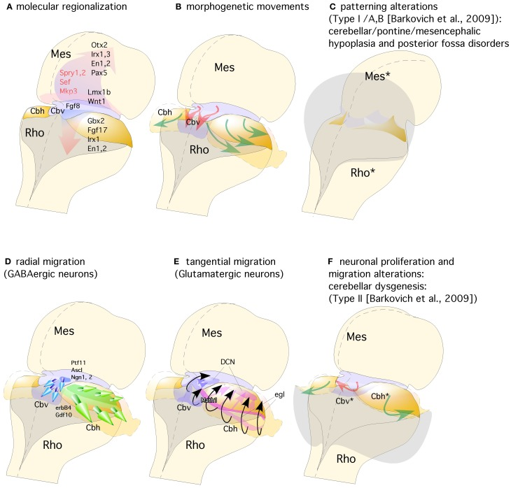

(A) The isthmic organizer expressing Fgf8 induces the expression of Sprouty, Sef, and Mkp3 in this region; and is also required for other genes differentially expressed in the midbrain (Mes) or rhombencephalic (Rho) neuroepithelium. (B) The spatio-temporal expression of these genes regulates the normal morphogenesis and growth of the cerebellar vermis (Cbv; red arrows) and hemispheres (Cbh; green arrows). (C) Failure in proper isthmic organizer development (due to a lack of morphogenetic signaling or disruption of gene expression) can result in cerebellar (Rho*) and mesencephalic (Mes*) hypoplasia due to a strong increase of cell death with posterior fossa disorders and fourth ventricle dilatation (gray shadow). (D) Radial migration of GABAergic neurons in the cerebellar vermis (Cbv; blue arrows) and hemispheres (Cbh; Green arrows). (E) Rhombic lip specification is regulated by Math1. Tangential migration of glutamatergic neurons of the deep cerebellar nuclei (DCN) and granule cells (egl) are represented by pink and black arrows, respectively. (F) When normal development of cortical cerebellar cells is disrupted, the structural phenotype is classified as cerebellar dysgenesis (Cbv* and Cbh*), with enlargement of the fourth ventricle and reversion of cerebellar-choroidal junction (arrows).
The topographical boundary between the mesencephalon and rhombencephalon is the isthmic constriction or simply the isthmus. This was initially interpreted to bridge the midbrain-hindbrain boundary, but is now thought to co-localize with the prospective isthmic territory (r0), as defined early on by the expression of the well-known secreted molecule fibroblast growth factor 8 (Fgf8). The homeodomain transcription factors of Engrailed family En1 and En2 are expressed early on in cerebellar and mesencephalic primordial neuroepithelium and both are involved in the formation of the mesencephalic tectum and cerebellum. Thus, mouse En1 mutants lack most of the tectum and cerebellum and die at birth, whereas En2 mutants are viable with a smaller cerebellum and foliation defects. Experimental studies indicate that the severeness of En1 and En2 phenotypes differs due to a relatively early onset of En1 expression compared to the onset of En2 expression, rather than differences in protein function. Studies on conditional mutant alleles of En1 and/or En2 demonstrated that En1 is required for cerebellar development only before embryonic day 9, but plays a substantial role in forming the tectum. In fact, En2 was found to be more potent than En1 in cerebellar development .
Fgf8 expression is first activated at HH9+ in birds and at E8.5 in mice at the interface of Otx2 and Gbx2 positive neuroepithelial cells. WNT1 and EN2 proteins are already expressed at this stage across the incipient boundary, with a maximum expression level at the Fgf8 positive domain, showing decreasing gradients oriented either rostrally toward mesencephalic epithelium or caudally toward rhombencephalic epithelium, respectively. The co-expression of Otx2 and Gbx2 in the IsO territory essentially disappears by HH11–12 and both domains become thereafter mutually excluded and complementary. The caudal limit of Otx2 expression and the rostral limit of Gbx2 therefore mark the mid-hindbrain molecular bound. Secondarily, Lmx1b and Wnt1 are co-expressed in a thin band confined to the caudal most Otx2 expression domain, abutting the Fgf8 domain at the rostral most edge of the hindbrain. Lmx1b activates Wnt1 in a cell-autonomous manner and represses Fgf8 in a non-autonomous way, thus contributing to maintain the rostral limit of Fgf8 at the MHB and thus being essential for the initial steps of mid-hindbrain development. Note that although early Fgf8 expression appears in the territory co-expressing Otx2/Gbx2, double deletion of these two transcription factors in the mouse does not affect the activation of Fgf8 expression. Other genes expressed at very early stages across the prospective MHB, such as Pax2 and Iroquas (Irxs) seem required for the expression of Otx2, Gbx2, and Fgf8 and the proper formation of the mesencephalic and rhombencephalic vesicles. Recently it was proposed that Gbx2 and Fgf8 are sequentially required for formation of the mid-hindbrain boundary, playing a crucial role in maintaining here a boundary of cell lineage by restricting cell movement.
Moreover, FGF8 signal may act at the IsO in concert with other signaling molecules, such as WNT1, Sonic Hedgehog (SHH) and transforming growth factor (TGF)-β family members. The morphogenetic activity of the IsO is then a consequence of a specific temporo-spatial expression of molecular signals, which regulate the specification and structural development of mesencephalic and cerebellar neuroepithelial territories. Alterations of Fgf8 and Gbx2 gene expression lead to massive disruption of the mid-hindbrain neural territory by gene patterning dysregulation. A decreasing gradient of FGF8 protein concentration in the alar plate of the isthmus and r1 is fundamental for cell survival and the differential development of cerebellar regions. In the basal plate, FGF8 gradient is crucial for cell survival and, together with SHH, essential for the development of caudal serotonergic and rostral dopaminergic fates of progenitor cells, as well as the localization and development of other basal derivatives, such as noradrenergic cells in the locus coeruleus (in the rhombencephalon) and the red nucleus (in the mesencephalic tegmentum; Wurst and Bally-Cuif, 2001; Chi et al., 2003; Puelles and Rubenstein, 2003; Prakash and Wurst, 2006; Prakash et al., 2006). On the other hand, mesencephalic and diencephalic epithelia are also receptive to FGF8 (Martinez et al., 1991, 1999; Crossley et al., 1996; Crespo-Enriquez et al., 2012), which possibly regulates gene expression and neuroepithelial polarity in the alar plate of these territories (Vieira et al., 2006; Crespo-Enriquez et al., 2012).
The cerebellum is indeed a unique brain structure dependent of FGF8 signal and Gbx2 homeobox expression.

References
Airey D. C., Lu L., Williams R. W. (2001). Genetic control of the mouse cerebellum: identification of quantitative trait loci modulating size and architecture. J. Neurosci. 21, 5099–5109 [PMC free article] [PubMed] [Google Scholar]
Alcaraz W. A., Gold D. A., Raponi E., Gent P. M., Concepcion D., Hamilton B. A. (2006). Zfp423 controls proliferation and differentiation of neural precursors in cerebellar vermis formation. Proc. Natl. Acad. Sci. U.S.A. 103, 19424–19429 10.1073/pnas.0609184103 [PMC free article] [PubMed] [CrossRef] [Google Scholar]
Altman J., Bayer S. A. (1997). Development of the Cerebellar System in Relation to its Evolution, Structure and Functions. New York, NY: CRC Press [Google Scholar]
Alvarado-Mallart R. M. (1993). Fate and potentialities of the avian mesencephalic/metencephalic neuroepithelium. J. Neurobiol. 24, 1341–1355 10.1002/neu.480241007 [PubMed] [CrossRef] [Google Scholar]
Alvarez-Otero R., Sotelo C., Alvarado-Mallart R. M. (1993). Chick/quail chimeras with partial cerebellar grafts: an analysis of the origin and migration of cerebellar cells. J. Comp. Neurol. 333, 597–615 10.1002/cne.903330411 [PubMed] [CrossRef] [Google Scholar]
Aroca P., Puelles L. (2005). Postulated boundaries and differential fate in the developing rostral hindbrain. Brain Res. Brain Res. Rev. 49, 179–190 10.1016/j.brainresrev.2004.12.031 [PubMed] [CrossRef] [Google Scholar]
Barkovich A. J. (2012). Developmental disorders of the midbrain and hindbrain. Front. Neuroanat. 6:7 10.3389/fnana.2012.00007 [PMC free article] [PubMed] [CrossRef] [Google Scholar]
Barkovich A. J., Millen K. J., Dobyns W. B. (2007). A developmental classification of malformations of the brainstem. Ann. Neurol. 62, 625–639 10.1002/ana.21239 [PubMed] [CrossRef] [Google Scholar]
Barkovich A. J., Millen K. J., Dobyns W. B. (2009). A developmental and genetic classification for midbrain-hindbrain malformations. Brain 132, 3199–3230 10.1093/brain/awp247 [PMC free article] [PubMed] [CrossRef] [Google Scholar]
Basson M. A., Echevarria D., Ahn C. P., Sudarov A., Joyner A. L., Mason I. J., et al. (2008). Specific regions within the embryonic midbrain and cerebellum require different levels of FGF signaling during development. Development 135, 889–898 10.1242/dev.011569 [PMC free article] [PubMed] [CrossRef] [Google Scholar]
Bermingham N. A., Hassan B. A., Wang V. Y., Fernandez M., Banfi S., Bellen H. J., et al. (2001). Proprioceptor pathway development is dependent on Math1. Neuron 30, 411–422 10.1016/S0896-6273(01)00305-1 [PubMed] [CrossRef] [Google Scholar]
Blaess S., Corrales J. D., Joyner A. L. (2006). Sonic hedgehog regulates Gli activator and repressor functions with spatial and temporal precision in the mid/hindbrain region. Development 133, 1799–1809 10.1242/dev.02339 [PubMed] [CrossRef] [Google Scholar]
Broccoli V., Boncinelli E., Wurst W. (1999). The caudal limit of Otx2 expression positions the isthmic organizer. Nature 40, 164–168 10.1038/43670 [PubMed] [CrossRef] [Google Scholar]

GENETICS OF CEREBELLAR DISORDERS
The approach to identifying a genetic cause in patients with cerebellar disorders relies on history, examination, consultation, and testing, combined with specialized expertise because they are rare and genetically diverse. Cerebellar disorders can be caused by a variety of DNA alterations including single-nucleotide changes, small insertions or deletions, larger copy number variants, and nucleotide repeat expansions, exhibiting autosomal-recessive, autosomal-dominant (inherited and de novo), X-linked, and mitochondrial modes of inheritance. Imaging findings and a variety of neurologic and nonneurologic clinical features can help direct genetic testing and choose the most appropriate strategy. Clinical and genetic diagnoses are complementary, each providing distinct information for the care of the patient. In this chapter, we provide an overview of inheritance modes for different cerebellar disorders and the variety of genetic testing and tools that are currently available to reach a genetic diagnosis, including conventional and next-generation sequencing, classic, molecular and virtual cytogenetics, testing for repeat expansions, and other techniques. Practical examples are presented in both the text and accompanying vignettes.
1. Cerebellar Hypoplasia: characterized by reduced cerebellar volume, even though cerebellar shape is normal. Patients with trisomy 18, trisomy 21 and patients suffering from the autosomal recessive acro-callosal syndrome. these patients showed callosal agenesis and cerebellar hypoplasia.
2. Cerebellar Atrophy: cerebellar degeneration is a condition in which cerebellar cells, otherwise known as neurones become damaged and progressively weakened in the cerebellum. There are 2 types: paraneoplastic cerebellar degeneration and alcoholic/nutritional degeneration.
3. Pontocerebellar hypoplasia: characterized by hypoplasia of the brainstem and cerebellum by birth; a condition that usually further suggesting that some pontocerebellar hypoplasias can be classified as a neurodegenerative condition. The CHMPLA (charged multivesicular body protein 1a) gene encodes chromatin modifying protein 1a, has been identified as a candidate gene for pontocerebellar hypoplasia.

Copyright © 2018 Elsevier B.V. All rights reserved.
A Variation in FGF14 Is Associated with Downbeat Nystagmus in a Genome-Wide Association Study.
Strupp M, et al. Cerebellum. 2020. PMID: 32157568 Free PMC article.

