Name: Ayenor E. Christabel
Matric no: 17/MHS01/076
Level: 300
Write a concise review on the developmental genetics of the cerebellum and highlight the genetic bases of known cerebellar disorders.

Developmental genetics of the cerebellum and Genetic basis of known cerebellar disorders
Ayenor E. Christabel
9th July 2020
Abstract
Cerebellum is a large dorsally projecting part of the brain concerned especially with the coordination of muscles and the maintenance of bodily equilibrium, situated between the brain stem and the back of the cerebrum, and formed in humans of two lateral lobes and a median lobe. In relation with the development of the cerebellum, there are different genes, hormones responsible for this development. In cases that there are damages in the cerebellum, like disorders of the cerebellum, most of them can be due to the mutations of this genes or depletion of some certain genes. There is still ongoing research on the genes responsible for the development of the cerebellum. Here, we will be looking at how genetics is involved in the development of the cerebellum and the causes of some known cerebellar disorders genetically.
Introduction
The Cerebellum is Latin for Little brain. It is a part of the hind brain that coordinates voluntary movements such as posture, balance, coordination, and speech, resulting in smooth and balanced muscular activity. It is also important for learning motor behaviours. It is a small portion of the brain but contains roughly half of the neurons in the brain. There are 2 major components of the cerebellum, they are: the cerebellar cortex and cerebellar nuclei. The cerebellum can be developed genetically and some of the disorders of the cerebellum are due to this genetic basis
Disruption of the cerebellum or its connections to other parts of the nervous system can happen in a variety of ways. For instance, the cerebellum can sustain damage due to a head injury, Stroke or autoimmune conditions, such as multiple sclerosis, neurodegenerative conditions, such as Parkinson’s disease.
This review is talking about how the genes help in the development of the cerebellum and the basis of genetics in the disorders of the cerebellum. In humans, the cerebellum develops from the dorsal region of the posterior neural tube, and its cells arise from two germinal matrices.
Discussion
In the first stage, characterization of cerebellar territory occurs at the midbrain–hindbrain boundary, which is crucial for specifying midbrain and cerebellar structures. At the isthmus, restricted expression of secreted factors, such as fibroblast growth factor 8, FGF8 and Wnt1, the mammalian homolog of Drosophila wingless gene, as well as homeobox proteins En1 and En2 and paired box genes Pax2 and Pax5 are required for early specification of midbrain and hindbrain structures.
In the second stage, two compartments for cell proliferation are formed. Purkinje cells and cells of the deep cerebellar nuclei are generated in the roof of the fourth ventricle, and granule cell precursors, as well as cells of the precerebellar nuclei are formed in the rhombic lip. Development of Purkinje cells is not well understood, but they are known to secrete Sonic hedgehog which regulates proliferation of granule cells. By this time point, granule neuron precursors express a number of markers, Math1, nestin, zipro1/RU49 and Zic genes 1, 2. Purkinje cells migrate radially to their final positions, whereas granule neurons migrate over the surface of the developing cerebellum, forming the external granule layer (EGL).
In the third stage, cells of the External Granule Layer migrate inward along the processes of Bergman glia to their final position in the internal granular layer (IGL). Finally, cerebellar circuitry is established and further differentiation occurs. The lower portion of the rhombic lip also gives rise to cells of the precerebellar nuclei such as the inferior olivary nuclei, which migrate to positions in the brainstem.
Disorders of the cerebellum
a.) Joubert syndrome: This is a disorder of brain development that may affect many parts of the body. It is characterized by the absence or underdevelopment of the cerebellar vermis (a part of the brain that controls balance and coordination) and a malformed brain stem (connection between the brain and spinal cord). Together, these cause the characteristic appearance of a molar tooth sign on MRI. Signs and symptoms can vary but commonly include weak muscle tone (hypotonia); abnormal breathing patterns; abnormal eye movements; ataxia; distinctive facial features; and intellectual disability. Various other abnormalities may also be present. Joubert syndrome may be caused by mutations in any of many genes. It is associated with mutations of genes encoding components of the primary cilia, which are determinant for sonic hedgehog signal transduction. Inheritance is usually autosomal recessive, but rarely it may be X-linked recessive. Treatment is supportive and depends on the symptoms in each person.
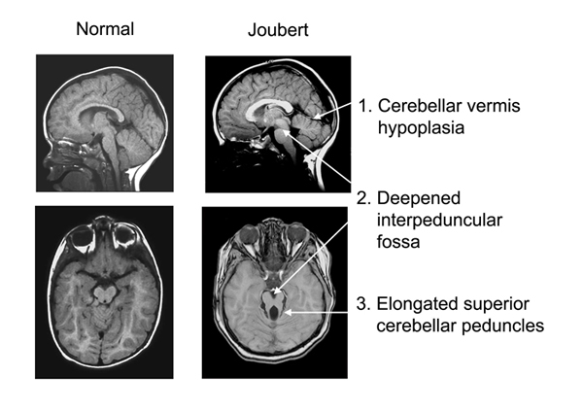
b.) Rhombencephalosynapsis:- This a rare genetic brain abnormality of malformation of the cerebellum. This a malformation of the hindbrain due to fusion of the cerebellar hemispheres, fusion of dentate nuclei and the cerebellar vermis is either absent or only partially formed, fusion of the middle cerebellar peduncles. It may be detected in the ultrasound of the fetus. It can be associated with the mutations of the MN1 gene.
c.) Dandy- walker malformation:- is a rare heterogeneous brain malformation in which the part joining the 2 hemispheres of the cerebellum does not fully form, there is presence of a hypoplastic, upwardly rotated vermis, an enlarged fourth ventricle, and an enlarged posterior fossa with cerebrospinal fluid also with an elevated confluence of sinuses. Few genes have been implicated in rare cases of DWM, including genomic imbalances that are part of a congenital syndrome and rare single gene disorders. FOXC1-related DWM is associated with multiple congenital anomalies, especially eye malformations. Most of those affected develop hydrocephalus within the first year of life, which can present as increasing head size, vomiting, excessive sleepiness, irritability, downward deviation of the eyes and seizures. Other, less common symptoms are generally associated with comorbid genetic conditions and can include congenital heart defects, eye abnormalities, intellectual disability, congenital tumours, other brain defects such as agenesis of the corpus callosum, skeletal abnormalities, an occipital encephalocele or underdeveloped genitalia or kidneys. It is sometimes discovered in adolescents or adults due to mental health problems.

References
1. Seladischulman, J. and Seunggu, H. (2020) ‘What is the cerebellum and What does it do?’
2. Louie. C and Gleeson, J. (2005) ‘Genetic basis of Joubert syndrome and related disorders of cerebellar development’ Human Molecular Genetics, 14(2) pp. R235-R242.

