NAME: SALISU FAROUK
MATRIC NUMBER:17/MHS01/293
ANA 303 NEUROANATOMY ASSIGNMENT
The cerebellum (“little brain”) is a structure that is located at the back of the brain, underlying the occipital and temporal lobes of the cerebral cortex. Its major function is to coordinate muscle movements, maintain posture, and balance. It contains over 50% of the total number of neurons in the brain.
During embryonic development, the anterior portion of the neural tube forms three parts that give rise to the brain and associated structures:

- Forebrain (prosencephalon)
- Midbrain (mesencephalon)
- Hindbrain (rhombencephalon)
The hindbrain subsequently divides into the metencephalon (superior) and the myelencephalon (inferior). The cerebellum develops from the metencephalon division.
Gross Anatomy of the Cerebellum
The cerebellum consists of two major parts. The cerebellar deep nuclei (or cerebellar nuclei) are the sole output structures of the cerebellum. These nuclei are encased by a highly convoluted sheet of tissue called the cerebellar cortex, which contains almost all of the neurons in the cerebellum. Lobule architecture is distinct between anatomical divisions that separate the mediolateral axis of the cerebellum into three broad regions. The most medial region is called the vermis, which is surrounded on either side by the paravermis. Even more laterally are the hemispheres, which in mice are each roughly the same size as the vermis. The paraflocculi and flocculi are lateral extensions of the hemispheres that extend outward and curl toward the underside of the cerebellum. None of these anatomical divisions are present when the cerebellum first forms.
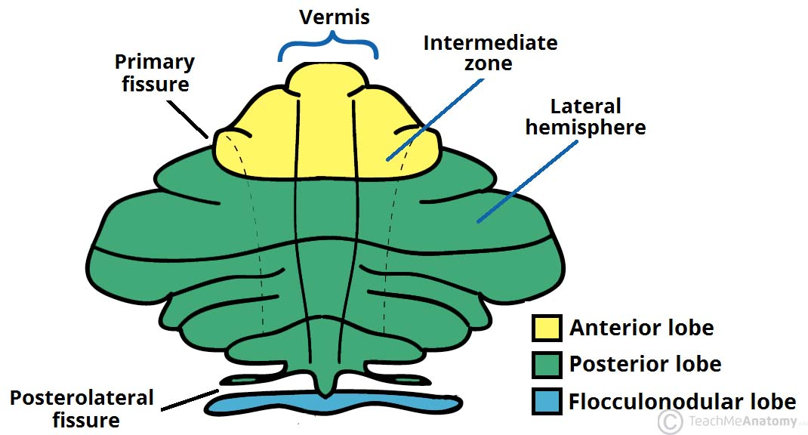
ETABLISHMENT OF CEREBELLAR PRIMORDIUM
The cerebellum is derived from dorsal rhombomere 1, which comprises the most anterior aspect of the hindbrain, in humans, the cerebellum develops from the dorsal region of the posterior neural tube, and its cells arise from two germinal matrices. Most cells are derived from the ventricular zone, but the granule neurons come from a specialized germinal matrix called the rhombic lip. Expression of the homeobox genes Otx2 and Gbx2 are essential for the development of the midbrain and hindbrain. During development, these two genes are expressed in abutting domains where they antagonize each other to establish the mid/hindbrain boundary and formation of an isthmic organizer (IsO). The IsO functions as a classic signaling center by secreting fibroblast growth factor 8 (FGF8), which maintains the posterior border of Otx2 expression and is crucial for normal cerebellar development. FGF expression is strongly controlled during hindbrain development and its loss results in the absence of the midbrain and cerebellum. Otx2 and Gbx2 form part of a regulatory loop that includes Wnt1, En1 and Fgf8. Many other genes, including members of the Pax and Hox families, are also involved in patterning this region. Purkinje cells (PCs), Golgi neurons, stellate and basket cells all arise from the ventricular neuroepithelium. PCs are born around embryonic day 13, and they migrate along radial glial fibres into the cerebellar anlage. During their final maturation phase, PCs develop extensive dendritic arbors and synapse onto granule neurons. This depends on granule neuron signals, probably including Wnt3. Various growth factors are required for PC survival, including nerve growth factor, acetylcholine, neurotrophin 4/5, brain-derived neurotrophic factor and ciliary neurotrophic factor. The rhombic lip, located between the fourth ventricle and the metencephalic roof plate, gives rise to granule neurons. Proliferation in its germinal epithelium is governed by the Math1 gene. Rhombic lip cells migrate to the cerebellar anlage and settle on its periphery to form the external granule layer, another zone of proliferation. As the cells begin to migrate, they express markers that include RU49/Zipro1, Zic1 and Zic3. RU49/Zipro1 and Zic1 are thought to be involved in cell proliferation, which requires interaction with PCs. PCs might release a diffusible factor such as sonic hedgehog (Shh), and Zic1 could control cell proliferation by indirectly regulating the Shh pathway. The final stage of granule neuron maturation occurs after precursor cell migration into the inner granule layer. Many genes, including En1, En2, Pax2, Wnt7b, and some of the ephrins and their receptors, show characteristic patterns of spatial expression in the cerebellum, but only En2 has been studied specifically for its role in compartmentalization. In addition to the patterning genes, several other gene families, such as the heat shock proteins and proteins involved in neuronal migration, are also expressed in specific patterns.
CEREBELLAR DISEASES AND THEIR GENETIC BASES
- Huntington Disease: Huntington disease is a progressive brain disorder that causes uncontrolled movements, emotional problems, and loss of thinking ability (cognition).
Signs and Symptoms: Early signs and symptoms can include irritability, depression, small involuntary movements, poor coordination, and trouble learning new information or making decisions. Many people with Huntington disease develop involuntary jerking or twitching movements known as chorea. A less common form of Huntington disease known as the juvenile form begins in childhood or adolescence. It also involves movement problems and mental and emotional changes. Additional signs of the juvenile form include slow movements, clumsiness, frequent falling, rigidity, slurred speech, and drooling.
Genetic Basis: Mutations in the HTT gene cause Huntington disease. The HTT gene provides instructions for making a protein called huntingtin. Although the function of this protein is unknown, it appears to play an important role in nerve cells (neurons) in the brain.
The HTT mutation that causes Huntington disease involves a DNA segment known as a CAG trinucleotide repeat . This segment is made up of a series of three DNA building blocks (cytosine, adenine, and guanine) that appear multiple times in a row. Normally, the CAG segment is repeated 10 to 35 times within the gene. In people with Huntington disease, the CAG segment is repeated 36 to more than 120 times. People with 36 to 39 CAG repeats may or may not develop the signs and symptoms of Huntington disease, while people with 40 or more repeats almost always develop the disorder.
An increase in the size of the CAG segment leads to the production of an abnormally long version of the huntingtin protein. The elongated protein is cut into smaller, toxic fragments that bind together and accumulate in neurons, disrupting the normal functions of these cells. The dysfunction and eventual death of neurons in certain areas of the brain underlie the signs and symptoms of Huntington disease.

- Ataxia-telangiectasia: Ataxia-telangiectasia is a rare inherited disorder that affects the nervous system, immune system, and other body systems. This disorder is characterized by progressive difficulty with coordinating movements (ataxia) beginning in early childhood, usually before age 5.
Symptoms: Affected children typically develop diffculty walking, problems with balance and hand coordination, involuntary jerking movements (chorea), muscle twitches (myoclonus), and disturbances in nerve function (neuropathy).
Genetic Basis: Mutations in the ATM gene cause ataxia-telangiectasia. The ATM gene provides instructions for making a protein that helps control cell division and is involved in DNA repair. This protein plays an important role in the normal development and activity of several body systems, including the nervous system and immune system. The ATM protein assists cells in recognizing damaged or broken DNA strands and coordinates DNA repair by activating enzymes that Qx the broken strands. E=cient repair of damaged DNA strands helps maintain the stability of the cell's genetic information.

REFERENCES:
- WIRES Developmental Biologywires.wiley.com/devbio
- https://teachmeanatomy.info/neuroanatomy/structures/cerebellum/
- https://www.nih.gov
- https://nba.uth.tmc.edu/neuroscience/m/s3/chapter05.html
- https://www.nature.com/articles/35081558

