FRANCIS NAOMI ONOTE
19/MHS01/176
BIO 102

- How are fungi important to mankind?
Fungi are important to everyday human life. Fungi are important decomposers in most ecosystems.
Fungi, as food, play a role in human nutrition in the form of mushrooms, and also as agents of fermentation in the production of bread, cheeses, alcoholic beverages, and numerous other food preparations.
- Illustrate the cell structure of a unicellular fungus with a well labeled diagram.
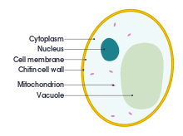
- Outline the sexual reproduction in a typical filamentous form of fungi.
Sexual reproduction in the fungi consists of three sequential stages: plasmogamy, karyogamy, and meiosis. The diploid chromosomes are pulled apart into two daughter cells, each containing a single set of chromosomes (a haploid state). Plasmogamy, the fusion of two protoplasts (the contents of the two cells), brings together two compatible haploid nuclei. At this point, two nuclear types are present in the same cell, but the nuclei have not yet fused. Karyogamy results in the fusion of these haploid nuclei and the formation of a diploid nucleus (i.e., a nucleus containing two sets of chromosomes, one from each parent). The cell formed by karyogamy is called the zygote. In most fungi the zygote is the only cell in the entire life cycle that is diploid. The dikaryotic state that results from plasmogamy is often a prominent condition in fungi and may be prolonged over several generations. In the lower fungi, karyogamy usually follows plasmogamy almost immediately. In the more evolved fungi, however, karyogamy is separated from plasmogamy. Once karyogamy has occurred, meiosis (cell division that reduces the chromosome number to one set per cell) generally follows and restores the haploid phase. The haploid nuclei that result from meiosis are generally incorporated in spores called meiospores.

- How do Bryophytes adapt to their environment?
Two adaptations made the move from water to land possible for Bryophytes: a waxy cuticle and gametangia. The waxy cuticle helped to protect the plants tissue from drying out and the gametangia provided further protection against drying out specifically for the plants gametes.

- Describe with illustration the following terminologies: (a) eusteles (b) atactostele (c) siphonostele (d) dictyostele.
- eusteles : a stele typical of dicotyledonous plants that consists of vascular bundles of xylem and phloem strands with parenchymal cells between the bundles.
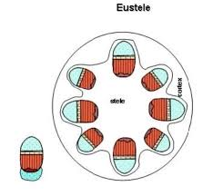
- atactostele : A type of eustele, found in monocots, in which the vascular tissue in the stem exists as scattered bundles.
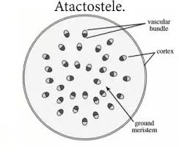
- siphonostele : A stele in which the vascular tissue is in the form of a cylinder surrounding the pith, as in the stems of most ferns and other seedless vascular plants.
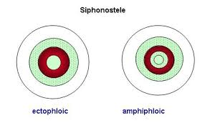
- dictyostele : a stele in which the vascular cylinder is broken up into a longitudinal series or network of vascular strands around a central pith (as in many ferns).
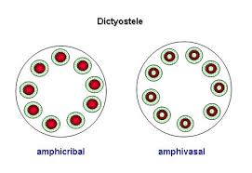
- Illustrate the life cycle of a primitive vascular plant.
