James Emem Grace
18/MHS01/192
Anatomy
ANA 204

Ever wondered what the camel does differently than us to survive in the hot environment? The camel does have a special kidney and a special GI tract. The camel's kidney actually can concentrate the urine more than sea water but less than a dessert rat. Since the camel can concentrate the urine more than sea water, salty water intake won't harm the animal. Investigators have studied the structure of the camelian kidney to discover whether or not the anatomical features necessary for producing a highly concentrated urine were present or not. The relative thickness of the medulla was calculated in the camelian kidney as it has been demonstrated that this thickness has a direct relationship with the ability to produce a highly concentrated urine. A relative thickness of the medulla is a good measure of the length of the loop of Henle which is an indicator of urine concentration. The thickness reported in camels was 7.89 in comparison to the value of 8.5 in kangaroo rats, much more than humans.
Also, what happens if you haven't drunk water in 5 days and all of a sudden you re hydrate. A dehydrated camel can replace water within minutes of drinking, and some of this water is quickly absorbed into the bloodstream. With water in the bloodstream, ADH declines and the kidney will return to normal renal function within 30 minutes of drinking. Not only does the camel adopt to scarce water but the kidney can also adopt to rapid dehydration and not lead to demylination of the brain.
What are some other features this animal has to store water for long periods of time?
Another interesting part of the camel physiology is that they have 3 stomachs, acting as storage( 1.5 gallons per stomach) for the water and hence when water is not available, they can slowly replenish the system. The camel stores water in its blood stream, an interesting physiological process. Capable of losing forty percent of its body's weight before becoming distressed, it is able to go five to seven days before having to drink. The amount it drinks when water is available would cause severe problems in most animals, up to 21 gallons in about 10 minutes. The camel's mouth, stomach, and teeth have all developed to allow it to eat plants that are not palatable to other desert animals. Contrary to popular myth, the camels don't store water in their humps, its full of fat for food storage. Longer the Henle's loop, more amount of solute will be reabsorbed and hence more amount of water could be removed from filtrate.

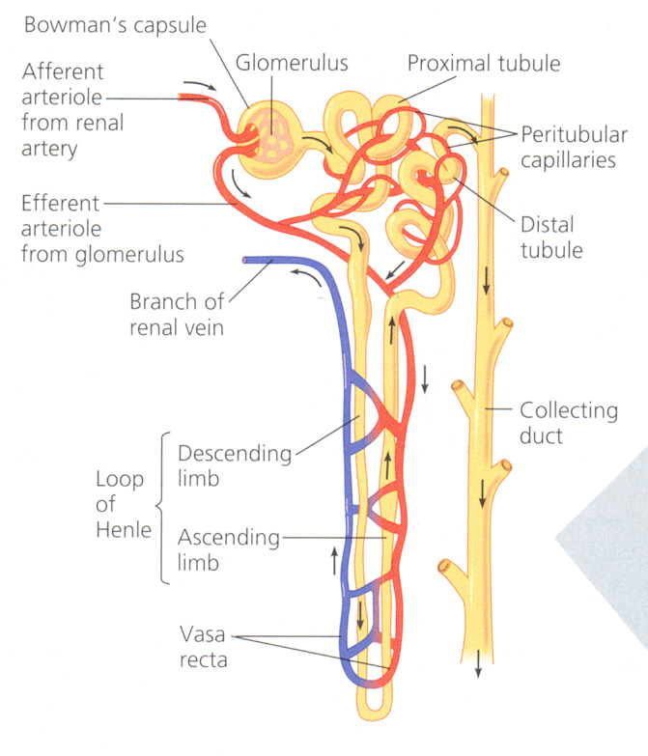

CLINICAL IMPORTANCE
Glomerular Filtration Barrier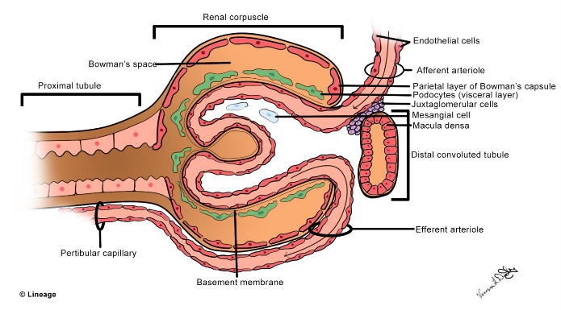
The glomerular filtration barrier functions as a highly organized, semipermeable membrane preventing the passage of the majority of proteins into the urine. The glomerular filtration barrier consists of the fenestrated endothelium, the glomerular basement membrane, and the podocyte foot processes, which are connected by a slit-diaphragm. The filtration barrier normally acts to retain protein inside the lumen of the capillaries separate from the urinary space; however, defects in the podocytes affecting the feet, tight junction (podocin, nephrin), and the slit diaphragm signalling, actin cytoskeleton, and cell matrix interactions have been identified in causing a breakdown of this barrier.
The glomerular filtration barrier has several layers.
The first is a glycocalyx made up of proteoglycans and an adsorbed layer of plasma proteins that is located between the endothelial cells and the capillary lumen.
Fenestrated endothelial cells form the next layer. Next is the thick glomerular basement membrane (GBM), which is synthesized by podocytes and endothelial cells and has an inner layer composed of collagen type IV and laminin sandwiched between layers of heparin sulphate. Podocyte foot processes line the epithelial side of the GBM; the intercellular junctions between adjacent foot processes are closed by the slit diaphragm, a specialized intercellular junction that acts as a molecular sieve and the final component of the filtration barrier. The slit diaphragm comprises several proteins, including nephrin, CD-associated protein (CD2AP), podocin, the tight junction protein ZO-1 (zonula occludens 1), P-cadherin, catenins, and the calcium channel TRPC6 (transient receptor potential cation channel, subfamily C, member 6), each of which is required for slit diaphragm integrity. Slit diaphragm proteins are supported by the highly dynamic podocyte actin cytoskeleton that in turn is anchored to an integrin complex that fastens each podocyte foot process to the GBM.
Clinical corellate
- Goodpasture's syndrome
An autoimmune disorder that consists of antibodies against α3 chain of type IV collagen of the basement membrane of both the glomerulus and alveoli
this is categorized as a type II hypersensitivity reaction

epithelial layer contains podocyte foot processes

clinical correlate
- Minimal change disease
a type of nephrotic syndrome that is categorized by effacement of the podocyte foot processes appreciated on.

Reference
- Sciencedirect.com
- www. Reference.com

