NAME: IGWE KAMSOCHI NGOZI-CHIBUZOR
MATRIC NO: 19/MHS01/196
LEVEL: 100
COLLEGE: MEDICAL AND HEALTH SCIENCES
DEPARTMENT: MEDICINE AND SURGERY
CHEM 102 ASSIGNMENT
1. Alkanols can be classified based on the number of hydrogen attached to the carbon carrying the functional group.
PRIMARY ALCOHOLS: if the number of hydrogen attached to the carbon carrying the -OH is 2 or 3. E.g. CH3CH2OH(ETHANOL)
SECONDARY ALCOHOLS: if the number of hydrogen attached to the carbon carrying the -OH is just 1 e.g. CH3CHOHCH3(PROPAN-2-OL)
TERTIARY ALCOHOLS: if there is no hydrogen atom attached to the carbon carrying the hydroxyl group. E.g. (CH3)3OH (2 METHYL-PROPAN-2-OL)
They can also be classified based on the number of hydroxyl groups present in the compound.
Monohydric alcohols: They are alcohols with just one hydroxyl group. E.g. CH₃CH₂CH₂OH (Propanol).
Trihydric alcohol: They have 3 hydroxyl groups. E.g. Propan-1.2.3-triol, CH₂(OH)CH(OH)CH₂(OH).

Dihydric alcohols: They have 2 hydroxyl groups. E.g. CH₂(OH)CH₂(OH) – Ethan-1,2- diol.

Alcohols are soluble in water. This is due to the hydroxyl group in the alcohol which is able to form hydrogen bonds with water molecules. Alcohols with a smaller hydrocarbon chain are very soluble. As the length of the hydrocarbon chain increases, the solubility in water decreases. With four carbon in the hydrocarbon chain and higher, the decrease in solubility becomes visible as the mixture forms two immiscible layers of liquid. The reason why the solubility decreases as the length of hydrocarbon chain increases is because it is requires more energy to overcome the hydrogen bonds between the alcohol molecules as the molecules are more tightly packed together as the size and mass increases.

- INDUSTRIAL PREPARATION OF ALCOHOL:
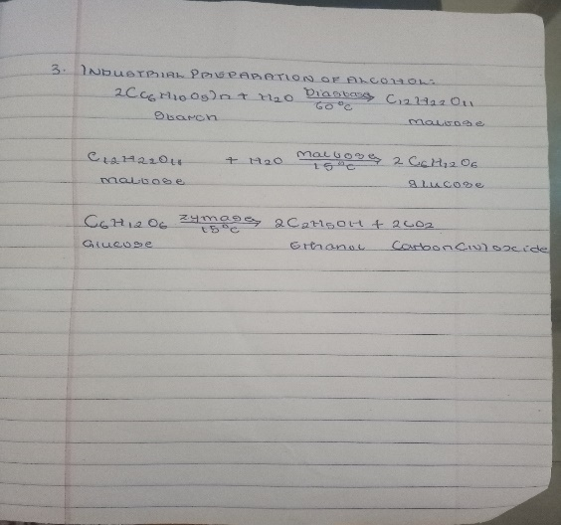

- 2-Methyl propanal and butylmagnesiumchloride
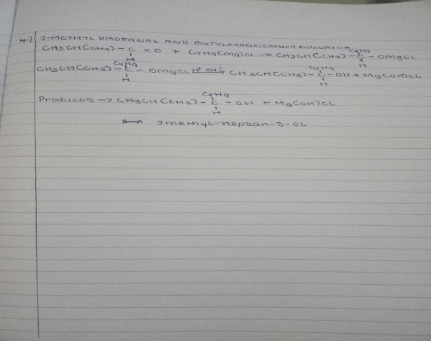

QUESTIONS 5 AND 6 ARE INCORRECT

7. Reduction of 2 methyl propanal
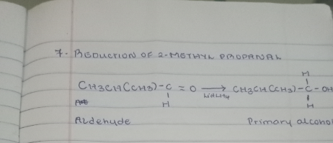

8. Conversion of propan-1-ol to propan-2-ol
