OGHENEKARO S. IFOTO
Neurophysiology assignment
17/MHS01/149
Medicine and Surgery

- Discuss the physiology of sleep

SLEEP refers to a state of unconsciousness from which the individual can be aroused by sensory or other stimuli. When asleep, an individual is not aware of the environment and is unable to perform activities that require consciousness.

Sleep-wake cycle
Sleep and wakefulness, like many of the body’s regulatory mechanisms, have circadian rhythm of about 24 h. A newborn infant has many cycles of sleep and wakefulness in 24 h, but after the age of 2 years a single sleep-wake cycle is established. In a normal adult, the sleep-wake cycle consists of 7–8 h of sleep and 16–17 h of wakefulness.

Factors affecting sleep
factors which minimize sensory stimulation and favour the onset of natural sleep are:
- Darkened room,
- Comfortable surrounding temperature,
- Silence,
- Physical and mental relaxation,
- Consumption of a basic urge, such as hunger or sex
- Low-frequency stimulation, such as by patting or knocking in a cradle or sitting in a moving vehicle.
The above described factors have only a modest effect if any. The only behavioural factor that reliably and substantially increases sleep is prior sleeplessness. On the other hand, anxiety and emotional stimuli by release of epinephrine cause activation of RAS and make sleep more difficult.

TYPES OF SLEEP
Sleep is of two types: non-REM (non-Rapid Eye Movement) sleep and REM (Rapid Eye Movement) sleep, which alternate in a sleep cycle.

NON-RAPID EYE MOVEMENT SLEEP - NREM or Non-REM sleep
Non-rapid eye movement (NREM) sleep is the type of sleep without the movements of eyeballs. It is also called slow-wave sleep, because in this type of sleep brain waves are very slow. Dreams do not occur in this type of sleep and it occupies about 70% to 80% of total sleeping period. Non-REM sleep is followed by REM sleep.

RAPID EYE MOVEMENT SLEEP – REM SLEEP
Rapid eye movement sleep is the type of sleep associated with rapid conjugate movements of the eyeballs, which occurs frequently. Though the eyeballs move, the sleep is deep. So, it is also called paradoxical sleep. It occupies about 20% to 30% of sleeping period. Functionally, REM sleep is very important because, it plays an important role in consolidation of memory. Dreams occur during this period.

STAGES OF SLEEP AND ELECTROENCEPHALOGRAM (EEG) PATTERN
Stage I: Stage of Drowsiness
Alpha waves are diminished and abolished. EEG shows only low voltage fluctuations and infrequent delta waves.
Stage II: Stage of Light Sleep
Stage II is characterized by spindle bursts at a frequency of 14 per second, superimposed by low voltage delta waves.
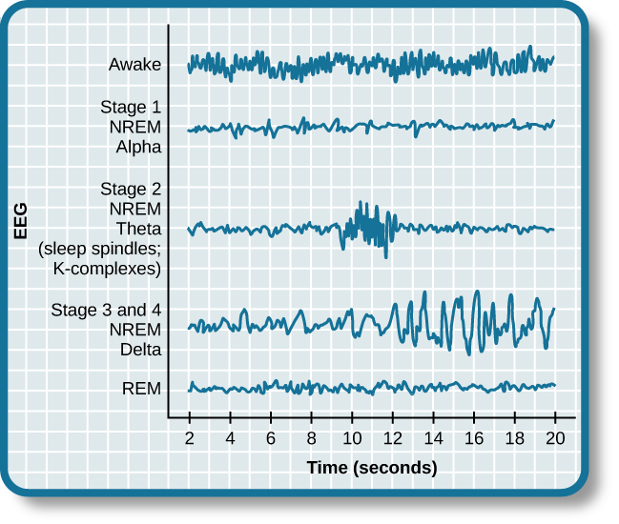
Stage III: Stage of Medium Sleep
During this stage, the spindle bursts disappear. Frequency of delta waves decreases to 1 or 2 per second and amplitude increases to about 100 µV.
State IV: Stage of Deep Sleep
Delta waves become more prominent with low frequency and high amplitude.

MECHANISM OF SLEEP
Sleep occurs due to the activity of some sleep-inducing centers in brain. Stimulation of these centers induces sleep. Damage of sleep centers results in sleeplessness or persistent wakefulness called insomnia.

SLEEP CENTERS
Complex pathways between the reticular formation of brainstem, diencephalon and cerebral cortex are involved in the onset and maintenance of sleep. However, two centers which induce sleep are located in brainstem:
1. Raphe nucleus
2.Locus ceruleus of pons.
Recently, many more areas that induce sleep are identified in the brain of animals. Inhibition of ascending reticular activating system also results in sleep.

1.Role of Raphe Nucleus
Raphe nucleus is situated in lower pons and medulla. Activation of this nucleus results in non-REM sleep. It is due to release of serotonin by the nerve fibers arising from this nucleus. Serotonin induces non-REM sleep
2.Role of Locus Ceruleus of Pons
Activation of this center produces REM sleep. Nor-adrenaline released by the nerve fibers arising from locus ceruleus induces REM sleep.

Inhibition of Ascending Reticular Activating System
Ascending reticular activating system (ARAS) is responsible for wakefulness because of its afferent and efferent connections with cerebral cortex. Inhibition of ARAS induces sleep. Lesion of ARAS leads to permanent somnolence, i.e. coma.

APPLIED PHYSIOLOGY-SLEEP DISORDERS

INSOMNIA
Insomnia is the inability to sleep or abnormal wakefulness. It is the most common sleep disorder. It occurs due to systemic illness or mental conditions such as psychiatric problems, alcoholic addiction and drug addiction.

HYPERSOMNIA
Hypersomnia is the excess sleep or excess need to sleep. It occurs because of lesion in the floor of the third ventricle, brain tumors, encephalitis, chronic bronchitis and disease of muscles. Hypersomnia also occurs in endocrine disorders such as myxedema and diabetes insipidus.

NIGHTMARE
Nightmare is a condition during sleep that is characterized by a sense of extreme uneasiness or discomfort or by frightful dreams. Discomfort is felt as of some heavy weight on the stomach or chest or as uncontrolled movement of the body. After a period of extreme anxiety, the subject wakes with a troubled state of mind. It occurs mostly during REM sleep. Nightmare occurs due to improper food intake, digestive disorders or nervous disorders. It also occurs during drug withdrawal or alcohol withdrawal.

NOCTURNAL ENURESIS
Nocturnal enuresis is the involuntary voiding of urine at bed. It is also called or bed-wetting. It is common in children.

NARCOLEPSY AND CATAPLEXY
Narcolepsy is the sudden attack of uncontrollable sleep. Cataplexy is sudden outburst of emotion. Both the diseases are due to hypothalamic disorders.

- Discuss the role of the basal ganglia in controlling movement.

Basal ganglia are the scattered masses of gray matter submerged in subcortical substance of cerebral hemisphere. Basal ganglia form the part of extra pyramidal system, which is concerned with motor activities.

COMPONENTS OF BASAL GANGLIA
Basal ganglia include three primary components:
- Corpus striatum
- Substantia nigra
- Subthalamic nucleus of Luys.

- Regulation of Voluntary Movements
Movements during voluntary motor activity are initiated by cerebral cortex. However, these movements are controlled by basal ganglia, which are in close association with cerebral cortex. During lesions of basal ganglia, the control mechanism is lost and so the movements become inaccurate and awkward.
Basal ganglia control the motor activities because of the nervous (neuronal) circuits between basal ganglia and other parts of the brain involved in motor activity. Neuronal circuits arise from three areas of the cerebral cortex:
- Premotor area
- Primary motor area
- Supplementary motor area
All these nerve fibers from cerebral cortex reach the caudate nucleus. From here, the fibers go to putamen. Some of the fibers from cerebral cortex go directly to putamen also. Putamen sends fibers to globus pallidus. Fibers from here run towards the thalamus, subthalamic nucleus of Luys and substantia nigra. Subthalamic nucleus and substantia nigra are in turn, projected into thalamus. Now, the fibers from thalamus are projected back into primary motor area and other two motor areas, i.e. premotor area and supplementary motor area.

- Regulation of Conscious Movements
Fibers between cerebral cortex and caudate nucleus are concerned with regulation of conscious movements. This function of basal ganglia is also known as the cognitive control of activity. For example, when a stray dog barks at a man, immediately the person, understands the situation, turns away and starts running.

- Regulation of Subconscious Movements
Cortical fibers reaching putamen are directly concerned with regulation of some subconscious movements, which take place during trained motor activities, i.e. skilled activities such as writing the learnt alphabet, paper cutting, nail hammering, etc.

APPLIED PHYSIOLOGY

- PARKINSON DISEASE
Parkinson disease is a slowly progressive degenerative disease of nervous system associated with destruction of brain cells, which produce dopamine. It is named after the discoverer James Parkinson. It is also called parkinsonism or paralysis agitans.

Causes of Parkinson Disease
Parkinson disease occurs due to lack of dopamine caused by damage of basal ganglia. It is mostly due to the destruction of substantia nigra and the nigrostriatal pathway, which has dopaminergic fibers. Damage of basal ganglia usually occurs because of the following causes:
- Viral infection of brain like encephalitis
- Cerebral arteriosclerosis
- Injury to basal ganglia
- Destruction or removal of dopamine in basal ganglia. It occurs mostly due to longterm treatment with antihypertensive drugs like reserpine. Parkinsonism due to the drugs is known as drug-induced parkinsonism.
- Unknown causes: Parkinsonism can occur because of the destruction of basal ganglia due to some unknown causes. This type of parkinsonism is called idiopathic parkinsonism.

Symptoms
- Tremor
- Slowness of movements
- Poverty of movements
- Rigidity
- Gait
- Speech problems
- Emotional changes
- Dementia

- CHOREA
Chorea is an abnormal involuntary movement. Chorea means rapid jerky movements. It mostly involves the limbs. Chorea is due to the lesion in caudate nucleus and putamen.

- ATHETOSIS
Athetosis is another type of abnormal involuntary movement, which refers to slow rhythmic and twisting movements. It is because of the lesion in caudate nucleus and putamen.

