NAME: ibukun oluwatomiwa samuel

COLLEGE: COLLEGE OF SCIENCES

DEPARTMENT: COMPUTER SCIENCE

LEVEL: 200

MATRIC NUMBER: 18/SCIO1/036

COURSE CODE: GST 212

COURSE TITLE: ENTREPRENEURSHIP

QUESTION: PREPARE A BUSINESS PLAN YOU WANT TO ESTABLISH

FRUITS FARM BUSINESS PLAN

INTRODUCTION
Fruits farm is a fruit based company that located in Calhoun County, whose mission will be to provide high quality, nutritional fruits for consumption in both near and remote regions of NIGERIA .Additionally the company will provide high quality planting materials for use nationwide.
Farmers Group's management team is led by Mr. James Jackson as Business Manager, who has extensive knowledge of the industry. The company expects to employ five temporary employees during the equipment re-location phase, four employees on a permanent basis, and three part-time employees.
OUR PRODUCTS
We plan to concentrate on fruits as its primary products. This includes growing Apple, mango, orange, watermelon, cherries, coconut, guava, grapes, lemon, peaches, pear, and pineapples.
The farm will have the capacity sufficient to produce in excess of 200.000lbs.Of fruits per year.
The farm plans to utilize traditional and more advance plant technology to produce new cultivars of orange and lemons with locally-adapted superior characteristics for the south growing area.
This strategy will allow the farm to produce fruits during most of the year and will allow double cultivation of the greenhouse with almost no additional heating necessary in the winter months.

OUR MISSON
The fruit Farm Company, whose mission is to provide high quality, nutritional, and flavorful fruits for consumption in both near and remote regions of the United States. Additionally the company will provide high quality planting materials for use nationwide.

SPONSORSHIP
The farm is going to be sponsored by Agriculture fast track fund (“AFT”), Farm rowdy, and Agriculture technology adoption institute (ATAI). AFT are donating $830,000 in long term loans to finance the fruit farm, upgrade the facilities, and cover start –up expenses and the first year losses. It is estimated that the company will begin to make a profit in year 2 of operations.
The company does not expect to have cash flow problems during the first four years of operations. While the others are still yet to conclude about the amount of money to donate.
MANAGEMENT
PERSONAL PLAN
PERSONNEL PLAN
 | YEAR 1 | YEAR 2 | YEAR 3 | YEAR 4 | YEAR 5
Business Manager | $25,000 | $30,000 | $30,000 | $30,000 | $30,000
Executive Director | $25,000 | $30,000 | $30,000 | $30,000 | $30,000
Manager Trainee | $9,000 | $6,000 | $6,000 | $6,000 | $6,000
Manager Trainee | $4,000 | $6,000 | $6,000 | $6,000 | $6,000
Logistic engineer | $18,000 | $18,000 | $18,000 | $18,000 | $18,000
Heavy equipment | $18,000 | $18,000 | $18,000 | $18,000 | $18,000
Welder | $3,500 | $3,000 | $3,000 | $3,000 | $3,000
Contract workers | $15,000 | $0 | $0 | $0 | $0
TOTAL PEOPLE | 7 | 7 | 7 | 7 | 7
Total Payroll | $117,500 | $111,000 | $111,000 | $111,000 | $111,000

Overall, fruit farms will have 12 personnel. the company expects to employ 5 temporary employees during the equipment re-location phase,4employees on a permanent basis, and 3part- time employees.
The management consists of
Omotola Odebowale, business manager, full time
Victor David, executive director, full time
Sadiku David, management trainee, ¾ times
TECHNICAL ASSITANCE
We are seeking technical assistance from NIHORT which will help with their sorting machines, pruning towers, hand tools, a tractor or two, and a compact spreader and we are also in relationship with NORWEGIAN REFUGEE COUNCIL (NRC). Our fruit farm will fund the processing factory and finance for the fruit production from (NRC) at the rate of 10%. The fruit farm also as a relationship with commercial banks and will approach one for laon to the land which will be leased to cooperative.
MARKET AND SALES
MARKET STRATEGY
Fruit farm will initially market and supply its products to customers. The company is further exploring marketing opportunities on the internet. To this extent, the company would like to set up a website to market its products. The company will utilize aggressive advertising strategies to further market its products. These strategies include the promotion of products throu t chefs to help promote this fledgling industry.gh the sponsoring of spots on cooking shows and exhibitions, and also engaging prominent
SALES STRATEGY
At fruits farm, the sales process is primarily the same for vegetables as it is for composting products, in that both products will be mainly sold through wholesale marketing. As in the past, live shipments will be delivered by contracts carriers in special oxygenated tanks carrying 8,000 fruits or more, and will be continued as demanded. Fruit farm bagged manure products will be delivered and unloaded in sizeable wholesales quantities by the pallet.
The company’s average sales cycle from first contact to closing of the sales is approximately 3 to 12 days for fruits products. Fruits farm plans to shorten this cycle. Furthermore, the company estimates that from first contact to sale conclusion, the cycle for fresh strawberries will run 3 days or less. Composted products sale cycle should run from 3 to 12 days.
Direct sales contacts of fruit market by delivery personnel, as well as cold calling by telephone of potential markets outlets, will also be employed.
COMPETITIVE ADVANTAGE
People are going to buy from us because of the following reason:
- High quality , nutritional, and flavorful products
- All year round available of our customers’ choicest vegetables and fruits
- Fresh and highly hygienic and well –packaged vegetables and fruits
- Excellent customer care services are going to be provided
- Fair and best possible prices and discount offers

TARIFF AND IMPORT RESTRICTION
Forex restriction on agricultural produce importation to allow us to develop our agricultural sector to the point where exportation of crude oil is not our primary source of foreign exchange.

MARKET POTENTIALS
According to my own view there is actually a strong demand for fruits especially oranges in the northern and southern part of Nigeria .so we still supports and trade within Nigeria.

PROFITABILITY
Fruit farming profitability depends on:
Location
Demand
Availability
Competition
Sophistication
Africa as a continent has vast arable land, good climate and recourses that are advantageous in growing fruits of different types. The high rate of fruit consumption in the urban and rural areas has made fruit farming in Nigeria and Africa very lucrative. Fruits are highly perishable to increase market value process them into fruits juice and package them very well. It will increase income as well.

TECHNICAL FEASIBILITY
Production of orange involves squeezing or reaming juice out of either whole or halved oranges by means of mechanical pressure. After final washing and inspection, the fruit is separated according to size into different streams or lanes. Individuals’ oranges are directed to the most suitable extractor in order to achieve optimum juice yield. As extraction determines juice yield and quality, the correct setting of extractor operating conditions is very important.

GOVERNMENT SUPPORT AND REGULATION
The business is going to benefit from government intervention fund in the fruit farming sector and it will also benefit from the policy of zero duty for the agricultural and equipment importation. The business conforms to the economic diversification objective of the government. The business will also help in contributing to job employment, stable price, stable exchange rate, and output increase.

PROJECT TIMELINE
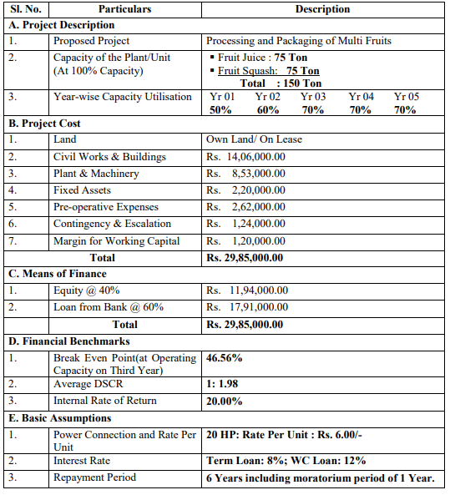

FUNDING MECHANISM
The business will provide 3,000mt silo capacity as equity contribution and also up to 300hecta of farmland on lease to it cooperative member. And we will also give out loans to farmers who are seeking for loans for fertilizers and fruit seed.

CONCLUSION
The business is recommended for funding cause it creates employment opportunities for those looking for jobs and also loans out to other farmers.

