Table of Contents
INTRODUCTION 2
BRIEF HISTORY ABOUT Abebe’s fingers 2
THE MANAGERIAL SYSTEM 3
AIMS AND OBJECTIVES OF THE FIRM 3
MARKET SEGMENTATION AND TARGET MARKET 4
SEGMENTATION 4
TARGET MARKET 5
PRODUCTS: 6
PRICE: 8
PLACE: 8
PROMOTION: 8
RECOMMENDATIONS 8
CONCLUSION 9
REFERENCES 9

INTRODUCTION

First of all, the name of my firm is ABEBE’S FINGERS. As a marketer of ABEBE’S finger, my sole goal is to find and create the perfect market segmentation to suit our product. Finding the perfect segmentation will determine the success or failure of this product. The products offered in ABEBE’S Fingers have many diversifications, so therefore it is important that each product line and its diversification is put into consideration when selecting a target market. ABEBE’S fingers we specialize on anything concerning jewelries related to the hands, like bangles and all types of wedding rings, but over the years, as the company growth started becoming rampant, we spread our tentacles to other forms of jewelries like wristwatches, neck chains/piece and ear rings. The good thing is, males and females of different culture, religion and occupation can always walk in and get whatever they desire at their own convenience.
As a ABEBE’S Finger Marketer, I have come up with the perfect market segmentation and even target market, by making use of the segmentation approach which includes geographical approach, which divide the market into geographical zone, behavioral approach, which divides the consumer in different user and loyalty to brand, demographical approach, which considers age, gender, income, family and even religion, and lastly, psychological approach, which has to do with status, class and personality. If I must get the perfect segmentation to foster the companies’ growth and brand loyalty, I must consider the various users or consumers so as to help me serve them more.

ABEBE’S Fingers is not just offering jewelries, but also class, and a clear difference from other jewelers out in the public. There is never a bad moment with us, and the team of ABEBE’S fingers. As a marketer I have carefully considered all this kind of consumer and also considered the fact that consumer taste always change from time to time. Looking at our product and its diversification we can say that no matter how often consumer may change they can never out change this product because if some set of consumer change from platinum jewelries to gold or diamond ABEBE’S finger still offers sure product. Our products are not on based on platinum jewelries but also gold and diamond as well and this this good because if a consumer taste changes from diamond to gold ABEBE’S finger can and will still offer that product because of we are diversify.

THE MANAGERIAL SYSTEM

As an organized system of labor, there is a hierarchy of order in ABEBE’S Fingers. This is so because the company won’t be able to function properly if everyone doesn’t have a place. First of all, there is the CEO which is Miss. johnson. Then the general manager, who oversees the affairs of the company, then down to the regional managers in all the countries worldwide.

AIMS AND OBJECTIVES OF THE FIRM
The following are parts of the goals and ambitions of ABEBE’S Fingers:
1: To change the way people value Jewels: Throughout the world as a whole, most people don’t attach so much value to the jewelries they buy simply because they are affluent and feel that the money spent to acquire the jewelries is nothing substantial to them. In ABEBE’S Fingers, we actually make a stand out because; all our products are specially designed with the topmost supervision and with state of the art technologies.
2: To allow people get the best value for their money: We all know money is not easy to come by, so we try to ensure customer satisfaction in all we do. One too many times, customers complain about so many products they buy, especially in the fashion and computer world, but in ABEBE’S Fingers, our aim is to make do without complaints at least to the barest minimum.
3: Diversification of resources: ABEBE’S Fingers as a firm is interested both in the young and old, so we diversify our resources to suit almost every aspect of the economy. In other words, everyone, both young and old would benefit from this firm, thereby making it a win-win case.
4: Giving back to society: The Company helps in giving back to the society, as 5% of monthly sales are given to charity.
Satisfying consumer.
Maximize profit

MARKET SEGMENTATION AND TARGET MARKET

SEGMENTATION

INCOME LEVEL AND WORKING CLASS: ABEBE’S Fingers as a firm, offers different varieties of goods and services but are dedicated to serve the middle class and wealthy better because actually, our goods and services are always with a touch of class. Furthermore, this is not to say the poor don’t use our jewels, actually there are seasons when we donate to the needy in the society.
GENDER: The gender of a person doesn’t necessarily matter if you are to patronize ABEBE’S Fingers because we offer ready services for both male and female. This was put into consideration so that no aspect of the society would say they are being raced against, so we serve both gender.
AGE: As a team, we believe that as an adult you are up to the age of wearing or acquiring jewels. We actually have a restriction as regarding the age because as a platinum jeweler, we believe kids are not supposed to wear such expensive stuff, but on the other hand, we make for kids based on customer order/request.

TARGET MARKET
Based on our product and considering different consumer, income, occupation and above all the cost of production and features and also the materials for producing this product I have chosen the beast target market which are the middle and high class earners. Therefore, considering the cost of producing this good it is beast to choose this set of consumer in other not to run into a loss.

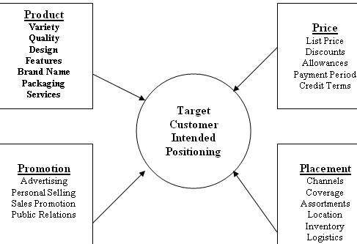

PRODUCTS: It is believed that the type and line of products a company issues out to the public s going to determine the success or failure of the company, provided they are unique. In ABEBE’S Fingers, we have an organized and well-structured line of services provided by abebe’s Fingers and they include the following:

-WRISTWATCHES
-NECKLACES/NECK PIECE
-ENGAGEMENT RINGS
-EAR RINGS
-HAND BANGLES
-STUDDED RINGS

GOLD AND SILVER PLATED ACCESSORIES | DIAMONDS AND SPECIAL STONES
Wristwatches | Studded Rings
Necklaces | Engagement Rings
Ear Rings | Hand Bangles
Customized Electronics | Neck Pieces
Men Cufflinks | Pendants

HERE ARE SOME OF THE SAMPLES OF PRODUCTS WE OFFER

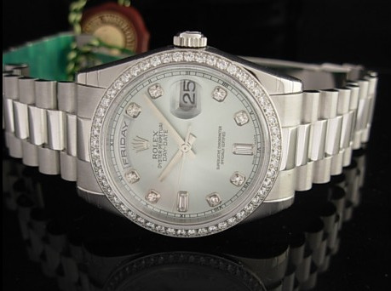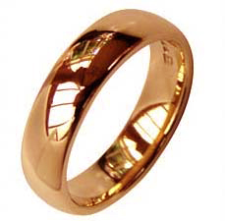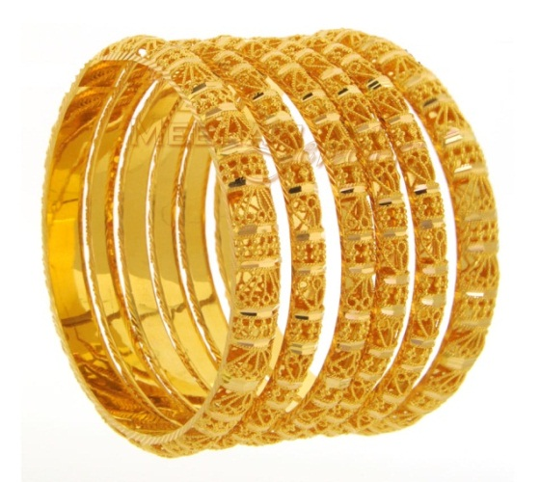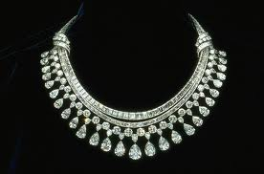

PRICE: We have put a lot into consideration and come up with the best form of cheap labor so as to avoid the price of our goods and services being too high for the consumers. Right now, we serve you based on your budget. Also, different countries have different economies, so this is also considered. In a country like China where the population is highly dense, the demand for our products is so high that if we don’t employ more hands in the production sector, we would have a shortage of supply. On the other hand, they enjoy our goods at an affordable rate because over there, there is some form of relatively cheap labor.

PLACE: Since ABEBE’S Fingers is an outlet for platinum jewelries, we situate our branches in the heart of the city, so as to make it easy for people to reach and also for security purposes. For example, the one in Garki is in the capital city, Abuja, where luxury is appreciated. We also choose places where the goods would be sold fast and easily. Also in deciding our locations, we considered the class of people living in that particular area/place, so as to know what kind of services they need. Lastly, we looked into the stability of the weather. This is so because in the past, we have seen so many industries shut down because of certain natural disasters. This product will be sold in Our store outlet which are located in the big cities like wuse, apo, gwarimpa and Garki and considering the stat that this city contains more of the population we can say that this product is located where they will be seen by people and not just seen but bought.

PROMOTION: We have periodical promotional attachments which we introduce annually through TV ads and other media. This is to foster the growth of the firm, and also to encourage the buyers to remain loyal to us. Promotion is a very important key because you can use it to know the value people attach to your company. It is believed that promotion is for smaller or growing companies, but this is not true because even the older or prosperous firms need it once a while to stay in business.

RECOMMENDATIONS
Abebe’s Fingers is a multi-national company, and has diversified a lot. So I would suggest and ensure to the best of my power that we put in place facilities that would help deliver the goods or jewels to people in the comfort of their homes or offices, because right now, we lack that facility. The staff should keep up the good work, as hard work is paying off right now in abebe’s Fingers.

CONCLUSION
In conclusion, I think this market segmentation and strategies would help boost my firm as a marketer in it, also as an owner because the people or consumers like it when products in the market are properly labeled and spelt out and also easily accessible. Abebe’s Fingers is not a perfect firm, and this is not to say we don’t know what we are doing, it simply means that we have flaws just like every other firm, but they don’t limit our services to the public. As a sole owner, and a marketer, I can’t think of any other place or firm that treats its partners so exclusively and with genuine intentions. Time spent in/with abebe’s Fingers is never regretted.

REFERENCES

www.meenajewelers.com/details/Bangles/Set_of_Bangles/1408/22Kt_Gold_Bangles/

www.minnies-haverfordwest.co.uk/page11.htm
www.ablogtowatch.com/diamond-platinum-rolex-president-timepiece-on-jameslistcom/

www.mnh.si.edu/earth/text/dynamicearth/6_0_0_GeoGallery/geogallery_specimen.cfm?SpecimenID=4081&categoryID=1&categoryName=Gems&browseType=name

