NAME: ONOH IKECHUKWU CHINEDU
MATRIC NUMBER: 16/ENG06/087
COURSE: MEE 510 (ASSIGNMENT)
DESIGN AND FABRICATION OF A VERTICAL LIFT CONVEYOR SYSTEM
INTRODUCTION
A conveyor system is a common piece of mechanical handling equipment that moves
Materials from one location to another. Conveyors are especially useful in applications
Involving the transportation of heavy or bulky materials. Conveyor systems allow quick and
Efficient transportation for a wide variety of materials, which make them very popular in the
Material handling and packaging industries. Many kinds of conveying systems are
Available, and are used according to the various needs of different industries. There are chain
Conveyors (floor and overhead) as well. Chain conveyors consist of enclosed tracks, I-
Beam, towline, power & free, and hand pushed trolleys. Conveyor systems are used
widespread across a range of industries due to the numerous benefits they provide
.Conveyor systems are commonly used in many industries, including the automotive,
Agricultural, computer, electronic, food processing, aerospace, pharmaceutical, chemical,
Bottling and canning, print finishing and packaging. Although a wide variety of materials
Can be conveyed, some of the most common include food items such as beans and nuts,
Bottles and cans, automotive components, scrap metal, pills and powders, wood and furniture
And grain and animal feed. Many factors are important in the accurate selection of a
Conveyor system. It is important to know how the conveyor system will be used beforehand.
Some individual areas that are helpful to consider are the required conveyor operations, such as transportation, accumulation and sorting, the material sizes, weights and shapes and where
The loading and pickup points need to be.
Conveyers have many kind of benefits, it can almost can be installed anywhere. Besides,
Using conveyer as transportation to move load are much safer than using forklift or other
Machines. It also can move loads of all sizes and shapes. There are many types of
Conveyer machines such as gravity conveyer system, power belt conveyer systems, vibration
Conveyer systems, flexible conveyer systems and live roller conveyer system. The design
Capacity of the conveyor belt system was calculated from the information collected using
Different methods of calculation. Three different methods of calculation were used to
Determine the design capacity of the conveyor belt system. The design of the belt
Conveyor must begin with an evaluation of the characteristics of the conveyed material and in
Particular the angle of repose and the angle of surcharge. The angle of repose of a material,
Also known as the “angle of natural friction” is the angle at which the material, when heaped
Freely onto a horizontal surface takes up to the horizontal plane.

The conveyer belt installations have been used for moving a wide variety of goods and
Materials for many decades. They continue to provide the fastest, safest, and most effective
And economical method of transportation over relative long distance often in areas where
Space is limited an operating under some of the most adverse conditions imaginable. The
Conveyer belt plays an integral role in the efficient operation of every conveyer system and
has to be able to cope with an enormous variety of stresses and demands. Every
Conveying installation and the conditions that are required to operate in are of course different
. This means that the correct choice of belt type and cover quality is crucial. There
are several important technical rules, values and calculations involved when selecting a
Conveyer belt. This is also applies to installing new belts, so that they operate at maximum
Efficiency. A belt conveyor consists of an endless and flexible belt of high strength with
Two end pulleys (driver and driven) at fixed positions supported by rollers. In this work, 3 roll
Idlers are required for adequate support of materials transported and protection of the belt
Along its length. Pulleys are used for providing the drive to the belt through a drive unit
Gear box powered by an electric motor. It also helps in maintaining the proper tension to
The belt. The drive imparts power to one or more pulleys to move the belt and its loads.

Roller conveyor chains are generally used in production or assembly lines where individual
Large objects need to be conveyed. Roller conveyor chains differ from transmission roller
Chains such as a bicycle chain, which is used to transfer torque instead of conveying goods.
Conveyor chains have a large pitch which is efficient in bridging large distances with
Fewer shackles, they generally have thicker side plates and rollers with large diameter.
Therefore they can withstand higher tensile and shock loads than transmission chains.
Furthermore they can bear large amounts of wear before breakage occurs. On the other
Hand, roller conveyor chains have a necessary clearance that easily becomes contaminated
With particles from the conveyed material.

MATERIAL SELECTION
In designing our system we will carefully carry out material selection- a process which is performed to select the best materials which may have the potential to perform well both in industrially and commercially. This process was required due to the tensile strength and physical conditions (working environment) surrounding the design thus ensuring the long term success of engineering applications. In the selection process, materials will be assessed for tensile strength and modulus, flexural strength and modulus, impact strength, compressive strength, fatigue endurance, creep, and stress-relaxation properties depending on the application. This will ensure that the design will have a better probability of succeeding. It will also assure that the design is technically fit to obtain desired properties.
The guide columns and case not only provides a strong support to the entire assembly but also has the “paths” as the integrated parts of the case. The case, largely consisting of parts made of mild steel requires a very minimum welding as most of the parts including the paths have been connected by the means of hexagonal nuts and bolts of suitable sizes. It will also be provided with wall supports so that the mechanism can be uncompromisingly installed at the location of the end user.
FACTORS CONSIDERED IN CHOOSING THE MATERIAL
- Compressive strength
- Tensile strength
- Creep and stress relaxation
- Fatigue endurance
- Modulus
- Impact strength
DESIGN SPECIFICATION
Vertical conveyors work under a wide umbrella of performances, ratings, and features. Some common specifications used to determine the best conveyor for specified applications are stated below.
- Load capacity & pieces per minute
Know the desired capacity and mass flow of product through your vertical conveyor. These values will help find a conveyor with the right maximum load and speed that will fit your needs; if these values are not important specifications, then you may consider a simpler vertical conveyor such as a module or portable model.
- Conveyor design, height, and footprint
Vertical conveyors come in almost every conveyor type, so choose one that fits with the conveyors already in use in the facility; this way, the product will experience the smoothest transfer between horizontal and vertical segments. Also, determine the traversal height and overall space requirements to ensure the vertical conveyor will fit into your application. It is imperative that these conveyors are not over or undersized, as they are rated for very specific tolerances.

- Control & special considerations
Vertical conveyors are typically automatic, but make sure your supplier knows if control is needed. There are more complex vertical conveyors capable of user input and variable speeds, but these specifications must be detailed. Also, if power consumption is of concern, consider a vertical conveyor that will minimize its power usage or one with low power drives that will save energy. Finally, consider any important criteria specific to the application. These can be considerations such as static protection, environmental hazard protection, containment/safety features, or anything that will make the system run as reliably as possible. As always, your supplier will know best, so contact them with these special considerations.

DESIGN CALCULATIONS
Essential design calculations were done in order to determine and select the strength and size of the conveyor components. This was done with the aid of the results and established formulae in the design analysis.

The shaft
In designing the shaft, its diameter was ascertained in order to ensure satisfactory strength and rigidity when the shaft is transmitting power during operation and under loading condition.
Bending control
The bending stress “σb” of the shaft was calculated using Equation (1) for hollow shaft:
$σ_{b}= \frac{32BMd_{o}}{π(d_{o}^{4}-d_{i}^{4})}$ (1)
where $σ_{b}$ = bending stress (N m-2);
BM = bending moment (N m);
d_{o} = outside shaft diameter (mm);
d_{i} = inside shaft diameter (mm);
π =3.142 (constant).
To obtain bending moment “BM”
q = 2.14 kg m⁻¹ = 21.0 N m⁻¹
l = 2440 mm
For uniformly distributed load (UDL)
If reaction at A=R_{a} and at B=R_{b}
R_{a} + R_{b} = ql (2)
where, q = weight of the material;
l = length of the shaft.
ql = 21.0× 2.44 = 51.24 N/m
But R_{a} = R_{b}
And $R_{a} = \left(ql\right)1/2and R_{b} = \left(ql\right)1/2$_{b}
$$R_{a}= \frac{51.24}{2}=25.62$$

But 2.44 m R_{a} = R_{b}
Since the system is an UDL
R_{b} = 25.62 N
To obtain bending moment “BM” for Equation (3)
Hibler (2002)
$$BM= \frac{ql^{2}}{8}$$
q = 21.0 N m⁻¹
l = 2.44 m
$$BM= \frac{21.0⨯({2.44}^{2})}{8}=15.63Nm$$
BM = 15.6282 N m
From Equation (1)
$$σ_{b}= \frac{32BMd_{o}}{π(d_{o}^{4}-d_{i}^{4})}$$

d_{o} = 33 mm = 0.033 m
d_{i} = 24.5 mm = 0.00245 m
π = 3.142
$$σ_{b}= \frac{32⨯15.63⨯0.330}{3.142({0.330}^{4}-{0.245}^{4})}=6.362×{10}^{-6}N/m^{2}$$

Torsional control
$Angle of twist = \frac{T×L}{G×J}$(4)
where, T = Torque or torsional moment (N m);
L =Length of the shaft (m);
G = Modulus of rigidity of the shaft (N m-2)
J = Polar moment of inertia of the cross section area about the axis of rotation (Nm-2)

$$Torsional moment, T= \frac{2T×J}{D} (5)$$

J = Polar moment of inertia of the cross section area about the axis of rotation (Nm-2)
But
𝐽= $\frac{π(d_{o}^{4}-d_{i}^{4})}{32} (for holllow shaft)$
$$T= π×J×\frac{π(d_{o}^{4}-d_{i}^{4})}{σ×D}$$
where, J = maximum shear stress (according to ASME code is 53 × 10⁶ N m⁻²);
π = 3.142;
D = Diameter of the shaft (m);
do = outside diameter of the shaft (m);
di = inside diameter of the shaft (m)
$$\frac{3.142× 53 ×{10}^{6}× \left({0.0344}^{4}- {0.0245}^{4} \right)}{16×0.085}= 1010.9353 Nm$$
T = 1010.9353 N m
Diameter control $dL=\frac{3 \sqrt{32Tt}}{πt}$
where,
BM = bending moment = 15.6282 N m;
T = torsional moment = 1010.9353 N m;
J = allowance
shear = 53×10⁶ (N m⁻²);
$$T=\sqrt{{(15.6282)}^{2}+ {(1010.9353)}^{2}=} 1011.0561 N m^{-2}$$

$$\frac{3 \sqrt{32 ×1011.056092}}{3.142×53××{10}^{6}}=5.79cm$$
dL= 5.7912cm
dḺ = 5.7912,
π = 3.142
D = diameter of the auger (m)
S = pitch of the auger = 31 mm = 0.031 m
Driving power of the motor “P”
$P = Q× g (Lv.K_{i} ± H)k$(9)
where, Q = capacity of the auger (kg s⁻¹);
K_{i} = coefficient of friction for grains and chopped hags (k_{i} ranges between 2.2-2.7);
K_{i} = overloading coefficient (k = 1.05-1.2);
Lv = length of the conveyor = 2.44 m,
H = perpendicular height = 1.840 m;
g = acceleration due to gravity =9.81 m s⁻²
From Equation (9)
P = 0.8333× 9.81(2.44× 2.7 +1.840)×1.2 = 82.68 W
Therefore for safety factor the driving power “P” is taken to be 90 watt.
Driving force of the conveyor
If the conveyor must function, the angular moment is expected to be directly proportional to the angular force which should be greater than the required driving force.
Actual angular force
$$F_{w}=\frac{{2M}_{w}}{d_{i}tan⁡(a+B)}$$
where, M_{w} = Angular moment;
d_{i} = Diameter of screw where the bulk of the materials moves (m);
Q = Pitch angle, R = 23°;
B = Frictional angle for the whole screw(°)
From F = tan B (11)
F = Coefficient of friction (F = 0.32-0.58)
B = tan⁻¹ F (12)
Therefore
B = tan⁻¹ 0.38= 20.81°
Angular momentum for the shaft was calculated using the Equation (13)
$$M_{w}=\frac{q_{m}}{2πn}(Nm)$$
where, q_{m} = weight of the materials to be transported (kg m⁻¹) and is given as Equation (14)
$$q_{m}= \frac{Qs}{V}$$
n = number of screw rotation and is taken according to the conveyor materials for dense (Coarse) material.
where, n = 0.8-1.5.
V = Velocity of the auger (m s⁻¹) and is given as Equation (15)
V = S ×π (15)
where, S = Pitch of the auger = 0.031 m s-¹;
V = 0.031 × 3.142 = 0.09740 m s⁻¹
From Equation (14)
$$q_{m}=\frac{0.8333}{0.09740}=8.56 kg/m$$
Therefore
Actual qm = 8.56 × 2.44 = 20.88 kg
From Equation (13)
$$M_{w}=\frac{20.88}{2×3.142×1.5}= 2.2151 Nm$$
$$F_{w}=\frac{2×2.2151}{110tan⁡(23°+20.81°)}=0.04198N°$$
Magnitude of the driving force “F₀” was determined using the Equation (16)
$$F_{o}^{'}=q_{m}\left(L_{v}±H\right)f.g(N)$$
where, L_{v} = length of the conveyor (m
H = vertical height (m);
f = coefficient of friction;
g = acceleration due to gravity (m s⁻²).
therefore
$$F_{o}^{'} = 8.56(2.44 +1.84)0.38× 9.81 =136.57 N$$
The driving force F′₀ must be greater than the Angular force. i. e. F′₀>F₀
i.e. 136.57 > 0.04198

DETAILED DRAWING
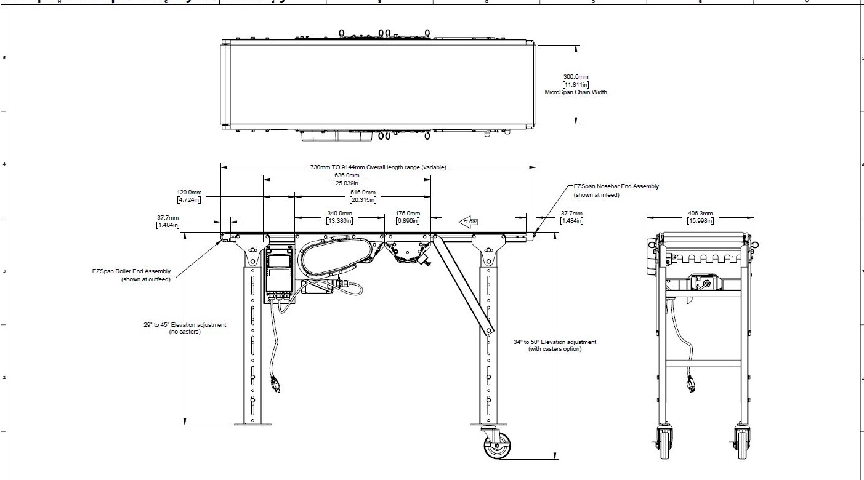
BILL OF ENGINEERING AND MATERIAL EVALUATION (BEME)
S/N | MATERIAL | TYPE | QUANTITY | AMOUNT(Naira)
1 | H-CHANNEL | H-CHANNEL | 8 | 250,000
2 | METAL PLATE | 2mm PLATE | 3 | 36,000
3 | MOTOR | GEAR MOTOR | 1 | 200,000
4 | ANGLE IRON | 3” ANGLE IRON | 10 | 120,000
5 | METAL PLATE | 3mm PLATE | 1 | 20,000
6 | ANGLE IRON | 2” ANGLE IRON | 6 | 54,000
7 | BEARING | PILLOW | 4 | 8,000
8 | WIRE ROPE | WIRE ROPE | 1 | 18,000
9 | SHAFT | 40mm SHAFT | 2 | 4000
10 | SHAFT | 30mm SHAFT | 2 | 68,000
11 | METAL PLATE | 10mm PLATE | 1/2 | 50,000

DESIGN PROCESS/MANUFACTURING
The fabrication of the lifting structure will begin with assembling the two main posts. The Two-Posts will be assembled using horizontal braces that will be evenly spaced along its length. The top horizontal brace of the lifting structure is the most important of all of the horizontal braces because it housed the electric chain hoist mounts. These braces will be attached to the two main posts using screws. The installation of the braces give room for the added weight of the load the hoist would be lifting to be fully supported by the lifting structure.
After which the material cart fabrication begins with cutting the aluminum into the necessary lengths.
The safety cage will be the last piece of the conveyor to be installed. The safety cage will be designed to fit around the base of the conveyor with a safety space between it and the conveyor. This space between the safety cage and the conveyor is to restrict a person from placing a finger through the holes in the cage panels and becoming caught in the moving parts of the conveyor.
Finally, the electric chain hoist is added to the conveyor so that testing could begin. The hoist is hung from the eye bolt that is installed into the top horizontal brace of the lifting structure, and the hoist is then simply plugged into a 110 volt outlet to supply power for the hoist's operation. The hoist chain is then attached to the mounting hole on the plate on the back of the material cart.

