NAME: Akinderu sultanbasit

MATRIC: 15/EN06/006

COURSE: MEE510

ASSIGNMENT TITLE: ASSIGNMENT 1

**CASE STUDY: DESIGN AND FABRICATION OF A POWER GENERATING SPEED BREAKER**

1. **PRODUCT/PROJECT DESIGN:** Currently, the most advanced and efficient methods of power generation are from carbon related sources extracted from fossil fuels. In Nigeria, the existing power network is mostly operated on fossil fuels. Thus, an alternative source of power is needed to provide solution on the over-dependency of non-renewable resources which are harmful to our environment. A need of clean and environmentally friendly sources is vital in combating against the carbon related environmental impacts such as global warming. A combination of renewable energy and energy harvesting would provide a viable solution. Harvesting the energy from vehicles through speed breakers would contribute to the Nigeria’s target of becoming carbon neutral.

However, there are doubts in our society on the practical implementation of traffic energy harvester. This is the main reason for low implementation of traffic energy harvester devices across the world. Among many traffic energy harvester devices that have been proposed, this project emphasizes on the speed breaker as the mechanism to harvest the traffic energy. In order to implement the speed breaker as a power generation unit, impact study on this new mechanism is important. It is important to prove that it has the potential to be developed in large scale, and prove its practicability and cost effectiveness in comparison to conventional speed breaker in order to clear the doubts on its effectiveness as a power generation unit. Thus, this project is to investigate the impacts of traffic energy harnessing system on speed breakers to determine its positive and negative impacts on our society.

The aim of this project is to design and simulate a power generating speed breaker for a metropolitan city able to power street lights. In order to achieve this, the following specific objectives shall be followed;

1. To design a system that functions well as a speed breaker and a power generator.
2. To achieve the completion of this project with a relatively low cost.
3. To design and simulate a bio friendly system

# Rack and Pinion Mechanism

In this mechanism, the load will act upon the speed breaker and further be transmitted to the rack and pinion arrangements, as the plate below shows. Here the reciprocating motion of the speed-breaker is converted into rotary motion using the rack and pinion arrangement. The axis of the pinion is coupled with the sprocket arrangement. The sprocket arrangement is made of two sprockets: one of larger size and the other of smaller size. Both sprockets are connected by means of a chain which serves in the transmission of power from the larger sprocket to the smaller sprocket. As the power is transmitted from the larger sprocket to the smaller sprocket, the speed that is available at the larger sprocket is relatively multiplied at the rotation of the smaller sprocket, also making similar arithmetic to the gears in mesh, thereby providing the dynamo with a high speed. This mechanism appears to be the most adopted one used, but with its backdrop of easy wear of components and the likes. Figure 2.1 shows a typical rack and pinion model.



Figure 2.1: Rack and Pinion Model

**2. MATERIALS SELECTION:**

* Bearing: The purpose of a ball bearing is to reduce rotational friction and support radial and axial loads. In most applications, one race is stationary and the other is attached to the rotating assembly.
* **ROLLER:** This is a revolving cylinder over or on which something is moved or which is used to press, shape, spread, or smooth something.
* **BELT:** This is a loop of flexible material used to link two or more rotating shafts mechanically, most often parallel. Belts may be used as a source of motion to transmit power efficiently or to track relative movement. Belts are looped over pulleys and may have a twist between the pulleys and the shafts need not be parallel.
* **PULLEY:** This is a wheel on an axle of shaft that is designed to support movement and change of direction of a cable or belt, or transfer of power between the shaft and cable or belt.

**PLATE 7 : PULLEY**

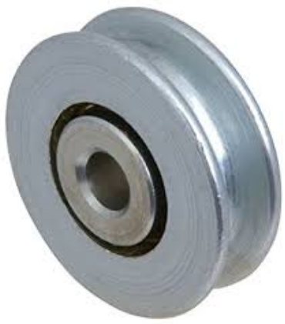

* **FLYWHEEL:** This is a heavy wheel located on the shaft to smooth out delivery of power from a motor to a machine. It reduces the fluctuation in the speed.
* **SHAFT:** It is a rotating element, which is used to transmit power from one place to another place. The material used for ordinary shafts is mild steel. When high strength is required, an alloy steel such as nickel, nickel-chromium or chromium-vanadium steel is used.

**PLATE 8 : SHAFT**

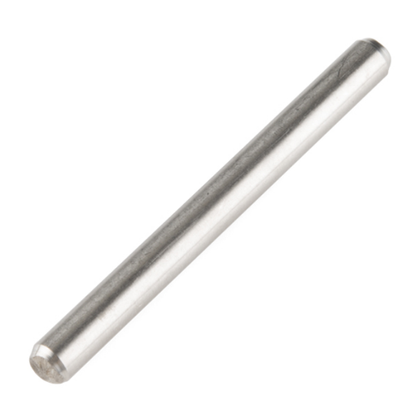

* **D. C. GENERATOR:** A dcgenerator an electricity generator that produces direct current with the use of a commutator. The dynamo uses rotating coils of wire and magnetic fields to convert mechanical rotation into a pulsing direct electric current through Faraday's law of induction. A dynamo machine consists of a stationary structure, called the stator, which provides a constant magnetic field, and a set of rotating windings called the armature which turn within that field. The motion of the wire within the magnetic field causes the field to push on the electrons in the metal, creating an electric current in the wire. On small machines the constant magnetic field may be provided by one or more permanent magnets; larger machines have the constant magnetic field provided by one or more electromagnets, which are usually called field coils. The electricity created by this dynamo can be stored in batteries and can be further used according to requirement.

**PLATE 9 : D.C. GENERATOR**

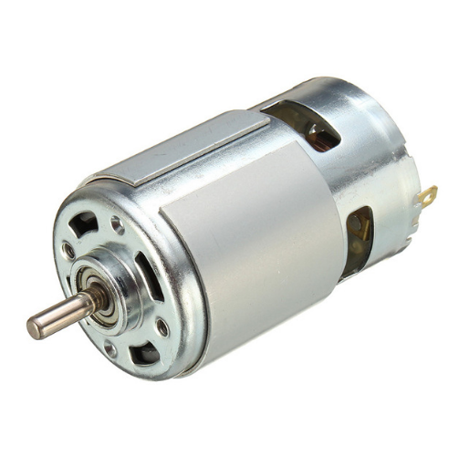

**3.FACTORS CONSIDERED IN CHOOSING THE MATERIALS**

1. The availability of materials must be paramount.
2. The machinability of the materials to the required dimensional accuracy and size should be very paramount for the design.
3. The materials requirement must be properly defined and audited in terms of cost.
4. The immediate materials that could perform the required functions must be readily identified as well as their alternative substitutes.
5. The amenability of the materials would be amendable to the production process and assembly of parts.

**4. DESIGN SPECIFICATIONS**

The mechanism comprises of a roller, frame and mechanical moving components. The base of the entire component is 650mm × 410 mm. having a height of 420mm. The 20mm shaft was subtended at length 283mm on both sides. The shaft is therefore mounted with mechanical components and also used to relay the rotational motion to the other components. The roller, serving as a portion of the bump, having an outer diameter of 140mm is fixed firmly on a 130mm diameter flywheel. It is connected with a set of pulley: the bigger pulley having a diameter of 40mm, and the smaller pulley having a diameter of 14mm. The pulley in turn is connected via a belt, having an open drive mechanism.

**Assumptions for specification**

Load exerted on roller: 12.5kg (approximate value of push of a 100kg man)

Force exerted on roller: Ma=12.5 Kg × 9.81 = 122.625N (Same as Torque)

# DESIGN SPECIFICATION OF THE SHAFT.

To determine the appropriate diameter of shaft usable for the set up.

Material of shaft = mild steel

Diameter of shaft = 20mm

Bending, torsion, and axial stresses may be present in both midrange and alternating

Components. For analysis, it is simple enough to combine the different types of stresses into alternating and midrange von Mises stresses. It is sometimes convenient to customize the equations specifically for shaft applications. Axial loads are usually comparatively very small at critical locations where bending and torsion dominate, so they will be left out of the following equations. The

Fluctuating stresses due to bending and torsion are given by:









** -** Midrange bending moment

 - Alternating bending moment

 - Midrange Torque

 - Alternating Torques

- fatigue stress-concentration factors for bending

- fatigue stress-concentration factors for torsion

Putting in consideration that the shaft used is a solid shaft with round cross section, appropriate geometry terms can be introduced for *c*, *I*, and *J* resulting in:









Combining these stresses in accordance with the distortion energy failure theory, the von Mises stresses for rotating round, solid shafts, neglecting axial loads, are

Given by:





The stress-concentration factors are sometimes considered optional for the midrange components with ductile materials, because of the capacity of the ductile material to yield locally at the discontinuity. For design purposes, it is also desirable to solve the equation for the diameter. This results in:



For this design, the diameter of the shaft is 20mm, and a length 605mm. calculations to verify the radius specification is duly shown in the design calculation.

# DESIGN SPECIFICATION OF A BELT

Belt type = Flat belt

Thickness range = 0.75 to 5mm

Belt geometry = open drive mechanism

For a flat belt with this drive the belt tension is such that the sag or droop is visible as in the plate below, when the belt is running. Although the top is preferred for the loose side of the belt, for other belt types either the top or the bottom may be used, because their installed tension is usually greater.

**PLATE 10 : OPEN BELT DRIVE MECHANISM**

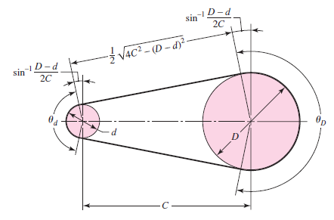

From the above plate, the following deduction were utilized:





 OR



Where *D =*Diameter of the bigger pulley= *40mm = 0.04m*

*d =* Diameter of the smaller pulley = 15mm = 0.015m

*C =* *Center distance =* *190mm = 0.19m*

*L =* Length of belt = To be det.

 = angle of wrap between the belt and the bigger pulley

 = Angle of wrap between the belt and the smaller pulley

Where  = 

















So the length of belt used is:











# DESIGN SPECIFICATION OF THE DRIVING PULLEY

Pulley material = cast iron

Groove diameter = 20mm

Groove width =8mm

Flange diameter = 35mm

# DESIGN SPECIFICATION OF THE DRIVEN PULLEY

Pulley material = plastic

Groove diameter = 7.5mm

Groove width = 8mm

Flange diameter = 15mm

**5. BEME**

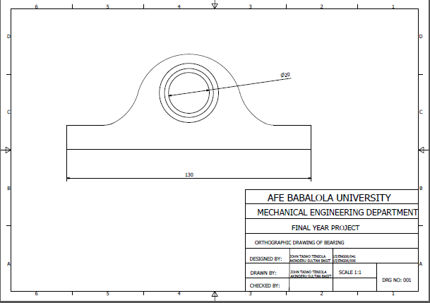

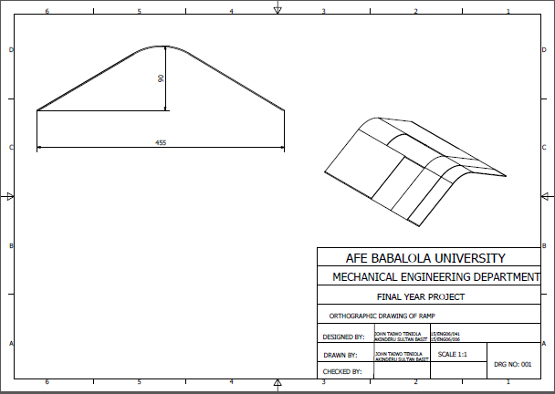

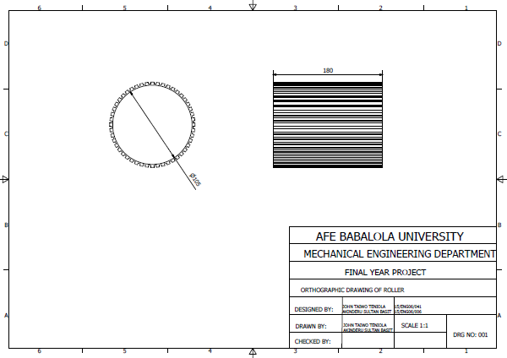

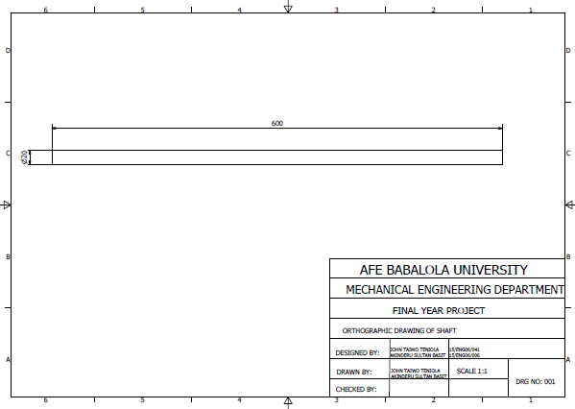

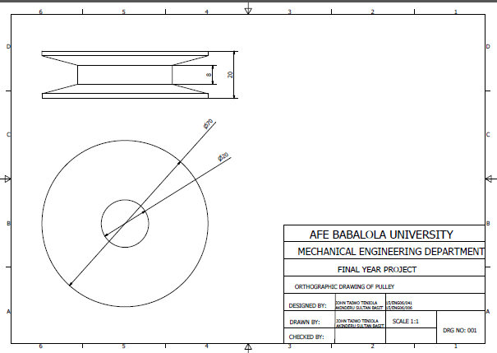

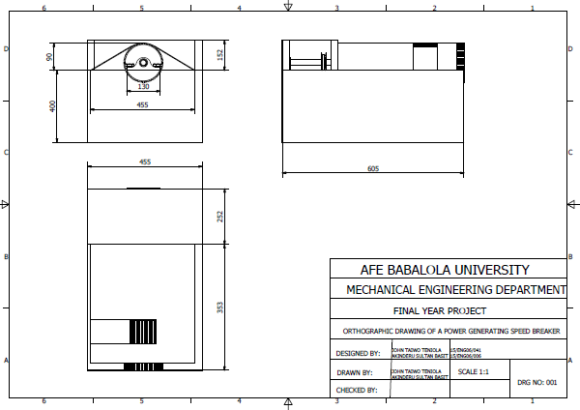

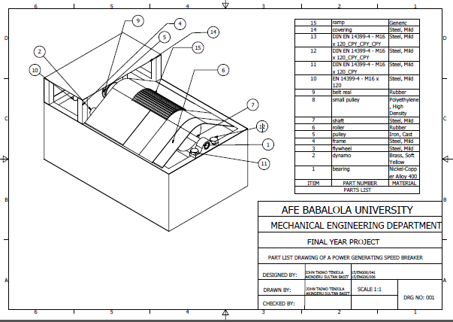

**6. DESIGN CALCULATION**

# TO CALCULATE TORQUE OF THE SHAFT.

Flywheel inner diameter = 20mm

Flywheel outer diameter = 130mm

Shaft diameter = 20mm

Assume the flywheel makes a rotational speed of 65rpm, with mass of 2kg, then



Where 





6.8067rads/s rads/s

So 



So 



This is the same amount of torque transmitted by the shaft.

# TO DETERMINE THE ROTATIONAL FORCE OF THE BIG PULLEY.

The rotational force of the big pulley can be obtained as:



Where *r* = 0.01m

So 





# CALCULATION OF THE POWER OUTPUT OF THE SET UP.



Where 



Assume 

So 



So (where mass of the big pulley is 0.2kg)









So 





# TO VERIFY THE SHAFT DIAMETER COMPATIBILITY.



Where:

Shear stress (Pa)

T = Twisting moment (Nm)

r = Distance from centre to stressed surface in given position (m)

J = Polar moment of inertia of area ()



Where

F= force applied (N)

A = cross sectional area of the shaft ()

And 

So 

Where F = 12.0464N

T = 350Nm

J = 







Where D = 2r, D = 0.01603m = 16mm

So having a safety factor of 1.25, the use of a 20mm shaft appear very appropriate.

CALCULATION OF THE MAXIMUM BENDING MOMENT OF THE SHAFT. 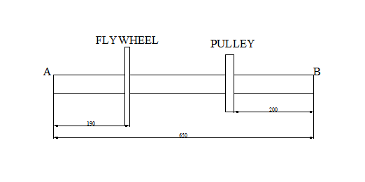

FIG. 1 : MECHANISM LAYOUT

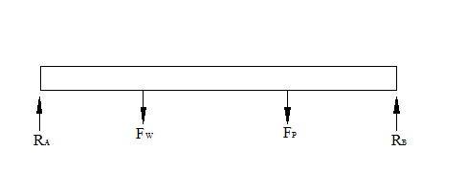

**FIG. 2:** FREE BODY DIAGRAM





Where = Reaction in point A

= Reaction at point B

= Force from pulley

= Force from flywheel

Recall, mass of flywheel = 2Kg

And mass of pulley = 0.2Kg

So 

Also 

So 









Recall that 

So 





Maximum bending moment = 2.75Nm as shown below

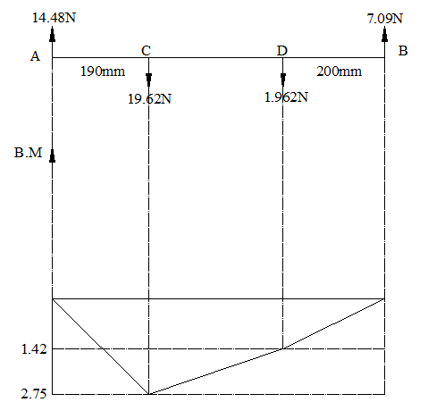

**FIG. 3:** BENDING MOMENT DIAGRAM

**7. DESIGN PROCESS/MANUFACTRING**

