CHAPTER 3

METHODOLOGY

This chapter studies the various components, and processes used for the design and construction of the domestic greywater treatment station. Components such as the mechanical filters, granular activated carbon filters, germicidal ultraviolet light and submersible pump used in the project are discussed. Also discussed are the AutoCAD Plant 3D and Arduino Nano applications which are used for design and programming. The domestic greywater treatment station design is shown in Figure 3.1:
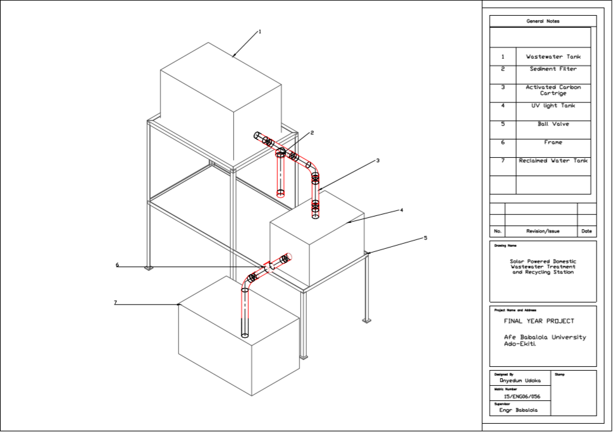
Figure 3.1 Domestic Wastewater Treatment and Recycling Plant

3.1 Materials Used
The following materials were employed for the construction of the domestic wastewater treatment station, and for water quality testing
- Rectangular water tank, 50-liter capacity
- Rectangular water tank, 30-liter capacity
- 1” PVC pipe
- 1.5” PVC pipe
- Frame
- 254nm submersible ultraviolet lamp
- Mechanical Sediment Filter
- Backnut
- 90-degree elbows
- Socket joints
- 1” PVC adapters
- 1.5 inch to 1-inch PVC bushing
- 1.5-inch PVC nipple
- 1” Union
- Thread Tape
- Pipe gum
- Arduino Nano microcontroller
- Flow rate sensor
- Ultrasonic sensor
- pH sensor
- Turbidity sensor
- Solenoid Valve
- 24 Character LED display
- Relay Module
- Power Supply
- Inverter
- Solar Panel

3.1.1 Filter Selection
Filtration is the process of passing water through a porous medium with the expectation that the filtrate has a better quality than the influent. To efficiently remove larger particles such as sand, hair and clay from the water, a sediment filter with mesh size of 0.5 microns was selected. The rating of the filter selected is as follows;
Minimum working pressure: 20psi
Maximum working pressure: 125psi
Maximum working temperature: 120ºF
Pressure drop: 2.5psi

3.1.2 Clean Water Reservoir

Water tanks are large chambers for storing water. They come in a variety of styles, including horizontal cylinders, vertical cylinders, and rectangles. The proper method for determining tank capacity depends on the shape of the water tank.

3.1.2.1 Tank Area
The cross-sectional area of the tank is given in equation 3.1 as:
Area = L*B (3.1)
Where: L= Length of the tank = 520mm
W= Width of the tank = 340mm
Area= 520*340 = 176800mm²

3.1.2.2 Tank Volume

The Volume of the tank is given in equation 3.2 as:
Volume = L*B*H (3.2)
Where: L= Length of the tank = 520mm
W= Width of the tank = 340mm
H= Height of the tank = 310mm
Volume= 520*340*310 = 54,808,000 mm³
= 54.8 Liters

3.1.2.3 Flow Rate Through an Orifice at the side of the tank

The velocity of the fluid leaving the tank through an orifice at the side of the tank is given in equation 3.3 as:
Velocity = $\sqrt{2gh}$ (3.3)
Where: g= Acceleration due to gravity = 9.81 m/s²
h= Height of water above the orifice = 235mm = 0.235m (Assuming the orifice is located 20mm from the bottom of the tank, and the maximum height of water in the tank is 280mm)
Velocity = (2*9.81*0.235)^{1/2} = 2.147m/s

Area of the orifice, A= $πd^{2}$/4 (3.4)
Where: d= Diameter of the orifice = 25.4mm= 0.0254m
Area, A= π*(0.0254)²/4 = 0.00051m²

Flow Rate = cd*A*V (3.5)
Where: cd= Coefficient of Discharge = 0.62
A= Area of the orifice= 0.00051m²
V= Fluid Velocity= 2.147m/s
Flow Rate= 0.62*0.00051*2.147 = 0.00067m³/s

3.1.2.4 Pressure in the Tank

The pressure in the tank is given in equation 3.6 as;
P= P₀ + ρgH (3.6)
Where P₀ = Atmospheric Pressure = 0 (The system is closed)
Ρ = Density of water = 1000kg/m³
H = Height of the tank = 310mm = 0.31m
Pressure, P = 0 + 1000*9.81*0.31 = 3041.1N/m²

3.1.3 Ultraviolet Light Disinfection Reservoir

3.1.3.1 Tank Area

The cross-sectional area of the tank is given in equation 3.1 as:
Area = L*B
Where L= 0.39m
B= 0.28m
Area = 0.39*0.28 = 0.109m²

3.1.3.2 Tank Volume

The Volume of the tank is given in equation 3.2 as:
Volume = L*B*H
Where L= 0.39m
B= 0.28m
H= 0.26m
Volume = 0.39*0.28*0.26 = 0.028m³ = 28 Liters

3.1.4 Microcontroller and Sensors
A microcontroller is a small integrated circuit designed to control or govern a given operation in an embedded system. For this project, the micro controller employed is the Arduino Nano, and it governs an array of sensors and components shown in table 3.1 below.

Table 3.1 List of Sensors and Components
S/N | ITEM
1 | Flowrate Sensor
2 | pH sensor
3 | Ultrasonic Sensor
4 | LCD Screen
5 | Solenoid Valve
6 | Electric Motor

3.2 Methodology
This section covers the activities involved in the construction of the wastewater treatment station, and the sequence in which those activities were carried out.

3.2.1 Construction of the Frame
The following were the steps taken to fit and weld the frame for the wastewater treatment and recycling plant. 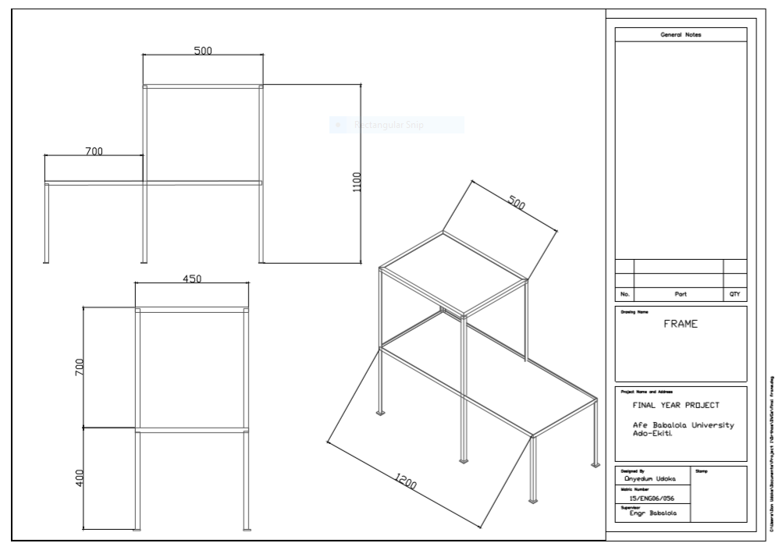
Figure 3.2 Frame for the Wastewater Treatment Plant
- The required lengths of the angle iron were measured using the measuring tape, and cut using the cutting machine, according to the dimensions in fig 3.2
- The required length of the steel plate was measured and cut according to the dimensions in fig 3.2
- A try square was employed to ensure that the joints to be welded were perpendicular.
- Arc welding was employed to join the edges by tacking, in case further adjustments needed to be made.
- After tacking, the joints were fully welded.
- The grinding machine was used to smoothen the joints for good surface finish.

3.2.2 Assembly of the Tanks and Piping
The following were the steps taken to connect the pipes and fittings to the reservoir tanks and filtration media.
- The location for the Backnut were marked out on the plastic tanks according to design specifications.
- The orifice for the Backnut was made using a portable power drill with a sandpaper drill bit attachment.
- An adaptor was wrapped with the threaded tape and screwed to the back nut of the reservoir tank with the use of adjustable wrench.
- A hack saw was used to cut the 1-inch PVC pipe according to design specifications.
- A 50mm length of PVC was fitted into the adapter and set in place using the pipe gum. The other end of the PVC was fitted into a 1-inch ball valve.
- A 50mm length of PVC was fitted into the outlet of the ball valve and the other end was fitted into an adaptor attached to the 0.5-micron sediment filter.
- An adapter was fitted to the outlet of the sediment filter, followed by a 50mm length of pipe, attached to a 1-inch elbow using the pipe gum.
- An assembly of three 1.5-inch threaded sockets, two threaded nipples and two 1.5 inch to 1-inch bushings was constructed to act as a filter housing for activated carbon adsorption. Filter materials were fitted at both ends of the assembly so the carbon does not flow with the rest of the fluid.
- An adaptor was attached to the end of the assembly and connected to a 60mm length of pipe, with the other end connected to the Backnut of the ultraviolet tank as shown in fig 3.1.
- The Backnut at the side of the ultraviolet tank was connected by a reducer, to a ½ inch solenoid valve.
- The solenoid valve was connected to a flow rate monitor, and the flow rate monitor was connected by a male to female threaded connector, to the storage tank.

3.2.3 Leak and Integrity testing.
After the components were assembled, water was poured into the tank and the system was allowed to run, so as to check for leakages, and also wash out carbon dust and other debris accumulated in the system during assembly.

3.3 BEME (Bill of Engineering Measurements and Evaluation)
This is the Engineers’ bill of materials showing a developmental analysis of costs associated with materials utilized for the project. it is detailed in Table 3.2

Table 3.2 Bill of Engineering Measurements and Evaluation
S/N | ITEM | QTY | PRICE (NGN)
Piping and Mechanical

1 | Water Tank (30 liters) | 1 | 2700
2 | Water Tank (50 Liters) | 2 | 7000
3 | 1” Ball Valve | 1 | 2000
4 | 90-degree Elbow | 4 | 240
5 | 1” PVC Pipe | 1 length | 1500
6 | 1 ½” nipple | 4 | 1200
7 | 1” Adapter | 7 | 420
8 | 1” Sediment Filter | 1 | 7600
9 | 1” Backnut | 4 | 1200
10 | Bushing | 4 | 1200
11 | 1” Socket | 8 | 2400
12 | 1” Union | 4 | 800
13 | Thread Tape | 2 | 700
14 | Pipe Gum (Abro or Top-grid) | 1 | 1200
Electrical and Measurement

1 | 1” Flow Rate Sensor | 1 | 5000
2 | 1” Solenoid Valve | 1 | 1200
3 | pH Sensor | 1 | 4000
4 | Ultrasonic Sensor | 1 | 1200
5 | UV Germicidal Light (Submersible) | 1 | 4000
6 | Arduino Nano | 1 | 3000
7 | Relay Module | 2 | 1000
8 | Inverter 50w | 1 | 8000
9 | Battery | 1 | 15000
10 | 20x4 Character LED display | 1 | 4000
11 | Electrical wires | 4M
12 | Connecting wires
13 | Vero board
14 | Soldering lead
Others

1 | Frame Materials | - | 40000
2 | Fabrication Cost (Workmanship) | - | 15000
3 | Activated Carbon | 1 bag | 4000
4 | Miscellaneous | - | 15000
5 | Estimated Shipping Cost | - | 30000
TOTAL |  |  | 179,360

