OYUGBO OBEHIOYE CHRISTINE
18/SCI01/078
AFE 202 ASSIGNMENT
Instruction: Prepare a business plan for an agricultural enterprise

INTRODUCTORY PAGE

BUSINESS PLAN FOR OBEHIOYE’S CASSAVA ENTERPRISE
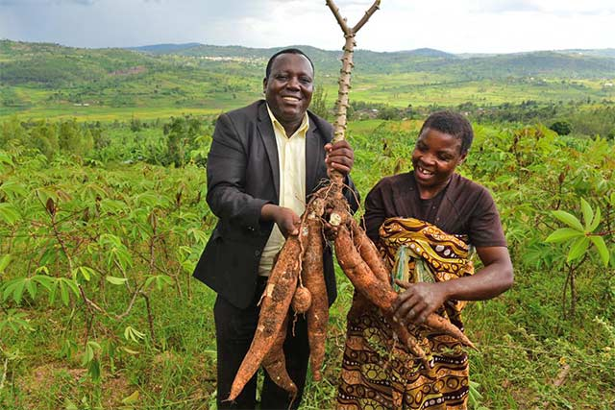
Content of Business plan
Chapter 1…………………………….Introductory Page
Chapter 2……………………………..Executive Summary
Chapter 3……………………………..Environmental and Industrial Analysis
Chapter 4……………………………..Description of Venture
Chapter 5…………………………......Production of Operational Plan
Chapter 6……………………………...Organizational Plan
Chapter 7………………………….......Assessment of Risk
Chapter 8………………………….......Financial Plan
Chapter 9……………………………….Appendix

Obehioye’s Cassava Enterprise
By
Obehioye Oyugbo
Address: No 1 Avenue Lily Lane, Banana Street.
Phone: 09111188811
EXECUTIVE SUMMARY
Obehioye’s Cassava Enterprise is an agricultural establishment serving in West Africa, Nigeria. The enterprise would be run by Oyugbo Obehioye, a member of the prominent Oyugbo family. The enterprise was established for the growing of cassava crops as well as the manufacturers of cassava flour, animal feed, alcohol, sweeteners, paper and textiles
ENVIRONMENTAL AND INDUSTRIAL ANALYSIS
ENVIRONMENTAL ANALYSIS
The framework PESTEL provides means to analyze how the political, economic, sociological, technological, legal and environmental factors affect the enterprise.
This enterprise would only be trading within the country, hence would be unbothered by foreign trade policies but however would need to adhere to local trade policies.
Economic growth is taken into consideration because this enterprise provides several jobs for its workers, whether in the manufacturing or distributing aspects, hence taking people off the streets. Unemployment rates as well as disposable income is also noted because the enterprise distributes its goods to popular markets at affordable bulk prices.
For the sociological aspects, the enterprise produces and sells to places where there isno cultural barrier and so selling of this produce would not be a problem. The production is also done in a hygienic order to avoid any unsanitary health risk.
The enterprise makes use of the most suitable and up to date technology to get work done quicker and faster.
Studies have been done in order to find out the appropriate time to pant the cassava to ensure maximum yields. This is in the rainy season.
INDUSTRIAL ANALYSIS
The market is growing and as of last month the enterprise had only 2 competitors. Surely the enterprise can cope well. Cassava is always in high demand be it for the crop itself, or for the numerous products that can be gotten from it.
For the market analysis, the market is situated close to the production point, hence there is not much transportation cost. The market would be located in Area 1 Agabada.
For future economic outlook, cassava would always be in trend. It is the most consumed crop in West Africa along with its products.

DESCRIPTION OF VENTURE
The enterprise deals with the production of cassava and the processing of the cassava into flour, animal feed, and garri. The cassava plant is eaten on a large scale as a staple food, could be processed into cassava flour which is a healthier baking flour as well as soup thickener. Cassava can also be processed into garri which could be drunk or eaten as a swallow.
The Obehioye’s Cassava Enterprise is a large scale enterprise as it includes both production and processing,
PRODUCTION OR OPERATIONAL PLAN
MANUFACTURING PROCESS
Cassava growers plant cuttings from the stems of recently harvested plants. They typically cut 8 inches from the bottom of the stem then slice 10-inch cuttings from the next 30 inches. Cuttings are best planted as soon as possible, although they can be stored successfully in a cool, shaded place for up to 3 months. The lower half of the cuttings are planted every 3 feet in rows that are 3 feet apart. If the soil is dry, the the cuttings are planted at a 45-degree angle. If the soil is wet, they are planted vertically.
Tapioca is a starch extracted from the cassava root through a process of washing and pulping. The wet pulp is then squeezed to extract a starchy liquid. Once all the water evaporates from the starchy liquid, the tapioca flour remains. Alternatively, cassava flour is the whole root, simply peeled, dried and ground.
The manufacturing industry is located in Area 1 Isokoyo.
The facilities used for the manufacturing and processing of cassava include cassava chips processing machine(for animal feed), garri processing machine, cassava flour processing machine, hydraulic press, garrci fryer, cassava grater, etc
The estimated total initial investment cost of cassava processing plant in Nigeria is N70,800,000.
ORGANIZATIONAL PLAN
This enterprise adopts a functional structure of organization whereas it is broken up based on the specialization of its workforce. It divides the enterprise into departments consisting of marketing, sales, and operations is the act of using a bureaucratic organizational structure. It is a limited partnership business. General partners are fully liable for the debts of the partnership, while limited partners are not liable for the debts of the partnership, but may not participate in management of the business.

ASSESMENT OF RISK
The major risk in this business enterprise would be the rise of pest and crop diseases. General partners are fully liable for the debts of the partnership, while limited partners are not liable for the debts of the partnership, but may not participate in management of the business. Limited partnerships are taxed exactly like general partnerships. However, Obehioye’s Cassava Enterprise had this under control with the help of pesticides. Examples of specific synthetic chemical pesticides are glyphosate, Acephate, Deet, Propoxur, Metaldehyde, Boric Acid, Diazinon, Dursban, DDT, Malathion, etc. Hence the risk of pests would be low and subsequently the impact of pests would be low.
FINANCIAL PLAN
This enterprise has planned to raise capital and funds from the following
- Personal Savings.
- Retained Profits.
- Working Capital.
- Sale of Assets.
- Bank Loans.
INCOME STATEMENT
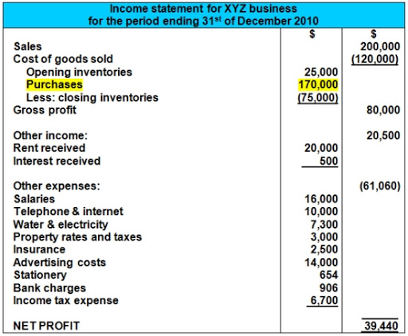

APPENDIX
GRAPH SHOWING PROSPECTIVE BUSINESS SALES AND BUSINESS EARNINGS.
