MEE 510
PRODUCT DESIGN ASSIGNMENT
DEVELOPMENT OF WOOD LATHE MACHINE

EKE, UROUPA VICTOR
15/ENG06/023

(GROUP PROJECT WITH ANYANG JOSHUA & IBRAHIM AYODOTUN)

Assignment 1

Early Development of Wood Lathe
A wood lathe is an ancient tool and it is assumed to be the oldest machine tool used by man having its origin from the early tree lathe which was turned by a rope wound around the work and attached to a sparingly branch overhead (Jain R, 2008). The earliest evidence of lathe dates back to ancient Egypt around 1300BC. Primarily, there are two things that are achieved in this lathe machine set-up. The first is the turning of the wood working piece manually by a rope; and the second is the cutting of shapes in the wood by the use of sharp tool. As civilization progresses, there have been constant modifications and improvements over the original two-person lathe machine, most importantly on the production of the rotary motion (Raffan, 2001).
The production of the rotary motion therefore evolved according to the following procedures: the Egyptians manual turning by hand; the romans addition of a turning bow; the introduction of the pedal in the middle ages; the use of steam engines during the industrial revolution; the employment of individual electric motors in the 19th and mid-20th centuries; and the latest of which is the adaptation of numerically controlled mechanisms in controlling the lathe machine.
Also, during the industrial revolution, mechanical power was applied to the lathe via steam engine and shafting, which allows fast and easier work to be made. Apart from the fact that the early inventions were so crude and demanding much of manual effort in operations, it was also limited to operation on the wood. The design of this crude beginning continued over a period before the engine lathe evolved (Sacky, 1999). They all found no application in metal cutting until above 1970 because they lacked adequate power, strong and accurate holding device which could guide the tool and ensure safety of the operator, the work piece and the machine. From different historical records, the design capacity of the lathe was reported to be useful only for turning woods into the desired shapes. The integration of those design to be suitably employed for metallic material led to the development of the sliding carriage by Henry Manldstey (Jain, 2008). He also built a screw cutting lathe in 1880. Metal working lathe evolved into heavier machines with the introduction of thicker and more rigid parts. Ultimately the carriage aid the application of lead screws, slide rests, and gearing which practically enhanced the producing of screw cutting for commercial purpose.
Lathe machine come in variety of models amongst which are bench lathes which can sit on a bench or table, CNC lathes that are controlled by a computer, vertical lathes i.e. lathe with vertical axis. Also, there are some lathes that are equipped with indexing plates, profiled cutters, spiral or helical guide, etc. so as to enable ornamental turning. Thus, the machine from its inception till date have under gone series of improvement, some parts have been simplified, modified or eliminated where found not absolutely necessary, hence different models exist in the market. What remains indisputable in all model is the fact that the same principle of machining is employed. The wood lathe, just like other types of lathe can be used to carry out a wide range of machining operations. It saves time and does not need much skill as in the use of hand tools.
Machine Description and Principle of Operation
The wood lathe is a machine which hold and rotates wood between two rigid supports called centers which revolves to produce circular, cylindrical or any desired shape (Gasper, 1981). Wood lathes all have the same general functional parts, even though the specific location of a certain part may differ from the other. The bed is the foundation of the working parts of the lathe to another. The main feature of its construction is the ways which are formed on its upper surface and run the full length of the bed. Ways provide the means for holding the tailstock and the tool rest, which slides along the ways, in alignments with the permanently attached headstock.
The wood lathe has seven major components. Which are the
- bed
- drive mechanism
- headstock
- tool rest
- Tailstock
- control mechanism
- mounting means.

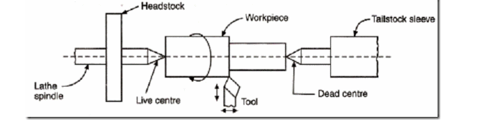

Component of a Wood Lathe Machine

The Bed
The bed of the wood lathe machine is its basic structure which is a horizontal beam. It is usually a frame in which the basic components can be mounted. The bed is a heavy, rugged casting in which are mounted the working parts of the lathe. The essential part of the bed of the wood lathe is that which provide a reference surface for other components to ride. It carries the headstock and tail stock for supporting the workpiece and provides a base for the movement of carriage assembly which carries the tool

The Drive Mechanism
These ranges from a basic electric motor in line with the turning axis of the wood lathe to an elaborated set of belts and pulleys driven by a motor

2.2.2 Electric Motor
Electric motor is use to convert electric input into mechanical output (torque) which rotates a shaft. This power required by the lathe is generated by an electric motor consist of a stator and a rotor. The rotor is the moving part of the electric motor which turns the shaft to deliver the mechanical power. The rotor usually has conductors laid into it which carry currents that interact with the magnetic field of the stator to generate the forces that turn the shaft. However, some rotors carry permanent magnets, and the stator holds the conductors. While the stator is the stationary part of the motor’s electromagnetic circuit and usually consists of either windings or permanent magnets. The stator core is made up of many thin metal sheets, called laminations. Laminations are used to reduce energy losses that would result if a solid core were used. The distance between the rotor and stator is called the air gap. The air gap has important effects, and is generally as small as possible, as a large gap has a strong negative effect on the performance of an electric motor. It is the main source of the low power factor at which motors operate. The air gap increases magnetizing current. For this purpose, air gap should be minimum. Very small gaps may pose mechanical problems in addition to noise and losses.

2.2.3 The Headstock
The headstock is usually clamped on the left side of the bed of the lathe machine, It serves as a housing for the drive pulleys and gears. It consists of the main spindle and the gearing mechanism for obtaining different speeds and also for transmission of power to the threading and feeding mechanism. The headstock is driven by an electric motor which is either connected to a pulley system or a belt, or to a geared system. The spindle is mounted on bearings in the headstock and specially ground to fit different lathe holding devices.
- Headstock spindle
The headstock must be strong. Otherwise the cutting forces involved may deform it, which in turn instigate harmonic vibrations. These vibrations would be passed to the workpiece thereby, reducing the quality of the finished workpiece.
- Hollow cylindrical shaft
The main spindle is hollow in order for long bars to extend through to the work area. It is supported by precision bearings and is fitted with chucks or faceplates to grip workpieces. A taper is often included at the end of the spindle. This allow hollow tubular (Morse standard) tapers to be inserted, reducing the size of the tapered hole and permitting the use of centers.
- Driving work-holding devices
On machines built during the 1950s, the bull gear was used to lower spindle speed. Modern lathes use gear boxes. various speeds are selected through the gearbox.

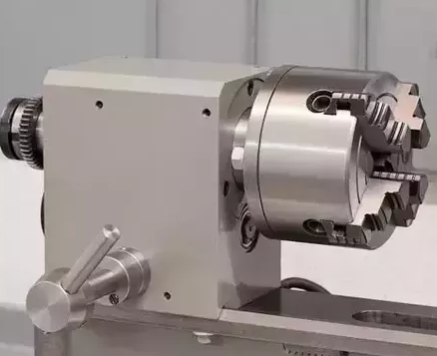

Figure 2.2.3: A Headstock
Source: (Ehsan Pourali, 2020)

2.4.4. Tool Rest
The tool rest provides an edge onto which to reference the turning tool. The toll rest assembly has a base which ride on the ways. In a manner such as the tailstock, the tool rest clamps to the ways to keep in one place. The tool rest based has a means of holding a vertical shaft and enabling it to be adjusted up and down. The tool rest itself is made up of the vertical shaft and a horizontal bar or some other resting edge. The tool rest is moved often while turning almost any object, so easy adjustment is critical. Most modern lathes have a cam locking device, which allows for easy movement and lock down of the tool rest. Size of the tool rest varies.

(diagram 0f tool rest here)

Figure 2.5: A Tool Rest
2.4.5 Tailstock
The tailstock is located on the opposite end of the headstock (the right side). It can be moved along the ways from touching the headstock to the far end of the lathe. It supports one end of the work when machining between centers, support work pieces held in the tool rest. The tailstock is mounted on the bed and is designed to be camped at any point along the bed. It has a spindle that is operated by a hand wheel and clamped in position by means of a clamp. The tailstocks can be adjusted toward or away from the operator by sliding it along the bed to accommodate different lengths of workpiece between the centers.

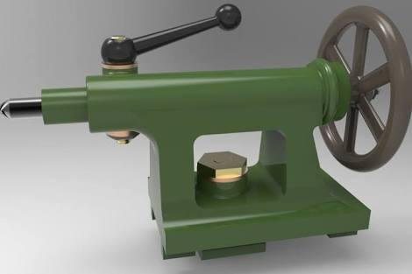

Figure 2.2.3: Tailstock

2.4.5.1 Tailstock Quill
The tailstock has an adjustable quill which provides a means to attach centers which fix the right end of some work pieces, keeping them from moving longitudinally, thus holding them between the headstock mounting and the tailstock. The fixing means are called centers. A dead center is just a point which fits into an indentation in the end of the work piece. A live center is a similar device but with a bearing, enabling the center tom turn the work piece. Thus, eliminating the friction developed by the dead center.
Mounting Mechanism
There are two basic mounting means for any lathe – between the centers and face work.

Between Centers.
Mounting between centers means that the work piece is held to the headstock by bringing the tailstock up to fix it between them. This can be for any piece from a spindle to a large piece of wood intended, for example, to be turned for a bowl.
Face Mounting
In this process the work piece is attached to headstock alone. This can be done by use of anything from a spindle faceplate and screws to elaborate chucks

Materials
There are many different types of materials that can be used on a lathe. Anything from metals like aluminum, steel, and titanium to plastics, wax, and Delrin can be used on a lathe. The different materials used must be within the size limitations of the machine (8" diameter, 42" length). The material used also affects aspects of manufacturing, like the speed of rotation, time used to produce the lathe, the cost etc. All of this must be considered while deciding on the best material to use

Design Consideration
One of the most important factors considered before the start of this design is failure. A machine parts fails whenever it does not function the way it was designed to function or does not perform it’s required function. It is therefore important that proper selection of material for fabrication of a machine in engineering is the most important aspect to be considered before and during design. Materials selection is the core of engineering design are selected on the bases of putting machinability, cost, and all other physical and mechanical properties of the material into consideration. The following should be considered for materials selection when designing, so as to obtain high efficiency and reliability of the machine.
- Material Availability
- Ease of machinability
- Environmental consideration
- Materials should be easily machined
- Cost effective
- Chemical and mechanical properties of the material
S/N | Components | Function | Materials | Reasons for Selection
 | Headstock | It houses the spindle (on a lathe, the spindle holds a chunk which holds and rotates the work piece) | Mild Steel | Durability High Strength
 | Tool Rest | It supports one end of the work when machining between centers | Angle bar mild steel | Durability High Strength
 | Tailstock | It provides a support the free end of work during operation. | Cast Iron | High Strength Better wear resistance Easy Machinability
 | Shaft | It transfers torque and motion from the pulley to turn the headstock | Cast Iron | High strength better wear resistance easy Machinability
 | Flange Bearing | Put the bearing into position | Cast Iron | Firm support better wear resistance
 | Pulley | It transmits the torque from the electric motor to the Shaft | Cast Iron | Low cost
 | Stand | It allows the body to rest on firmly and absorbed vibration | Angle bar mild steel | Durability high strength
 | Bearing | To allow free movement of the live center | Cast Iron | Low cost
 | V-Belt | To transmit the torque from the electric motor to the pulley | V-belt 25mm IS-2494-1974 Leather | Suitability for the working condition in service
 | Metal Sheet | It is used to protect the headstock | 1mm mild steel | High strength
 | Electric motor | To generate a torque for the  System | 2hp

3.2 Belt Design
The belts is used to transmit power from one shaft to another by means of pulleys which rotate at the same speed or at different speeds (Khurmi & Gupta, 2005). According to (Khurmi & Gupta, 2005) the amount of power transmitted by a belt depends upon the following factors:
- The velocity of the belt.
- The tension under which the belt is placed on the pulleys.
- The arc of contact between the belt and the smaller pulley.
- The conditions under which the belt is used.
A belt can also be defined as a loop of flexible material used to link two or more rotating shafts mechanically. Belts are frequently necessary to reduce the higher rotational speeds of the electric motor to lower values required by mechanical equipment (Spotts, 1995). A V-belt is selected for this design.
According to (Khurmi & Gupta, 2005) the V-belts are made of fabric and cords molded in rubber and covered with fabric and rubber. These belts are formed to a trapezoidal shape and are made endless. These are particularly suitable for short drives. The included angle for the V-belt is usually from 30° to 40°.
V-belt is selected for use because of the following
- Efficient means of transmitting power from one pulley to another
- For low cost
- Easy installation and removal
- Do not require axial alignment
- Operation of the belt is quiet
- V-belt has the ability to cushion shock when the lathe is started
- The drive of the smooth, since the belt are made endlessly and there is no joint trouble.

DESIGN CONSIDERATION
With reference to some standard values recorded by (Khurmi & Gupta, 2005), the following assumptions were made.
- Allowable tensile stress in belt, a = 2.8MPa = 2.8N/mm²
- Coefficient of friction between belt and pulley (u)=0.25
- Maximum permissible stress in the shaft, T_{max} = 42N/mm²
- Required speed of belt, V=6.7m/s = 400m/min
Length of Belt Required
The length of the belt is given by;

Where:
L = the length of belt
D = diameter of motor pulley
d = diameter of the spindle pulley
Y = distance between the two pulleys

=1474.2mm
Hence standard grade A V-belt designated A 62, 1636 is selected.
Power Transmitted Per Belt
According to (Banga, et al, 2004), the power transmitted per belt is given as the product of the belt velocity and the effective pull applied at the rim of the pulley. It is expressed mathematically as:

Where:
P = power transmitted
T₁ = tension in the belt tight side
T₂ = tension in the belt slack side
V = velocity of belt
For a wood working lathe the belt drive operates at a speed range of 1 to 10m/s (Khurmi and Gupta, 2008), with a spindle speed ranging from 1200 to 36000rpm.
But weight per meter length of belt
W =1.06N/M
Mass per length, m = 0.11kg/m

Centrifugal tension:

Where:
= the centrifugal tension
M = mass per length
V = required speed of belt
therefore;
= 0.11 X 8²
= 7.04N
Maximum tension in the belt:
With reference to some standards values recorded by (Khurmi and Gupta, 2005) the following assumptions were made;
- Allowable tensile stress in belt, a = 2.81MPa= 2.8N/mm²

= 2.8 x 83.25
= 233.1N
Hence, in the belt tight side:

=233.1-7.04
= 226.06N
According to (Erik et al, 200), the lap angle (Ѳ) is given as

Where:
D = diameter of driven pulley
D = diameter of driving pulley
Y = distance between centers of pulleys
= are of control (lap angle)

= 176.04º
E | 30-350 500 38 23

From table 3.2 above and a motor rating from 2.0kw, the suitable choice is class A. for the pitch length: the standard for class A according to IS standard are in table 3.3.
Type of belt | Standard pitch length of V-belt (mm)
A | 645, 969, 747, 848, 925, 1001, 1026, 1051, 1102, 1128, 1204, 1255, 1331  1344, 1458, 1509, 1560, 1636, 1661, 1687, 1763, 1814, 1941, 2017, 2068  2093, 2195, 2322, 2474, 2703, 2880, 3084, 3287, 3693.

Shaft
A shaft is a rotating machine element which is used to transmit power from one part of a machine to another. The power is delivered to the shaft by some tangential force and the resultant torque (or twisting moment) set up within the shaft permits the power to be transferred to various machines linked up to the shaft. In order to transfer the power from one shaft to another, the various members such as pulleys, gears etc., are mounted on it. The various members are mounted on the shaft by means of keys or splines. (Khurmi & Gupta, 2005)
According to (Redford, 1987) there two main types of shaft;
- transmission shaft: Transmission shaft are used to transmit power between the source and the machine using power Such shaft carrying machine parts such as gears and pulley and therefore are subjected to bending the twisting.
- machine shaft: this shaft is a main part of the machine; a typical example is the crank shaft.
The design of this wood lathe machine is such that the shaft receives power from the electric motor by a V-belt with the aid of a pulley.

Shaft Speed and Motor Speed
- Shaft speed (N₁): According Khurmi & Gupta, 2005 the shaft speed is calculated by the formula:

=
= 1060 rpm.
- Motor speed (N₂): According Khurmi & Gupta, 2005 the speed of the motor is gotten from the formula:
=

= 1591 rpm.

The Power Required
The power required by the wood lathe to perform the turning operation is a function of the weight of the different component that is to be driven by the electric motor. A wood is fixed to the lathe shaft on which two pulley are attached. In order to avoid failure of the lathe. A power that will able to overcome the weight of the wood shaft and pulley is required. For the purpose of this work, a squired induction motor is selected. The power rating of an electric motor is the product of its torque and rotational speed. According to (Woodbury, 1986), the required power of the motor for a machine tool using belt drive is given as:
Power_{(req)} = Power transmitted by belt x machine service factor (3.11)
P_{(req)} = P x K
= 1.4 x 1.3
= 1.82kw
= 1820w
= 2.0 Horse power
Torque =
=
=P
=
=
=
= 10.92NM
The implies that the motor have a capacity of 2hp and can rotate at 1591rpm given a torque of 10.92NM
Where service factor for a machine tool is 2.0

Least Permissible Shaft Diameter
The minimum diameter of shaft that can withstand torsion and bending effect is given as in equation.
d = (( M² +_{T}²)^{1/3} (3.13)
But

Torque transmitted by the shaft:
T = (T₁ – T₂) R (3.14)
= (226.06 – 16.6) 65
= 13614.9 Nmm
Vertical weight on the pulley:
w =T₁ +T₂ (3.15)
=226.06 +16.6
= 242.66N (3.16)
Bending moment:
M=Wx X
= 242.66 x 150
= 36399Nmm (3.17)
Substituting T equation 3.13 and M 3.15 in equation
d = ( (M² +T²)^{1/3}
d = ( (36399² + 13614,9²) ^{1/}3
= 4469.89mm

Key Design
This is a demountable machinery part, which when assembled into keysets, provides a positive means for transmitting torque between a shaft and a hub or bushing. In order to lock a hub or bushing and shaft together, and prevent the shaft from rotating in the bore, a key is commonly inserted into a keyway that is machined in both the bore and shaft. The key is responsible for preventing rotation between the shaft and the bore, and carries a portion of the torque load. Improperly fitted keys and keyways – either too tight or too loose- can result in mechanical failures. Different types of keys are available, the choice of which is dependent on power requirement, stability of connected, tightness of fit, and cost. For a light transmission, a screw thread may be employed. But for this work a flat key was adopted.
Therefore, to ensure appropriate fit, the width and height dimensions of standard key and keyways must be held to recommended tolerances. Industry standard for key sizes in various bores exist for both English and Metric systems. A common standard available from the Mechanical Power Transmission Association is MPTA –B1-2003.

Metric Standard Parallel Keyway and Key Sizes
Keyway (mm) |  | Key (mm)
From | To | Width (W) | Depth (h) | Width (W) | Depth (T)
6 | 8 | 2 | 1.0 | 2 | 2
9 | 12 | 3 | 1.4 | 3 | 3
11 | 17 | 4 | 1.8 | 4 | 4
13 | 22 | 5 | 2.3 | 5 | 5
18 | 30 | 6 | 2.8 | 6 | 6
23 | 38 | 8 | 3.3 | 8 | 7
31 | 44 | 10 | 3.3 | 10 | 8
39 | 50 | 12 | 3.3 | 12 | 8
45 | 58 | 14 | 3.8 | 14 | 9
51 | 65 | 16 | 4.3 | 16 | 10
59 | 75 | 18 | 4.4 | 18 | 11
66 | 86 | 20 | 4.9 | 20 | 12
76 | 96 | 22 | 5.4 | 22 | 14
86 | 110 | 25 | 5.4 | 25 | 14
96 | 130 | 28 | 6.4 | 28 | 16
111 | 150 | 32 | 7.4 | 32 | 18
131 | 170 | 36 | 8.4 | 36 | 20
151 | 200 | 40 | 9.4 | 40 | 22
171 | 230 | 45 | 10.4 | 45 | 25
201 | 260 | 50 | 11.4 | 50 | 28
231 | 290 | 56 | 12.4 | 56 | 32
261 | 330 | 63 | 12.4 | 63 | 32
291 | 280 | 70 | 14.4 | 70 | 36
331 | 440 | 80 | 15.4 | 80 | 40
281 | 500 | 90 | 17.4 | 90 | 45

s

Table 3.4: Standard Metric Keyway and Key Dimensions (Khuni and Guptta, 2005)

Fabrication of Wood Lathe Machine
Fabrication can be defined as the building of metal structures by assembling, bending and cutting processes. The fabrication of wood lathe machine was done in the central workshop of the Department of Mechanical and mechatronics Engineering, college of engineering, Afe Babalola University Ado-Ekiti, Ekiti State. Nigeria.

Fabrication Operations
The operation involved in the fabrication of wood lathe machine include;
- Cutting
- Grinding
- Welding
- Drilling
- Rolling
- Lathe machine
- Guillotine machine

Cutting
This is done by using various kind of cutting tools such as the milling machine, lathe machine are saw, power are saw and clamping the materials on a vice. The work is held on the table and moved against the power are saw to perform the quick and automatic sawing operation. And also used to remove unwanted materials to produce a desired shape, size.

Grinding
The operation is performed to give a surface finish to the work piece and reduce stress build up resulting from surface imperfection from various machining operation.

Welding
Along with cutting, welding is one commonly used metal fabrication processes among craft men. It is a process for joining two separate similar or dissimilar metals part. It joins different metals/alloys, with or without the application of pressure and with or without the use of filler metal. A weld can be achieved through the application of heat along the points where the pieces of metal are to be joined. In the fabrication of a wood lathe machine an electric arc welding machine was used.
Electric Arc Welding
The work piece is prepared for welding. In this the filler metal is supplied by metal welding of electrode which ranges from gauge 10 or gauge 12 based on the thickness of the metal to be welded. The tongue hold the electrode, the material to be welded is earthed such that as the griped electrode strikes the papered work piece the electrode melts and from a molten substance between.
Rolling Machine
This is a technique of metal working whereby metal sheets are folded, repeatedly forged and annealed and unfolded. This operation is done by roller b, it forms predetermined bends by clamping the work piece between a matching die.

Equipment and Tools Used.
The following tools and equipment were used in the workshop to carryout the machining process:

Lathe Machine
This is used to remove metal from a job to give it the required shape and size of the shaft. The job is securely and rigidly held in the chuck or in between centers on the lathe machine and then turn it against a single point cutting tool which will remove metal from the job in the form of chips. (Rajender, 2005).
Milling Machine.
This is used to removes metal and develop a key way as the work is fed against a rotating multipoint cutter. The milling cutter rotates at high speed and it removes metal at a very fast rate with the help of multiple cutting edges. It was also used for machining external and internal threads.
Arc Saw
Single face cutting tools used to cut already marked cut metal sheet, angle iron and shafts into required sizes needed.
Other tools and equipment used:
- Grinding machine: This is a machine for used material removal with geometrically non-defined, bonded cutting edges, where the relative movement between tool and workpiece is rotational or linear.
- Vernier caliper: A Vernier Caliper is a visual aid to take an accurate measurement reading between two graduation markings on a linear scale by using mechanical interpolation, thereby reducing measurement uncertainty by using Vernier acuity to reduce human estimation error
- Tape rule: A tape measure or measuring tape is a flexible ruler used to measure size or distance
- Chisel: chisel is a tool with a characteristically shaped cutting edge of blade on its end, used for cutting a hard material such as wood, stone, or metal by hand, struck with a mallet, or mechanical power.
- Sand paper
- File: A file is a tool used to remove fine amounts of material from a workpiece.
- Drilling machine: A drilling machine, called a drill press, is used to cut holes into or through metal, wood, or other materials

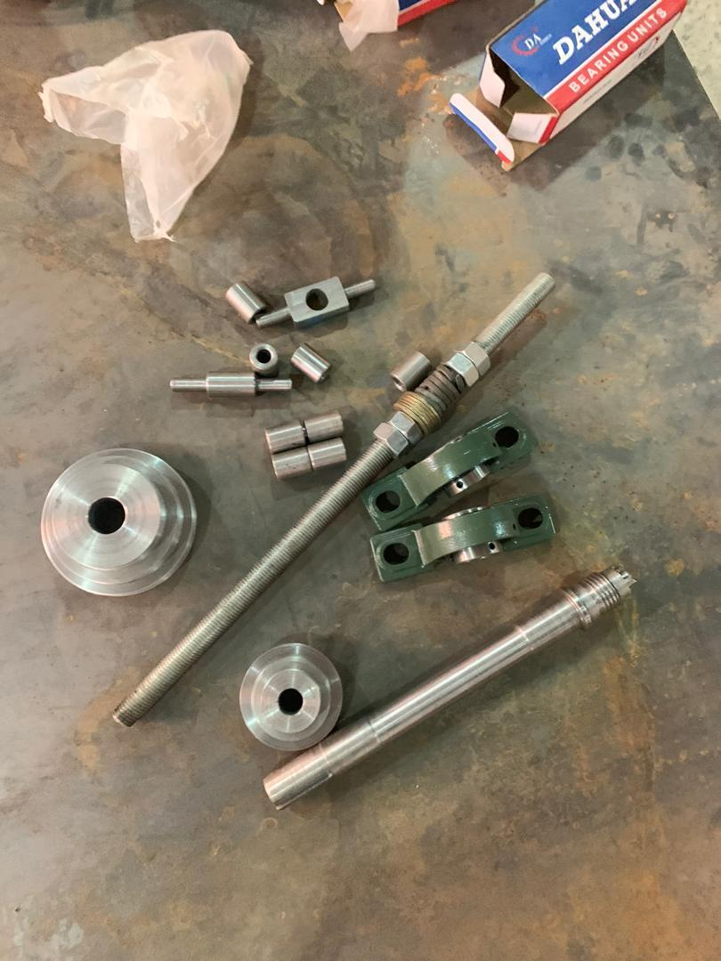Figure 3.1: Components of head stock before assembly
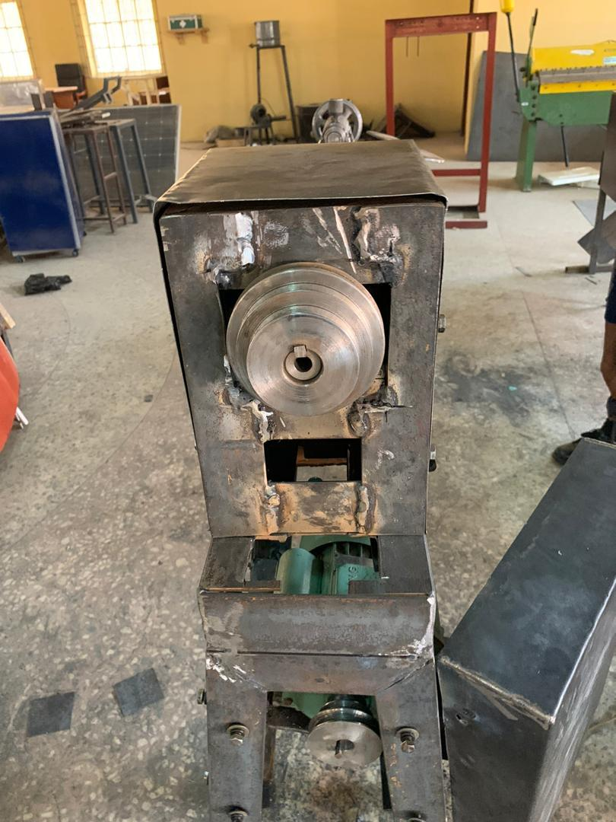

Figure 3.2: Components of head stock after assembly

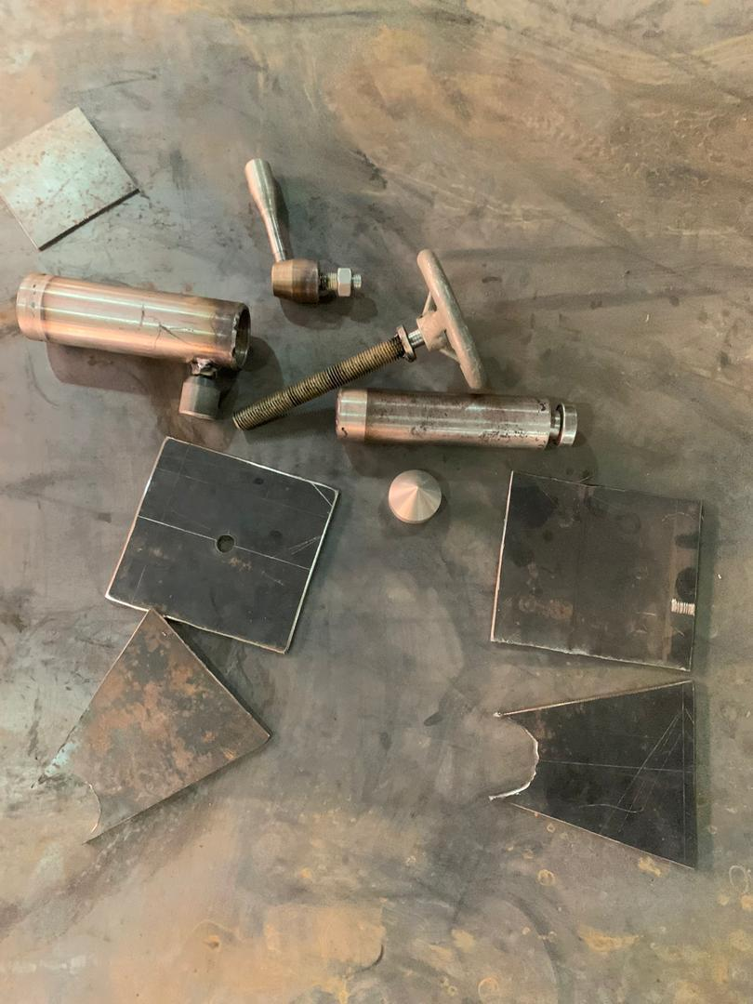
Figure 3.3: Components of tail stock before assembly
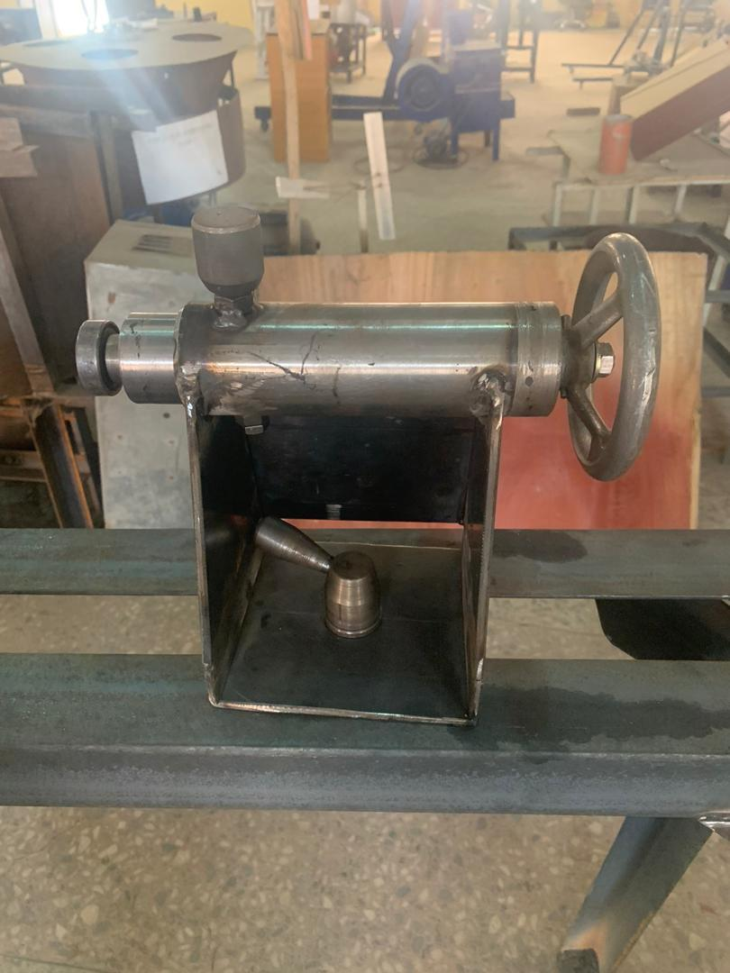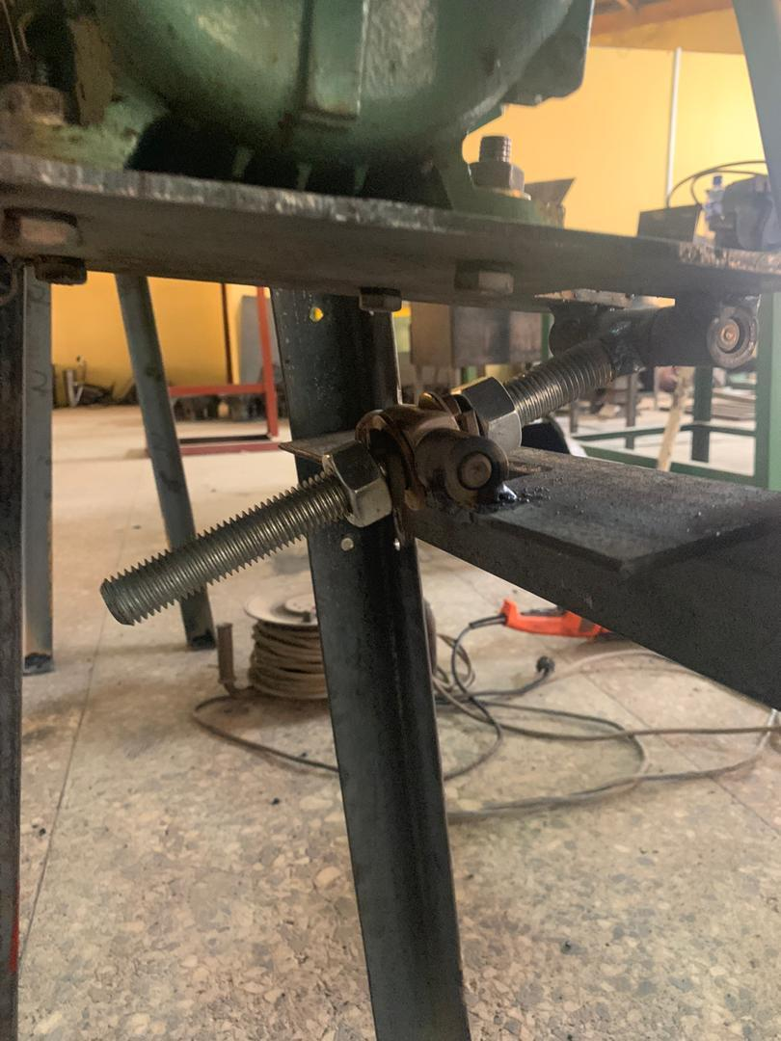Figure 3.5: Tensioning system
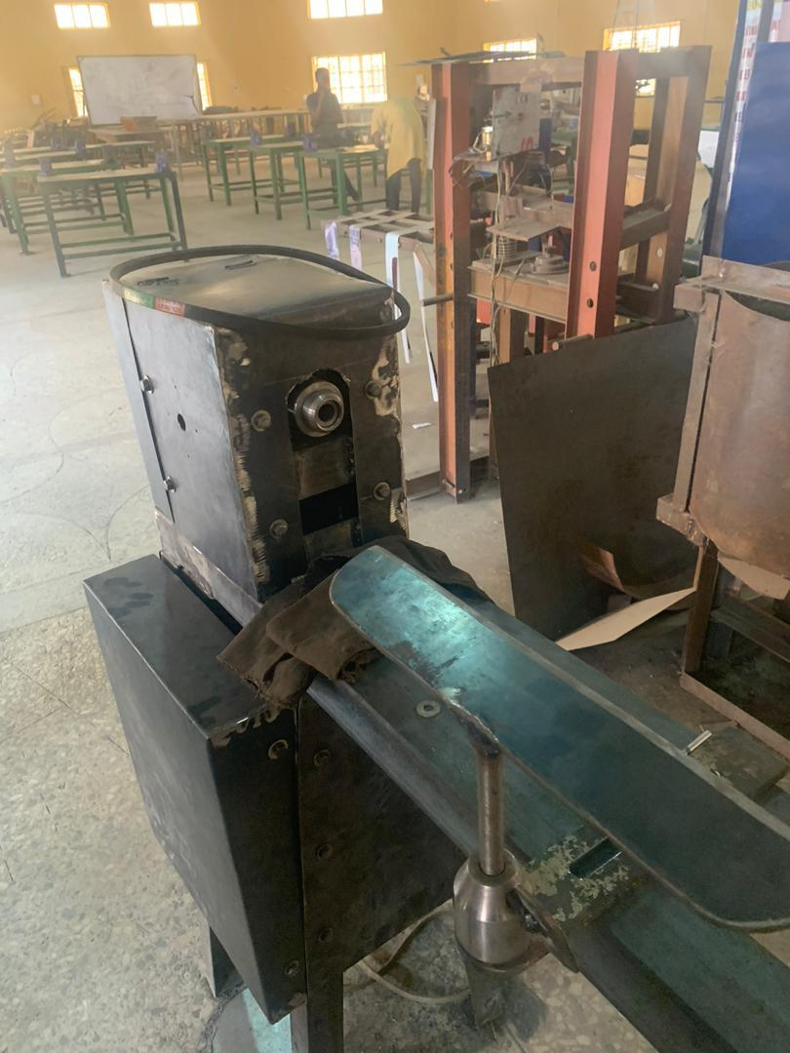Figure 3.6: Tool rest
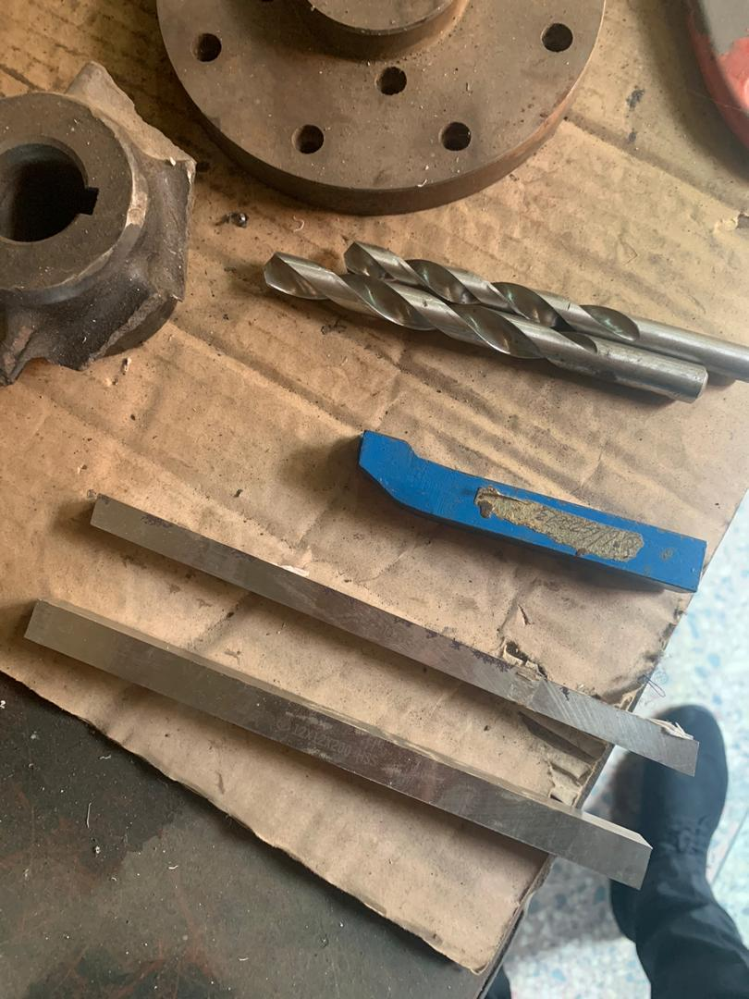Figure 3.7: Hss tool, carbide turning tool and drill bit

Bill of Engineering Measurement and Evaluation (BEME)
This is a tool used before starting a work to give an estimate cost of the work and to show how reliable the project would be. It contains the materials, quantity and price of the material. BEME does not show the total cost of the project, only gives an estimate.

Table 3.8: Bill of Engineering Measurement and Evaluation
1 | Materials | Parts | Quantity | Rate | Processing | Amount
2 | Angle Iron 3"x3" 6mm thick | Frame | 2 | 9000 |  | 18000
3 | Angle Iron 2"x2" 6mm thick | Frame | 1 | 6500 |  | 6500
4 | Mild steel plate 6mmX500mm x500mm | Frame | 1 | 30000 |  | 30000
5 | Mild steel diameter 30 x400mm | Spindle Shaft | 1 | 3000 | 15000 | 18000
6 | Mild steel diameter 25x300mm | Tail stock Shaft | 1 | 2000 | 6500 | 8500
7 | Mild steel diameter 25x350mm | Electric motor base hinge | 1 | 2500 | 3000 | 5500
8 | Mild steel hollow diameter 60x250x5mm | Tail stock barrel | 1 | 5500 | 7500 | 13000
9 | Hand wheel diameter 120mm | Tail stock handle | 1 | 1500 | 1000 | 2500
10 | Pillow bearing diameter 25mm | Bearing | 2 | 4000 |  | 8000
11 | Mild steel diameter120x200mm | big step pulley | 1 | 15000 | 9500 | 24500
12 | Mild steel diameter 70x150mm | small step pulley | 1 | 3000 | 5500 | 8500
13 | Sheet metal 1mmx600x200mm | Frame | 1 | 18000 |  | 18000
14 | Mild steel bar 60x200mm | Revolving centre | 1 | 3500 | 2500 | 6000
15 | Mild steel bar 50x100mm | Dead centre | 1 | 2000 | 2000 | 4000
16 | Mild steel bar 25x400mm | lock, hand for tail stock | 1 | 3000 | 1500 | 4500
17 | Mild steel bar 50x400mm | Lock base for tail stock | 1 | 4000 | 2500 | 6000
18 | Mild steel plate10x100x300mm | Crest base slider | 1 | 12000 | 2500 | 14500
19 | Electric motor 2hp | Power | 1 | 50000 |  | 50000
20 | V belt | Transmission | 1 | 1500 |  | 1500
21 | M10 bolts and nut, flat washer and spring | Fastner | 1 dozen each | 1300 |  | 1300
22 | M8 bolts and nut, flat washer and spring | Fastner | 1 dozen each | 1000 |  | 1000
23 | M12 bolts and nut, flat washer and spring | Fastner | 1 dozen each | 1500 |  | 1500
24 | M24x50 bolts and nut, flat washer and spring | Fastner | 1 dozen each | 3000 |  | 3000
25 | electrode |  | 1pack | 5000 |  | 5000
26 | cutting disc |  | 4 pieces | 500 |  | 2000
27 | grinding disc |  | 3pieces | 1000 |  | 3000
28 | hack saw blade |  | 3pieces | 1000 |  | 3000
29 | paint red oxide | Paint | 1litre | 1500 |  | 1500
30 | paint blue | Paint | 1litre | 1500 |  | 1500
31 | tinner | Paint | 1litre | 1500 |  | 1500
32 | paint brush |  | 2 pieces | 500 |  | 1000
33 | Transport |  |  |  |  | 30000
 | TOTAL |  |  |  |  | 302800

RESULT AND DISCUSSION
This chapter includes the analysis of data and observed results generated from the Autodesk inventor software, the performance evaluation and discussion of results of the wood lathe machine.
Result
Load Carrying Capacity and Stability of the Machine Bed
In the design specification;
Length of bed, L = 1500mm
Width of bed, b = 210mm
Inclination of table’s leg, 0=85º
Modulus of elasticity of steel, E – 210 GN/m²
Strain developed, E= 0.25mm
Factor of safety for steady load FOS =2
The ultimate stress developed in the machine table is estimated using the relations
Stress = strain x modulus of elasticity (4.1)
And stress = (4.2)
Substituting required values into the equation, we have ultimate stress
a_{out} = 2.5 x 10⁻¹ x 201
= 5.25 x 10⁻² GN/m²
Total estimate the safe working stress we have
Working stress a_{w} = (4.3)
= =
=
= 2.6 x 10⁻²GN/m²
Again, since the table is inclined at a given angle with the floor then, the working stress can be expressed as:
Working stress aw = (4.4)
α_{w} =
P_{r} = α_{w} x A = α_{w x L x b}
= 2.6 x 10⁻² x 1.50 x 0.21
= 81.9MN
Hence the machine can carry an estimated load of 81.9MN. But at each application of load, the horizontal component of the Load (P_{h}) is:
Ph = Pr cos 85^{O} (4.5)
= 81.9 x cos 85º
= 7.14MN
The percentage of horizontal force:
= x 100
= 8.72%
Specification of the Machine
The specification of the machine is as follows:
- Maximum diameter of work that can rotate between the centers, D = 50mm
- Height of the centers above the top of the bed, H=230mm
- Maximum length of work that can be accommodated between the centers, L=900mm
- Width of ht e bed, W =210mm
- Height of the headstock = 410mm
- Height of the machine table, H = 900mm
- Height of the machine, H = 1200 mm
- Diameter of driving pulley, D = 80mm
- Diameter of driven pulley, d = 120mm
- Distance between centers of the two pulley, Y = 540mm
Table 4.1: Computations
Quantity Formula Value Unit
Length of belt L = 1474.2 mm
2y
Power transmitted by belt, p (T₁ – T₂) v 14 Kw
Centrifugal tension, T_{c} Mv² 7.04 N

Maximum tension in the belt, T a x A 233.1 N
Tension in the belt slack side, T₂ 16.6 N

Speed of shaft, N₁ 1060 rpm

Speed of motor, N₂ 1591 rpm

Power rating of electric motor, P(req) P x K 2.0 hp

Torque transmitted by the shaft, T (T₁ – T₂) R 13614.9 Nmm

Vertical weight on the pulley, w T₁ – T₂ 242.66 N

Bending moment, M w x X 36399 Nmm
Permissible shaft diameter, d (( M² +_{T}²)^{1/3} 4469.89 mm
Working stress, αw αw 2.6 x 10⁻² GN/m²
Resultant load on bed, Pr αw x L x b 81.9 MN

Discussion of Results
The model of the machine was tasted and simulation was carried out in dynamic simulation environment of the Autodesk Inventor Software. The shafts are made of steel with the required properties. Other components were appropriately computed and calculated and they all indicate design compliance.
Wood lathe machine was fabricated based on engineering approach with the aid of software computer aided design and values, the performance and efficiency of the machine is a benchmarked against the commercially available wood lathe machines. The wood lathe machine was tested to determine the extent to which the design specification and the overall performance goals of the machine were achieved. This was done at the College of Engineering central workshop. The test of the result confirmed the performance of the machine. The electric motor rotated the headstock spindle with the aid of the V- belt ad pulley with the speed range of 1591 rpm and the headstock spindle rotated the wood mounted between the headstock and the tailstock centers of 480mm to create the desired shape.

