**MEE 510**

**PRODUCT DESIGN ASSIGNMENT**

**THERMOCATALYIC DEGRADATION OF RUBBERIZED WASTE**

**BY**

**AWURUM CHARLES**

**15/ENG06/015**

Rubber is an example of waste material but this waste material can be converted into a valuable source of energy production. By the process of converting waste materials into useful products to be used effectively, it can reduce the net cost of waste collection, sorting and reprocessing (Mabood et al.,2010).

Since most of the rubber materials are thrown away after being used it has contributed in the accretion of rubber solid wastes in the earth. Rubber is a non-biodegradable material so it takes a very long time to decompose and they create a problem for the society.

In industrialized countries, rubber products are everywhere to be found, though few people recognize rubber in all of its applications. Rubber materials have presently found wide applications and acceptance in the production of domestic household utensils, in automobile parts industry and several other manufacturing processes (UNEP ,2010). Rubber wastes causes localized flooding by clogging municipal drainage systems and constitute a significant portion of floating anthropogenic marine debris (Howell,2012).

About 242 million tyres are discarded every year in the United States alone. Less than 7 percent are recycled. 11 percent are incinerated for their fuel value and another 5 percent are exported. The remaining 78 percent are either landfilled, or are illegally dumped. According to a recent report of the US Environmental Protection Agency (U.S EPA), this has resulted in a national stockpile of over 2 billion waste tyres. (Biocyle,1992).

Runaway rubber wastes continue to be a huge hazard on the surface and surface water such as waterways, seas and oceans making it unsafe for both animals and humans (Pinto,1999). Despite the implementation of various policies like clean environment, developed technologies and waste reduction, it is not likely that the volumes of rubber waste will decline. From the perspective of catalyst, chemical recycling of rubber waste is the best for rubber waste recovery techniques. (Yla-Mella, 2005).

**3.1.1. Pyrolysis batch reactor**

The thermo chemical conversions of discarded plastic to crude plastic oil were conducted using a stainless-steel pyrolysis batch reactor. The system contains a 30 L reactor, connected to a condenser unit via a pipe, which is obliquely projected from the centre of the cover of the reactor

**3.1.2. Fourier Transform Infrared Spectrophotometer FTIR**

A FT-IR spectrometer (Infrared spectrometer Varian 660 MidIR Dual MCT/DTGS Bundle with ATR) Spectrum-100, employed for analytical purposes. FTIR program set up are elaborated, before sample run, visible light range were 400 - 4000 cm-1, taken scan number is 17 and resolution number is 4

**3.1.3. Gas chromatography-mass spectrometry (GC-MS)**

GC-MS Varian 3800/4000 Gas chromatography-mass spectrometry (GC-MS) has been the technique most widely used in the analyses of the component.

**3.2. Layout of Rubbers Pyrolysis**

A laboratory scale externally heated fixed bed pyrolysis batch reactor was used for production of oil from plastic. Figure 3.1 shows the schematic diagram of plastic pyrolysis setup. Basic instruments of the pyrolysis chamber are temperature controller, condenser, temperature sensor, a heating coil, insulator, storage tank, valve, and gas exit line. The effective length and diameter of the stainless steel made reactor are 38cm and 15cm, respectively. The reactor with tire was heated electrically up to 475∘C with NiCr wire electric heater. Here it is necessary to mention that the sensor was used through the wall of the stainless-steel pyrolysis chamber to measure the temperature. Therefore, the temperature mention may have appeared small in amount as compared to conventional system. Besides, a nitrogen hole was used in the pyrolysis chamber to provide uniform heating across the cross-section of the reactor chamber and to create inert environment in the pyrolysis chamber. There was no output at low temperature range and the process was carried out between the temperature ranges of 330∘C and 490 ∘C in the reactor for about two hours and forty minutes. The vapor products of pyrolysis were carried out through two condensers. The condensers were cooled by water and the condensed bio-oil was collected into two collectors. The non-condensed gas was flared to the atmosphere and the char was collected from the reactor after completion of pyrolysis cycle.

Fig 3.1. Schematic diagrams of pyrolysis plant.

Figure 3.1 shows a scheme of the rubber pyrolysis where this work was developed. The recycling cycle was composed by a sector rubber reception, followed by a sector for storage while pre-heating them at 100–110◦C. All processing conditions were based on Chaala et al. (Chaala et al. 1996) and Roy et al. (Roy et al. 1990). The heat was generated by a furnace that ﬁres fuel oils. Rubber samples were loaded into the reactor for putting the samples in contact with internal heat. Gaseous products from the reactor were condensed in a distillation tower for separation of gas, light oil, heavy oil, and crude oil, which are used as fuel, polymers and asphalt components. The solid products from reactor were cooled in a heat exchanger, after which a magnetic separation to remove metal was applied. Afterwards, they were crushed in a milling machine and mashed to obtain carbon black, which is sold to dyeing companies. However, to obtain the experimental data, a scale up of the reactor was fed with a mass ﬂow of 25 kg/h of rubbers at 600±50 ◦C and 20 kPa. The reactor temperature was monitored on line by an internal thermostat. Samples were collected periodically for monitoring the pyrolysis of rubbers.

**3.3. Experimental setup**

Discarded rubbers wastes were collected and sorted by handpicking municipal waste dumps and street litters across Ado Ekiti, Ekiti State, Nigeria. The rubbers were cleaned by soaking for about an hour in water, using detergent. They were thoroughly washed, sun dried for about five hours and shredded. The dried shredded rubbers wastes were weighed (ranges from 400 grams to 3kg) and charged into the batch reactor without a catalyst. The reactor was covered using gaskets and sealed with the aid of, gasket seal to avoid leakage. The reactor was then placed on an LPG gas burner and was connected to the condenser and separating system. A thermocouple was then placed in the reactor and heated gas burner while the temperature was maintained between 170-300°C starting at 170 to 300°C with an increment of 5 to 10°C in order to make the plastics change gradually. In a typical run, the reactor is heated without oxygen. The gaseous products were cooled in the condenser maintained at 5-15°C. The cooled liquid from the process was called pyrolysis liquid fuel (PLF). The pyrolysis process involves the breakdown of large molecules into smaller molecules. Produced hydrocarbon with a small molecular mass can be separated by fractional distillation and then used as fuel and chemicals. The condensed products were measured and the yield of liquid products was determined by dividing the collected material by the weight of feeding plastics. The schematic diagram of the pyrolysis plant used to the produce pyrolysis liquid fuel (PLF) is shown in Figure 3.1

Mass input power of the input rubbers during the experiments was 30 kg per hour and the time of the material stay in the reactor was 30 minutes in the primary part and 15 minutes in the secondary part of the reactor. Temperatures from 400 °C, 500 °C to 600 °C were selected for the experiments because the gases created within the temperature range from 500 °C to 1200 °C, are stable. It applies to such gasses as H2, CO, CO2 and CH4 which is also stated in the literature (Koppe and Juchelkova, 2011; Staf, 2005; Vymetal and Plesnik, 1994).

Fig. 3.3. pyrolysis plant.

The liquid fuel collected will be undergone for purification process. In this purification process equal proportion of rubbers fuel and water in a container, mixed well and allowed it for 5-7 hours to settle down. Now water along with some crystals is collected at bottom and pure rubbers fuel is collected at the top of the container. After purification pH value of rubbers fuel is measured using pH meter. If the pH is less than 7, the fuel is acidic in nature. This is improved by mixing 100g of KOH with one litter of water and stirred uniformly by using stirrer. Equal proportion of rubbers liquid fuel and dilution of potassium hydroxide in a container and mixed well, allowed it for 2-4 hours to settle down. Now along with dilution of potassium hydroxide some acids are collected at bottom and acid free rubbers liquid fuel is collected at top of the container.

**3.4. Characterization of the liquid fuel**

The liquid product obtained from both the thermal and catalytic pyrolysis at optimum condition (catalyst-to- rubbers ratio 1:3) was characterized for some of its physical properties, namely, density, viscosity, flash point, fire point, calorific value, and pour point according to American Standard for Testing and Materials (ASTM). Fourier Transformed Infrared Spectrometry (FTIR-S) characterization of the oil was also carried out to determine the functional groups present in the oil using A FT-IR spectrometer (Infrared spectrometer Varian 660 MidIR Dual MCT/DTGS machine.

**3.5. Proximate and ultimate analysis of waste rubbers Feed**

Proximate analysis was carried out on the samples to determine the percentage volatile matter content, % ash content, % content of fixed carbon and heating value of the samples. The procedures of ASTM E711-87 (ASTM standard E711-87, 2004).

**3.5.1. Determination of Percentage Moisture Content**

The moisture content (MC) was determined using standard CEN/TS 14774. 3.0 g of pulverized rubber sample sample was oven dried at 105±2◦C until a constant mass was obtained. The change in weight after 3–4 hours was then used to determine the sample’s moisture content expressed in percentage using the formula below;

Percentage Moisture content PMC (%) = Change in weight X 100

Initial weight before drying

**3.5.2. Determination of Percentage Volatile Matter (PVM)**

To determine the Percentage Volatile Matter PVM, 2g of pulverized rubber sample in a crucible were placed in the oven until a constant weight is obtained. The pulverized rubber sample were now kept in the furnace at a temperature of 5500c for 10 minutes and weighed after cooling, this was repeated for other samples. The Percentage Volatile Matter PVM was determined with the formula:

Percentage Volatile Matter PVM (%) = 100 (B – C)/ B

Where B is the weight of oven dried sample and C is the weight of sample after 10min in the furnace at 5500c

**3.5.3. Determination of Percentage Ash Content (PAC)**

The Percentage Ash Content PAC was also determined by heating 2g of the pulverized rubber sample in the furnace at a temperature of 5500c for 4hrs and weighed after cooling. The Percentage Ash Content PAC was determined:

Percentage Ash Content PAC (%) = 100 (D)/ B

Where D is the weight of ash and B is the weight of oven dried sample

**3.5.4. Determination of Percentage Fixed Carbon (PFC)**

The percentage ash content PFC was calculated by subtracting the sum of percentage volatile matter (PVM) and percentage ash content (PAC) from 100

**3.5.5. Determination of Heating Value (Hv)**

This was calculated using the formula: Hv = 2.326 (147.6c +144v)

Where c is the percentage fixed carbon and v is the percentage volatile matter (Bailey et al. 1982)

Ultimate analysis is performed to determine the elemental composition of the material. Ultimate analyses are used to determine the carbon, hydrogen, nitrogen, sulfur, ash, oxygen contents of the material. For the specific applications, other chemical analyses can be employed. These include identifying the forms of sulfur present. Sulfur occurs in the form of sulfide minerals, sulfate minerals, or organically bound sulfur. Other specific cases the analyses may involve determining the trace elements present which influence the suitability of the material for a particular purpose. This may include methods for reducing environmental pollution and so forth.

It was carried out using a CHNSO elemental analyzer (Variael CUBE Germany) which provides carbon, hydrogen, nitrogen, sulphur percentage composition. And when sum of theses compositions is subtracted from 100, it gives oxygen percentage composition

**3.6. Fuel Properties.**

All the fuel properties of the oil were tested by the following methods which are summarized in Table 3.1.

**3.6.1. Determination of Density**

Density of fuel at different temperatures was measured by a standard 25 ml marked flask. Weight of the fixed volume of fuel (25 ml) was measured at different temperatures by an electronic balance which measures up to 0.0001 gm. The density values are reported in kg/m3.

**

Fig. 3.2. Digital weighing balance

**3.6.2. Determination of pH**

The pH of the sample oils was read using a calibrated Oakion® 3520 pH meter (Figure 3.2). The pH meter probe was inserted into the containers holding the respective oils, making sure it did not touch the inside wall of the containers. The pH reading was then taken from the LCD display after it had stabilized.

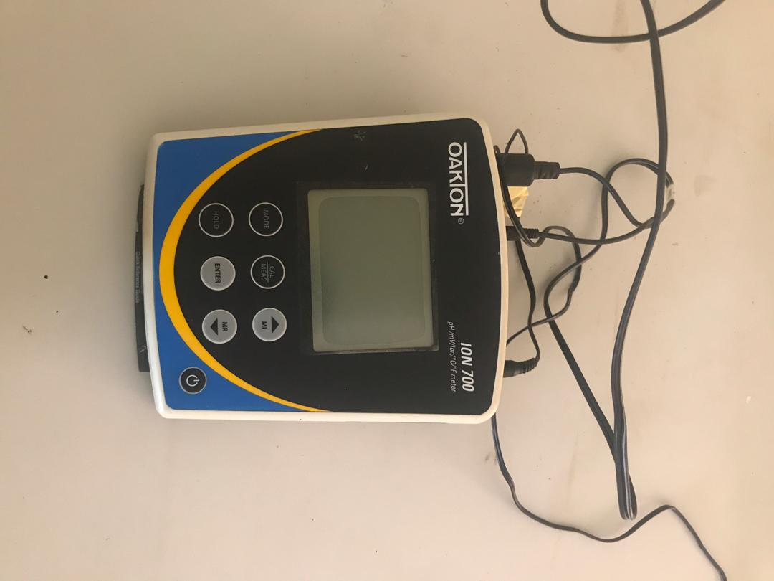

Fig. 3.2. pH meter

**3.6.3. Determination of Calorific Value**

The calorific value of a fuel is the quantity of heat produced by its combustion at constant pressure and under normal conditions. Calorific value determined by using bomb calorimeter.

Procedure:

1. Weight the empty crucible.

2. Take approximately 0.5gm of liquid fuel in a crucible & reweight.

3. Place the crucible in its support and coil a small loop of the nicrome wire between the two conductors and a piece of thread is dipped into the fuel screw the cap firmly on to the body of the bomb and charge with oxygen until a pressure of 25 bar is obtained.

4. Lower the bomb into the calorimeter and connect the firing wire. Pour about 2.25 liters of water into the calorimeter so as to completely cover the bomb, fit a thermometer and stirrer. Press fire button to start the ignition, temperature of water starts to rise, note down the temperature of water for every 10 seconds.

5. Until the transfer of heat from bomb has ceased has indicated by fall in temperature reading.

6. Take down the maximum temperature for the calculation of calorific value by using below relationship.

**3.6.4. Determination of Pour Point**

The specimen is cooled inside a refrigerator to allow the formation of paraffin wax crystals. For every 3°C after, the test-tube is removed and tilted to check for surface movement. When the specimen does not flow when tilted, the test-tube is held horizontally for 5 seconds. If it does not flow, 3°C is added to the corresponding temperature, since this is the last measurement when flow was observed, and the result is the pour point temperature (Dr.Tareq Albahri, 2001-2013).

**3.6.5. Determination of Flash Point**

The cup was filled at any convenient temperature (not more than 560C below the expected flash), so that the top of the meniscus is expected at the filling line. The light test flame would be on and adjusted to 3.2 - 4.8mm. The heat was applied initially to the sample to give a change in temperature of 14 – 170C per minute. When the sample was about 560C below the anticipated flash, the heat source was decreased to the rate of 5 – 60C per minute. Starting with at least 280C below the flash point, the test flame was also applied when the temperature reached each successive 20C mark. The test flame was passed across the center of the cup at right angles to the diameter and not more than 3mm above the upper edge of the cup in one direction. At the time of the next flame application, it was passed in opposite direction. The time taken to pass the test flame across the cup was about 1 sec. The flash point was recorded as the temperature at which an instantaneous flash occurs on application of the flame

**3.6.6. Determination of Fire Point**

Measured rubber liquid fuel is poured up to the mark indicated in the flash point Apparatus. Then the oil is heated and stirred at regular interval. The external fire is introduced at the regular period till flash is observed. Once the flash is observed the temperature is recorded. Recorded temperature at the time of the fire starts to see continuously is the fire point of the plastic liquid fuel.

**3.6.7. Determination of Viscosity**

Viscosity is an important property fuel and it is fluid ‘s resistance to the flow (shear stress) at a given temperature. Fuel viscosity is specified in the standard for diesel fuel within a fairly narrow range. Hydrocarbon fuels in the diesel boiling range easily meet this viscosity requirement. The viscosity range for typical fuels overlaps the diesel fuel range with some fuels having viscosities above the limit. If fuel viscosity is extremely excessive, there will be a degradation of the spray in the cylinder causing poor atomization, contamination of the lubricating oil, and the production of black smoke. Kinematic viscosity takes into account the fluid density and centistokes is the engineering unit used to express the kinematic viscosity.

The viscosity was measured at two different temperatures 40oC and 100oC respectively. At the start a proper viscometer spindle (3) was chosen. The sample was transferred to a beaker large enough to hold the viscometer spindle. The beaker was placed on a heating mantle which was set to a desired temperature, while the temperature of the sample was raised. The temperature of the sample was checked using a thermometer. When the desired temperature reached, the sample was then removed from the heat source and the viscosity was read. The spindle was attached to the upper coupling by holding the coupling between the thumb and forefinger while cautiously rotating the spindle counterclockwise. The knob was set to the minimum speed which includes the centipoise range on of the material that will be tested. The uppermost number on the knob indicates the revolutions per minute (rpm). The spindle was immersed into the sample up to the middle of the identification in the shaft. The viscometer was turned on and allowed to run until a constant reading (usually 5 to 10 revolutions) was attained. The viscosity of the sample was determined using Equation below. The viscosity was reported to two decimal place accuracy for viscosities under 100 and to the nearest whole number for viscosities over 100.

Viscosity = reading obtained x (factor for the spindle speed comb.)

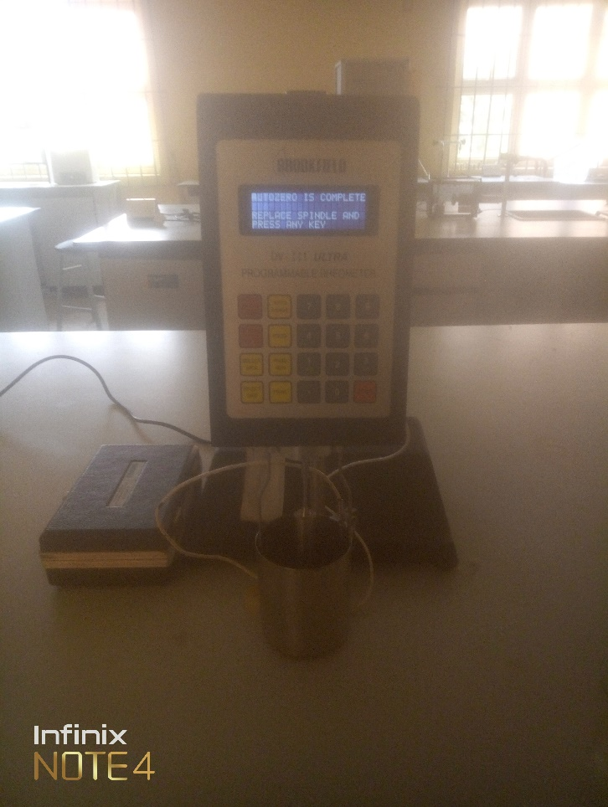

Fig. 3.4. Brookfield programmable rheometer

**3.7. Chemical Analysis of Products**

Characterization of liquid product: The chemical composition was analyzed by gas chromatography coupled with mass spectroscopy (GC-MS), and Fourier transform infrared spectroscopy (FT-IR) and standard methods of the American Society for Testing and Materials (ASTM). The caloriﬁc value was measured by the ASTM D129 method.

**3.7.1. Fourier Transform Infrared Spectrophotometer FTIR**

To record the absorption spectra and their absorbance measurements, a Varian 660 MidIR Dual MCT/DTGS Bundle with ATR spectrometer is used covering wavenumber range 4000 cm−1 to 400 cm−1. Resolution is 4 cm-1 and for each sample three spectra are obtained. They are then averaged to be a mean spectrum, used in subsequent analysis for giving high signal to noise ratio. At the time of measurements, the temperature is kept constant at 20±3°C. Steady-state humidity is maintained in the work place, as the FTIR instrument is sensitive to the changes of external environmental.

Before analysis, the samples were dried in an auto- desiccator for 24 hours. Samples were directly applied to a diamante crystal of ATR and resulting spectra of them were corrected for background air absorbance. Potassium bromide (KBr) disks were prepared from powdered samples mixed with dry KBr in the ratio of 1:100. The spectra were recorded in a transmittance mode from 4000 to 500/400 cm−1 at a resolution of 4 cm. Infrared spectrum was Fourier transformed and recorded in the absorption mode. The refractogram obtained from FT-IR spectroscopy between wave number and absorption is tabulated below. IR solution software is employed for getting the spectrum.

FTIR spectroscopy from the absorption of IR radiation through resonance of non-centro symmetric (IR active) modes of vibration and is a useful tool for quantifying secondary structure in metal nanoparticle–biomolecules interaction

The region of IRradiation helps to identify the functional groups of the active components present in extract based on the peak values of the FTIR spectrum. When the extract was passed into the FTIR, the functional groups of the components were separated based on its peak ratio

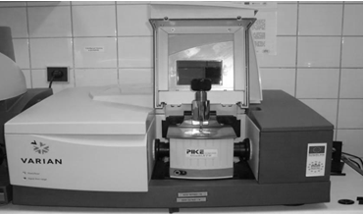

Fig. 3.3**.** Infrared spectrometer Varian 660 MidIR Dual

In a FTIR instrument, the monochromator and the slits are replaced by an interferometer of Michelson type. A beam of radiation is divided into two beams by means of a beam splitter. A path difference between the beams is also introduced whereupon it is allowed to recombine. In this way, interference between the beams is obtained. Intensity of the output beam from the interferometer is monitored as a function of path difference using an appropriate detector.

In order to determine the functional groups, present in the pyrolytic oil, Fourier Transform Infrared spectroscopy of the oil is being analyzed in a Perkin-Elmer infrared spectrometer.

The pyrolysis of waste tire tubes is a complex physicochemical reaction process involving many interlacing reactions, including bond breaking, molecular rearrangement, hydrogen transfer, and various condensation reactions. The reaction mechanism is complicated (Bicas et al; 2008, Kraidman, Mukherjee and Hill, 1969, Cadwalleder, et al; 1989). There are both endothermic and exothermic reactions in the pyrolysis process, and these reactions exhibit different reaction phenomena.

Table 4.1: Testing methods for fuel properties measurements

|  |  |  |
| --- | --- | --- |
| S/n | Properties | Test method |
| 1 | Density | IP 131/57 |
| 2 | Kinematic viscosity | ASTM D 445 |
| 3 | Flash point | ASTM D 93 |
| 4 | Fire point | ASTM D93 |
| 5 | Water content | ASTM D49 |
| 6 | Pour point | ASTM D 97 |
| 7 | Calorific value Bomb calorimeter | 12/58 |
| 8 | Sulphur content | ASTM D 129-00 |
| 9 | Carbon residue | ASTM D 189-65 |
| 10 | Ash content | ASTM D 48 |

Table 4.2: Standard parameters of gasoline, diesel and kerosene oil.

|  |  |  |  |  |
| --- | --- | --- | --- | --- |
| **S/no.** | **Parameters** | **Gasoline** | **Diesel** | **Kerosene** |
| 1 | Density (g/mL) | 0.736/0.725 | 0.834 | 0.780-0.82 |
| 2 | Specific Gravity | 0.70 | 0.85 | 0.78 |
| 3 | API gravity | 65 | 23-30 41.7-39.66 |  |
| 4 | Viscosity (Centipois) | 0.7750-0.8394 | 2.0-4.5 | 0.9-1.5 |
| 5 | Kinematic viscosity (mm2/s) | 5.0 | 3.77 -5.0 | 2.2 |
| 6 | Aniline point oC | 65 | 71 | 62 |
| 7 | Flash point oC | 37.8-38 | 55-60 | 50-55 |
| 8 | Watson characterization constant | 12.45 | 11.28 | 12.126 |
| 9 | Freezing point oC | -58 | -54 | - |
| 10 | Diesel index | 83.44 | 54 | 59.88 |
| 11 | Bromine number | 60 | 1-10 |  |
| 12 | Gross calorific value (MJ/kg) | 45.6 | 43.5-55.7 | 46.5 |
| 13 | Sulfur % | 1ppm | 0.70ppm | 0.9ppm |

Table 4.3: Standard ASTM Distillation parameters of gasoline, diesel and kerosene oil.

|  |  |  |  |  |
| --- | --- | --- | --- | --- |
| **S/no** | **ASTM Distillation** | **Gasoline** | **Diesel** | **Kerosene** |
| **Temp oC** | **Temp oC** | **Temp oC** |
| 0 | Dew point | 49 | 120 | 110 |
| 1 | 10 mL | 69 | 225 | 178 |
| 2 | 20mL | 78 | 238 | 180 |
| 3 | 30mL | 82 | 252 | 180 |
| 4 | 40mL | 86 | 272 | 182 |
| 5 | 50mL | 90 | 281 | 190 |
| 6 | 60mL | 94 | 290 | 192 |
| 7 | 70mL | 98 | 299 | 198 |
| 8 | 80mL | 102 | 300 | 200 |
| 9 | 90mL | 106 | 301 | 210 |
| 10 | 100mL | 112 | 305 | 220 |

Table 4.4: Effect of catalyst on yield and fuel properties of oil

|  |  |  |  |  |  |  |
| --- | --- | --- | --- | --- | --- | --- |
| Catalyst: Rubber ratio (by weight) | Oil yield (wt%) | Calorific value (kJ kg-1) | Density (g cm3) | Viscosity (cP) | Flash point (0C) | Pour point (0C) |
| 0 | 87.14 | 43.590 | 0.8538 | 2.0 | 48 | 21 |
| 1.00 | 87.59 | 44.472 | 0.8572 | 1.3 | 53 | 19 |
| 1.50 | 89.57 | 44.588 | 0.8690 | 1.8 | 55 | 16 |
| 2.00 | 87.62 | 44.745 | 0.8875 | 2.1 | 57 | 15 |
| 2.50 | 88.70 | 44.725 | 0.8972 | 2.0 | 59 | 14 |
| Diesel | - | 46.958 | 0.8750 | 2.4 | 63 | 2 |
| Kerosene | - | 44.216 | 0.7895 | 1.1 | 34 | - |

**4.2. ASTM Distillation**

Hydrocarbon groups generally found in rubber tube derived pyrolytic oil fractions are paraffinic, naphthenic, aromatic and olefinic. The quality and characteristics of rubber tube derived pyrolytic oil mainly depend on the types of compounds in the mixture. Knowledge of the composition of these mixtures is important in the evaluation of the quality of pyrolytic oil. The hydrocarbon groups of the oil derived from catalytic pyrolysis of rubber tube are in the boiling range of 80-217 ºC for using fluid catalytic cracking catalyst. The products are separated into gas, oil, and char residue by pyrolysis of waste rubber at different catalyst concentration are shown in figure 4.5 below;

Table 4.5: Effect of catalyst on product distribution from pyrolysis of used rubber tubes

|  |  |  |  |
| --- | --- | --- | --- |
| **Reaction product, wt% Of catalyst** | **Gas** | **Liquid** | **Char** |
| 0.0 | 20.98 | 17.15 | 61.87 |
| 1.00 | 22.14 | 23.76 | 54.10 |
| 1.50 | 25.06 | 39.54 | 34.40 |
| 2.00 | 26.53 | 38.26 | 35.21 |
| 2.50 | 28.42 | 36.31 | 35.27 |

**4.3. Effect of Temperature on Product Yield.**

About 38.5% of Waste rubber waste was obtained at temperature 330 ∘C as presented in Table 4.6 and Figure 4.1. The oil percentage increased constantly to 76.0% at 425 ∘C. The gases produced through plastic pyrolysis consist principally of hydrogen (H2), carbon dioxide (CO2), carbon monoxide (CO), methane (CH4), ethane (C2H4), and butadiene (C4H6), with trace amounts of propane (CH3CH2CH3), propene (CH3CH=CH2), n-butane (CH3(CH2)2CH3), and other miscellaneous hydrocarbons.

Table 4.6. Effect of temperature on product yield

|  |  |  |  |  |  |
| --- | --- | --- | --- | --- | --- |
| **Temperature (0C)** | **Yield of Waste Rubber oil, Catalyst: Rubber ratio (by weight)** | | | | |
| **0** | **1.00** | **1.5** | **2.00** | **2.50** |
| 300 | - | - | - | - | - |
| 325 | 38.50 | 38.62 | 38.62 | 38.68 | 38.70 |
| 350 | 47.50 | 48.63 | 49.05 | 49.28 | 49.80 |
| 375 | 50.00 | 50.84 | 52.11 | 52.46 | 53.00 |
| 400 | 54.00 | 54.72 | 55.86 | 56.05 | 56.83 |
| 425 | 76.00 | 76.54 | 77.21 | 78.39 | 79.01 |
| 450 | 87.14 | 87.59 | 89.57 | 87.62 | 88.70 |

Table 4.5 indicates the comparison of oil yield with and without catalyst at different catalyst ratio. Presence of catalyst slightly increased the yield of oil as compare to without catalyst at all catalyst ratio. The use of a catalyst enhanced the ability to decompose or crack the polymer, thereby increasing the condensable gas yield and ultimately more liquid product (Lopez, et al; 2011). The advantages of the proposed pyrolysis system re that no char or wax is formed during the process. This is attributed to the acidic nature of the fluid catalytic cracking FCC catalyst, which enabled the decomposition or cracking of waxes to lighter products. In contrast, Jan et al. used CaCO3 as catalyst for the pyrolysis of high-density plastics (HDPE) and found that wax formation occurred (Jan, et al; 2013). Mastral et al. also found that wax formed when undertaking pyrolysis of HDPE with HZSM-5 zeolite as an acidic catalyst (Mastral, et al; 2006). The highly acidic catalyst (low SiO2/Al2O3 ratio) was more active in cracking waxes compared to the less acidic catalyst (high SiO2/Al2O3 ratio) (Sharuddin, et al; 2016).

Plot graph of yield of oil against temperature

Figure 4.1: Effect of temperature on product yield.

After apply catalyst a liquid yield more than 87% was obtained. Lopez et al. used ZSM-5 and red mud as catalyst for the pyrolysis of mixed plastic wastes and found that the maximum liquid yield was 56.9 and 76.2 wt%, respectively (Lopez, et al; 2011). Shah et al. also found that liquid product yields were in the range 62–79% when using ZnO, MgO, CaC2, SiO2, Al2O3 and SiO2–Al2O3 as catalysts in pyrolysis of LDPE (Shah, et al; 2010). The system in this current work can obtain high liquid product with small amount of catalyst (catalyst to rubber waste ratio of 1.50) and at short reaction times (10 min). For example, optimum conditions for pyrolysis of HDPE with CaCO3 are catalyst ratio of 0.2 and reaction time of 1.5 h (Jan, et al; 2013). Panda and Singh also used catalyst ratio of 0.33 with reaction time of 75 min to received highest yield of liquid product around 89.5 wt% by pyrolysis of PP with kaoline (Panda and Singh, 2011). The catalyst ratio of 0.2–0.4 and pyrolysis time of 1–3 h were also used with ZnO, MgO, CaC2, SiO2, Al2O3 and SiO2–Al2O3 as catalysts for the pyrolysis of LDPE (Shah, et al; 2010). The catalyst did increase calorific values of the pyrolysis-oil to levels that were comparable to commercial fuels, diesel. Literature values reported the calorific value of diesel to be between 43 800–48 610 kJ kg-1 (Kumar, et al 2013, Abu-Hamdeh and Alnefaie, 2015). These literature values are in good agreement with the results obtained in this work, which demonstrated calorific values of 44 745 kJ kg-1 for sample with a catalyst: plastic ratio of 1.20 (by weight). The standard calorific value of commercial gasoline is reported as being 45 600 kJ kg-1, this figure is identical to the calorific value for kerosene used in this current study (Shah, et al; 2010). The calorific value of oil obtained from pyrolysis of plastic in this work was comparable to other studies. Panda and Singh who used silica alumina and kaolin as catalysts for the pyrolysis of PP, found that the received oil had calorific value of 47 120 and 47 095 kJ kg-1 respectively (Panda and Singh, 2011). Shah et al. demonstrated that, after using ZnO, MgO, CaC2, SiO2, Al2O3 and SiO2–Al2O3 as pyrolysis catalysts for LDPE, the calorific value of oils was in the range 40 500–45 000 kJ kg-1 (Shah, et al; 2010). This value is comparable when using bentonite (44 121–44 436 kJ kg-1). Kumar et al. who used kaolin as a catalyst for the pyrolysis of HDPE, demonstrated that the resulting oil had a calorific value of 40 170 kJ kg-1 , that is lower than those obtained when using a fluid catalytic cracking FCC catalyst, as demonstrated in this work (44 191– 44 750 kJ kg-1 ) (Kumar, et al 2013). Therefore, high calorific value of the obtained oils in this study by using catalyst showed their potential as alternatives to commercial fuel.

Application of the fluid catalytic cracking FCC catalyst had little significant effect on the density of pyrolysis oil did. The densities of oil from the various samples had higher than that without catalyst, which is close to density of diesel. Abu-Hamdeh and Alnefaie indicated that the density of diesel was 0.848 g cm-3 , and close to the values for pyrolysis oils reported in this current work (0.8750 g cm-3 ) (Abu-Hamdeh and Alnefaie, 2015). In contrast, to other studies that have reported pyrolysis oil densities from HDPE of up to 1.12 g cm-3 (Chen, et al; 2016), the results in this current study demonstrate promise for use in liquid fuel applications (0.8538–0.8972 g cm-3 ).

A viscosity of 1.3 cP was observed for pyrolysis-oil for rubber catalyst ratio of 1.0 when using catalyst, encouragingly this has a viscosity close to kerosene (1.1 cP). The viscosity of rubber catalyst ratio of 1.50, 2.00. 2.50 were 1.8 cP, 2.1 cP, and 2.0 cP respectively and close to that of diesel (2.4 cP) (Table 4.4). The viscosity of commercial diesel as reported in literature is in the range of 2.0–4.5 cP.29 In contrast to the application of FC catalyst as catalysts in this work, Chen et al. investigated the viscosity of oil from pyrolysis HDPE and reported viscosities of 2.96 cP (Chen, et al; 2016). Previous studies on the catalytic pyrolysis of PP with silica alumina and kaolin yielded pyrolysis oils with viscosities 2.21 and 2.27 cP, respectively (Panda and Singh, 2011). While Kumar et al. reported that oil from catalytic of kaolin of HDPE had viscosity of 2.1 cP (Kumar, et al 2013). These results are comparable to those obtained in this current work using FCC as catalyst (2.0 cP).

The flash point of the pyrolysis-oil (liquid products) increased when processing in the presence of the catalyst. Pyrolysis-oils produced from rubber catalyst ratios had flash points close to that of commercial diesel and kerosene. The standard values of flash point for diesel and gasoline are 55–60 and 37.8–38 0C (Shah, et al; 2010), respectively, which in agreement with this research. FCC is therefore an effective catalyst for the production of a diesel alterative from waste rubber. Shah et al. reported the flash point of catalytic oils when using ZnO, MgO, CaC2, SiO2, Al2O3 and SiO2–Al2O3 catalysts in the range of 30–62 0C (Shah, et al; 2010). Jan et al. demonstrated the use of CaCO3 in catalytic pyrolysis of HDPE and yielded an oil with a flash point of 50 0C (Jan, et al; 2013).

Comparison of the pour point of resulting oils and commercial fuels is presented in Table 4.4. The pour point of kerosene was not measured in this work due to the high volatility of the sample. This consistent with other research that did not measure the pour point of gasoline (Jan, et al; 2013). Jan et al. reported that there is no standard value of pour point for diesel and gasoline (Jan, et al; 2013). The pyrolytic oils from rubber wastes had higher pour point than diesel. For all plastic wastes investigated the use of the bentonite catalyst did not significantly affect the pour point of resulting oil. However, for rubber catalyst ratios of a small decrease in the pour point values were observed on application of the fluid catalytic cracking FCC catalysts. Pour point is known as the temperature at which the fluid stops to flow. Generally, the increase in viscosity may cause the fluid losses its flow characteristic. This is in agreement for the results.

**4.4. GCMS Characterization of Pyrolysis Oil**

Pyrolysis with no catalyst yields highly active pyrolysis-oils that can undergo polymerisation to form solid materials. Unlike pyrolysis in the absence of catalysts, the pyrolysis-oil products under catalytic conditions were low viscous liquids, indicating the enhanced breakdown and cracking of plastic wastes into low molecular weight liquid hydrocarbons. These results are supported by GC-MS data of the oils (Table 4.7), indicating greater proportions of lower molecular weight hydrocarbon fractions, C5–C9 (aliphatic and aromatic compounds) were produced using catalysts, while higher molecular weight hydrocarbon fractions, =C13, decreased. In conclude, the increasing amount of catalyst did not affect to the yield and fuel properties. Therefore, it is unnecessary to use high loadings of catalyst, leading to an optimum catalyst to plastic waste ratio of 1.00.

Table 4.7: Pyrolysis Oil Components Using GCMS

|  |  |  |  |  |  |  |  |  |
| --- | --- | --- | --- | --- | --- | --- | --- | --- |
| **Peak#** | **RT** | **Compound Detected** | **MF** | **MW** | **% Peak Area** | **% wt** | **m/z** | **Structure** |
| 1 | 5.01 | Cyclopentane, 1,3-dimethyl-, cis- | C7H14 | 98 | 4.22 | 2.74 | 41, 70, 98 | C7H14 |
| 2 | 6.42 | Hexane, 3-methyl- | C7H16 | 100 | 6.09 | 4.68 | 41, 43, 100 | C7H16 |
| 3 | 7.92 | Acetic acid, chloro-, ethyl ester | C4H7ClO2 | 122 | 6.60 | 0.86 | 29, 77, 122 | C4H7ClO2 |
| 4 | 9.34 | 1,4-Bis(trimethylsilyl)benzene | C12H22Si2 | 222 | 7.65 | 0.11 | 73, 207, 222 | C12H22Si2 |
| 5 | 10.68 | Oxirane, hexadecyl- | C18H36O | 268 | 8.71 | 0.88 | 55, 82, 268 | C18H36O |
| 6 | 11.93 | n-Hexadecanoic acid | C16H32O2 | 256 | 9.76 | 7.68 | 43, 73, 256 | C16H32O2 |
| 7 | 14.26 | Tetrasiloxane, decamethyl- | C10H30O3Si4 | 310 | 9.76 | 14.25 | 73, 207, 310 | C10H30O3Si4 |
| 8 | 15.31 | Oleic Acid | C18H34O2 | 282 | 8.44 | 21.01 | 41, 55, 282 | C18H34O2 |
| 9 | 16.26 | Octadecanoic acid | C18H36O2 | 284 | 8.18 | 10.00 | 43, 73, 284 | C18H36O2 |
| 10 | 17.18 | Cyclobarbital | C12H16N2O3 | 236 | 7.65 | 3.24 | 81, 207, 236 | C12H16N2O3 |
| 11 | 18.06 | 2-Octenal, (E)- | C8H14O | 126 | 6.33 | 1.92 | 21, 49, 126 | C8H14O |
| 12 | 18.98 | 4-Chloro-2,4-dimethylhexane | C8H17Cl | 148 | 5.81 | 0.93 | 41, 55, 148 | C8H17Cl |
| 13 | 19.72 | Tetradecanoic acid | C14H28O2 | 228 | 4.75 | 1.00 | 60, 73, 228 | C14H28O2 |
| 14 | 20.36 | Hexan-3-one | C6H12O | 100 | 3.17 | 0.94 | 43, 57, 100 | C6H12O |
| 15 | 21.28 | Propanoic acid, 2-methyl-, hexyl ester | C10H20O2 | 172 | 1.85 | 0.12 | 42, 69, 172 | C10H20O2 |
| 16 | 22.00 | Dodecanoic acid | C12H24O2 | 200 | 0.53 | 0.30 | 43, 57, 142 | C12H24O2 |
| 17 | 25.78 | Toluene | C7H8 | 92 | 0.26 | 0.26 | 65, 91, 92 | C7H8 |
| 18 | 28.96 | 1-octadecene | C18H36 | 252 | 0.26 | 0.30 | 43, 55, 252 | C18H36 |

The pyrolysis-oil (liquid products of pyrolysis) from plastic wastes were analyses by GC-MS (Table 4.7). The identified compounds were categorized according to the length of their carbon chain: C5–C9, C10–C13 and =C13. Those molecules with a chain length of C5–C9 comparable to the composition of gasoline, while =C13 are heavy oils. It was observed that catalytic and non-catalytic pyrolysis of PS mainly yielded aromatic hydrocarbons with carbon number C5–C9 around 60% and =C13 around 30%. These compounds are similar to those present in Table 4.3 kerosene more than diesel. It has been reported that one of the mechanisms of formation of aromatics during pyrolysis is via Diels–Alder reactions and subsequent dehydrogenation to form aromatic rings and it is probably related to the specific composition of the sample pyrolyzed (Lopez, et al; 2010). However, in the case of polystyrene, this feedstock is highly aromatic and as such would be likely to also yield aromatic products during catalytic pyrolysis.



Figure 4.2 GCMS chromatogram of pyrolysis oil

All compounds identified in the resulting oils are presented in Table 4.8. Although the major compounds did not demonstrate a significant difference in the oil’s products with and without a catalyst, significant differences can be observed in the minor compounds of the two oils. Some compounds including light hydrocarbons only appear after using catalyst, while heavy hydrocarbons disappear after using catalyst.

The composition of pyrolysis oil using different type of catalysts in catalytic pyrolysis can be determined by comparing the GC-MS peak area % of hydrocarbon and oxygenated compound as shown in Figure 4.2. Based on the result, pyrolysis oil produced by using fluid catalytic cracking FCC as catalyst shows high amount of hydrocarbon with 77.14 % and lower amount of oxygenated compound (22.25 %). The FCC catalyst shows a great ability to remove the oxygenated compounds and convert them into CO2, CO, H2O, and mixture of free oxygen hydrocarbon. This is in agreement with Asikin-Majid et al. (Asikin-Mijan, et al; 2015) where the researchers reported that Ca based catalyst acted as deoxygenation catalyst due to its relatively high capacity in removing oxygenated compound in the form of CO2 and CO under decarboxylation and decarbonylation reaction respectively. Based on the result, high yield of hydrocarbon chain length from C8-C24 was found in the pyrolysis oil using FCC catalyst y weight as follow 2.50 > 2.00 > 1.50 > 1.00 > 0.50. Even though the yield of pyrolysis oil without using FCC was lower, the quality of this pyrolysis oil was extremely good due to basicity of active sites from FCC which made the absorption of CO2 gas during deoxygenation reaction was more effective. In addition, based on the composition profile of liquid hydrocarbon as shown in Table 4.8, the presence of straight alkane and alkene in pyrolysis oil using fluid catalytic cracking FCC was higher with 23.85 % alkane and 35.63 % alkene for 2.50 catalyst ratio

Table 4.8: Composition profile of liquid hydrocarbon in pyrolysis oil

|  |  |  |  |  |  |  |  |  |
| --- | --- | --- | --- | --- | --- | --- | --- | --- |
| **Catalyst** | **Total Hydrocarbon on product (%)** | **Alkanes (%)** | **Cylcoalkane (%)** | **Alkene (%)** | **Cycloalkenes (%)** | **Diene (%)** | **Alkyne (%)** | **Aromatic (%)** |
| 0 | 48.68 | 21.60 | 5.11 | 16.43 | 2.72 | 0.74 | 1.18 | 0.91 |
| 1.00 | 49.01 | 25.14 | 4.29 | 13.46 | 2.60 | 0.42 | 0.94 | 2.16 |
| 1.50 | 51.54 | 21.32 | 6.84 | 15.30 | 1.41 | 0.09 | 0.12 | 6.46 |
| 2.00 | 62.20 | 18.40 | 6.51 | 25.37 | 4.50 | 0.07 | 0.87 | 6.48 |
| 2.50 | 77.14 | 23.85 | 10.20 | 35.63 | 4.59 | 0.72 | 0.54 | 1.61 |

The formation of branch alkanes in fluid catalytic cracking FCC product was also higher compared to others and the formation of long chain alkanes into these branched alkanes was the final step to enhance the fuel quality. It was known long ago that straight hydrocarbons are prone to induce engine knock (uncontrolled combustion) than highly branched or cyclic compound. This is due to straight hydrocarbon contain lower octane number making them burns so poorly in engines. The more branched hydrocarbon is, the higher the octane number. The small formation of cycloalkane, cycloalkene, diene, alkyne and aromatic could be observed in the composition of pyrolysis oil using all commercial catalysts especially catalyst ratio of 1.50 which favored aromatic rich liquid hydrocarbon production. Meanwhile, the fluid catalytic cracking FCC produced not only a low formation of oxygenated compound but also generated a low amount of aromatic hydrocarbon content in the pyrolysis oil compared to the others. This is considered an advantage because of the carcinogenic effect from aromatics compound in fuels as targeted by ‘European Programme on Emission Fuels and Engine Technologies’ to reduce benzene content of fuel.

Table 4.8: Composition profile of oxygenated compound in pyrolysis oil

|  |  |  |  |  |  |  |
| --- | --- | --- | --- | --- | --- | --- |
| **Catalyst** | **Total Oxygenated product (%)** | **Ester (%)** | **Carboxylic (%)** | **Ketone (%)** | **Alcohol (%)** | **Others (%)** |
| 0 | 49.97 | 0.80 | 32.92 | 2.51 | 11.54 | 2.20 |
| 1.00 | 47.17 | 0.27 | 34.53 | 2.00 | 9.75 | 0.62 |
| 1.50 | 48.45 | 0.12 | 32.18 | 0.90 | 13.74 | 1.51 |
| 2.00 | 35.73 | 0.63 | 23.28 | 1.74 | 7.93 | 2.15 |
| 2.50 | 22.25 | 2.72 | 3.26 | 6.18 | 4.22 | 5.87 |

**4.5. Element Analysis of Pyrolysis Oils**

The Element Analysis of obtained oil from waste rubber are given in Table 4.9. As can be seen from this table, derived oils contain less oxygen than the scrap waste rubber. The significant decrease in oxygen content of the derived oil is important contrasted with the original feedstock on the grounds that the high oxygen content is not attractive for the production of transport fuels. Further comparison of the H/C ratios with conventional fuels shows that the H/C ratios of the utilized tire oils got via catalyst are similar to those of petroleum diesel oil.

Table 4.9: Element analysis of waste rubber and pyrolytic oil.

|  |  |  |  |  |  |  |
| --- | --- | --- | --- | --- | --- | --- |
| Element | **Catalyst: Rubber ratio (by weight)** | | | | | |
| 0 | 1.00 | 1.50 | 2.00 | 2.50 | petroleum diesel oil |
| Carbon | 84.10 | 84.18 | 84.25 | 84.38 | 85.02 | 87.20 |
| Hydrogen | 10.21 | 11.00 | 11.02 | 11.07 | 11.00 | 13.02 |
| Sulphur | 0.98 | 0.91 | 0.74 | 0.72 | 0.72 | 0.4 |
| Nitrogen | 1.20 | 1.00 | 0.86 | 0.82 | 0.80 | - |
| Oxygen | 2.10 | 1.25 | 1.23 | 1.02 | 1.07 | - |
| H/C | 1.30 | 1.32 | 1.33 | 1.36 | 1.37 | 1.40 |

**4.6. FT-IR of pyrolytic oil**

FT-IR spectroscopic analysis was performed to determine the distribution of functional groups present in the pyrolytic oil. The FT-IR spectra of the pyrolytic oil are shown in Figure. 4.3, and the peaks of the functional groups in the pyrolytic oil are listed in Table 4.10. The oils obtained in the pyrolysis of rubber wastes under the optimum conditions of heating rate (10 0C min-1) and catalyst ratio (1.00 by weight) were characterized using FTIR (Table 4.10 and Figure 4.3) provides the presence of different functional groups present in the oil. The FTIR spectra obtained for the pyrolysis oils with and without catalyst from are all similar. The absorption at 3850cm-1 shows C≡C stretching of symmetrical alkyne. Pyrolytic oil has OH stretching vibration of 3430 cm-1 indicating the presence of polymeric OH especially phenols and alcohols. The C-H stretching vibration at 2070cm-1 shows the presence alkane likewise the C=O stretching vibration at 1650 cm-1 is signifying the presence of ketonic (acid) compounds. Absorption at 1270 and 1080 cm-1 denote the C-O of guaiacyl ring and aromatic skeletal respectively. The absorbance peaks at 627 cm-1 represent alkene C-H bending. This illustrates the highly aliphatic nature of the oils products and consistence with GC-MS results.

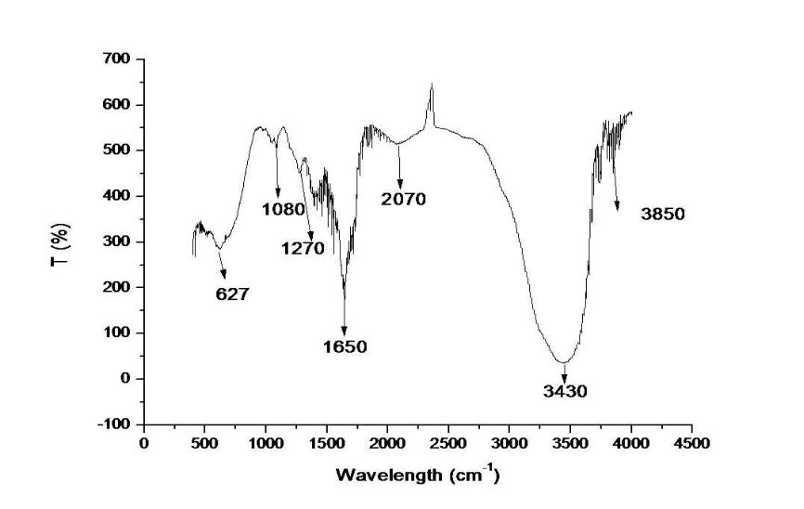

Figure 4.3: FTIR spectra of the pyrolytic oil.

Table 4.10: FT-IR peaks of the function groups of the pyrolytic oil

|  |  |  |
| --- | --- | --- |
| **Peak #** | **Wavelength (cm-1)** | **Spectral Assignment** |
| 1 | 627 | C-H bending |
| 2 | 1080 | C-O stretch |
| 3 | 1270 | C-O stretch vibration |
| 4 | 1650 | C=O |
| 5 | 2070 | C-H Stretching |
| 6 | 3430 | OH Stretching |
| 7 | 3850 | C≡C stretch |