MEE 510
PRODUCT DESIGN ASSIGNMENT
HIGH ENERGETIC SOLID FUEL FROM CONTROLLED CARBONIZATION OF WOODY BIOMASS
BY
AROKOYO TAIYE JOSEPH
15/ENG06/013
MECHANICAL ENGINEERING

Biomass can be described as a source of renewable energy which is derived from the remains of plants and animals. Bioenergy or biomass energy, which is the energy resulting from the use of biomass is a sustainable form of energy and on the world stage, biomass provides 10.6% of global primary energy supplies (Stephen, 2011). Biomass energy can be generated using various technologies which include thermo-chemical processes, bio-chemical processes, and physio-chemical processes. For the thermo-chemical processes, the techniques for energy generation include pyrolysis, gasification, hydrothermal processing. Pyrolysis is the initial step for other thermo-chemical processes. The products that can be generated from the use of biomass as a source of energy include solid fuels (e.g. char), liquid fuels (e.g. kerosene), and gaseous fuels.
MATERIALS AND METHODS
Collection and Preparation of Raw materials
Hard and soft woods have been collected from Afe Babalola University Ado-Ekiti, saw mill and are powdered before pyrolysis. The samples are labeled as thus;
Hard woods
Sample A: Gmelina
A1:600 microns
A2: 2.36 mm
Sample B: Iroko
B1:600 microns
B2: 2.36 mm
Sample C: African mahogany
C1:600 microns
C2: 2.36 mm
Soft woods
Sample D: Cedar
D1:600 microns
D2: 2.36 mm
Sample E: Red Word
E1:600 microns
E2: 2.36 mm
Sample F: Pines
F1:600 microns
F2: 2.36 mm

Wood powder preparation
Before putting woods for co-pyrolysis, they are processed to be reduced to fine particles. The process is as follows. The woods are dried in sun, and then hand crushed to large size pieces which are then dried in oven at 105°C for removal of moisture. The dried woods pieces are then sent to ball mill for further grinding. Before putting wood pieces, the inside of ball mill is washed with water and wiped with wet cloth and left for drying. Initially they are processed at large ball mill to reduce them to medium size pieces of around 1 cm². Rotating speed of 50 rpm is used. The product is then processed to small-size ball mill where they are ground again. The finer product is separated using sieve shaker, BSS 52. Thus, final particle size of ground woods are 600 microns and 2.18 mm.
Preliminary Analysis
Density of biomass
Density of biomass was measured using the known volume of glass beaker. For this purpose, initial weight of glass beaker was taken, later it was filled with dried and powder biomass. The weight of beaker along with the biomass was recorded. The weight of biomass was obtained by subtracting the weight of beaker from the weight of beaker and biomass. The density of biomass was calculated as per below mentioned formula:
Density of biomass = Mass/Volume (g/cm³).
Proximate Analysis of the Pretreated Sample
The proximate analysis provides information on moisture content, ash content, volatile matter content and fixed carbon content of the material. Fixed carbon other than ash does not vaporize when heated in the absence of air. Fixed carbon is usually determined by subtracting the sum of the first three values that is moisture, ash, and volatile matter (weight percent from 100 percent). So, it is very important for economic reasons to know the moisture and ash contents of the material. They do not contribute to the heating value of a coal. In most cases ash is an undesirable residue also a source of pollution. In some purposes (use as a chemical feedstock, liquefaction) the presence of mineral matter may be needed. Mostly heat value of the material comes from after excluding moisture, volatile matter, and fixed carbon content.
Proximate analysis on the pretreated sample was carried out to determine percentage volatile matter, percentage moisture content, percentage ash content and percentage ﬁxed carbon.
Moisture content on dry basis:
The moisture content (MC) was determined using standard CEN/TS 14774. 3.0 g of powdered sample was oven dried at 105±2◦C until a constant mass was obtained. The change in weight after 3–4 hours was then used to determine the sample’s moisture content expressed in percentage using the formula below;
Moisture content (%) = Change in weight X 100
Initial weight before drying

Volatile matter
The volatile matter (VM) was determined using the standard method CEN/TS 15148. 2.0g of powdered sample was pulverized and oven dried at 105◦C until its weight was constant. The sample was then heated at 950◦C for 10 min and weighed after cooling. The Volatile Mater (VM) expressed in percentage was calculated using:
Volatile Mater (%) = weight of the oven-dried sample X 100
Weight of the sample after 10 min in the furnace at 950◦C

Ash content
The ash content (AC) was determined using standard CEN/TS 14775. 2.0 g of the powdered samples was heated in a furnace at 750 ◦C for 1 hour and weighed after cooling to get the weight of the ash expressed in percentage. The Ash content expressed in percentage was determined using:
Ash content (%) = weight of sample after cooling X 100
Weight of the oven-dried sample

Fixed carbon
The ﬁxed carbon (FC) was computed by subtracting the sum of Volatile matter VM, Ash content AC and Moisture content MC from 100, expressed in percentage.
Fixed Carbon = 100%− (PVM + PAC + PMC)

Ultimate Analysis
Ultimate analysis is performed to determine the elemental composition of the material. Ultimate analyses are used to determine the carbon, hydrogen, nitrogen, sulfur, ash, oxygen contents of the material. For the specific applications, other chemical analyses can be employed. These include identifying the forms of sulfur present. Sulfur occurs in the form of sulfide minerals, sulfate minerals, or organically bound sulfur. Other specific cases the analyses may involve determining the trace elements present which influence the suitability of the material for a particular purpose. This may include methods for reducing environmental pollution and so forth.
It was carried out using a CHNSO elemental analyzer (Variael CUBE Germany) which provides carbon, hydrogen, nitrogen, sulphur percentage composition. And when sum of theses compositions is subtracted from 100, it gives oxygen percentage composition.
Heating Value
The standard measurement of the energy content of a fuel is its heating value (HV). HV is divided into lower heating value (LHV) and higher heating value (HHV) depending on the water produced through hydrogen in vapour or liquid phase. Heating value can be determination by the oxygen-bomb colorimeter method (Demirbas, 2009).
The heating value of the pyrolysis oils is affected by the composition of the oil (Sipila, et al., 1998). At present, HHV of bio-oil can be determined directly according to DIN 51900 by the oxygen-bomb colorimeter. In addition, the HHV of the bio-oil is also calculated using the following formula (Milne, et al., 1990).
HHV (KJ/KG) = 33801(C) + 14415{(H) – 0.125(O)} + 9413(S)
Experimental set up
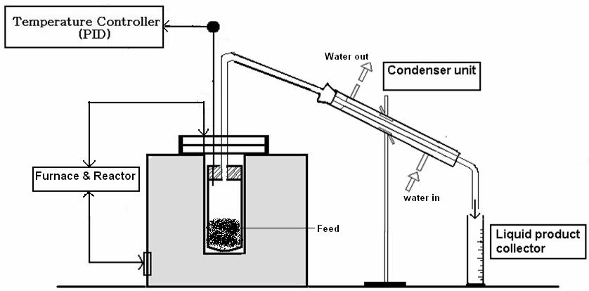
The pyrolysis setup used in this experiment is shown in Figure 3.2.

Pyrolysis experimental set up
It consists of a semi batch reactor made of stainless-steel tube (length- 145 mm, internal diameter- 37 mm and outer diameter- 41 mm) sealed at one end and an outlet tube at another end. The reactor is heated externally by an electric furnace, with the temperature being measured by a Cr-Al: K type thermocouple fixed inside the reactor, and temperature is controlled by an external PID controller. The condensable liquid product is collected through the condenser and weighed. After pyrolysis, the solid residue left inside the reactor is weighed. The weight of gaseous / volatile product was calculated from the material balance.
Sample Pyrolysis Runs
Once the temperature range was established then sample pyrolysis runs were done with 15.0 g of wood powder in that range at intervals of 500°C, 600°C, and 800°C to determine the temperature at which maximum yield of product is obtained. It was heated externally by electric furnace at a heating rate of 20°C min⁻¹. The temperature of the furnace is maintained by a highly sensitive proportional-integral-derivative (PID) controller and the temperature is measured by Cr-Al:K type thermocouple fixed in the reactor. During sample runs various data like yield of chars were noted down.
Preparation of activated carbon

Preparation of activated carbon is by following steps
- The dried wood powder transfer into the pyrolytic reactor and reactor put inside the furnaces, by maintaining 575°C temperature.
- After pre-carbonized of material, the material is crushed into powder or granular form using hand blender.
- Carbonaceous material was sized with the help of sieving technique and the30 BSS (British Standard Scale) sieve was used for 500, 600, and 800-micron sizes as particle size.
- Resulting sample was washed with distilled water and unwanted materials get separated as waste filtrate.
- Properly washed carbonized carbon is impregnated with 40% diluted H₂SO₄ acid solution with an impregnated ratio (W/W) of 4:1 for nearly 10 hours.
- Resulting chemically acid washed Carbon is again washed with single distilled water.
- Finally, the washed Activated Carbon is kept in the oven at 110°C for 3 hours for removal of moisture
- Dried activated adsorbent kept in plastic storage bottle container for further use.

Characterization of Solid Fuel
Fourier Transform Infrared Spectrophotometer FTIR
Fourier Transform Infrared Spectrophotometer (FTIR) is perhaps the most powerful tool for identifying the types of chemical bonds (functional groups) present in compounds. The wavelength of light absorbed is characteristic of the chemical bond as can be seen in the annotated spectrum. By interpreting the infrared absorption spectrum, the chemical bonds in a molecule can be determined.
A FT-IR spectrometer (Infrared spectrometer Varian 660 MidIR Dual MCT/DTGS Bundle with ATR) was used to confirm the chemical structure of all samples. Before analysis, the samples were dried in an auto- desiccator for 24 hours. Samples were directly applied to a diamante crystal of ATR and resulting spectra of them were corrected for background air absorbance. Potassium bromide (KBr) disks were prepared from powdered samples mixed with dry KBr in the ratio of 1:100. The spectra were recorded in a transmittance mode from 4000 to 500/400 cm⁻¹ at a resolution of 4 cm. Infrared spectrum was Fourier transformed and recorded in the absorption mode. The refractogram obtained from FT-IR spectroscopy between wave number and absorption is tabulated below. IR solution software is employed for getting the spectrum.
FTIR spectroscopy from the absorption of IR radiation through resonance of non-centro symmetric (IR active) modes of vibration and is a useful tool for quantifying secondary structure in metal nanoparticle–biomolecules interaction
The region of IR radiation helps to identify the functional groups of the active components present in extract based on the peak values of the FTIR spectrum. When the extract was passed into the FTIR, the functional groups of the components were separated based on its peak ratio

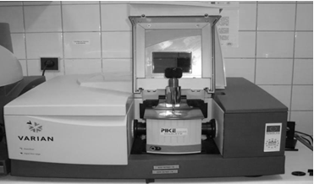
Infrared spectrometer Varian 660 MidIR Dual
In a FTIR instrument, the monochromator and the slits are replaced by an interferometer of Michelson type. A beam of radiation is divided into two beams by means of a beam splitter. A path difference between the beams is also introduced whereupon it is allowed to recombine. In this way, interference between the beams is obtained. Intensity of the output beam from the interferometer is monitored as a function of path difference using an appropriate detector.
In order to determine the functional groups, present in the pyrolytic oil, Fourier Transform Infrared spectroscopy of the oil is being analyzed in a Perkin-Elmer infrared spectrometer.
Gas Chromatography – Mass Spectrometry GC-MS
Gas Chromatography – Mass Spectrometry of the pyrolytic solid fuel is being performed using a GC-MS Varian 3800 gas chromatograph analyzer to determine the Chemical compounds present in the fuel. Chromatography is specially used to separate mixtures of chemicals into individual components for identification. After isolation, the components can be evaluated individually. In all most all chromatography, separation generally occurs when the sample mixture is introduced or injected into a mobile phase. In case of liquid chromatography, the mobile phase is a solvent. In the gas chromatography (GC), the mobile phase is an inert gas for example helium. Mobile phase carries the sample mixture through what is referred as stationary phase. The stationary phase is considered as a chemical that can also attract components in a sample mixture. This tube is called as a column. Columns can be glass or stainless steel of various dimensions. The mixture of compounds in the mobile phase interacts with the stationary phase. Each and every compound in a mixture interacts at a different rate. That interact the fastest will exit (elute from) the column first. Those that interact slowest will exit the column last. By observing the changing characteristics of the mobile phase and the stationary phase the different mixtures of chemicals can be separated. Further refinements to this separation process are also made by changing the temperature of the stationary phase or the pressure of the mobile phase. GC has a long, thin column containing a thin interior coating of a solid stationary phase (5% phenyl-, 95% dimethyl siloxane polymer). This 0.25 diameter column is called as a capillary column. This particular column is used for semi volatile, non-polar organic compounds such as the PAHs we will look at. The capillary column is held in an oven that can be programmed to increase the temperature gradually (or in GC terms, ramped). As the temperature increases, that compounds which have low boiling points elute from the column sooner than those that have higher boiling points. There are actually two distinct temperature, separating forces and stationary phase interactions mentioned previously. After the compounds are separated, they just elute from the column and enter a detector. Detector is capable of creating an electronic signal whenever the presence of a compound is detected. Greater the concentration in the sample the bigger the signal becomes. The signal is then processed by the computer. Time from when the injection is made (time zero) to when elution occurs is referred to as the retention time (RT). While the instrument runs, the computer generally generates a graph from the signal. Each of the peaks in the chromatogram represents the signal created only when a compound elutes from the GC column into the detector. The x-axis shows the RT, and the y-axis shows the intensity (abundance) of the signal.

Analysis was done using a Varian 3800 gas chromatograph equipped with a Agilent MS capillary column (30 m × 0.25 mm i.d.) connected to a Varian 4000 mass spectrometer operating in the EI mode (70 eV; m/z 1 – 1000; source temperature 230°C and a quadruple temperature 150°C). The column temperature was initially maintained at 200°C for 2 min, increased to 300°C at 4°C/min, and maintained for 20 min at 300°C. The carrier gas was Nitrogen at a flow rate of 1.0 mL/min. The inlet temperature was maintained at 300°C with a split ratio of 50:1. A sample volume of 1µL in chloroform was injected using a split mode, with the split ratio of 50:1. The mass spectrometer was set to scan in the range of m/z 1-1000 with electron impact (EI) mode of ionization, runtime were 40 minutes. Using computer searches on a NIST Ver.2.1 MS data library and comparing the spectrum obtained through GC – MS compounds present in the samples were identified.
All the samples and replicates were continuously injected as one batch in random order to discriminate technical from biological variations. Additionally, the prepared pooled samples were used as quality controls (QCs), which were injected at regular intervals throughout the analytical run to provide a set of data from which the repeatability can be assessed.
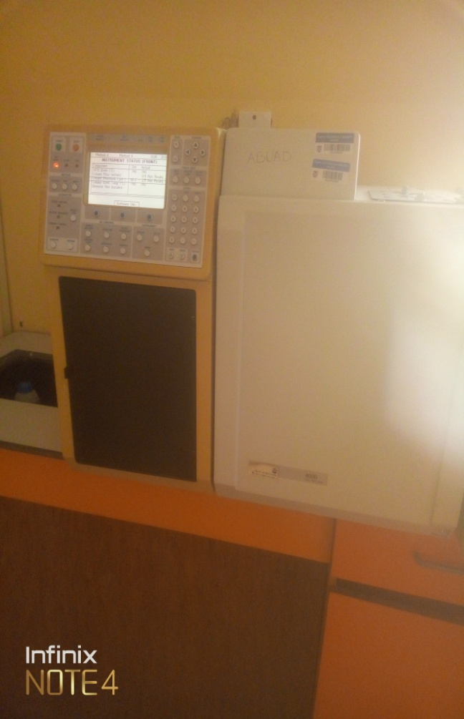
Varian 3800/4000 Gas Chromatography – Mass Spectrometry
Powder X-ray Diffraction XRD Analysis
Solid samples were characterized by powder X-ray diffraction (XRD), In XRD analysis, a focused X-Ray beam is shot at the sample at a specific angle of incidence. The X-Rays deflect or "diffract" in various ways depending on the crystal structure (inter-atomic distances) of the sample. The locations (angles) and intensities of the diffracted X-Rays are measured. Every substance has a unique diffraction pattern. In order to identify a substance, the diffraction pattern of the sample is compared to a library database of known patterns.
In addition to identification of crystalline phases, the peak shapes and intensities collected during XRD analysis can be used to gather information about percent crystallinity and crystalline size. blet from a Cu-anode (generator settings E = 40 keV, I = 40 mA) was used as incident radiation. For better collimation of the incident beam a Goebbel-mirror was attached to the exit slit of the generator. The Goebbel-mirror also removed Cu-Kβ radiation from the incident beam. A scintillation counter was used as the detector. To minimize effects due to spatial divergence of the reflected beam a Soller-aperture (width=1 mm) was mounted in front of the detector entrance slit. The resolution limit of the diffractometer was checked using a reference quartz sample and an Al₂O₃ powder. The Full Width-Half-Maximum (FWHM) of all peaks was in the range of 0.045º to 0.07^{o.} There was no significant angle dependence of the peak width; only a slight increase with decreasing peak intensity. Two-theta osets were also checked using these standards. Two scanning modes were used during this work, i.e. symmetric scanning and asymmetric scanning. Standard symmetric XRD θ - 2θ scans give an integral picture of a thin lm sample, since the intensity of the incident radiation is nearly homogeneous across the sample thickness. In order realize more surface sensitive scans asymmetric scans were performed where the incident beam is fixed at a very small angle θ and only the detector is scanned. The penetration depth of the incident X-ray intensity into a thin l m, assuming an absorption coefficient of µ = 730 cm−1 (corresponds to CuInS2), is plotted for different angles of incidence of the primary beam. It can clearly be seen that for an incident angle of θ =65.0º the sampling volume accessible for XRD is of the order of 2 µm which is the typical thickness of samples investigated in this work. In the case of an angle of incidence of θ =0.5⁰ the first 500 nm only will contribute to the measurement. Thus, by varying θ the surface sensitivity of the measurement can be influenced
The prepared sample was placed in a lucite holder on the goinometer of the instrument which was configured with a graphite monochromator. The diffraction beam monochromator operated at 40 KVA and a current of 40 mA with the 2θ range of 0 – 70º with deviation of ±0, 05° and at a scan speed of 2º C/minute with step size of 0.02º for 120 minutes to create x- ray patterns with enough intensity to produce lines to identify minerals at the 2θ angles., The parameters selected were: peak positions (2θ), Plane and relative intensities.
The XRD patterns indicated crystalline orthogonal phases. After the X-ray scanning of the samples, mineral peaks were identified using Software. The background and peak-positions were identified and based on the peak positions and intensities; a search-match routine was performed.
The X-ray diffraction was performed to obtain further evidence about the structure of the samples. X – Ray Diffraction (XRD) Analysis of the samples were performed on bulk samples using a Shimadzu XDS 2400H diffractometer with Cu anode, λ1_{CU} = 1.541838 [A°], attached to digitized computer along with graphical assembly on uncompressed powders in order to collect the maximum of the diffraction lines and a better identification of the phases and tungsten filament operated with a voltage of 40 kV and a current of 30 mA, and NaI(Tl) scintillator detector in a 2θ range of 0° to 65°.
The mid-plane of each sample was exposed by cutting and the resulting surface was prepared in the same way as described above, adding an electrolytic polishing step. The diffracted radiation was collected between 0 and 65◦ with an ultra-fast PixCel area detector with unfiltered Co-Kα radiation at 45 kV and 40 mA current for quantitative XRD to measure the volume fraction of phases from a 2θ spectrum that was acquired at a step size of 0.0260 over an angular range of 0° to 70°. The step scan angle and step scan time were settled in 0.026◦ and 939 s respectively. In order to deal with orientation effects, XRD measurements were performed in two configurations, i.e. with the main dimension of the sample parallel and perpendicular to the incident beam. The spectra were processed by the Rietveld refinement method with the software MAUD (materials anal-ysis using diffraction) (Lutterotti L. 2010). Peak broadening was considered by modeling microstrains and crystallite sizes. Texture effects were taken into account considering previous work in literature (Eng-Poh et al; 2012).
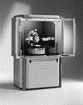
Shimadzu XDS 2400H diffractometer
Pyrolysis Yield
The yield of solid fuel is a co-product of fast pyrolysis with the biomass. Table 4.1 shows that the percentage of pyrolysis yield declined with increased temperature, where there was 65.29% of the real mass at 500⁰C to 40.37% at 800⁰C for A1, 67.24% to 40.44% for B1 and 67.41% to 41.65% for C1 at 500⁰C and 800⁰C for hardwood samples at 600 microns respectively while for softwood at 2.36 mm we have 65.32% of the real mass at 500⁰C to 40.37% at 800⁰C for D1, 67.31% to 41.18% for E1 and 67.39% to 41.63% for F1. On the other hand, there was 65.11% of the real mass at 500⁰C to 40.32% at 800⁰C for A2, 67.20% to 41.07% for B2 and 67.35% to 41.41% for C2 at 500⁰C and 800⁰C for 600 microns samples and 65.24% of the real mass at 500⁰C to 40.35% at 800⁰C for D2, 67.31% to 41.18% for E2 and 67.35% to 41.59% for C2 at 500⁰C and 800⁰C for 2.36 samples. This diminishing direction of samples as pyrolysis increased was in agreement with studies on the pyrolytic properties of woody biomass (DeSisto, et al; 2010). Based on the results of research on various materials, a reduction in yield can be due to the loss of chemically bound moisture, the decomposition of organic substances and the dehydration of hydroxyl groups, or at higher temperatures it can be induced by the buildup of aromatic structures, with damage to large amounts of CO₂, CO, H₂O, and H₂ (Stefaniuk and Oleszczuk, 2015).
Table 4.1 Pyrolysis yield of solid fuel at different temperature
Temperature (⁰C) | Pyrolysis yield (%)
 | A |  | B |  | C |  | D |  | E |  | F
 | A1 | A2 | B1 | B2 | C1 | C2 | D1 | D2 | E1 | E2 | F1 | F2
500 | 65.29 | 65.11 | 67.24 | 67.20 | 67.41 | 67.35 | 65.32 | 65.24 | 67.31 | 67.25 | 67.39 | 67.35
800 | 40.37 | 40.32 | 40.44 | 41.07 | 41.65 | 41.41 | 40.37 | 40.35 | 41.18 | 40.74 | 41.63 | 41.59

Table 4.2 Proximate and Ultimate Analysis of Samples at 500 ºC
Parameters | Samples
 | A |  | B |  | C |  | D |  | E |  | F
 | A1 | A2 | B1 | B2 | C1 | C2 | D1 | D2 | E1 | E2 | F1 | F2
Density (g/cm³) | 0.59 | 0.54 | 0.83 | 0.80 | 0.77 | 0.72 | 0.54 | 0.51 | 0.63 | 0.56 | 0.52 | 0.48
Moisture Content MC (%) | 5.63 | 5.25 | 5.90 | 5.81 | 5.35 | 5.48 | 5.16 | 4.41 | 5.08 | 4.98 | 5.48 | 4.62
Volatile matter VM (%) | 80.17 | 81.13 | 87.42 | 80.31 | 78.62 | 77.05 | 80.12 | 80.06 | 80.72 | 78.95 | 76.74 | 77.83
Ash content AC (%) | 2.03 | 2.00 | 2.51 | 2.38 | 2.25 | 2.23 | 2.04 | 2.00 | 2.17 | 2.02 | 2.00 | 2.00
Fixed carbon FC (%) | 20.02 | 20.72 | 20.52 | 21.01 | 20.54 | 20.55 | 24.91 | 21.37 | 23.72 | 20.90 | 23.72 | 21.40
Higher heating value (MJ/kg) | 25.30 | 24.80 | 21.00 | 24.47 | 29.00 | 28.60 | 25.10 | 20.84 | 21.10 | 24.20 | 29.00 | 28.20
Lower heating value (MJ/kg) | 21.24 | 22.38 | 19.13 | 20.11 | 20.14 | 20.05 | 17.24 | 14.98 | 15.03 | 17.00 | 23.76 | 22.59
Carbon content  (%) | 50.78 | 53.41 | 45.63 | 48.05 | 47.82 | 47.91 | 41.20 | 35.82 | 35.90 | 40.62 | 56.77 | 53.90
Hydrogen content (%) | 7.12 | 5.48 | 6.40 | 6.76 | 6.70 | 6.74 | 5.80 | 5.04 | 5.05 | 5.70 | 7.98 | 7.58
Oxygen content (%) | 54.64 | 41.88 | 48.91 | 51.66 | 51.20 | 51.53 | 44.34 | 38.50 | 38.61 | 43.57 | 58.02 | 54.94
Nitrogen content (%) | 0.24 | 0.20 | 0.23 | 0.23 | 0.21 | 0.26 | 0.24 | 0.21 | 0.25 | 0.23 | 0.24 | 0.22
Sulfur content (%) | 0.30 | 0.28 | 0.27 | 0.26 | 0.26 | 0.23 | 0.27 | 0.25 | 0.31 | 0.28 | 0.30 | 0.28

As observed from Table 4.2, softwood species (samples) had a superior ash content related to hardwood species (samples) due to its high mineral content. Ash content is the amount of solid wastes after complete burning process of a fuel. High ash content of a fuel generally reduces heating value. Therefore, the low ash content of the wood samples was desirable.
A mean value of 17.59%±3.78 moisture content was obtained from the results, which is a reasonable moisture level for the wood fuels (Table 4.2). This agrees with Adekunle (Adekunle, 2004) who concluded that the moisture content of air-dried biomass depends on the relative humidity and that it varies from 10-26%. High moisture content has big effect on the heating value of woods during combustion, as heat would be expended to vapourize it.
The results obtained from volatile matter indicates that the quantity of hydrocarbons in the wood samples was high, and hence would have high energy content. The relatively high fixed carbon would be expected to increase the heating value. The result agreed with Huhtinen (Huhtinen, 2009), that the share of volatile matters is wood is typically high; constituting about 80% of the energy originating in the combustion of volatiles.
The proximate analysis of these samples showed that they have good potential for domestic cooking and good combustion properties. The relatively high fixed carbon would be expected to increase the heating value. The result agreed with Huhtinen (Huhtinen, 2009), that the share of volatile matters is wood is typically high; constituting about 80% of the energy originating in the combustion of volatiles.
The heating value for hardwood samples (A1, A2, B1, B2, C1 and C2) was recorded as 25.48, 21.83, 24.02, 29.47, 28.05, and 40.67KJ/kg, respectively while that of softwood samples (D1, D2, E1, E2, F1 and F2) was recorded as 25.29, 20.91, 21.14, 24.23, 29.21 and 28.28 KJ/kg. However, there was no significant different in heating value of these samples. The heat per unit volume of wood depends on its specific gravity, and is the weight of material per unit of volume expressed on an oven-dry-weight base (Quaak, et al; 1999). The average value of 0.72±0.14 presupposes that the potential energy of the samples was high
Table 4.2 also shows the results of the chemical analysis of the wood samples, with higher carbon contents than other elements. High carbon content is expected to increase the heating value of the wood. The mean value of 50.03%±0.92 agreed with literature that puts the carbon content of wood at between 45 – 50% (Fapetu, 2000).

Tale 4.3 Proximate and Ultimate Analysis of Samples at 800 ºC
Parameters | Samples
 | A |  | B |  | C |  | D |  | E |  | F
 | A1 | A2 | B1 | B2 | C1 | C2 | D1 | D2 | E1 | E2 | F1 | F2
Density (g/cm³) | 0.59 | 0.54 | 0.83 | 0.80 | 0.77 | 0.72 | 0.54 | 0.51 | 0.63 | 0.56 | 0.52 | 0.48
Moisture Content MC (%) | 5.52 | 5.20 | 5.76 | 5.80 | 5.31 | 5.44 | 5.10 | 4.37 | 5.00 | 4.98 | 5.47 | 4.60
Volatile matter VM (%) | 80.03 | 81.00 | 83.41 | 83.72 | 78.83 | 80.02 | 80.12 | 80.25 | 80.42 | 81.34 | 77.13 | 77.52
Ash content AC (%) | 2.00 | 2.23 | 2.48 | 2.52 | 2.25 | 2.27 | 2.63 | 2.50 | 2.37 | 2.42 | 2.20 | 2.16
Fixed carbon FC (%) | 20.12 | 20.30 | 20.50 | 20.81 | 20.52 | 20.55 | 20.91 | 21.07 | 23.22 | 20.30 | 23.42 | 22.96
Higher heating value (MJ/kg) | 25.48 | 24.83 | 21.02 | 24.47 | 29.05 | 28.67 | 25.29 | 20.91 | 21.14 | 24.23 | 29.21 | 28.28
Lower heating value (MJ/kg) | 21.28 | 22.41 | 19.20 | 20.15 | 20.18 | 20.11 | 17.31 | 14.99 | 15.07 | 17.03 | 23.78 | 22.61
Carbon content  (%) | 50.78 | 53.41 | 45.63 | 48.05 | 47.82 | 47.91 | 41.20 | 35.82 | 35.90 | 40.62 | 56.77 | 53.90
Hydrogen content (%) | 7.12 | 5.48 | 6.40 | 6.76 | 6.70 | 6.74 | 5.80 | 5.04 | 5.05 | 5.70 | 7.98 | 7.58
Oxygen content (%) | 54.64 | 41.88 | 48.91 | 51.66 | 51.20 | 51.53 | 44.34 | 38.50 | 38.61 | 43.57 | 58.02 | 54.94
Nitrogen content (%) | 0.24 | 0.20 | 0.23 | 0.23 | 0.21 | 0.26 | 0.24 | 0.21 | 0.25 | 0.23 | 0.24 | 0.22
Sulfur content (%) | 0.30 | 0.28 | 0.27 | 0.26 | 0.26 | 0.23 | 0.27 | 0.25 | 0.31 | 0.28 | 0.30 | 0.28

