NAME: IRERUKE EMMANUELLA OGHENETEGA
MATRIC NUMBER: 17/MHS01/163
DEPARTMENT: MBBS
LEVEL: 300
COURSE TITLE: NEUROPHYSIOLOGY
COURSE CODE: PHS 305

QUESTION 1
Discuss the physiology of sleep
Sleep is a state of reversible unconsciousness in which the brain is less responsive to external stimuli. We are functionally blind during sleep with no response to visual stimuli and a decreased threshold of response to auditory stimuli. Babies have been exposed to sound of up to 100 dB, which is above the legal limit for ear protection for employees, without waking up. In adults, the process is selective demonstrating continuing cortical function. For example, a sleeping mother is woken by her crying baby but not by other louder noises.
Sleep is distinguished from unconsciousness and anaesthesia by a characteristic cycle of sleep phases with specific EEG patterns and physiological changes. Natural sleep is divided into two distinctive states: non-rapid eye movement (NREM) and rapid eye movement (REM) sleep. NREM sleep is then further divided into 4 stages where stage 1 is the lightest and stage 4 the deepest level of sleep. REM sleep is divided into phasic and tonic phases. The two distinctive states follow a regular pattern called a sleep cycle which, in an adult, lasts about 90 min and comprises a period of NREM sleep followed by REM sleep. The cycles may be separated by a period of wakefulness and are repeated 3–6 times each night and are typically displayed as an hypnogram.

Functions of sleep
The functions of sleep are still poorly understood. However, the observation that sleep (or, at least, an activity–inactivity cycle) is present in all species and has been preserved throughout evolution and that sleep deprivation leads to a drastic deterioration in cognitive function and eventually to mental and physical morbidity proves its importance.
It has been suggested that sleep might conserve energy by reducing core temperature slightly and lowering metabolic rate by 10% compared with quiet wakefulness. Sleep would prevent perpetual activity as a response to environmental stimuli leading to excessive energy consumption. However, sleep is a state of starvation and there is no evidence that sleep is important for tissue repair. Sleep has been implicated as an important factor in storage of long-term memory. Facts learned during the day are usually better remembered the next morning whereas facts learned shortly before going to sleep are often poorly recalled.
Electrophysiological characteristics of sleep
The stages of sleep are characterised by typical patterns of electroencephalogram, electro-myogram (EMG) and electro-oculogram (EOG) activity. Wakefulness with open eyes is characterised by an EEG with dominant low amplitude, high frequency beta activity of 16–25 Hz. Muscle tone is usually high with high-to-moderate EMG activity.
Stage 1
Sleep is usually initiated by a transition from wakefulness to a state of drowsiness with closed eyes and a shift from EEG beta activity to alpha activity of 8–12 Hz passing to Stage 1 NREM sleep with a mixed frequency EEG-pattern with low amplitude theta waves of 3–7 Hz accompanied by slow rolling eye movements. Involuntary muscle clonus occurs frequently, resulting in jerky movement of the whole body (hypnic jerks) and EMG activity is moderate-to-low. This stage lasts typically only 5–10 min, during which time minor auditory stimuli will cause arousal.
Stage 2
Stage 2 is characterised by short bursts of high frequency activity (12–15 Hz – sleep spindles) and K-complexes (large amplitude biphasic waves). Bodily movements continue and the EMG activity is low-to-moderate. This stage is generally short (10–20 min) in the first 1–2 cycles but predominates in later cycles. It is the most abundant sleep stage in adults accounting for up to 50% of TST.
Stages 3 and 4
Deep NREM sleep stages 3 and 4, sometimes combined as slow wave sleep (SWS) are characterized by high amplitude low frequency delta waves (> 75 µV and 0.5–2 Hz) with stage 3 having between 20–50% and stage 4 more than 50% delta activity. EMG activity is low and eye movements are rare. Arousal through auditory stimuli from this stage of sleep is difficult and, if awakened, the individual is often disorientated and slow to react. Return to sleep is easy and short arousals (< 30 sec) are rarely remembered.
REM sleep
NREM sleep is followed by REM sleep, the proportion increasing with each cycle. REM sleep is characterised by a fast mixed frequency low voltage EEG with saw-tooth waves and rapid eye movements on the EOG. During the tonic phases of REM sleep, there is marked reduction of muscle tone and EMGactivity in skeletal muscles. The tonic phases of REM sleep are interrupted by short episodes of phasic REM sleep with increased EMG activity and limb twitches. The atonia of REM sleep affects all skeletal muscles, except the diaphragm and the upper airway muscles, and is associated with hyperpolarisation of the α-motor neurones. The purpose of this may be to prevent the acting out of dreams. About 10% of the population have experienced sleep paralysis (i.e. wakening from sleep and finding that the atonia has persisted into wakefulness). It can be frightening but is entirely harmless. Natural wakening usually occurs from REM sleep. Subjects woken from REM sleep are much more likely to recall dream content than those awakened from NREM sleep. NREM dreams are generally vague and formless in contrast to REM dreams.
Physiological changes during sleep
Respiratory system
During NREM sleep, there is a decrease in respiratory drive and a reduction in the muscle tone of the upper airway leading to a 25% decrease in minute volume and alveolar ventilation and a doubling of airway resistance accompanied by a small (0.5 kPa) increase in PaCO2 and decrease in PaO2. Hypercarbic and hypoxic ventilatory drives are reduced compared with wakefulness. The breathing pattern is regular except at the transition from wakefulness into sleep when brief central apnoeas are common. During REM sleep there is a further decrease in hypercarbic and, particularly, hypoxic ventilatory drives. The breathing pattern is irregular especially during phasic REM sleep. The loss of skeletal muscle tone in REM sleep affects the intercostal and other muscles which stabilise the chest wall during inspiration. In infants, this may be seen as paradoxical movement of the rib cage and abdomen. In adults, there may be maldistribution of ventilation and impaired ventilation–perfusion matching with consequent arterial hypoxaemia. In normal subjects, this is unimportant but it may be very important in patients with chronic lung disease or abnormalities of the thoracic (e.g. kyphoscoliosis). The great majority of patients with impaired respiratory function will be at their worst during REM sleep.
Cardiovascular system
Blood pressure decreases during NREM and tonic REM sleep but may increase above waking values during phasic REM sleep. Cardiac output is generally decreased during all sleep phases. Systemic vascular resistance (SVR) and the heart rate are both reduced during NREM and tonic REM sleep and increased during phasic REM sleep.
Central nervous system
Cerebral blood flow (CBF) increases by 50–100% above the level of resting wakefulness during tonic REM sleep and is even greater during phasic REM sleep. Cerebral metabolic rate, oxygen consumption and neuronal discharge rate are reduced during NREM sleep but increased above resting values during REM sleep. The autonomic nervous system shows a general decrease in sympathetic tone and an increase in parasympathetic tone, except in phasic REM sleep.
Renal system
The glomerular filtration rate and filtration fraction are reduced and ADH secretion is increased resulting in a low volume concentrated urine.
Endocrine system
The secretion of several hormones is directly linked to the sleep/wake cycle. Melatonin is released from the pineal gland under the control of the supra-chiasmatic nuclei (SCN) in a 4–5 h pulse, usually beginning at the onset of darkness (~9 pm). The pulse is inhibited or delayed by exposure to bright light in the evening. It is best regarded as being permissive of sleep (‘opening the gate to sleep’) rather than as an hypnotic, as it is possible to maintain wakefulness during this period. Growth hormone is mostly secreted during the first episode of SWS, particularly during puberty. Prolactin concentrations also increase shortly after sleep onset and decrease with wakefulness. Sleep phase delay delays secretion of both of these hormones. The secretion of cortisol decreases with the onset of sleep and reaches a trough in the early hours of the morning and a peak just after waking.
Temperature control
In contrast to anaesthesia, thermoregulation is maintained during sleep. However, the shivering threshold is decreased and body core temperature decreases by about 0.5°C in humans and 2°C in hibernating mammals. Body temperature is linked to the circadian rhythm and reaches its nadir at about 3 am. Thermoregulation is quite good in human infants compared with other species.

QUESTION 2
Discuss the role of basal ganglia in coordinating movement
In order to understand the functions of the basal ganglia, we must mention the extrapyramidal system. This system is the part of the brain and brain stem that participates in motor control except for the corticospinal (pyramid) system. It includes:
- Basal ganglia and their pathways
- Portions of the cerebral cortex that give projections to the basal ganglia
- Parts of the cerebellum that give projections to the basal ganglia
- Parts of the reticular formation that are connected to the basal ganglia and cerebral cortex
- Thalamus nuclei associated with the basal ganglia and reticular formation.
The role of the extrapyramidal system is to control automatic movements, skeletal muscle tone, and maintenance of postural reflexes.
The basal ganglia exert their role in motor control through constant interaction with the cerebral cortex and the corticospinal pathway. They get information mainly from the cerebral cortex and send out information.
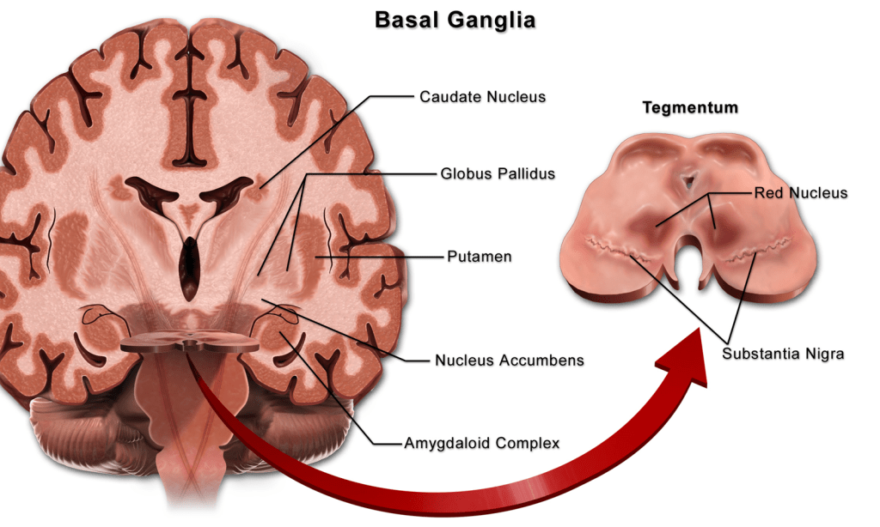

Almost all the motor and sensory nerve fibers that connect the cerebral cortex to the spinal cord pass between the major masses of the basal ganglia (nucleus caudatus and putamen) and are called the internal brain capsule.
The connections of the motor cortex, the thalamus and the joint circuits of the brain stem and cerebellum are very important. Namely, the main circuit of the basal ganglia system involves a huge number of connections between the basal ganglia themselves, as well as numerous entry and exit pathways between the motor regions of the brain and the basal ganglia.
One of the most intensively studied functions of the basal ganglia is their role in controlling eye movements. Eye movement is influenced by an extensive network of brain regions that converge on a midbrain area called the superior colliculus (SC).
The SC is a layered structure whose layers form two-dimensional retinotopic maps of visual space. A bump of neural activity in the deep layers of the SC drives eye movement toward the corresponding point in space.
Clinical notes
Degeneration of the basal ganglia and consequently, its dysfunction can lead to several neurological conditions including the following:
Parkinson’s disease
Parkinson’s disease results from loss of dopaminergic innervation (loss of the nigrostriatal connection) to the striatum and other basal ganglia structures. It is also referred to as Parkinsonism or Paralysis agitans (shaking palsy). The condition is characterized by rigidity (increased muscle tone), which leads to a stooped posture, a slow shuffling gait, difficulty in speech and a mask like face. Parkinsonism is believed to be due to degenerative changes in the striatum and the substantia nigra. Patients with this disease lack the nigrostriatal afferents to the striatum, and are also deficit of the neurotransmitter, dopamine in their striatum. Parkinson’s disease is also well characterized by hypokinesia (paucity or insufficient movement).
Cerebral palsy
People with cerebral palsy have various motor problems, such as spasticity, paralysis, and even seizures. Spasticity is a condition in which some muscles are abnormally stiff and as a result interfere with normal movement. This is the reason for the unusual hand and arm positions seen in some people with cerebral palsy. Causes may include fetal infection, environmental toxins, or lack of oxygen (hypoxia). Although cerebral palsy tends to remain relatively stable throughout life, there is no cure currently, and is very difficult to deal with for both the person and his or her family.
Tremor
This is an abnormal movement in which there is an involuntary shaking (tremor) of the hand, head or other parts of the body. Usually the basal ganglia, cerebellum and the subthalamic nucleus are involved. However, intention tremor is also seen in disorders of the cerebellum, in which case, the tremor comes when the individual tries to perform a voluntary movement.
PAP (or athymhormic) syndrome
PAP is characterized by an unusual lack of motivation due to damage to the caudate nucleus. People with PAP also ignore the usual social and moral motivations. Without the motivating influence of the basal ganglia, the frontal lobe simply stops planning for the future. Oddly, they can still respond to external motivation, such as a loved one's request or an authority's command.
Huntington’s disease
Huntington’s disease is a basal ganglia disorder lying at the other end of the spectrum of the basal ganglia disorders. It is a hereditary, progressive, fatal syndrome characterized by hyperkinesia, dyskinesias, dementia, impaired cognitive abilities and disorders of personality.
Huntington’s disease is particularly “insidious”, because its symptoms do not appear until well into adulthood. The most characteristic sign of Huntington’s disease is chorea (involuntary movement of parts of the body, particularly the distal parts of the limbs). The most obvious pathology of the Huntington’s brain is a profound loss of neurons in the corpus striatum and the cerebral cortex. Neuronal degeneration or neuronal loss in the cerebral cortex is usually accompanied by dementia (‘abnormal forgetfulness’) and personality disorders. Hence these conditions are characteristics of Huntington’s disease.
Cognition and behaviour
Most individuals suffering from basal ganglia disorders also suffer deficits of cognition as the disease progresses. The basal ganglia have also been implicated in several disorders of behavior control like:
- Tourette syndrome
- Hemiballismus
- Schizophrenia
- Obsessive compulsive disorder
- Attention deficit hypersensitivity disorder (ADHD)

