DOMINIC TIMOTHY DOMINIC
15/ENG06/021
MECHANICAL ENGINEERING
MEE 510

- Product/product design
Ans. DEVELOPMENT OF DIGITAL TACHOMETER
- Materials selection
Ans. a. Totalizers or counters
- Timers
- Built-in or self-calibration
- Self-test diagnostics
Display configurations include analog visual indicators, digital numerical displays, or graphic video displays. User interfaces and control types include analog front panels, digital front panels, or computer programmable interfaces. Some tachometers may come equipped with software for running on the hose computer. Many have network or communications interfaces. Available electrical outputs include:
- Analog voltage
- Analog current
- Analog modulated frequency
- Serial
- Parallel
- Switch or alarm

- Factors considered in choosing the materials
Ans. a. Availability
b. Durability
c. Corrosion
d. Cost

- Design specifications
Ans. The two most important parameters to consider when specifying tachometers are operating speed range and accuracy. Operating speed range is the range of rotary speed measurement the tachometer can monitor. The accuracy is typically given in units such as $±$RPM, etc. The sensor technology used in tachometers can be contact type, photoelectric, Inductive or hall effect. In a contact type instrument, the tachometer probe or sensor comes in contact with the rotating part. In a photoelectric instrument, light beams, visible or infrared, are employed to measure speed calculation. Inductive instruments use magnetic elements to induce magnetic fields; frequency of activation is used to measure speed. Hall effect tachometers use hall effect technology to determine rotational speed.

- Details drawing
Ans.
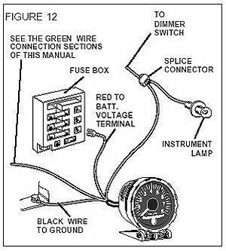

- BEME
Ans.
- Design calculations
Ans.
- Design process/manufacturing
Ans. Tachometer is comprised of a dial, needle and markings. The needle of the device indicates the result received, while the markings (high and low) indicate safe and dangerous levels of the rotating speed that is measured. Every engine spins within the limit of its design the pistons the engine pump the crankshaft to spin. This spinning crankshaft sends the horsepower. A tachometer counts the number of rotations the crankshaft is making in a minute. If the RPM of an engine is allowed to go above a specified range, moving parts will generate heat and friction to become damaged so by using a tachometer we could know the RPM of an engine and the engine can be operated at a specified range. There are many types of electrical tachometer the current, or drag type is widely used in automobile speedometers. Electric generators tachometers work by generating either an alternating or direct current.

