NAME: GIWA ABDUSSAMI ADEYINKA
MATRIC NUMBER: 15/ENG06/031
DEPARTMENT: MECHANICAL ENGINEERING
COURSE: MEE 510 – PRODUCT DESIGN
DEVELOPMENT OF A SOLAR TRACKER FOR A HYBRID SOLAR-WIND POWER SYSTEM

- PRODUCT/PRODUCT DESIGN

System Design Approach
This chapter presents relevant information on the system design approach and provides details of all methods and materials employed to achieve the study aim. The chapter will discuss these details in two categories;
- The hardware design
- Software development
The hardware section discusses parameters relating to the mechanical design and fabrication, while the software section presents information on electrical control system and the electronic circuitry.

The Hardware Design
The materials employed in designing the hardware setup for the light intensity tracking system will be presented in a step-wise manner based on the following sub-units of the entire system.
- Solar panel power rating and selection
- Design of panel tracking and repositioning mechanical system
- Designing the electronic control system

Design of Panel Tracking and Repositioning Mechanical System
The panel repositioning system chassis is sectioned into three parts;
- The moveable panel tray
- The actuation and adjustment section
- The water storage and supply control

- MATERIALS SELECTION & DESIGN PROCESS
- MATERIALS AND COMPONENT SELECTION
Angle iron metal bars were used in the fabrication of the system chassis and frame. This is due to its availability, known capabilities like yield and ultimate stress, density and ductility.

Metal Specification
Material property | Value and Unit
Thickness | 1.214mm
Mass Density | 7850[kg/m³]
Yield Strength | 370[MPa]
Ultimate Tensile strength | 440[MPa]
Young’s Modulus | 200[GPa]
Poisson’s Ratio | 0.29[-]
Shear Modulus | 80[GPa]
Expansion Coefficient | 0.000001[1/ºC]
Thermal Conductivity | 46[W/m-K]
Specific Heat | 0.49[J/Kg-K]
Bulk modulus | 140[GPa]
Modulus of elasticity | 205[GPa]

Electric Motor Selection
The electric motors used in this work were carefully selected so as to meet the torque, and particular speed and power requirements of the system. The motor specifications are given below.
Electric Motor Specifications
Voltage | 12v
Starting current | 10A
Power (HP) | 120watts
Speed | 20rpm
Weight | 5kg
Colour | Black
Rotor diameter | 17mm

Result
Table 4.4 below shows the design input specification that was used for the design of the mechanical system. The electric motor which provides the tractive power has a power rating of 120W at a speed of 20RPM. All other input parameters used in the design are given below.
Input parameter specification
INPUT PARAMETER | VALUE | UNIT
Input Power, P | 120 | w
Input Speed, n | 20 | RPM
Yield point of sprocket material, | 207 | MPa
Weight of the system without water tank, W | 78 | kg
Factor of safety, F.S | 2.0
Maximum weight allowed | 120 | kg
Charge controller current | 10 | A
Charge controller voltage | 12 | V

Several component tests, physical tests and system tests were done in the design process of the system, the result of which are represented in table 4.5 below.

Physical tests and outcomes
S/N | QUANTITY | UNIT |  | VALUE
 | Light intensity(sunlight intensity) | Lum | (5V/2.5V). 512 | 1024byte
 | Motor Power | W | I.V | 120watt
 | Battery power | W | P_{B} =IV = 7.5*12 | 90watt
 | Discharge time | mins | D (varies with respect to load) | 43mins (Average discharge time)
 | Time taken to for solar panel to fully charge battery | mins | T (varies with respect to sun intensity heating panels) | 43 mins (Average sun intensity)
 | Maximum speed of repositioning motor | rpm | operational speed (12rpm) | 20rpm
 | soil moisture |  | (5V/2.5V). 512 | 1024byte
 | Measured weight of panels | kg | 0.4*2 | 0.8Kg

From the results of the computations above, the total analog range of the sunlight intensity sensor as well as the soil moisture sensor ranges from 0V to 1024byte which is the 5V refences range for the low voltage section of the system.

The Moveable Panel Tray
The moveable panel tray is designed as a moveable hanger, holder or carrier for the solar panels. The moveable panel tray holds two solar panels of 20 watt each. The tray is designed from angle-iron bars as a rectangular post with a partition. The panels are firmly attached to the tray by screws, driven side ways to bind both panel to the tray. The tray is suspended on either sides of the structure by two angular-iron bars. The angular-iron bar creates a joint with the flat iron-bar extension rod designed to give vertical raise or allowance while it isolates the fixed part of the chassis from the moveable part. The tray is designed to have a reasonable allowance of about 10cm vertically. This is done to give room between the base of the solar panels and the sprocket or repositioning rod for repositioning and actuation. Figure 3.2 presents the design of the panel tray or holder.

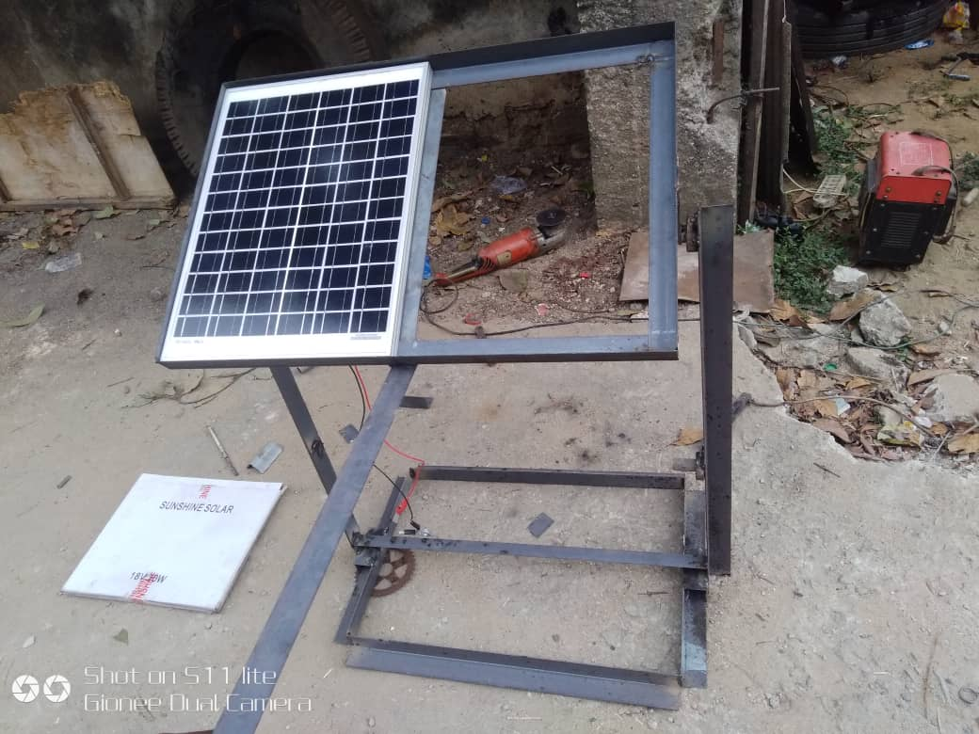
Design of the panel tray or holder

The Actuation and Adjustment Section
The repositioning actuation and adjustment section is comprised of two sprockets (A lower sprocket and a top sprocket) linked by a chain setup and a 12V high torque bi-directional actuation DC motor. The lower sprocket is selected to be slightly bigger than the top sprocket because a smaller angular distance covered by the lower sprocket implies a slightly higher rotation on the top sprocket, thus the lower sprocket diameter is designed to have a small difference of about 2cm from the top sprocket. The bi-directional DC motor system forms a joint with the lower sprocket and is coupled with the top sprocket through a chain linkage system. The lower sprocket and the DC motor form a part of the stationary sections of the mechanical chassis, while the moveable panel holder or tray comprises the moveable part. By reason of the DC motor being bidirectional, it creates possibility for a one axis sun tracking, making the system able to express reposition over an angular distance of about 80 degrees at least. The DC motor sits on a simple enclosure prepares by joining two angular bars to achieve balance. illustrates the design of the actuation and adjustment section.

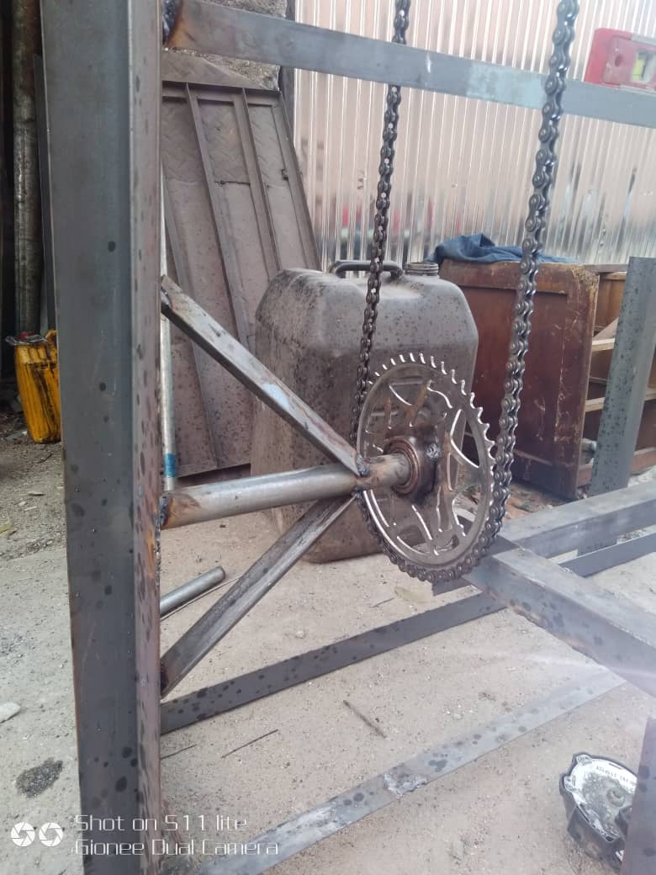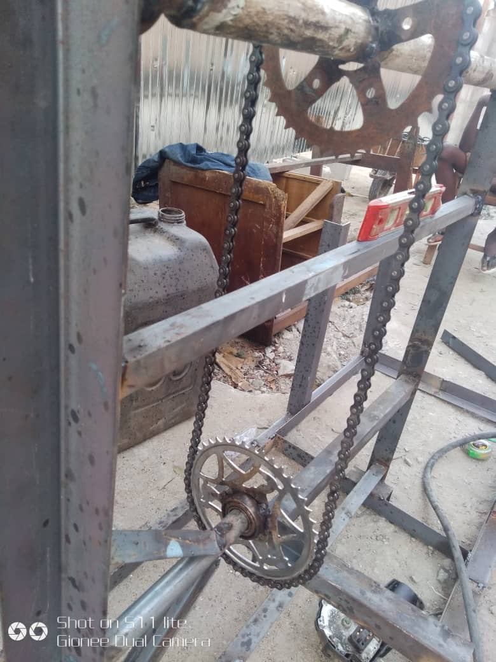

Design of the actuation and adjustment section

Orientation of Chassis
The chassis is a very important part of the system hardware since it directly interfaces with the actuators to reposition the solar panel. It is thus critical in analyzing the orientation and best fit movements to effectively move the panel.
Before the design of the sun-light position detecting circuit can be considered, it is necessary to choose an appropriate method of movement for the solar panel.
There are two ways of aligning the panel;
- Two Axis Tilt: This involves tilting the array in two axes to maintain the required position as shown in Figure 3.4(a).
- Rotate and Tilt: This involves rotating and tilting the array to maintain the same position as shown in Figure 3.4(b) In this work, the tilt method was adopted because it is flexible less complicated in terms of mechanical construction.

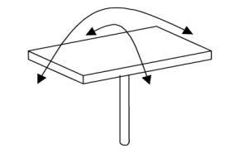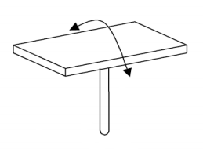
(a)Two axis tilt (b) One axis tilt
Methods of wood frame Alignment of Solar Panel

The Water Storage and Supply Control
The water storage is achieved by the tank system designed and painted with an anticorrosion agent for prevent rusting. The tank supplies water for irrigating the farm. However, control of water supply is required to prevent water logging or uncontrolled irrigation. This is achieved by attaching a control valve to the supply line outlet from the tank. The valve is a 12V DC system capable of receive control signals from 12V rated switching devices. The central control system handles the signal sending for valve open and closure. Fig 3.5 presents the design of the water tank and valve attachment process.
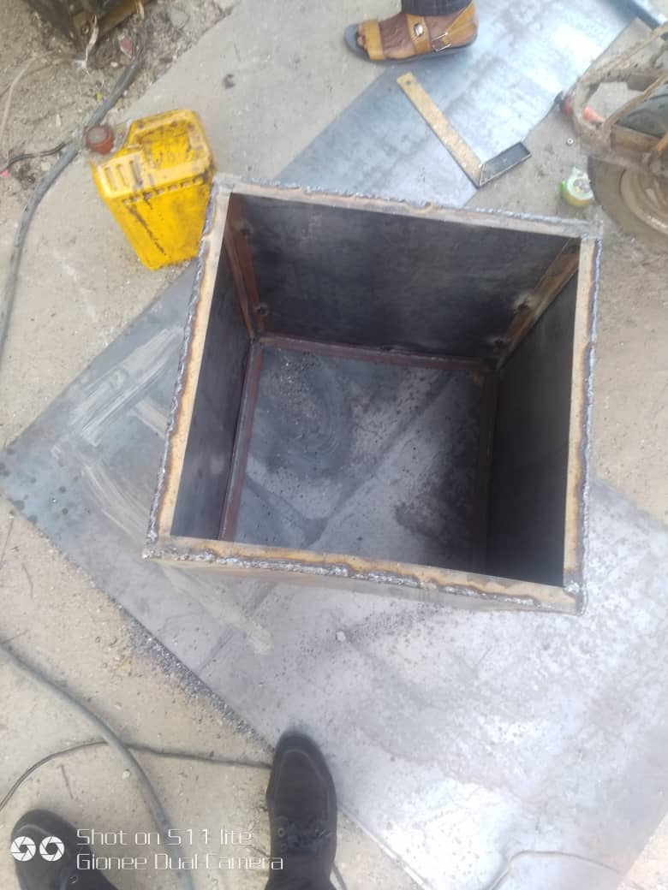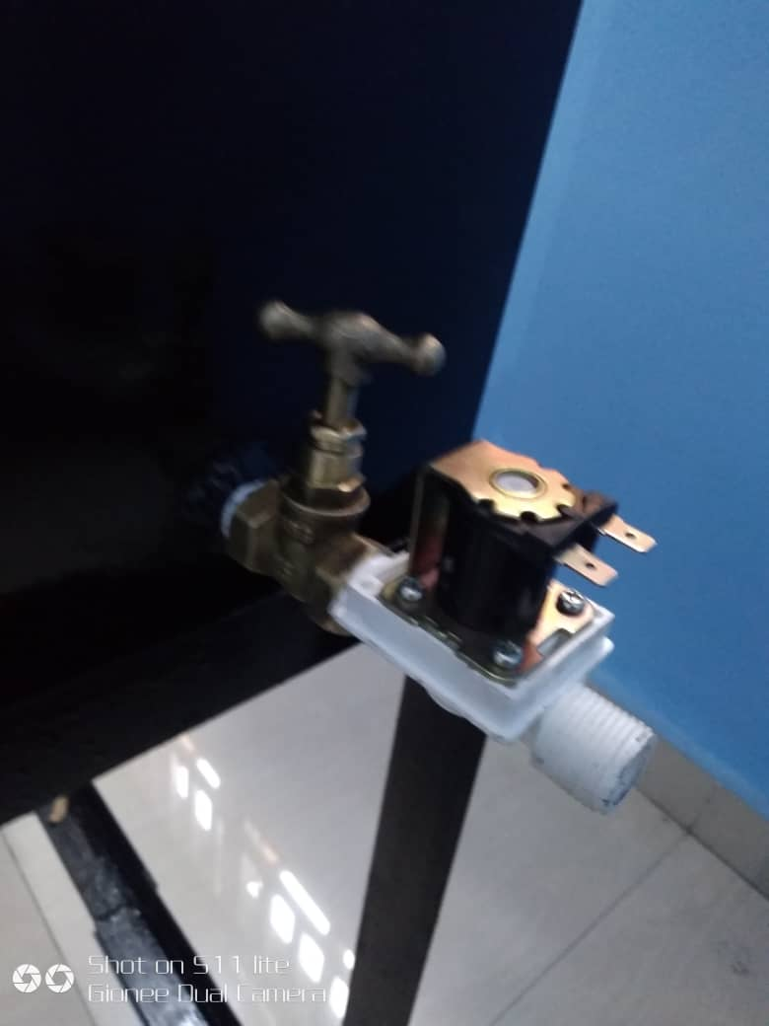
The water storage and supply control

Also, for implementation of the design, the system features a soil moisture sensor that jointly controls the irrigation process based on the dryness of the soil. The soil moisture provides an analog stream of data that handles the decision making process of whether to irrigate or not to irrigate. Figure 3.5 shows the soil moisture sensor.

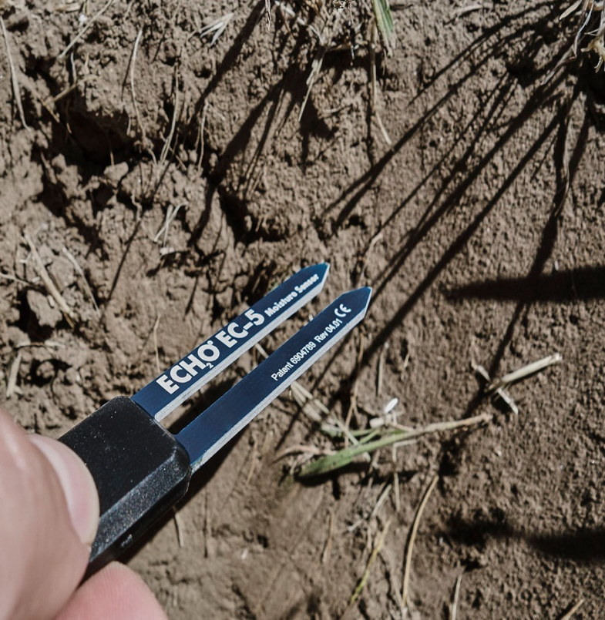
Soil moisture sensor

The mechanical chassis is a able to perform a one axis sun intensity tracking activity through the assembly of the different system units, the solar panel hanger together with the sprocket and chain linkage jointly interpret the motor actuation into the progressive repositioning of the panels for optimized charging, the soil moisture sensor as well as the control valve are able to control irrigation based on preset program references. Figure 3.7 presents the entire mechanical fabrication of the entire system.
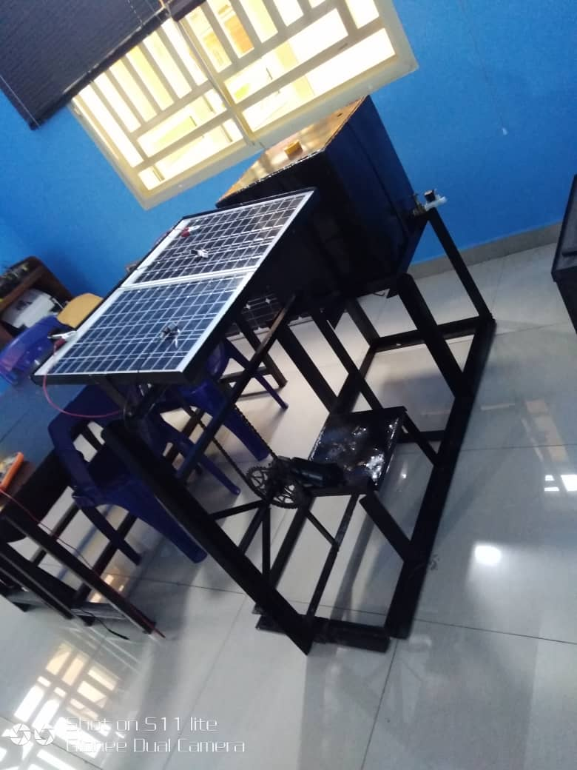
Mechanical fabrication of the entire system.

- FACTORS CONSIDERED FOR CHOOSING THE MATERIALS
MATERIALS AND COMPONENT SELECTION
Angle iron metal bars were used in the fabrication of the system chassis and frame. This is due to its availability, known capabilities like yield and ultimate stress, density and ductility.

Metal Specification
Material property | Value and Unit
Thickness | 1.214mm
Mass Density | 7850[kg/m³]
Yield Strength | 370[MPa]
Ultimate Tensile strength | 440[MPa]
Young’s Modulus | 200[GPa]
Poisson’s Ratio | 0.29[-]
Shear Modulus | 80[GPa]
Expansion Coefficient | 0.000001[1/ºC]
Thermal Conductivity | 46[W/m-K]
Specific Heat | 0.49[J/Kg-K]
Bulk modulus | 140[GPa]
Modulus of elasticity | 205[GPa]

Electric Motor Selection
The electric motors used in this work were carefully selected so as to meet the torque, and particular speed and power requirements of the system. The motor specifications are given below

Electric Motor Specifications
Voltage | 12v
Starting current | 10A
Power (HP) | 120watts
Speed | 20rpm
Weight | 5kg
Colour | Black

- DESIGN SPECIFICATIONS

Design Considerations
Several factors and parameters were taken into consideration in the design of the one axis sun-tracking solar based irrigation system. Some of these factors include:
- Tractive torque: This is the torque required to reposition the solar panel tray from one position to another but on the same axis. This torque determines the choice of the electric motor for the design. This torque is expressed mathematically as:
$$T=m×a×r$$
Where:
T = torque
m = combined mass of solar panel and metal tray
a = angular distance/time
r = radius for sprockets
- Power: this is the total amount of power required by the system for optimal operation. This power, P can be expressed mathematically as:
$$Power=2×3.14×N×\frac{T}{60s}$$
Where:
N= rpm of motor.
T= combined motor torque
60s= 1 minute of time

- Solar Panel Requirement
Considering the total power consumption, the rating of solar panel and battery to be used has to be carefully determined. The design features two solar panel amounting to 12V/20W each. Electric motor specification details are presented in table 4.1.
Table 4.1 Electric motor power requirement
S/N | QUANTITY | VALUE | UNIT
1 | Voltage | 12 | V
2 | Starting current | 10 | A

P_{E} =IV
Where:
P_{E}= Electric power of motor.
P_{B} =Battery power.
Battery discharge/charge time = 7.5AH
Solar panel rating= 12V
The measured time, T taken for solar panel to fully charge battery is tested to be 43minutes
- DETAILED DRAWING

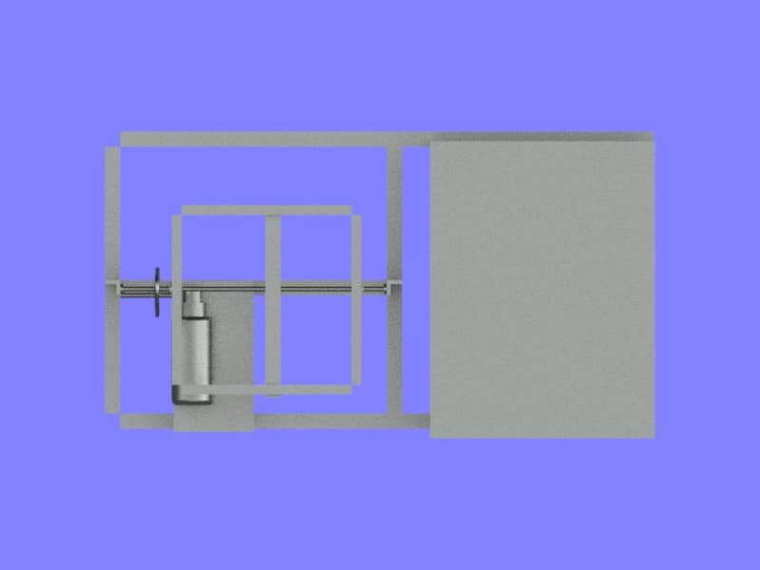
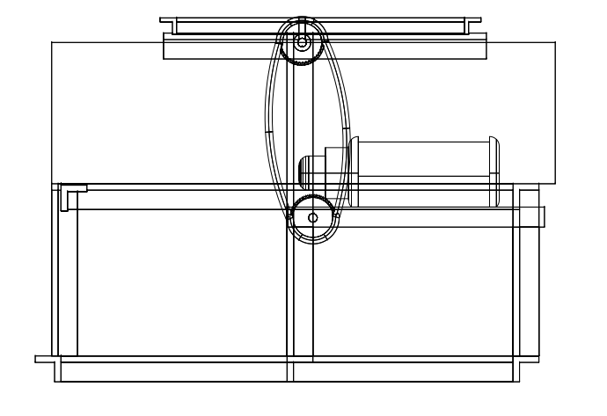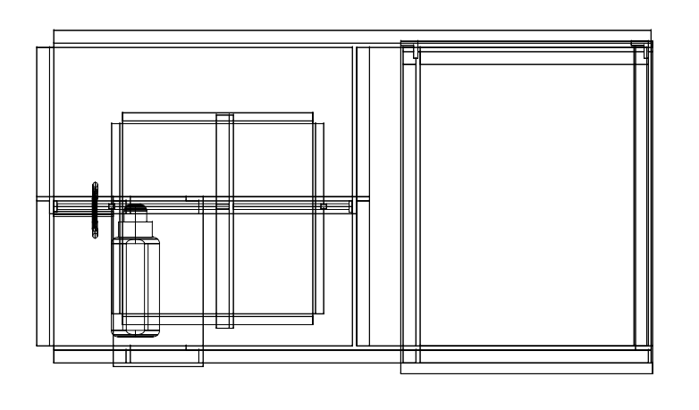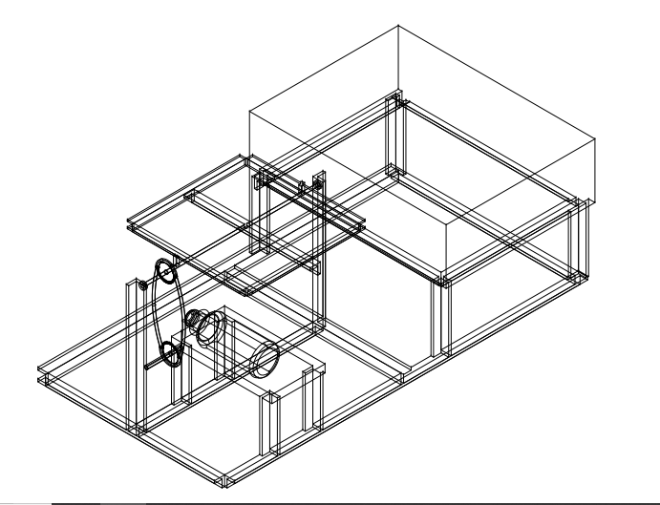

- BEME