Name: Orisunmibare Nimat
Department: Mechanical Engineering
Level: 500
Matric no:15/ENG06/058
Course code: MEE 510
Course title: Product Design

1)

2) Material Selection
The selection of materials for the development of certain products will be established successfully based on mechanical properties such as toughness, durability, flexibility, availability, flexibility, etc.

3) Factors considered in choosing materials
- Wood: Wood was selected for the frame of the project for the following reasons
- Adjustments can be made easily
- It was more economical as wood is cheaper than metal
- It does not affect the temperature of the system thereby acting as a neutral frame
- It can be made to be more presentable as compared to metal
- Copper pipe: The copper pipes are used to pass and eat the water from the cold storage to the hot storage tank. The copper was selected because of its conductivity properties.
- Fresnel lenses: The lenses converge the sunrays in straight lines and this is the most effective means of heating the water as it passes through the pipes.
- The Tank: The tanks have the thickness and durability required to hold the hot water which is the main point of the project and design
4) Design specification
The design is done the way it is to provide maximum flow of water as well as a simple means of refilling the tanks and cleaning of the lenses. The overall design gives room for maintenance that can be done by anyone.
5) Details drawing
*the details and dimensions may be off as changes were made in the process of fabrication.
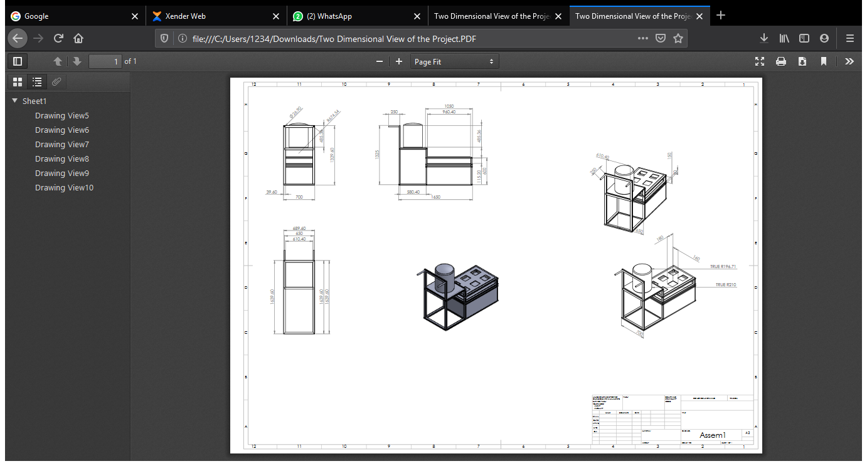

6)BEME
S/N | PART | QUANTITY | PRICE
1 | Insulation |  | 10,000
2 | Enamel paint | 1 liter | 3000
3 | Plumbing Fittings |  | 6,000
4 | Wood framing |  | 5,000
5 | Lens | 6 | 40,000
6 | Probe Thermometer | 1 | 20,000
7 | Tank | 3 | 5,000
8 | Simulation |  | 30,000
 | Total |  | 119,000

7) Design Calculations
8) Design process/ Manufacturing
- Project understanding
- Sketches
- Fabrication design
- Wood work fabrication
- Attachment of plumbing fittings to tank
- Project setup
- Adjustments
- Testing
- Further adjustments
- Final setup

