ASSIGNMENT PRODUCT DESIGN (MEE510)

BRIEF REPORT ON
PRODUCTION OF AUTOMOBILE BRAKE PAD USING COW HORN AS FILLER

BY AKINOLA OLUMAYOWA D.

MECHANICAL ENGINEERING

(15/ENG06/008)
INTRODUCTION
Transportation means moving objects or people from one location to another. Transportation is a key sector in the development of a nation. Transport is important because it enables communication, trade and other forms of exchange between people, which in turn establishes civilizations. It pays an important role in economic growth and globalization. There are various mode of transport namely: air, water, and land transport, which includes rail, and road. Transportation on road includes the use of vehicle. An integral and major part of a motor vehicle is brake. The designing of efficient brake friction material for passenger car and commercial vehicle becomes a vital issue which not only involves the complication of handling four prime classes of constituents (which are binder, fiber, filler and friction modifiers) but also reaching at a felicitous level of performance related demands such as: high and stable level of friction, low fade, more preponderant recovery, low wear and less noise at wide ranges of braking conditions,
In the past years asbestos is used in brake pad. But the asbestos used as the filler causes carcinogenic effects on human health. It leads to research on new materials especially agricultural residues or wastes. Agricultural residues and wastes are now emerging as new and inexpensive materials in the brake pads development with commercial viability and environmental acceptability for brake pad which possesses all the required properties. There are metallic, semi metallic and organic brake pad materials, In order to reduce or completely phase out the carcinogenic effect which may leads to lung cancer caused by using asbestos (Rinek & Cowen, 1995), it is necessary to find some other materials that can be used and that will be more environmental friendly. Thus, there has been a long felt need to find alternative reinforcing materials for the production of brake linings.
The main aim of this project is to produce a brake pad using non-asbestos material as filler.
The objectives of this project are:
- To produce a brake pad using the agricultural residue as a filler.
- To determine the mechanical properties, density of the brake pad.
To determine the friction co-efficient, specific gravity, and wear
This project work covers the evaluation of mechanical properties like compressive strength and hardness test, density, porosity, wear rate, specific gravity and friction coefficient of the asbestos – free automotive brake pads produced from cow horn and to compare it properties with that of the commercial brake pad.

MATERIALS SELECTION
The materials selected for the execution of the production of the ceiling sheet are those required to give it its best quality, with use of natural fibre.
These materials are as follows:
- Un pulverised Cow horns
- Graphite Kaolin
- Pulverised cow horns
- Filler: Barrium sulphate
- Frictional Additives: Alluminum oxide
- Rice husk
- Binder Resin: Epoxy Resin

FACTORS CONSIDERED IN MATERIAL SELECTION
Each material has its individual role to play as a content of a brake pad. They all play various benefitting roles that help to yield quality performance, which are considered as the factors for their selection.
They are as follows:
- Horn
Horns are growths that protrude from the skulls of some animals. Horns are made of two components: bone and keratin. The bone is the center, or core, of the horn and is fused to the bone of the skull. The bone core is covered by a resilient sheath (protective covering) made of keratin. Horns are a permanent part of the animal, which means the horns an animal is born with are the same horns it has its entire life. In other words, horns are not annually shed and re-grown like antlers. Horns do not branch out, but instead end in only one point on each side of the animal’s head. Depending on the species of animal horns might be found on both males and females, or males only. Horns are found on animals from the family Bovidae. The family Bovidae includes such species as cattle, sheep, goats, gazelles, antelope, bison, buffalo, and others. Bovids (animals from the family Bovidae) roam across the continents of North America, Europe, Asia, and Africa. In many species of Bovids horns are found on both males and females, but in some species are found on males only.
The two main components of the horn are the following:
- The bone: Bone is a porous, mineralized, and rigid organ. While it is one of the two items that make up a horn, bone is probably best known for making up the endoskeleton of vertebrates. In a living animal bone is alive, made up of osseous tissue, blood vessels, nerves, marrow, and other components.
- The keratin: Keratin is a tough, non-mineralized, protein. It not only makes up the sheath of a horn, it is also a primary component of hair, nails, claws, hooves, feathers, and the shells of tortoises, turtles, and terrapins.
- Reinforcing Fibers
The main objective of adding fibers in the friction materials is to increase the strength of the material. Fibers impart physical strength thereby increasing both strength and impact resistance of the brake pads and also provide resistance to thermal shocks. These fibers should have high strength, good thermal resilience, wear resistance, low thermal conductivity, and compatibility with wide varieties of binders and should be non-toxic and non-carcinogenic.
- It was observed by that reinforcing fibers play an important role in friction and wear performance (Eriksson and Jacobson, 2000). These fibers form primary plateaus during the sliding of the two surfaces that bear the actual braking load and prevent other constituents from degradation. Also, they support the secondary plateaus formed by the compacted wear debris. (Bach et al. 1999) observed that as the amount of reinforcing fibers decreases, wear resistance of the composite reduces. Many fibers such as ceramic, glass, metallic, aramid, carbon, cellulose, etc are in use as reinforcement in non –asbestos organic friction materials. Adding fibre to the mix improves the boards resistance to the hazards.

- Binder Resin
Binder resin provides a medium for binding and holding all ingredients together. Also, it protects other ingredients from environmental degradation and serves to transfer load from one insert to another. The interaction between fiber and binder matrix is one of the key factors to decide the composite strength of friction material. The behavior of the friction material is affected by the degree of polymer cross linking. Hence the selection of the binder resin is very important and depends on the other ingredients and the environmental conditions.
The proportion is much important as too little use of the binder weakens the material, while too much use results in friction drop-off at high temperatures. The binder should maintain the structural integrity under mechanical and thermal stresses, have high thermal stability and oxidation resistance, prevent other constituents from crumbling apart and be cheap to produce. Phenolic, COPNA (condensed polynuclear aromatic), cynate ester, cashew nut shell oil, epoxy modified & novolac etc. are some examples of the binder resins of which phenolic resin is the most common.
- Frictional Additives
Frictional additives, sometimes called as property modifiers, are added to improve frictional properties, i.e. friction and wear. These additives can be divided into two broad categories such as abrasives and non-abrasives (Bijwee 1997). Mineral, metal or metal oxides come under the abrasive type. During sliding of the friction pair, the temperature rise at the interface results in changes to the organic matrix. The degradation or softening of the binder often results in lowering the friction. In such cases, abrasives help to maintain the friction level constant. Particular abrasives are most effective at a particular temperature range only.
Therefore, in the friction formulations, more than one abrasive are added to cover the whole temperature range. A suitable blend of such abrasives will result in continuous and constant friction level. The amount and the particle size are also important issues. Quartz, Al₂O₃, SiC, zirconium oxide etc, are some examples of abrasive additives.
- Fillers
Fillers are low cost additives that are added in relatively high proportions. Fillers which are in the form of finely divided powder are mainly used to increase the volume of the composite & to reduce the manufacturing cost. Most of the fillers are non-reinforcing, so that they stiffen and the organic matrix gets weakened. Barium sulfate, calcium carbonate, rubber dust, mica, molybdenum trioxide etc. are some examples. Out of these, barium sulphate and calcium carbonate also impart heat stability to the friction material.
Friction materials are composites with many ingredients and these ingredients affect the tribological performance. Also, operating parameters such as normal pressure, sliding speed, temperature etc. have a major influence on friction and wear performance of brake materials as these parameters affect the sliding conditions as well as mechanical properties of sliding pair. This section reviews effect of ingredients and operating parameters on friction and wear performance.

MATERIAL CONTENT (% WT) IN THE BRAKE PAD.
Raw materials | Sample 1 | Sample 2 | Sample 3 | Sample 4
Epoxy Resin | 43 | 40 | 35 | 30
Rice husk | 20 | 20 | 20 | 20
Cow horn | 2 | 5 | 10 | 15
Graphite | 10 | 10 | 10 | 10
Alumina oxide | 13 | 13 | 13 | 13
Barrium Sulphate | 12 | 12 | 12 | 12
Total | 100 | 100 | 100 | 100

TESTS
Hardness test
The resistance of the produced brake linings to indentation was carried out using the ockwell hardness tester. It was done according to the provisions in American Society of Testing and Materials (ASTM) D2240. Each sample was placed on a hard flatten surface. The indenter of the instrument was then pressed into the specimen with an applied load of 50N for 15 seconds. The hardness value was read from the durometer. A sample with a thickness of 12 mm was used to carry out the test at different filler. The test was conducted using a 1/8-inch-diameter steel ball indenter with a load of 100 kg.

Compressive strength
The resistance of the developed brake pad to compression under compressive force or load was performed using the universal hydraulic material testing machine. Each sample was placed between the plates of the load frame. Force was applied gradually and the value was displayed on a digital device. Three samples from each formulation were tested for compressive strength and the average calculated. Equation 1 was used to calculate the compressive strength (σc) of the linings.
$σc=$ $\frac{F}{A}$ (1)
where F = Applied force, A = cross sectional area.

Relative density
The relative density of the brake linings were found using Archimedes principle. The buoyant force on a submerged object is equal to the weight of the fluid displaced (Talib, 2007; Nirmal et al., 2011). The samples were weighed in air and when fully immersed in a beaker of water by means of a thread without touching the walls of the beaker. The weight difference is equal to the volume of water displaced, which is to the volume of each sample. The relative density (ρbr) was calculated using Equation 2;
ρbr = $\frac{Wa}{Wa-Ww}$ (2)
where Wa = weight in air (g), Ww = weight in water (g).

Wear rate
The wear test was carried out using an adopted method [16]. The method involves placing each sample (clamped rigidly in position) along the disc of a grinding machine for 10 seconds. The weights of the samples were taken before and after grinding. The weight difference from each sample indicates the lost in weight. The speed of the grinding machine and its disc diameter were 6500 revolutions per minute (rpm) and 180 mm respectively. The wear rate (Wr) was calculated using Equation 3.
Wr = $\frac{ΔW}{2πNRt}$ (3)
where ΔW = weight loss (weight difference before and after wear (g), R = radius of disc (m), N = speed in rpm, t = time it takes each sample on the grinding machine (min).
Water and oil absorption
The water and oil (SAE 20/50) absorption of the samples was determined by soaking the samples in water and oil for 24 hours. Before the test, the samples were oven dried and the weight measured. The samples were cleaned after 24 hours in water and oil, and weighed. The percentage absorption was calculated using equation 4 (Idris et.al, 2015).
Absorption = $\frac{W-Wo}{Wo} X100$ (4)
where Wo = weight of sample before immersion (g), W1 = weight of sample after immersion.

Friction test
Inertia dynamometer was used for conducting friction and wear tests. Brake pad sample along with back plate were assembled in disc brake pad caliper. Once the brake pad assembly is over, dynamometer is operated until the pad fully worn out. During this period friction coefficient, wear at different temperatures and at different speeds were recorded by data acquisition system. Stopping time, brake release time, and temperature generated at contact surfaces were monitored.

DESIGN CALCULATIONS
Result of Elemental Composition of Cow Horn and Others
The result of elemental composition of the pulverized cow hooves determined using the X-ray fluorescence is presented in Table below which has the following properties:
Bulk density of pulverized cow hooves = 683 kg/m3
Specific gravity of pulverized cow hooves = 1.89
While the results shown in Figures below are for the tests of hardness, compressive strength, coefficient of friction, relative density, wear rate, water absorption, and oil absorption for the developed brake lining samples respectively.

Tab X-ray fluorescence analysis of cow horns
Element | Percentage
Silicon | 50.20
Phosphorous | 15.30
Sulphur | 1.3
Potassium | 21.30
Calcium | 5.5
Titanium | 1.4
Barrium | 0.19
Manganese | 1.24
Iron | 3.22
Silver | 0.3
Zinc | 0.246
Rubidion | 0.33
Scrontium | 0.092
Yttrium | 0.05
Zarconium | 0.29
Copper | 0.0001
Vanadium | 0.3
Europium | 0.2
Rhenium | 0.1

Variation of hardness with different samples of brake pad

Variation of compressive strength with different samples of brake pad

Variation of coefficient of friction with different samples of brake pad

Variation of relative density with different samples of brake Pad

Variation of wear rate with different samples of brake Pad

Comparison of results of cow horn brake pad with existing formulations
Property
Property | Commercial (Asbestos based) | Formulation (PKS based) | Formulation (Bagasse based) | Sample 3 (Pulverized cow hooves) | Sample 4 (Pulverized cow hooves)
Hardness(HRD) | 60.0 | 59.4 | 62.5 | 69.3 | 68.4
Compressive strength (Mpa) | 110 | 103 | 105.6 | 65 | 60
Coefficient of friction | 0.3-0.4 | 0.43 | 0.42 | 0.41 | 0.38
Relative density | 1.89 | 1.65 | 1.43 | 1.63 | 1.65
Wear rate (g/m) | 0.0038 | 0.0044 | 0.0042 | 0.005 | 0.0065
Water absorption (%) | 9.0 | 5.03 | 8.48 | 7.10 | 9.00
Oil absorption (%) | 3.0 | 4.0 | 4.5 | 3.5 | 4.5
Toxicity | Toxic | Non-toxic | Non-toxic | Non-toxic | Non-toxic

BEME
The breakdown of the B.E.M.E is with my supervisor and I am not able to access it because of unforeseen occurrence on my end.

DESIGN PROCESS
The cow horns were obtained from a local abattoir, washed and properly sun-dried. The horns were further dried in an electric vacuum oven for three hours at 250ºC to remove contaminating oil. The hooves were crushed using pestle and mortar and further grounded into powder in a conventional mill and thereafter sieved using sieve size of 710μm. Graphite was obtained from dead dry cell batteries which was crushed into powder and sieved using 710μm sieve size. The elemental composition of the pulverized cow horns was determined by X-Ray Fluorescence (XRF) by forming the pulverized cow hooves into pellet using a pelletizer with hydraulic press. The pellet was then enclosed in the chamber of the XRF and allowed to run for 1000 seconds at a voltage of 25kV and a current of 50μA. The resulting spectrum measures the elemental composition of cow horns
The raw material was mixed in the proportion as shown in the table. Mould was made from a 10mm mild steel plate (the mould served as a place where the raw materials were poured after mixture just to allow it solidifies before attaching it to the aluminum plate). The rice husk, cow horn, graphite, alumina oxide, barrium sulphate, and epoxy resin were mixed together. The mixture was poured into the already prepared mould and the mould containing the matrix mixture was transferred to a hydraulic press and subjected to hot pressing at a temperature of 70°C, and pressure of 30MPa for ten minutes. The product was then allowed to cool at a room temperature between (27-30°C). It was subsequently post cured in an electric oven at a temperature of 180°C for one hour and allowed to cool to room temperature.
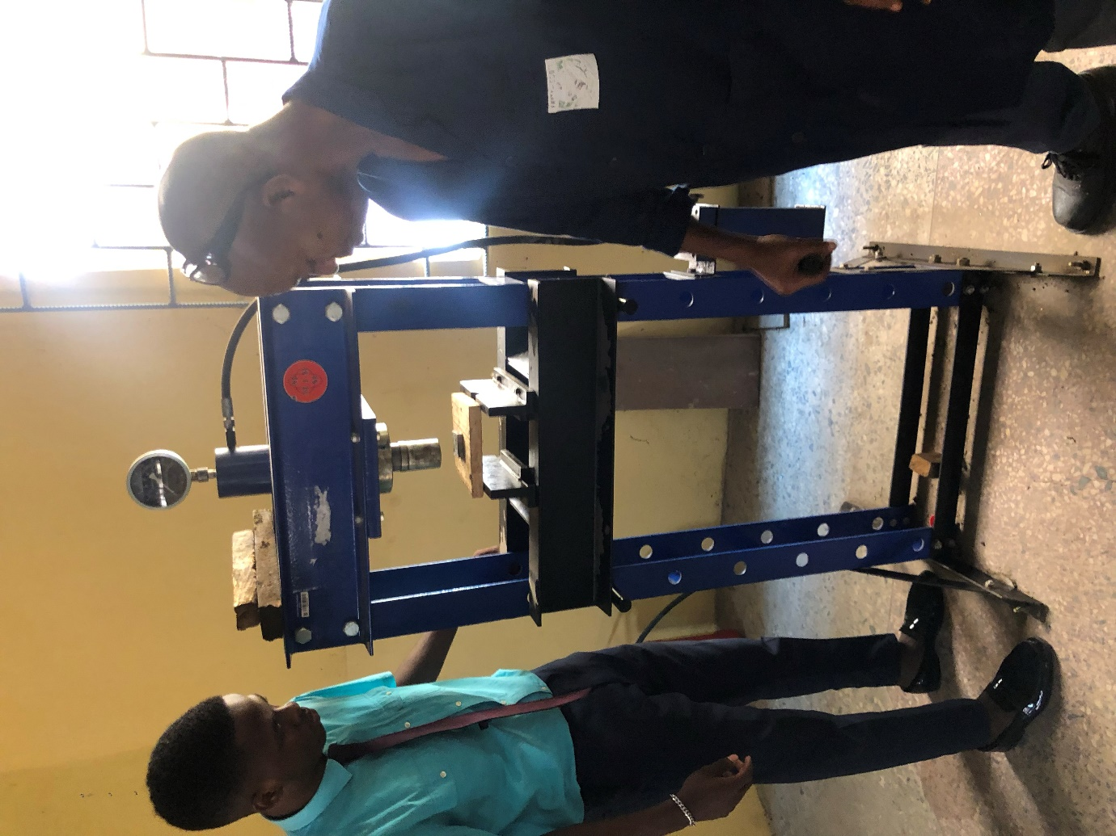
Pressing samples with hydraulic press

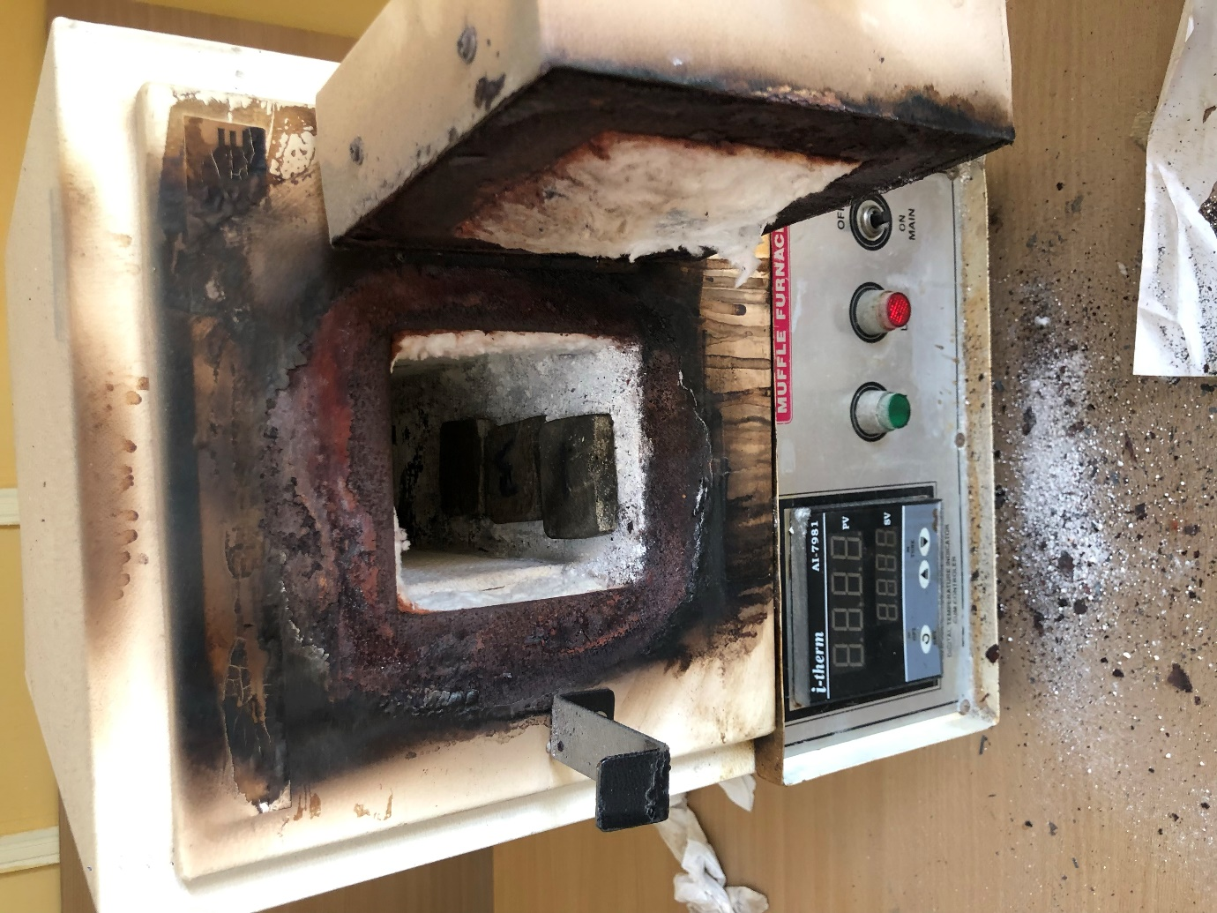
Curing process with electric oven

The binder which happens to be the epoxy resin, the purpose of the binder is to maintain the brake pads structural integrity under mechanical and thermal stresses. It holds the components of a brake pad together and prevents its constituents from crumbling apart.
The cow horn which serves as the filler in the brake pad are present for the purpose of improving its manufacturability as well as to reduce the overall cost of the brake pad.
Abrasives and lubricants are considered as friction additives, abrasives in a friction material increase the friction coefficient. The abrasive which is the barium sulphate remove iron oxides from the counter friction material as well as other undesirable surface films formed during braking. The lubricant used was graphite which stabilizes developed friction coefficient at high temperature. The rice husk serves as the reinforcement; the purpose is to increase mechanical strength to the friction material. The combination is to help in determining the right combination when producing the brake pad. The four samples produced using different mix ratio in accordance.
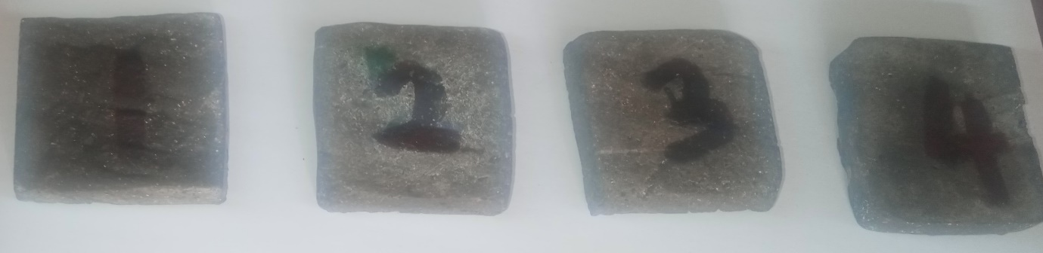
Pictures of the brake pads produced
CONCLUSION
The developed brake pad show that pulverized cow horns is a suitable material for brake pad with required characteristics. The analysis of the experiments conducted shows that: Pulverized cow horns contain non-toxic elements and its density values make it suitable in brake pad application. Compressive strength, hardness, relative density and coefficient of friction of the produced samples were seen to be increasing with increase in percentage epoxy resin and decrease in pulverized cow horns. While the water and oil absorption and wear rate decreased as epoxy resin increased and pulverized cow hooves decreases. The sample 3 containing 10% pulverized cow hooves, 35% epoxy resin and pad formulation. The results obtained compared favorably with that of commercial brake pad and other experimental brake pad formulations an indication that, pulverized cow horns can be used to replace asbestos in brake lining formulations.

