DEVELOPMENT OF MULTIPURPOSE FIRE EXTINGUISHER WITH NEW FORMULATED POWDER
PREPARED BY
SHOFARASIN GODSWILL OLUMIDE
15/ENG06/063

SUBMITTED TO
THE DEPARTMENT OF MECHANICAL AND MECHATRONICS ENGINEERING,
COLLEGE OF ENGINEERING,
AFE BABALOLA UNIVERSITY, ADO-EKITI, EKITI STATE, NIGERIA.

IN PARTIAL FULFILMENT OF THE REQUIREMENTS FOR THE AWARD OF BACHELOR OF ENGINEERING (B.ENG) DEGREE IN MECHANICAL ENGINEERING.

JUNE, 2020

DECLARATION

CERTIFICATION
This is to certify that this project was carried out by SHOFARASIN, Godswill Olumide with matriculation number 15/ENG06/063 under the supervision of Dr Kazeem Bello and submitted to the department of mechanical and mechatronics engineering, college of engineering, Afe Babalola Univeristy, Ado-Ekiti, Ekiti state, in partial fulfilment of requirements for the award of Bachelor of Engineering (B.ENG) degree in Mechanical Engineering.

____________________ _______________
Dr BELLO DATE
Project supervisor

____________________ ________________

Head of Department DATE

____________________ _______________
External Examiner DATE

DEDICATION
This project is dedicated to God and to my parents, Mr. and Mrs. Nathaniel Shofarasin for their love and support throughout the course of this project.

ACKNOWLEDGEMENT
With a heart full of appreciation, I humbly wish to express my profound gratitude to all those who in one way or the other contributed to my project work.
My sincere regards and thanks to my parents Mr. and Mrs. Nathaniel Shofarasin for their love, care and prayers and for always standing by me.
My sincere appreciation also goes to my supervisor Dr. Bello for his great support, guidance and direction throughout the course of the project.
Finally to God Almighty for his continued protection, mercy and abundant blessing always.

ABSTRACT
In introductory chapters, the complexities of relationship between man and fire are discussed as well as the status of human efforts to control its disastrous effects. A subsequent section examines characteristics and behavior of fire. Fire disaster is a common threat to lives and property. A newly improved chemical compound of dry chemical powder is going to be a game changer in the firefighting world as this paper presents a low cost, more effective means of combating the menace that is fire outbreak.
TABLE OF CONTENT

LIST OF FIGURES

LIST OF TABLES

NOMENCLATURE

LIST OF SYMBOLS

CHAPTER ONE

INTRODUCTION

1.0 Background
Fire is an element that is necessary for our everyday activities, from domestic uses such as cooking, smoking, to industrial uses such as in furnace ovens, to even reliving stone age experiences such as bushfire camping. It is important to know that in as much as it is necessary, it has its perks when it gets out of control and certain measures have to be put in place in order to reduce destruction and eliminate the threat which is the out-broken fire as it is. Fire is the result of a chemical reaction called combustion. At a certain point in the combustion reaction, called the ignition point, flames are produced. Flames consist primarily of carbon dioxide, water vapour, oxygen, and nitrogen. There is more to fire than just the emission of heat and light. Fire, simply put, is a chemical process of combustion involving the oxidation of a fuel source at a high temperature; it releases energy and produces heat and light. In our country fire accident is a very common phenomenon. Many wealth and lives are fallen in danger.
1.3 Statement of the problem
As a developing country we have no modern technology to solve this problem. Nowadays, securing one’s property and business against fire is becoming more and more important. Monitoring commercial and residential areas all-round is an effective method to reduce personal and property losses due to fire disasters

1.4 Aim of the study
The aim of this study is to be able to combat fire more effectively with even lesser resources(to be updated)
1.5 Objectives of the study
The primary objectives of this study is to develop a new chemical compound for more effective firefighting.(to be updated)
1.6 Justification of the Study
Reasons why the research is being conducted(to be updated)

1.7 Scope of the study
This contains areas to be covered by your work. Your scope of study comes down to tailor down the specific areas to focus on so that it shows us the boundaries in your work. Talk about the structure of the project work. (to be updated)

CHAPTER TWO

LITERATURE REVIEW

2.1 State of Matter of Fire
In a candle flame or small fire, most of the matter in a flame consists of hot gases. A very hot fire releases enough energy to ionize the gaseous atoms, forming the state of matter called plasma. Examples of flames that contain plasma include those produced by plasma torches and the thermite reaction.

Stages of fire
There are four stages of fire, including:
- Ignition: At this stage, a fire extinguisher can control the fire.
- Growth: Additional fuel ignites, causing the size of the fire to increase.
- Fully developed: This is when temperatures reach their peak, causing damage.
- Burnout: The fire gets less intense and begins to die out.
Fire can destroy your house and all of your possessions in less than an hour, and it can reduce an entire forest to a pile of ash and charred wood. It is also a terrifying weapon, with nearly unlimited destructive power. Fire kills more people every year than any other force of nature. But at the same time, fire is extraordinarily helpful. It gave humans the first form of portable light and heat. It also gave us the ability to cook food, forge metal tools, form pottery, harden bricks and drive power plants. There are few things that have done as much harm to humanity as fire, and few things that have done as much good. It is certainly one of the most important forces in human history…but fire is really something completely different. Earth, water and air are all forms of matter -- they are made up of millions and millions of atoms collected together. Fire isn't matter at all. It's a visible, tangible side effect of matter changing form – it is one part of a chemical reaction.

2.2 Fire Triangle
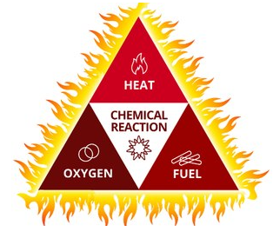

Figure 1: pictorial representation of the fire triangle

A simplified cousin to the fire tetrahedron, the fire triangle is a model for conveying the components of a fire. The fire triangle’s three sides illustrate the three elements of fire, which are heat, fuel and oxidization. The three elements must be combined in the right proportions for a fire to occur. If any of the three elements are removed, the fire is extinguished. The first element in the fire triangle is heat, which is perhaps the most essential of fire elements. A fire cannot ignite unless it has a certain amount of heat, and it cannot grow without heat either. One of the first things firefighters do to extinguish a fire is to apply a cooling agent – usually water. Another cooling agent is a chemical fire retardant, such as the ones used in fire extinguishers. Another method of diffusing heat from a fire is to scrape the embers from the fire source, such as wood embers on a burning building. Firefighters will also turn off the electricity in a burning building to remove a source of heat. The second element in the fire triangle is fuel. A fire needs a fuel source in order to burn. The fuel source can be anything that is flammable, such as wood, paper, fabric, or chemicals. Once the fuel element of the fire triangle is removed, the fire will go out. If a fire is allowed to burn without any attempt to extinguish, it will extinguish on its own when it has consumed all of the fuel. The final element of the fire triangle is oxygen, which is also an essential component of fire. A fire needs oxygen to start and continue. That is why one recommendation for extinguishing a small fire is to smother it with a non-flammable blanket, sand or dirt. A decrease in the concentration of oxygen retards the combustion process. In large fires where firefighters are called in, decreasing the amount of oxygen is not usually an option because there is no effective way to make that happen in an extended area. An alternative to the fire triangle model is the fire tetrahedron. The fire tetrahedron adds another element to the fire, which is chemical reaction. Fires involving metals such as titanium, lithium and magnesium have a chemical reaction that requires a different approach for firefighters. This is called a class D fire and the application of water will exacerbate the combustion. Because of the chain reaction caused by the metals in class D fires, firefighters must use a different approach involving the introduction of inert agents like sand to smother it. Learning about the fire triangle is a good way to understand the elements of fire and is an essential component of firefighting education.
In order for fire to take place, the following conditions must be in place
- There must be enough oxygen to sustain the combustion
- There must be enough heat to raise the material to its ignition temperature
- There must be some sort of fuel or combustible material
The chemical, exothermic reaction results in a fire.
The elements of Oxygen and fuel are always present therefore, eliminating and or controlling heat [ignition] sources is of primary importance in preventing the occurrence of fires. It is important to note or recognize that, the absence of any one of the essential elements as shown on the side of the fire triangle can eliminate fire occurrence.
- Oxygen removal: Since fire needs at least 16% of oxygen concentration on the atmosphere for burning, we can remove oxygen level by reducing its percentage to below 16. This we can do by purging and inserting carbon (IV) oxide in the atmosphere in closed containers or processing systems. Foam can also be used to produce a smothering action against oxygen actions.
- Fuel removal: It is practically impossible for us to remove all fuels in our daily operations. Despite the above fact, we need to try and keep the quantity of stored combustible materials at a minimum.
- Heat source control: The elementary steps in fire prevention are through eliminating and controlling of heat sources.
Heat generation can be eliminated through the control use of welding and cutting equipment, torches, heating equipment, spark producing equipment, and smoking materials. We should keep heat and ignition sources away from fuel; we need to know that the best time to stop a fire is before it starts.

2.3 Methods of fire extinction
There are three principal methods of extinction and the methods are listed below.
They include; i. cooling ii. Smothering iii. Starvation.
Cooling;
- The reduction of heat below ignition temperature by the application of a fire extinguisher (i.e. water or cooling agent e.g. foam) onto a burning substance. The water is applied either in bulk jet or spray. This method removes heat from the triangle of combustion or triangle of fire. It is used in class A fires.
Smothering;
- The cutting off or reduction in the supply of oxygen to the fire. There are certain substances that produce their own oxygen [oxidizing agents] required for combustion. This method may be ineffective or inadequate. It is used in classes B, C and D.
- Examples of smothering processes include;
- Covering burning cooking oil with a non-combustible cover/lid.
- Use of fire blanket.
- Use of dry chemical powder [DCP] for class B and D fires only. Special DCP called TEC- Ternary Eutectic Chloride is used in class D.
- By inserting the burning vicinity with an inert gas e.g. carbon iv oxide CO_{2,} in classes B and C.
- Use of foam and graphite can also be used in class D fires.
Starvation;
- Starvation is the removal of fuel from the vicinity of fire thereby starving the fire of combustible materials. It is used in classes B and C.
Examples of starvation or removal of fuel supply includes;
- Shutting of a gas supply.
- Draining of fuel from burning oil tanks.
- Throwing away combustible materials from a houseboat.

Table 1: classes of fire
Fire class | Pictogram | Mnemonics | Sources/causes
A | 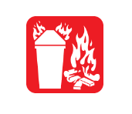 | A for Ash | Are fires caused by the burning of ordinary combustibles such as wood, paper, cloth, rubber, and many plastics
B | 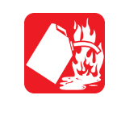 | B for Barrel | Are fires caused by the burning of flammable liquids such as gasoline, petroleum, greases, tars, acetone, solvents, alcohols etc. Inflammable gases such as propane and butane are also included
C | 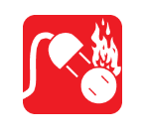 | C for Current | This type of fires are fires involving energized electrical equipment such as computers, servers, motors, transformers and appliances
D |  | D for Dynamite | Are fires caused by the burning of combustible metals such as magnesium, titanium, zirconium, sodium and potassium
E | 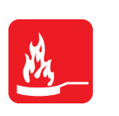 | K for Kitchen | Are fires caused by the burning of cooking oils and greases such as animal and vegetable fats.

2.4 Fire extinguishers
A fire extinguisher is an active fire protection device used to extinguish or control small fires, often in emergency situations. It is not intended for use on an out-of-control fire, such as one which has reached the ceiling, endangers the user (i.e., no escape route, smoke, explosion hazard, etc.), or otherwise requires the expertise of a fire brigade. Typically, a fire extinguisher consists of a hand-held cylindrical pressure vessel containing an agent which can be discharged to extinguish a fire. Fire extinguishers manufactured with non-cylindrical pressure vessels also exist but are less common.

2.4.1 Categories of fire extinguishers
Fire extinguishers are grouped into two main categories; manual and automatic extinguishers.

2.4.2 Manual extinguisher
The manually operated can either be stored-pressure and cartridge-operated. In stored pressure units, the expellant is stored in the same chamber as the firefighting agent itself. Depending on the agent used, different propellants are used. With dry chemical extinguishers, nitrogen is typically used; water and foam extinguishers typically use air. Stored pressure fire extinguishers are the most common type. Cartridge-operated extinguishers contain the expellant gas in a separate cartridge that is punctured prior to discharge, exposing the propellant to the extinguishing agent. This type is not as common, used primarily in areas such as industrial facilities, where they receive higher-than-average use. They have the advantage of simple and prompt recharge, allowing an operator to discharge the extinguisher, recharge it, and return to the fire in a reasonable amount of time. Unlike stored pressure types, these extinguishers use compressed carbon dioxide instead of nitrogen, although nitrogen cartridges are used on low temperature (-60 rated) models. Cartridge operated extinguishers are available in dry chemical and dry powder types in the U.S. and in water, wetting agent, foam, dry chemical (classes ABC and BC), and dry powder (class D) types in the rest of the world.
The first fire extinguisher of which there is any record was patented in England in 1723 by Ambrose Godfrey, a celebrated chemist at that time. It consisted of a cask of fire-extinguishing liquid containing a pewter chamber of gunpowder. This was connected with a system of fuses which were ignited, exploding the gunpowder and scattering the solution. This device was probably used to a limited extent, as Bradley's Weekly Messenger for November 7, 1729, refers to its efficiency in stopping a fire in London. Fire extinguishers are further divided into handheld and cart-mounted (also called wheeled extinguishers). Handheld extinguishers weigh from 0.5 to 14 kilograms, and are hence, easily portable by hand. Cart-mounted units typically weigh more than 23 kilograms. These wheeled models are most commonly found at construction sites, airport runways, heliports, as well as docks and marinas.
There is also the not so popular fire extinguishing ball. Elide Fire Ball is a revolutionary invention that can by itself extinguish fires. This small fire extinguisher in the shape of ball was developed by Thai inventor Mr. Woradech Kaimart. He spent a lot of experiments and got a bunch of rewards for this adaptation of this portable extinguish. Elide Fire Ball made of a lightweight casing of rigid plastic foam with an abrasion-resistant exterior sheathing. Inside this mini automatic fire suppression ball is a device with different fillers that explodes automatically. These are fire retardant substances like: dry chemical powder, two-part reactants and liquid components. This ball is quite simple to use since it only works when the fire is. Therefore, you can store it anywhere: at home, in the car, in the kitchen, in the room. To use the Elide Fire, you need to throw it into the fire and in 5-10 seconds, it is activated. The ball explodes and all the chemical powder goes out over an area of 8-10 square meters. Thus, oxygen leaves the fire and the powder directly extinguishes the fire. Its advantage is that it can be used by women, the elderly and even children.
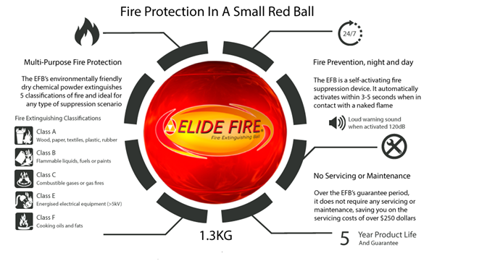

Figure 2: fire extinguisher ball (elide fire, 1997)
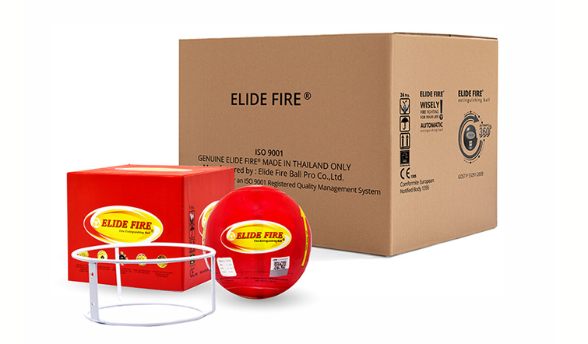

Figure 3: elide fire extinguisher ball

2.4.3 Automatic extinguishers
Automatic extinguishers basically operate the aid of sensory detectors. The sensors detect fire in the case of an emergency and the extinguishing agent is released and set to work on the fire.

2.4.4 Types of fire extinguishers
- Water and foam extinguisher: they extinguish the fire by taking away the heat element of the fire triangle. Foam agents also separate the oxygen element from the other elements. Water and foam extinguishers are for class A fires only-they should not be used on class B or C fires because the discharge stream could spread the flammable liquid in class B fire or could create a shock hazard in a class C fire as water is a conductor. Water and foam extinguishers are pressurized with CO₂. The liquid chemical produces thick foam (which is really dense that it would take a while for evaporation to take place) when pressurized and when such foam is dispensed, air is unable to penetrate.

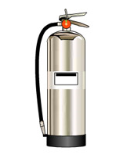

Figure 4: water fire extinguisher
- Carbon dioxide extinguisher: they extinguish fire by taking away the oxygen element of the fire triangle and also removing the heat with a very cold discharge. Carbon dioxide can be used on class B and C fires and they are usually ineffective on class A fires because they may not be able to displace enough oxygen to successfully put out the fire. The extinguishers are filled with non-flammable carbon dioxide gas under extreme pressure. You can recognize a CO₂ extinguisher by its hard horn and lack of pressure gauge. The pressure in the cylinder is so great that when you use one of these extinguishers, bits of dry ice may shoot out the horn. CO₂ cylinders are red and range in sizes from 5lbs to 100lbs or larger. In the larger sizes, the hard horn will be located on the end of a long flexible hose.
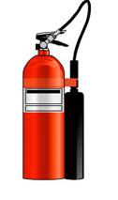

Figure 5: CO2 extinguisher
- Dry chemical extinguisher: they extinguish the fire primarily by interrupting the chemical reaction of the fire triangle. Today’s most widely used type of fire extinguisher is the multipurpose dry chemical that is effective on class A, B and C fires. The agent also works by creating a barrier between the oxygen element and fuel element on class A fires. Ordinary dry chemical powder is for class B and C fires only. Dry Chemical Powder (ABC Class) are mono ammonium phosphate-based powders that are generally for multipurpose use on Class A, B and C fires.
Mono ammonium phosphate, ABC Dry Chemical, ABE Powder, tri-class, or multi-purpose dry chemical is a dry chemical extinguishing agent used on class A, class B, and class C fires. It uses a specially fluidized and siliconized mono ammonium phosphate powder. ABC dry chemical is usually a mix of mono ammonium phosphate and ammonium sulfate, the former being the active one. The mix between the two agents is usually 40–60%, 60-40%, or 90-10% depending on local standards worldwide. The USGS uses a similar mixture, called Phos Chek G75F.
Dry chemical powder used on all classes of fires. Stops the chain reaction by smothering. Pressure is generated by Gas cartridges stored inside the cylinder. Its force will last for 2 minutes and can reach 10 – 15 feet
The powder breaks the chain reaction of liquid and gas fires by coating the surface to which it is applied. These fires (Class B in the American system; Classes B and C in the European and Australian systems) include the burning of gasoline, oil, propane, and natural gas.
ABC dry chemical is inappropriate for chlorine or oxidizer fires.^{[6]} The resulting chemical reaction can cause an explosion or a breakdown of the chemicals releasing toxic gases. Water should be used in that case.
ABC dry chemical is inappropriate for certain metal fires (Class-D) and does not possess a saponification characteristic and should therefore not be used on Class K fires.^{[9]} ABC dry chemical has been found to be effective in initially ceasing combustion of oils or fats, however re-application of additional dry chemical may be necessary due to the potential for re-flash of oils or fats heated to near or at their flash point. A Class K extinguisher is more effective in controlling fires involving primarily vegetable oils as it causes a chemical change to the oils or fats making re-flash far less likely. When a Class K extinguisher is not available an ABC dry chemical extinguisher can be carefully used to control a fire involving cooking oils or fats if the operator is aware of the potential need to re-apply more chemical if the oils or fats reignite. (Class-K).
Due to the corrosive properties of ABC dry chemical, it is not recommended for use around aircraft or sensitive equipment.

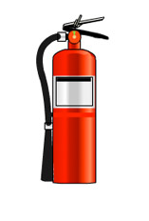

Figure 6: DCP extinguisher

2.4.5 How do fire extinguishers work
Fire extinguisher come equipped with cartridges and the cartridge is the component that contains extinguishing agent. When the lever is acted upon, it is pushed down and the gas is forced out into the cylinder, thereon acting on the cylinder content, forcing it out of the cylinder.
Fire extinguishers can be heavy, so it's a good idea to practice picking up and holding an extinguisher to get an idea of the weight and feel.
Take time to read the operating instructions and warnings found on the fire extinguisher label. Not all fire extinguishers look alike.
Practice releasing the discharge hose or horn and aiming it at the base of an imagined fire. Do not pull the pin or squeeze the lever. This will break the extinguisher seal and cause it to lose pressure.

2.4.6 Making use of an extinguisher
When it is time to use the extinguisher on a fire, just remember PASS!
P - Pull the pin.
A - Aim the nozzle or hose at the base of the fire from the recommended safe distance.
S - Squeeze the operating lever to discharge the fire extinguishing agent.
S - Starting at the recommended distance, Sweep the nozzle or hose from side to side until the fire is out. Move forward or around the fire area as the fire diminishes.

2.4.7 When to combat a fire
One should only attempt to fight a fire if any or all of the following conditions are met:
- The fire is small and contained
- You are safe from toxic smoke
- You have a means of escape
- Your instincts tell you it's okay to proceed
- You have previous experience
- You are a qualified firefighting personnel
NB. Co2 extinguisher is toxic to asthmatic patients.
Dry chemical powder blankets the fire. It is pressurized with co2 which is responsible for the forceful output. It is poisonous and corrosive to surfaces if left exposed for a long period of time.

2.5 Suppression of fire
Rate of spread is the forward rate of spread at the head of a surface fire, whereas heat
per unit area is a measure of heat released by a square foot of fuel within the flaming zone. Flame length is the length from the midway of active flaming zone to the average position of the flame tip, while fire line intensity is the amount of heat released per second by a foot wide slice of the flaming combustion zone.

Table 2: Fire suppression index
Flame Length (feet) | Fireline Intensity (Btu/ft/s)  (British thermal unit/feet/second) | Interpretation
<4 | <100 | ● Fire can be attacked at the head or flanks by persons using hand tools.  ● Handline should hold the fire.
4–8 | 100–500 | ● Fires are too intense for direct attack on the head by persons using hand tools.  ● Handline cannot be relied on to hold fire.  ● Equipment such as plows, dozers, pumpers, and retardant aircraft can be effective.
8–11 | 500–1000 | ● Fires may present serious control problems-torching out, crowning, and spotting.  ● Control effort at the fire head will be ineffective.
>11 | >1000 | ● Crowning, spotting, and major fire runs are probable.  ● Control efforts at the head of fire are ineffective.

CHAPTER THREE

3.0 Refilling of extinguishers

If the fire extinguisher is used, even partially, it is useless in case of a subsequent fire scenario. Hence it is essential to get the fire extinguisher recharged immediately, without any delay. The statutory framework in the country makes it mandatory for the shell of the fire extinguisher to undergo Hydrostatic Pressure Test every 3 years. The extinguisher refilling activity is often carried out by unskilled and untrained people in a highly compromised environment.
- In most cases refilling by the local players means only re-pressurizing of the cylinder. No component of the extinguisher is actually changed as a process.
- Only broken / dis functional parts are changed with local spares.
- In most cases the extinguishing agent (ABC Powder) is recycled. The top up is done many times with the local/sub-standard ABC powder.
- These days rampant use of marble dust being added as extinguishing agent by local players are being reported.

3.1 Refilling Process

The Fire Extinguisher is manually discharged / fired and emptied.
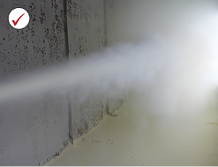
The extinguisher is then dismantled completely; cylinder is de-stressed
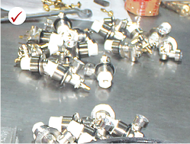
The cylinder then is made to undergo a Hydro Static Pressure Test at 30kgf cm sq
for 2 minutes to check for leaks and the burst capacity.
New extinguishing agent (powder, gas, water or foam) is filled in the cylinder through a vacuum based process that fills the cylinder with exact quantity of extinguishing agent.
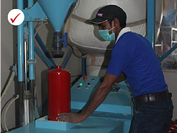
New Discharge fitment mechanism including all new rubber seals, O rings,
and hose pipe (EPDM with 50 kg burst capacity) are attached.
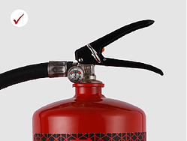
Fire extinguisher is charged pressurized) with 99.99% pure nitrogen mixed with helium.
The Fire Extinguisher is then made to go through Leak tests. The first is an inverted beaker test in water. The extinguishers also undergo a Mass Spectro Meter Helium Leak Detection Test which is the most advanced leak detection technology available currently in the world.

CHAPTER FOUR

CHAPTER FIVE

CONCLUSION AND RECOMMENDATION

CHAPTER SIX

REFERENCES
Z. Liu, A. K. Kim, and D. Carpenter, "A study of portable water mist fire extinguishers used for extinguishment of multiple fire types," Fire safety journal, vol. 42, pp. 25-42, 2007.
WSO Nigeria; HEALTH, SAFETY, SECURITY AND ENVIRONMENT
https://www.femalelifesafety.org
www.firesafe.org.uk
https://en.wikipedia.org/wiki/Firefighting_foam
https://en.wikipedia.org/wiki/Firefighting_history
https://en.wikipedia.org/wiki/fire
https://www.researchgate.net/publication/331047112_Use_of_Fire-Extinguishing_Balls_for_a_Conceptual_System_of_Drone-Assisted_Wildfire_Fighting
https://www.bing.com/search?q=fire+fighting+project+report&form=EDGEAR&qs=PF&cvid=2cd60a8250804e1baf3a88fdf18c2205&cc=NG&setlang=en-US&PC=HCTS
https://www.bing.com/search?q=fire+extinguisher+project+report&qs=n&form=QBRE&sp=-1&pq=fire+extinguisher+project+report&sc=1-32&sk=&cvid=10C95ECDA2724E8D8324414693E8C2CF
https://www.researchgate.net/publication/248066856_Na-X_a_new_fire_extinguishing_agent_for_metal_fires
https://www.researchgate.net/publication/303366944_Comparative_analysis_of_extinguishing_agents_for_structural_firefighting/citation/download
https://www.cityfiresafety.in/refilling-of-fire-extinguisher.html

APPENDIX

Firefighting
Firefighting is the act of extinguishing fires. A firefighter fights fires to prevent loss of life, and/or destruction of property and the environment. Firefighting is a highly technical skill that requires professionals who have spent years training in both general and firefighting techniques.
Firefighter’s duties
Any and everybody who combats fire can be termed a firefighter, emphasis on extinguishing it. Firefighters’ goals are to save lives, property, and the environment. A fire can rapidly spread and endanger many lives; however, with modern techniques, catastrophe is usually, but not always avoided.
Hazards caused by fire
The four major hazards associated with these situations are as follows:
Smoke, which is becoming increasingly dangerous due to the rise in synthetic household and office materials.
Oxygen deficient atmosphere, 21% O₂ is normal, 19.5% O₂ is considered deficient
Elevated temperatures
Toxic atmospheres
Reconnaissance and reading of fire
The first step of a firefighting operation is a reconnaissance to search for the origin of the fire (which may not be obvious for an indoor fire, especially when there are no witnesses), and identification of the specific risks and any possible casualties. Any fire occurring outside may not require reconnaissance on the other hand, a fire in a cellar or an underground car park with only a few centimeters of visibility may require a long reconnaissance to identify the seat of the fire. The “reading” of the fire on the other hand is the analysis of the firefighters of the forewarnings of a thermal accident (flashover, backdraft, smoke explosion), which is performed during the reconnaissance and the fire suppression maneuvers. The main signs are:
- Hot zones, which can be detected with a gloved hand, especially by touching a door before opening it;
- Soot on windows, which usually means that combustion is incomplete and thus there is a lack of air;
- Smoke going in and out around a door frame , as if the fire breathes, which usually means a lack of air to support combustion;
- Spraying water on the ceiling with a short pulse of diffused spray (e.g. cone with an opening angle of 60°) to test the heat of the smoke;
- When the temperature is moderate, the water falls down in drops with a sound of rain;
Ideally, part of reconnaissance is to consult an existing preplan for the building. This provides knowledge of existing structures, firefighter hazards, and can include strategies and tactics.

