ADENIJI ABDUL LATEEF

15/ENG06/002

MECHANICAL ENGINEERING

PRODUCT DESIGN ASSIGNMENT

PROJECT TITLE: DESIGN AND FABRICATION OF Alcohol Detection with Go Kart Ignition Locking Project

**Question**

Take your project as a case study: Prepare a binding copy of your and bring it to school for submission immediately you resume while the soft copy should be submitted via this platform at end of this month

(1) produtct/project design

(2) materials selection

(3) factors considered in choosing the materials

(4) design specifications

(6) details drawing

(6) BEME

(7) design calculations

(8) design process/manufacturing

**Answers**

1. Product design

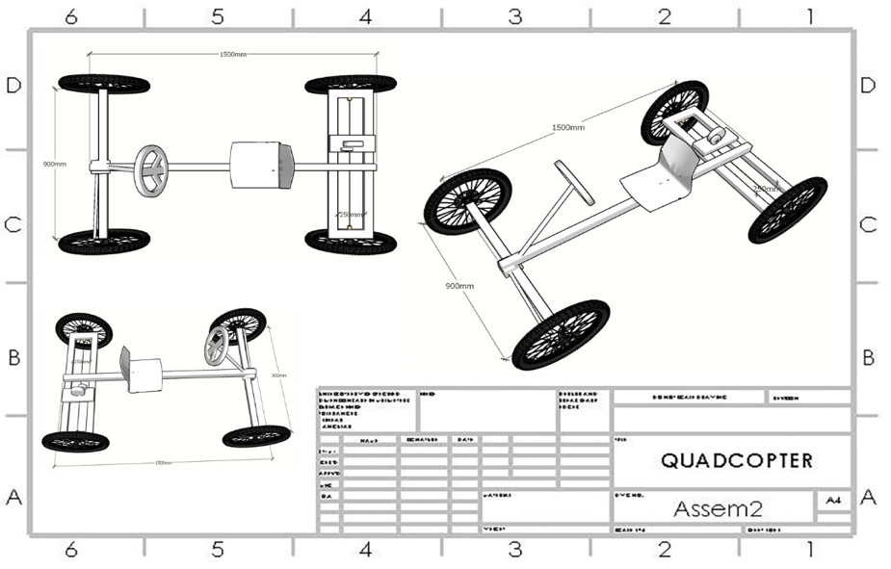

1. Material selection
2. Metal frames
3. Steering wheels
4. Dc motor
5. Alcohol sensor
6. Tires
7. Bearing housing
8. Bearing
9. Steering wheels
10. LCD display
11. LEDS
12. Arduino uno microcontroller
13. **Factors considered when selecting materials**
14. Strength
15. Rigidity
16. Reliability
17. Safety
18. Cost
19. Weight
20. Ergonomics
21. Aesthetics
22. Manufacturing considerations
23. Assembly considerations
24. Conformance to standards
25. Friction and wear
26. Life
27. Vibrations
28. Thermal considerations
29. Lubrication
30. Maintenance
31. Flexibility
32. Size and shape
33. Stiffness
34. Corrosion
35. Noise
36. Environmental considerations
37. Design specification
38. Form(shape)
39. Symmetry and shape
40. Color
41. Continuity
42. Variety
43. Proportion
44. Noise
45. Contrast
46. Impression and purpose
47. Style
48. Material and surface finish
49. Tolerance
50. Details drawing

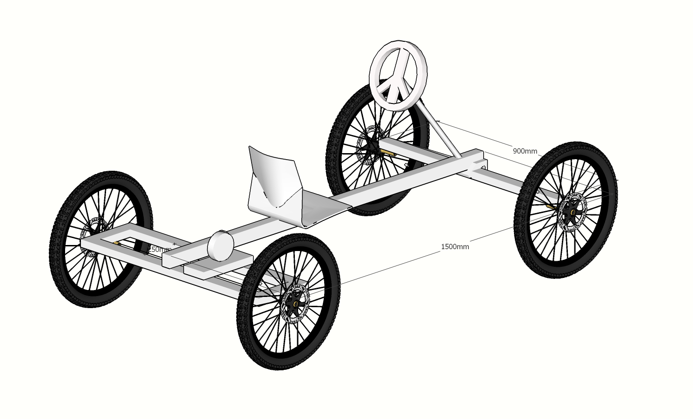

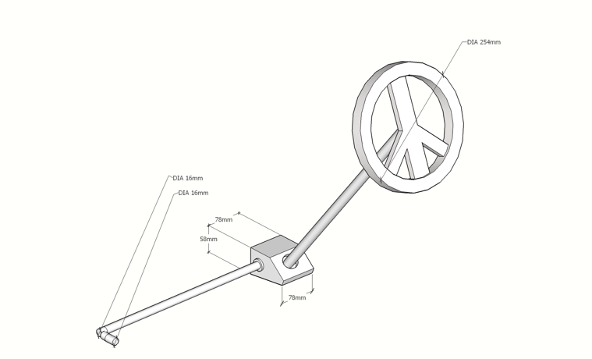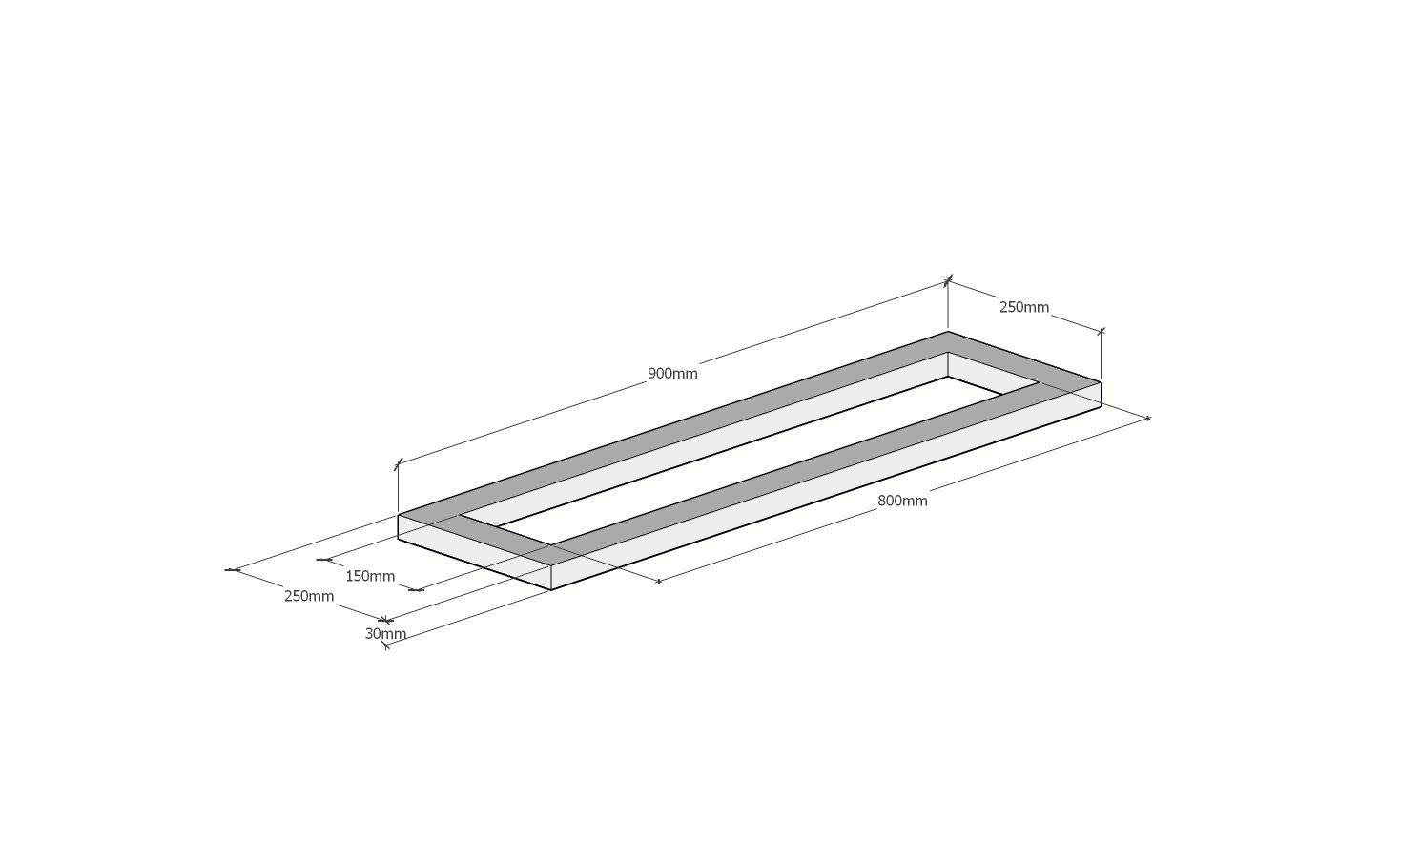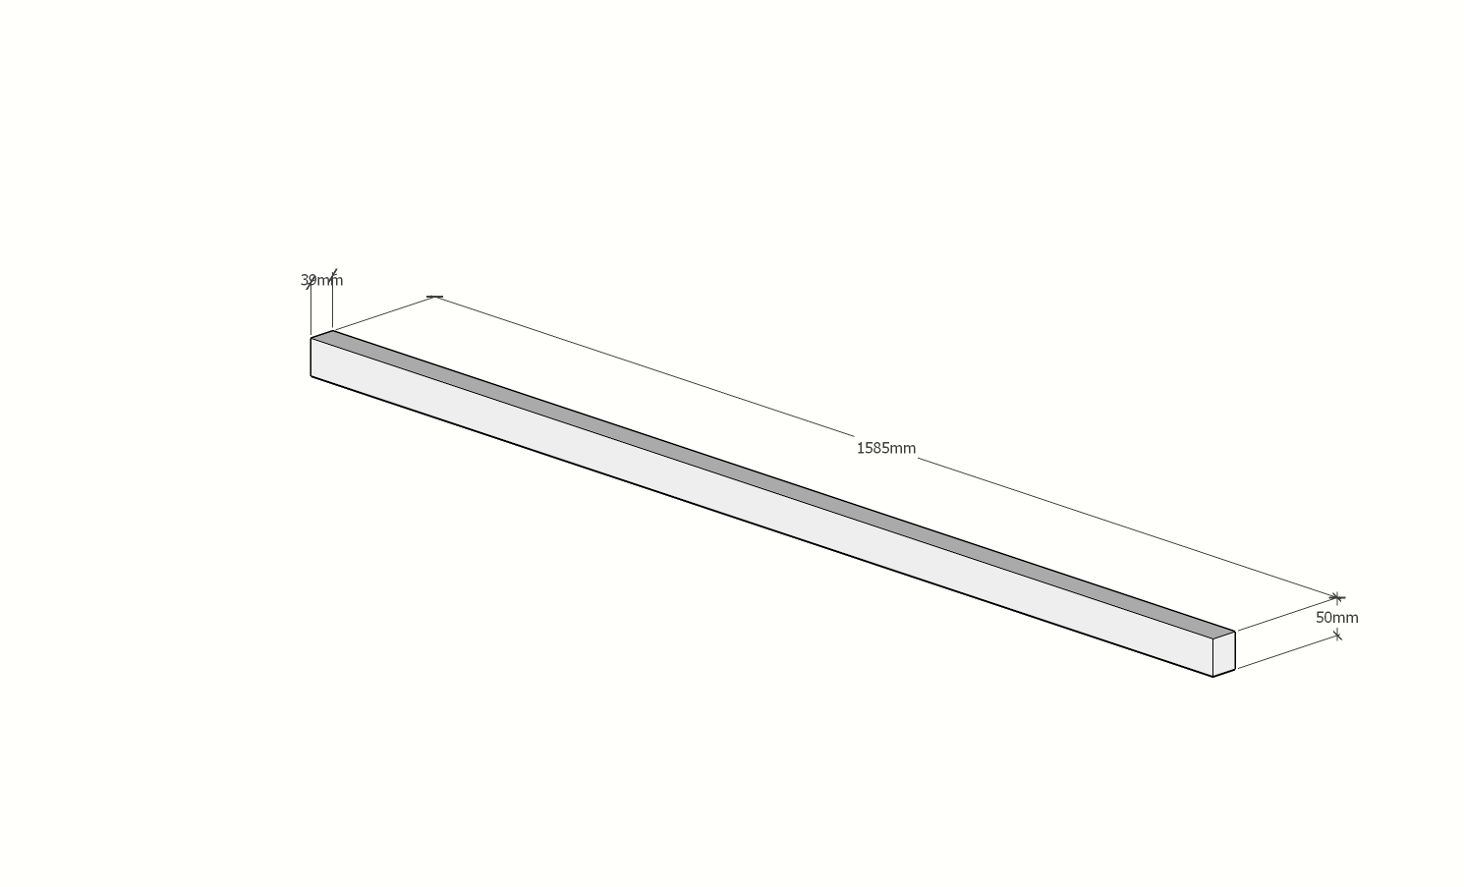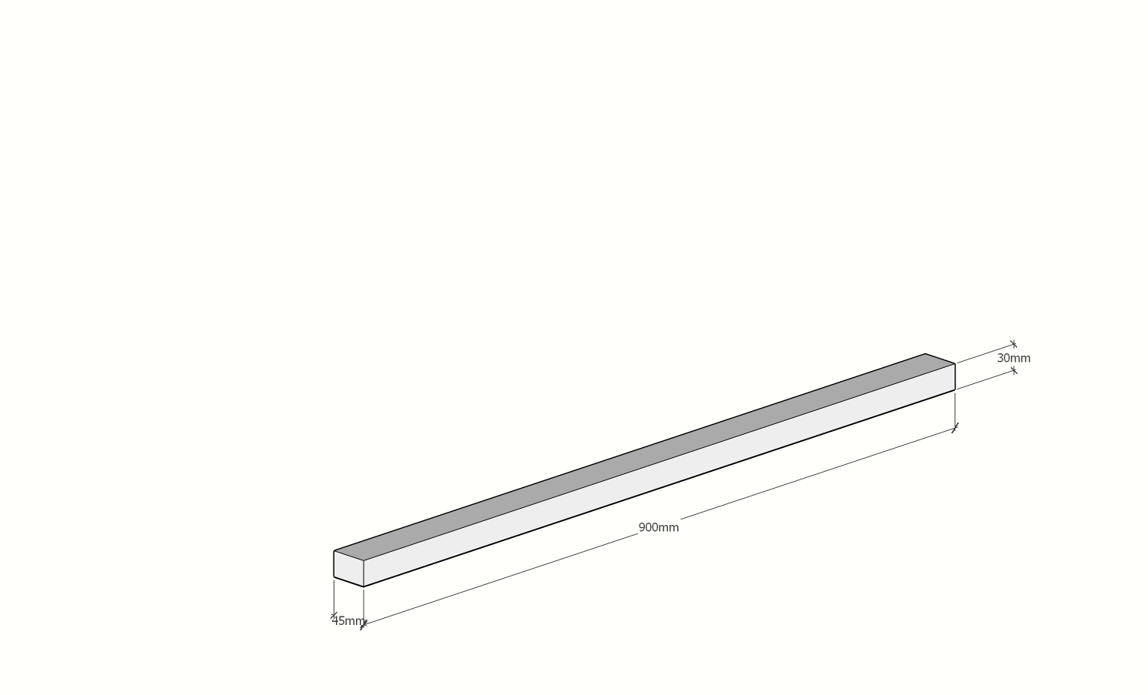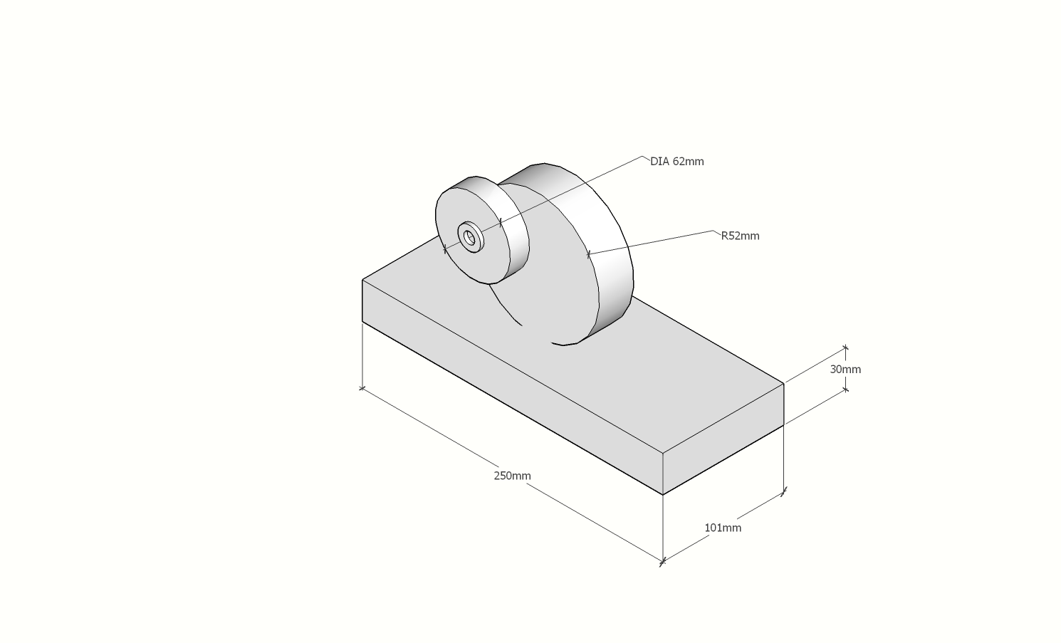

1. BEME

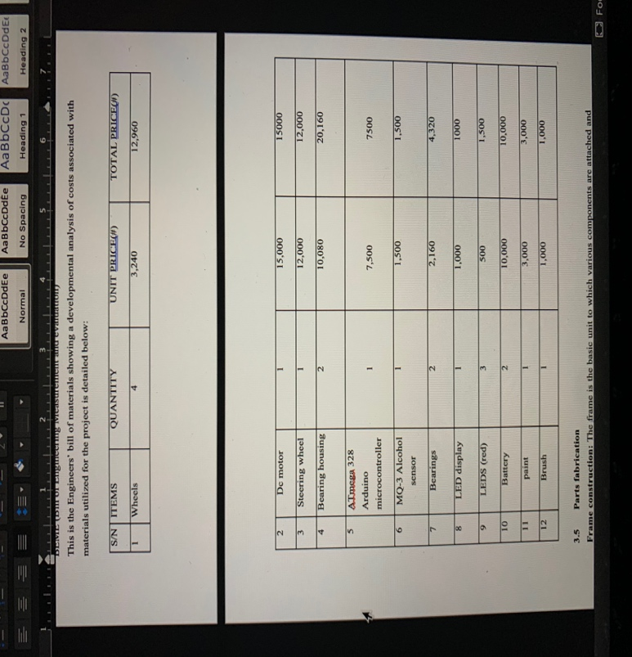

DESIGN PROCESSS

**Frame construction:** The frame is the basic unit to which various components are attached and body is bolted onto the frame later on. The frame is the main structure of the project where the different parts are attached. The main function of the frame is support the main assembly and transfer of the load.

As the mild steel is easily available in the local market, and it can be machined according to use we used the mild steel for the manufacturing of the frame.

Force Acting on the Frame:

1. Weight of the components
2. Force due to braking and acceleration

**3.5.1 Safety Precautions to be considered while doing these operations**

During cutting, grinding and welding safety precautions are must to be taken such that we can reduce accidents, such as;

1. Putting on safety hand gloves, putting on the half handed lab dress and wearing fully covered glasses for eyes during the cutting process.
2. In Welding process, welding gun should be properly handled, wear weld suit and the shield must be important to protect the eyes from strain due to high beam of rays during welding process and to see the weld path.

**3.5.2 Cutting**

According to the design made the dimensions are taken. All the members are not being cut some of them are gone through bending and rest of them come here. The cutting of the material is done using the hand cutter machine. With respect to the design made the angle of cutting seamless pipe depends on it. 45°, 60° and 90° angles were some of them we used in cutting the material.

**3.5.2 Grinding**

After cutting the material we can find the sharp edges to make those fine and smooth the bring operation is done. And it is also done after the welding for getting fine finishing at the weld joints. This process of smoothening the rough surface and removing the unwanted material to get a fine appearance after the welding is said to be grinding.

**Welding**

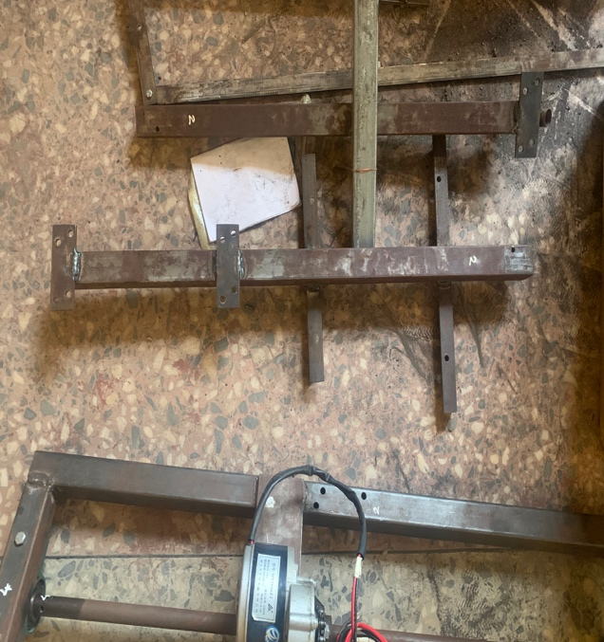

Fabrication of frame metals is developed by welding all the cutting and bending material according to the design. The final input of the frame metals design is taken by the lengths according to the design modified in the SKETCHUP.



**3.6 Steering system**

Mechanical steering mechanism of any type can be used (Rack and pinion/steer-by-wire is excluded) but the ackerman steering system was used. The steering wheel must be mechanically connected to the wheels. All parts of the steering system (steering column, tie rods, spindles (stub axles)) must be of metal. Steering is the assortment of elements, linkages, and so on. That allows any car to follow the required course of direction. The mechanism needs to have an effect on at least 2 wheels and should have agreeable steerage stops.

**3.7 Painting**

Painting of different parts is necessary. Painting of different part such as toe paint, jack point should was done because it should be visible and can access easily. The project was painted black.

**3.7 Project assembly**

In this step we made sure that everything fits probably and finished off the welding and assembled the motor and axle.

The motor was mounted on the rectangular beam and screwed down as shown in the figure below:

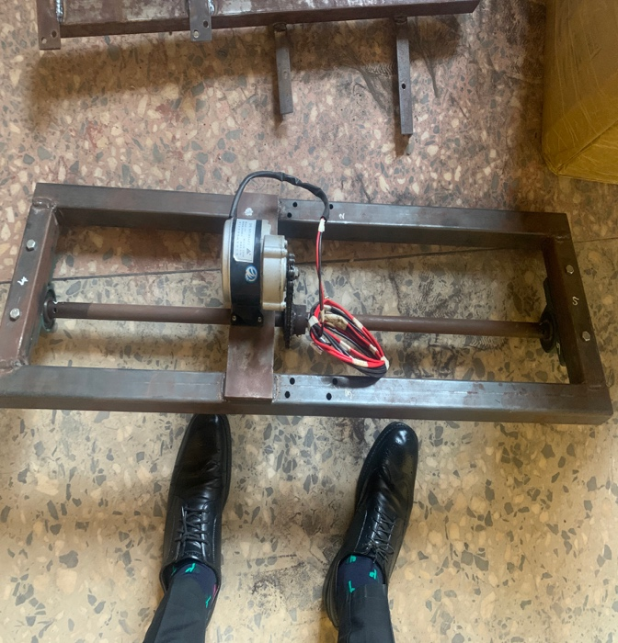

The rear tires were fixed and the beams were also being joined together with bolts and nuts

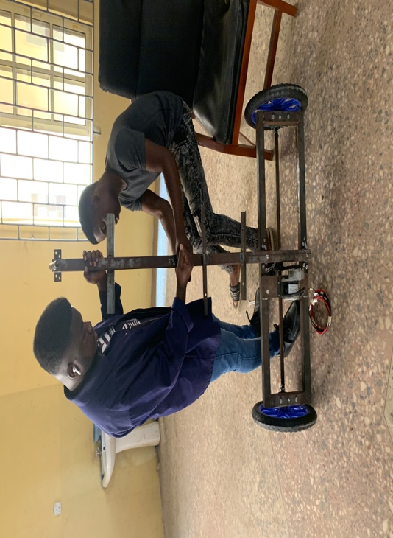

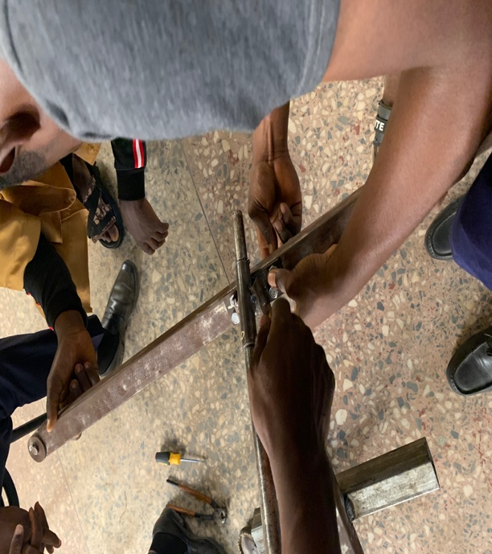

The front wheels were fixed after the beams were joined together as shown in the figure below:

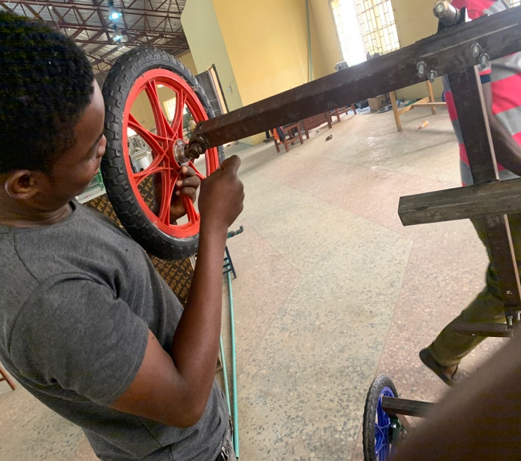

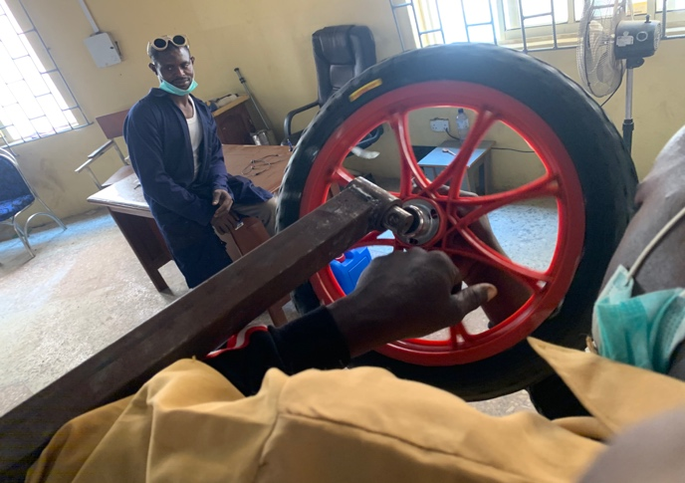

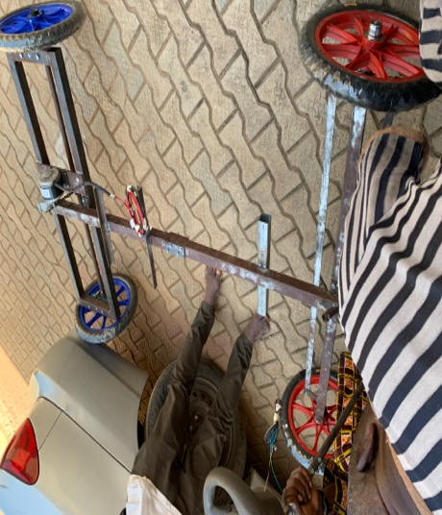 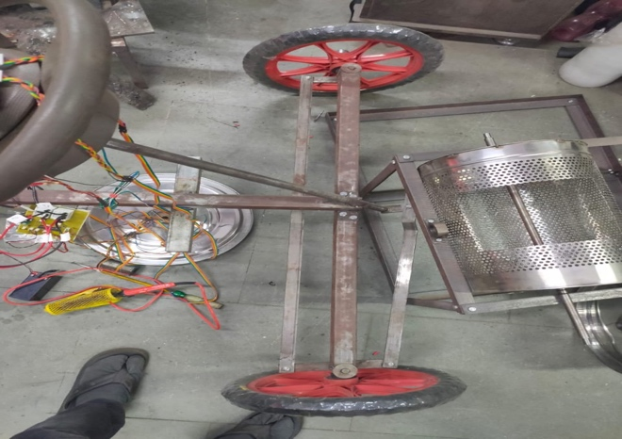

**Electronics**

**Developmental stages**

1. I made a list of required hardware outputs
2. I selected the architecture
3. The software specifications were selected
4. Building
5. Tested on the electrical go-kart

The target of this project is to give an idea and inventive method for avoiding drunken driving of a Motorcar by locking the car. Like wise to permit a man who is not alcoholic to drive a same Motorcar. To broaden this thought with more innovative headways and make it accessible in a financially effective way. We need to plan a sort of framework which can recognize the alcohol content in the cars to prevent the conduct of alcoholic driving. The electrical part of this project comprises of these two sections:

Sensor Part - used to identify the centralization of alcohol all around and send the concentration as voltage signals to the accompanying part.

Display Part - used to get the prepared signal and demonstrate the information to users in LCD.



