AFE BABALOLA UNIVERSITY ADO-EKITI

ENHANCEMENT OF THE MECHANICAL PROPERTIES OF ALUMINIUM REINFORCED WITH NANOGRAPHITE PARTICULATES AND COCONUT SHELL ASH.
BY
ENAGBARE KESSINGTON OSAYAMEN.
16/ENG06/081

PRODUCT DESIGN
The product is a coconut shell and nanographite particulate aluminium alloy.
The need of aluminum profile in manufacturing industry and building industry is on the increase, because of its low cost and light weight, the properties needs to be able to withstand all these external forces. Hence studies have shown that the reinforced aluminum composite has great potential and shows promising increase in various mechanical properties, this can be a cheap and reliable replacement for other alloy composites

MATERIALS SELECTION
The need of the aluminum profile to be harder, and resist high tensile stress and any sudden impact and still maintain it’s light weight lead to the research of metal matrix nano composites to improve properties of the material. Being tasked to provide an alternative metal matrix composite to the existing alloy composites, some materials were selected to meet these requirements
MATERIALS SELECTED:
- Aluminum 6063
- Coconut shell ash
- Nanographite particulates

FACTORS CONSIDERED IN CHOOSING THE MATERIALS
- Structural factors
- Cost efficiency/Economic factors
- Availability factors
- Manufacturing factors
- Durability
- Environmental impact

DESIGN SPECIFICATIONS
The design specifications for this project have been tabularized for effective and easy accessibility, and they are as follows.
Cost | The cost was put at a minimum so as to be consumer friendly: depends on quantity required
function | Is to be used in construction and manufacturing industries as alternatives to other alloy composites.
aesthetics | Has a metallic colour and has no odour, can be malleaed to any shape or form required
manufacturing | The resources needed are usually readily available, and the time of manufacture is relatively short
materials | Coconut shell, aluminum are readily available, and nano graphite can be sourced
Environmental considerations | The product could be used in the construction or manufacturing industries,and has a positive effect on the environment; proper disposal of coconut shell
Durability | The product is relatively durable and has good wear properties

DETAILED DRAWING

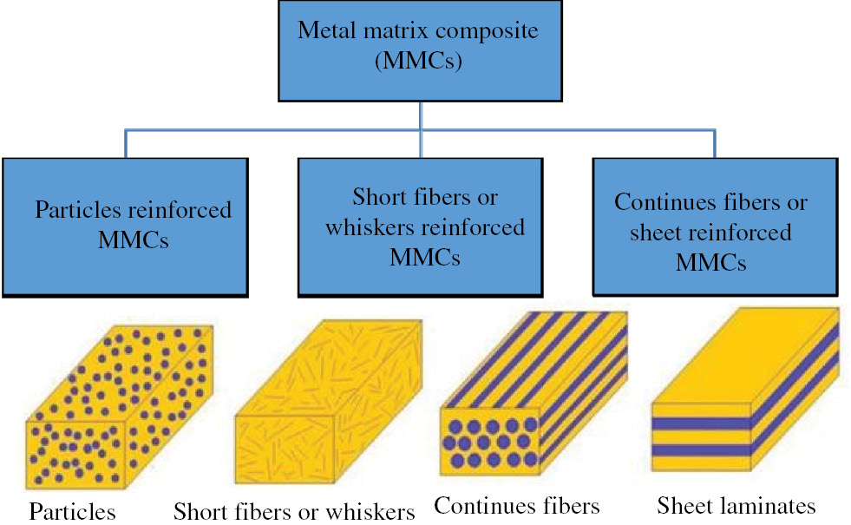
DESIGN PROCESS/MANUFACTURING
The coconut shell ash was produced, initially coconut shells are crushed in a jaw crusher in order to get small flakes and then the flakes are ground in a hammer mill to produce a coarser form of powder. The obtained powder is packed in a graphite crucible and fired in an electric resistance furnace at the temperature of 1,100°C up to five hours in a neutral atmosphere to form CSA.
SAMPLE PREPARATION: The sample preparation was carried out in three phases: impregnation of Silver Nano Particles with Synthetic Calcium Carbonate, recycling of discarded Aluminum profile and preparation of composites from the Aluminum alloy.
Impregnation of nanographite particles with coconut shell ash:
100ml of Nano graphite Particles was measured and mixed with 158g of Coconut shell ash in a beaker. The mixture was stirred and thoroughly mixed with Heidolph RZR 2021 Automatic stirrer at 1,783 Revolution Per Minute (RPM) until slurry is formed. It then spread on polythenenylon and sun-dry for 5hrs for solidification. It was grinded into fine powder using crucible later sieved through a 425um mesh so as to obtain even particle-size distribution. Equipment used in the preparation are:

a) Ohrus sensitive weigh balance
b) Beaker
c) Measuring cylinders
d) HeidolphRZR 2021 AutomaticallyStirrer
e) Test International sieve shaker and set of sieves

RECYCLING OF ALUMINUM SCRAP:
The whole process involved several steps.
i. Preparation of scrap:
Old scraps of Aluminum profiles collected from various construction sites were contaminated with foreign elements and organics. The profiles were first washed, cleaned and dried in open air to remove dirt and other contaminants.

ii. Melting of Aluminum scrap in Crucible Furnace:
Discarded Aluminum profiles weighing 7kg was packed in a diesel fired crucible furnace, heated to 900’C to re-melt the scraps.Salt-flux was added to absorb the contaminants and protect the aluminum metal against oxidation (burning).

iii. Refining of liquid aluminum in the furnace:
During melting, the metal phase melt first due to its lower melting point and settled down at the bottom of the crucible while other impurities present formed slags floating on top of the melt aluminum. The slags were screamed off the surface of the melt.

iv. Preparation of Aluminum Matrix (Billets):
The melt in the crucible (after screaming off the slags) was returned to the furnace and then re-heated to 9000C. The melt is poured in preheated(at 6000C)mouldsprepared in a sand core to produce billets.

PREPARATION OF THE ALUMINUM ALLOY COMPOSITES
Nano graphite particles of average size of 425um and coconut shell ash at different weight were measured and used to prepare six different composites of Aluminium-graphite Nano Particles samples MMCs by melt-stir technique.

