NAME: UKAIGWE CHRISTIAN CHIDERA
DEPARTMENT: PHARMACY
MATRIC NO.: 19/MHS11/143
CHM 102 NEW ASSIGNMENTS
- CLASSIFICATION OF ALCOHOLS
- Classification based on the number of hydrogen atoms attached to the carbon atom containing the hydroxyl group. If the numbers of hydrogen atoms attached to the carbon atom bearing the hydroxyl group are three or two, it is a primary alcohol (1⁰). If it is one hydrogen atom, it is called a secondary alcohol (2⁰) and if no hydrogen atom is attached to the carbon atom bearing the hydroxyl group, it is called a tertiary alcohol (3⁰). Example: CH₃CH₂OH ethanol(1⁰)

- Classification based on the number of hydroxyl groups they possess. Monohydric alcohols have one hydroxyl group present in the alcohol structure. Dihydric alcohol or Glycols have two hydroxyl groups present in the alcohol structure while trihydric alcohols or triols have three hydroxyl groups present in the alcohol structure. Polyhydric alcohols or polyols have more than three hydroxyl groups. Example: CH₃CH₂CH₂OH propanol (monohydric alcohol).

- SOLUBILITY OF ALCOHOLS IN WATER AND ORGANIC SOLVENTS
In water, lower alcohols with up to three carbon atoms in their molecules are soluble in water because these lower alcohols can form hydrogen bond with water molecules. The water solubility of alcohols decreases with increasing relative molecular mass.
In organic solvents, all monohydric alcohols are soluble in organic solvents. The solubility of simple alcohols and polyhydric alcohols is largely due to their ability to form hydrogen bonds with water molecules.

- INDUSTRIAL PREPARATION OF ETHANOL

- Carbohydrate such as starch is broken down by diastase contained in malt at a temperature of 60⁰c to give maltose. Equation: 2(C₆H₁₀O₅)_{n} + n H₂O –––––––––> n C₁₂H₂₂O₁₁ carbohydrate 60⁰c/diastase maltose
- Maltose is broken down into glucose by maltase found in yeast at a temperature of 15⁰c to give glucose.
Equation: C₁₂H₂₂O₁₁ + H₂O –––––––––––> 2C₆H₁₂O₆
Maltose 15⁰c/maltase glucose

- Glucose is converted to ethanol at constant temperature of 15⁰c by enzyme zymase also contained in yeast.
Equation: C₆H₁₂O₆ –––––––––––> 2CH₃CH₂OH + 2CO₂
Glucose 15⁰c/zymase Ethanol

- 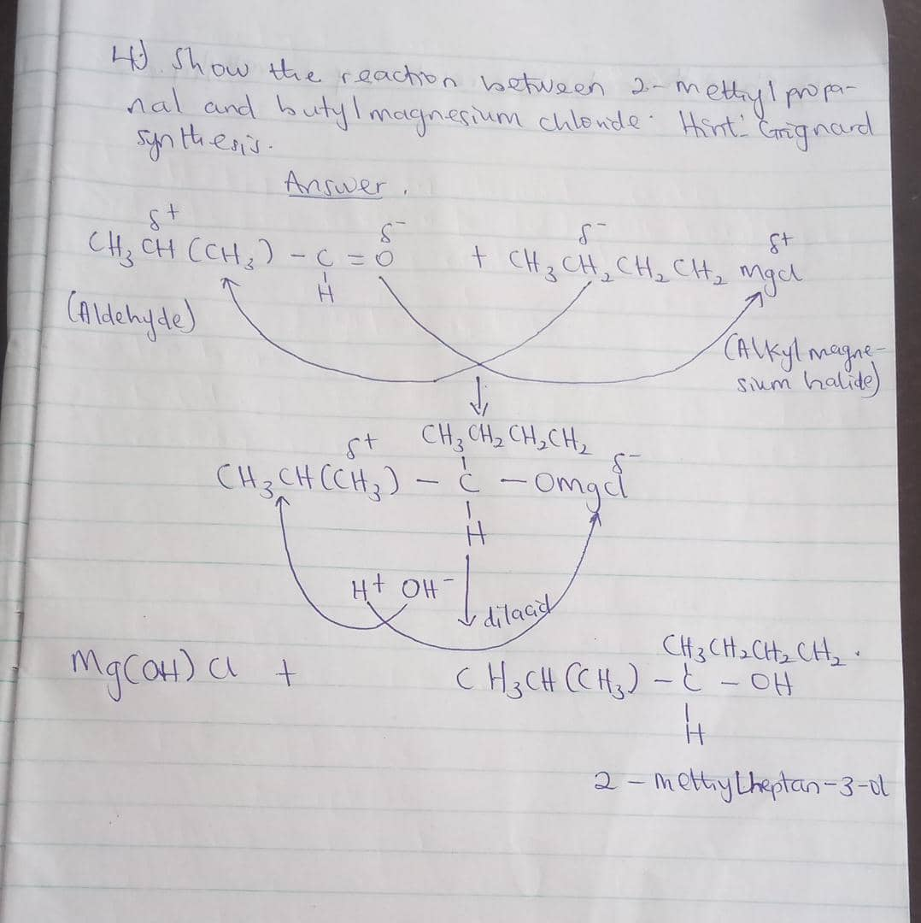
7. 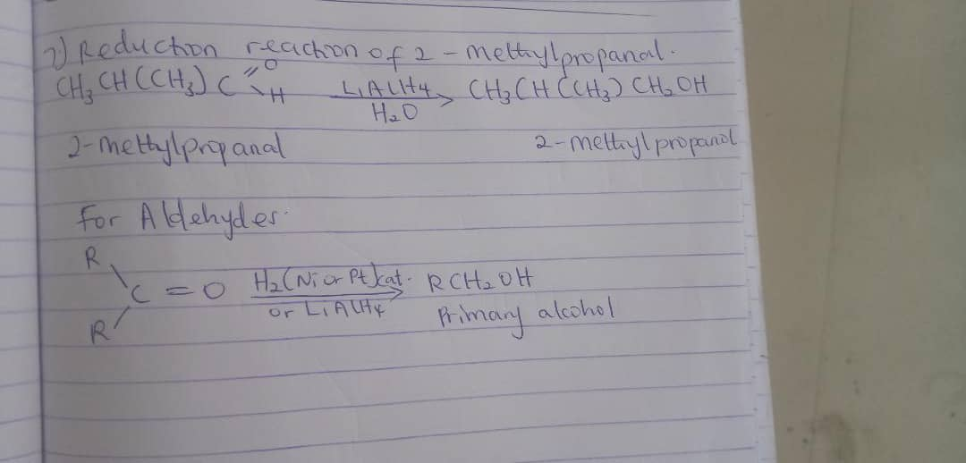

8. 