MEE 510 ASSIGNMENT

PRODUCT DESIGN

SUBMITTED BY

ADEWALE MONISOLA SEGILADE
15/ENG06/003

- PRODUCT/PROJECT DESIGN
ANSWER: Natural fibre infused with nanoclay reinforced polmer matrix composite for aerospace and automobile application
- MATERIAL SELECTION
- NATURAL FIBRE: Natural fibres includes all types of fibres that occur within nature, they are found especially in plants (cellulose fibres), animals (protein fibres) and minerals (asbestos). For this experiment the natural fibre being used is the tigernut fibre;
- NANOCLAY PARTICLE: Nano clay fillers can be natural or synthetic clays, the most widely used reinforcement is clay due to its natural abundance and its very high form factor. Nano composites which are clay based generate an overall improvement in physical performances by strengthening the natural fibres to avoid falling apart. It also improves the mechanical performance of concrete, it improves resistance to chloride penetration of concrete, it improves self-compacting properties of concrete, it reduces permeability and shrinkage of concrete, it improves post failure properties of the concrete. (harraz, nano clay and its applications, 2016)
- COBALT ACCELERATOR: Cobalt is also a byproduct in the mining of nickel, silver, lead and iron ores and it is found in meteorites. Cobalt has many uses today. For example, it enhances the performance of rechargeable batteries. It also enhances the high-temperature strength of alloys used in just engines. While the accelerators used in polyester resin manufacture are almost always cobalt products, a company in the Netherlands is developing alternatives that use no cobalt or a smaller amount of cobalt.
- MOULD RELEASING AGENT (PVC): Mold release agent is a chemical used to prevent other materials from bonding to surfaces. It can provide a solution in processes involving mold release, metal die-cast release, plastic release, adhesive release, and tire and PU foam release. Release agents provide the critical barrier between a molding surface and the substrate, facilitating separation of the cured part from the mold. Without such a barrier in place the substrate would become fused to the mold surface, resulting in difficult clean-up and excessive loss in production efficiency. Even when a release agent is used, factors such as irregular applications or improper release agent choice may have a dramatic effect on the quality and consistency of the finished product.
- EPOXY RESIN (DGEBA): Epoxy resins as binders are particularly used for corrosion protection in coating industry because they posses excellent corrosion resistance and adhesion to substrates. However, their outdoor usage is restricted due to their poor resistance to weather. On exterior exposure, conventional epoxy coatings exhibit chalking and discoloration and lose most of their gloss in three to six months. It is generally due to the presence of aromatic moiety in epoxy polymeric backbone; they absorb at about 300nm wavelength of light, comprising of UV light and degrade resulting in discoloration and chalking.
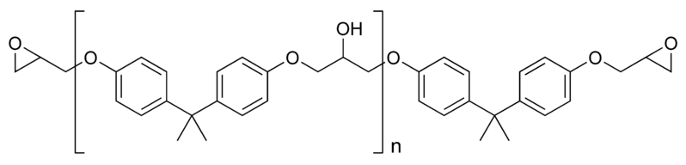
- THINNER: Thinner can be used to clean your equipment and tools once you have finished a job or experiment, especially when you have been using oil-based paint or anything oil-based. Thinner can also be used to 'thin' or reduce the viscosity of paint so it can be used in sprayer applicators. Another important use that most people are not aware of, is that paint thinner can be used to prevent paint or experiment samples from hardening when it has been left open.In this case the thinner prevents the natural fibre infused with nanoclay from hardening to the surface of the mould. Paint thinners should not be used with latex paints, shellac or lacquers. Thinner should be applied slowly until desired results are obtained. Normally, the manufacturers provide recommendations on the amount of thinner to be used, but normally they don't exceed the 4:1 thinner ratio. If for some reason you have added too much thinner, you will have some problems once you have completed the work. If you need to use thinner always remember to wear the correct PPE and take precautionary measures
- HARDNER: This product is use in rubber mold paver block to decrease the period of settling of mold and add mixture of concrete mix. Hardners are highly acclaimed in the market for their precise compositions and optimum quality. They are extensively used for the transportation of liquids and gas for easy consumption and they possess the following qualities; highly effective, long shelf life, precise quality.
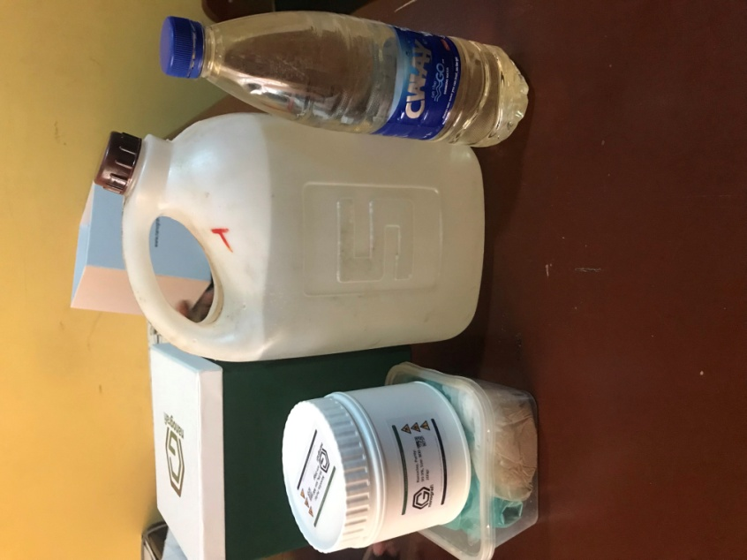
FIG 3.1; Materials used for fabrication
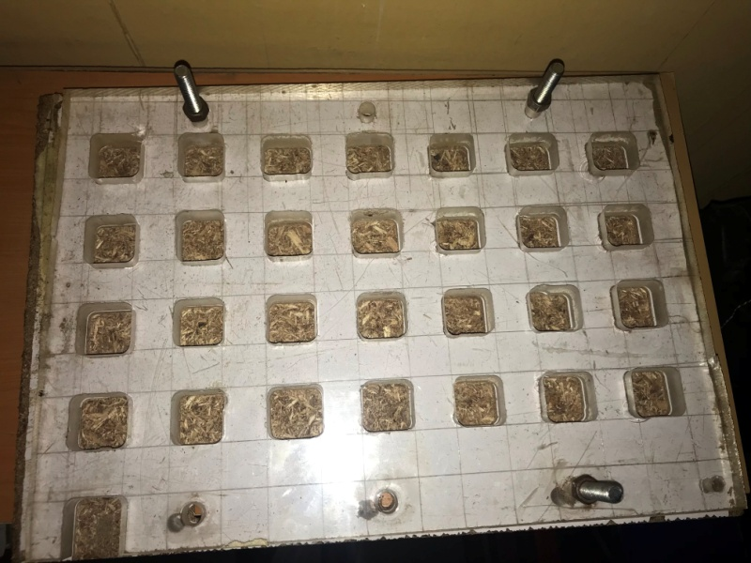
FIG 3.2 A mould

- FACTORS CONSIDERED IN CHOOSING MATERIAL:
- NATURAL FIBRE – Any natural fibre can be selected for this project
- NANOCLAY PARTICLE – Selected based on hardness quality
- COBALT ACCELERATOR – Selected based on high-temperature strength enhancement
- MOULD RELEASING AGENT (PVC) – Selected based on high lubricating properties, which is why the PVC agent is best for this project

- DESIGN SPECIFICATION
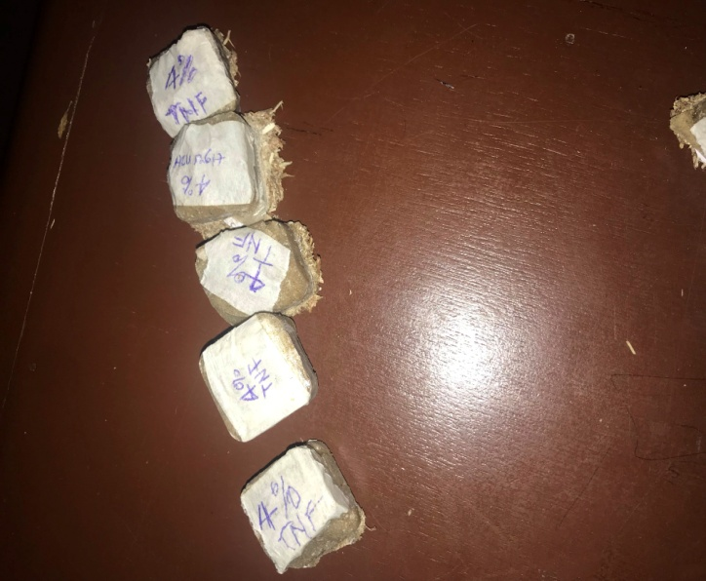

- BEME
STAGE 1 (MATERIALS NEEDED FOR FABRICATION OF SAMPLES)
S/N | MATERIAL DESCRIPTION | QUANTITY | UNIT COST(N) | COST
1 | NANO CLAY | 100 GRAMS | 50,000 | 50,000
2 | EPOXY RESIN | 5 LITERS | 3,500 | 17,500
3 | NATURAL PLANT FIBRE |  | PROVIDED | PROVIDED
4 | PEROXIDE CATALYST |  | 5,000 | 5,000
5 | COBALT ACCELERATOR |  | 3,500 | 3,500
TOTAL: N76,000
STAGE 2
CHARACTERIZATION OF THE SAMPLES
S/N | CHARACTERIZATION | NO. OF SAMPLES | UNIT COST(N) | COST
1 | X-RAY DIFFRACTION ANALYSIS (XRD) | 4 | 5000 | 20,000
2 | DIFFERENTIAL SCANNING CALORIMETRY ANALYSIS | 6 | 7000 | 28,000
3 | THERMO-GRAVIMETRIC ANALYSIS | 6 | 7000 | 28,000
TOTAL: 76,000
THE OVERALL COST CAN BE ESTIMATED TO BE 152,000

- DESIGN PROCESS
- Preparation and extraction of the natural fibre: Carrot and tiger nut are purchased from the market after which it is washed and blended the the juice is being extracted, the residue is the fibre(which is dried for over a week) the dried fibre is grinded into powder and sieved then you have coersed and fine fibre according to usain and Rafis.
- Preparation of Nano particle and composites: They are purchased from the supplier
- Fabrication: To prepare the composite samples, a mold of size (200*150*3 mm3) has been made from glass. Silicon was used for joining frames. Then plastic sheet was placed in the bottom of the mould. The composites have been prepared with hand lay-up technique. The carrot fiber-epoxy composites were prepared with 10, 20, 30, and 40 wt. % fiber content for both sizes. Initially epoxy resin and hardener have been mixed together based on the weight ratio to form a matrix. Then some of the weighted fibers were added to epoxy resin with continuous mixing. This process has been continued until weighted materials were finished. Then the mixture was poured into the mold. Then it was covered by plastic sheet. The curing time was around 24 h at room temperature (23 oC). The composite has been taken out of the mould in the form of a plate and was cut and machined to produce samples conforming to the ASTM standards for mechanical properties testing. All these tests have been carried out for pure epoxy, and carrot fiber reinforced epoxy composites of different loading for the both sizes.
- The samples are sent out for characterization: X-ray diffraction(XRD), Thermal gravimetric analysis(TGA), Differential scanning calorimetry(DSC).

