ENERGY PERFORMANCE ANALYSIS OF AN IMPROVED FLAPPING WING UNMANNED AERIAL VEHICLE (ORNIHOPTER)
BY
CHIEJINA ARNOLD 15/ENG06/017
OBINAJU, PRECIOUS 15/ENG06/046
OYENUGA MUSTAPHA 15/ENG06/061
EZIMUOBOR GREAT 15/SCI03/006
AMUSA OLUWATOBI 13/ENG06/008
AKINWUMI MAYOWA 16/ENG06/079
SUPERVISED BY
ENGR. DR. B. A. ADARAMOLA & HABIB ABDULKADRI
SUBMITTED TO
DEPARTMENT OF MECHANICAL AND MECHATRONICS ENGINEERING
AFE BABALOLA UNIVERSITY ADO-EKITI, EKITI STATE, NIGERIA
IN PARTIAL FULFILMENT OF REQUIREMENTS OF THE AWARD OF BACHELOR
OF ENGINEERING (B.ENG) IN MECHANICAL AND MECHATRONICS ENGINEERING
MAY, 2020

CHAPTER ONE
1.1 INTRODUCTION
Natural flight of animals such as birds, and insects has always captivated the minds of humans. These animals are capable of flying and cruising in the air with ease and grace; which surpasses that of man-made aircrafts and drones and their control systems. Throughout history; man has practiced Biomimetics or Biomimicry. Biomimetics is the imitation of models, systems and Elements of nature for the purpose of solving complex human problems. Biomimetics has given rise to new technologies inspired by biological solutions at macro and nano scales. Humans have looked at nature for answers to problems throughout our existence. Over thousands of years man has wanted to fly, this amazing feat was only made possible after studying the flight of birds. Although modern aircrafts are capable of reaching unprecedented air speeds, they lack a certain level of manoeuvrability while in motion. This is not to say that modern aircraft designs are ineffective, they are excellent in many respects. Propellers and turbines are very efficient methods of producing thrust and aerofoils efficiently produce lift, but these will never match the manoeuvrability of birds or insect.
Looking at flight from a scientific point of view, there are four main forces acting on a body. Weight is a downward force produced by gravity. For a body to achieve flight it has to produce a lift force that counteracts its weight. A body moving through air also experiences drag force, which slows it down, so there must be a forward-moving force known as thrust, to oppose the drag force. These two pairs of forces weight and lift, drag and thrust have to be roughly balanced in order for a bird or plane to fly.
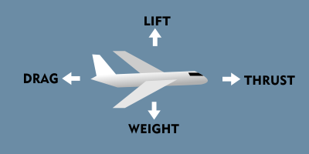
(Source: ARCH digital)
1.2 AIMS AND OBJECTIVES
The aim of this project is to design and construct a functional flapping wing unmanned aerial vehicle that mimics the flight of birds, and perform exergy performance analysis on it.
Objectives
- To design a working ornithopter
- Build a functional flapping wing unmannered aerial vehicle (Ornithopter)
- To develop two separate control systems for the Ornithopter
- To achieve short distance and sustained flight for a duration of at least 10 minutes
- To achieve durability enough to withstand impacts with minimum damage.

1.3 STATEMENT OF PROBLEM
It is known that man-made aircraft are capable of flying at immense speeds in harsh conditions, but they lack the level of manoeuvrability seen in birds and insects. Constructions of working ornithopters have a low success rate. Many designs still fail to fly despite the rapidly increasing population building electric ornithopters. The unsteady ﬂuid dynamics of ﬂapping wings are poorly understood and it’s difficult to get an ornithopter to manoeuvre as desired. A major hurdle in most designs is an inability to generate the necessary lift.

1.4 JUSTIFICATION OF STUDY
This study is being carried out to bring new understanding into the biomimetics of flight in birds. The aerodynamics of flight of birds is currently barely understood due to the unsteady nature of the fluid flow over the flapping wings.
The construction of an Ornithopter is a great challenge in itself, apart from the fact that this form of UAV is not researched in-depth like that of fixed wing or propeller driven UAV’s. It has mainly been explored by Hobbyists and Enthusiasts. The design of flapping wing UAVs until now mainly progressed by means of trial-and-error. Looking into existing designs reveals some insights that help to understand the key challenges in flapping wing design. Using the design presented in this research report, with Modern lightweight materials and electrical components we should be able to improve on the manoeuvrability & durability of the ornithopter design.

1.5 SCOPE OF STUDY
This project is limited to the construction of a working ornithopter and exergy analysis on its components. This will give an understanding of the electrical and mechanical energy required to generate adequate lift & thrust.

CHAPTER TWO
LITERATURE REVIEW
2.1 HISTORY OF ORNITHOPTERS
Since the earliest recorded history, humans have shared a nearly universal desire for the freedom of flight. Looking to nature's design, man for years attempted to replicate the flight of birds. The earliest experiments with flapping wing devices are often referred to by aviation historians as "tower jumpers" (Brady, 2000). Though records of attempts to fly in this manner exist as early as A.D. 60, perhaps the first attempt to be met with some success was that of Eilmer, a Benedictine monk who was seriously injured after gliding about 200 yards from the tower of Malmesbury Abbey in 1060 (Alexander, 2009).
Though many early experiments with flapping wing aircraft ended in failure, the aerodynamic principles behind the ornithopter are sound. As demonstrated by birds, flapping wings offer tremendous potential advantages in manoeuvrability and propulsive efficiency.
No practical ornithopter has yet been built big enough for people to fly in, although a team at the University of Toronto has been making progress since the 1970's. They have developed a fully functional engine powered scale model, and in 2006 made the first short flight of a full-size manned ornithopter. Other successful efforts have been made since the 1870's.
Leonardo Davinci's drawings from 1485 to the early 1490’s were the first conceptualizations of practical winged mechanical flight. Although this design was never actually built, and the design is not really practical for a working device, Davinci's design for the flapping mechanism comes close to maximizing the efficient use of human power.
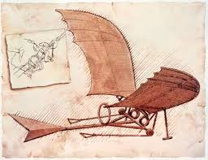
2.2 APPLICATIONS OF ORNITHOPTERS
An Ornithopter as an unmanned aerial vehicle (UAV) has applications in various industries and aspects of living as highlighted below:
2.2.1 Military and Paramilitary Applications
Ornithopters can be applied in intelligence and security. Currently the technology in use for stealth information gathering and reconnaissance are drones and satellite imagery. Drones are capable of flying at high & low altitudes for carrying out reconnaissance. When flying at low altitudes they are unreliable as stealth UAV’s Due to their conspicuous nature. Ornithopters blend in easily with the natural environment because of their birdlike nature. The flight of an ornithopter is also more efficient than that of other unmanned aerial vehicles and possesses better manoeuvrability. Ornithopters are also much quieter and less disruptive than drones, allowing for greater usage in areas such as reconnaissance. Ornithopters can be used to locate kidnap victims without alerting the perpetrators and also assess damage after natural disasters or acts of terrorism.
2.2.2 Wildlife Observation and Preservation
The Colorado Division of Wildlife has used Ornithopters to help save the endangered Gunnison sage grouse. An artificial hawk under the control of an operator causes the grouse to remain on the ground so they can be captured for study.
2.2.3 Airport Runway Clearing
Airports also make use of ornithopters to scare birds off the runway to allow planes to land. This is more effective than the use of flares because of the bird’s natural reaction to the predatory look of the ornithopter.
2.2.4 Recreation
The use of drones and other UAV’s for recreational purposes has become a global trend for hobbyist and enthusiasts who enjoy flying, assembling and modifying these drones. They put them to the test by racing the drones at high speeds, and using them to perform difficult tasks. They also make modifications to them to raise or reduce its performance for different purposes.

2.3 WORKING PRINCIPLE
The principle of operation of the ornithopter is same as the aeroplane. As in an aeroplane a lot of factors contribute to the flight and manoeuvrability of the ornithopter. These factors include:
2.3.1 Stability
This is described as the ability of an object to return to its equilibrium or trimmed position after being displaced from its initial position by a force. The two major components of stability of an ornithopter are the centre of gravity and the centre of pressure. The centre of gravity is the point at which the weight force of the ornithopter acts while the centre of pressure is the point on the ornithopter where the opposing force i.e. the lift force acts.
To locate the centre of gravity of the entire ornithopter, the individual weight of all its components are considered and analysed. The tail of the ornithopter is a great factor in moving the centre of gravity along the fuselage. By rotating vertically; it changes the position at which its weight acts therefore affecting the centre of gravity of the ornithopter.
The centre of pressure of a static wing is located along the first quarter of the aerofoil from the leading edge.
To achieve perfect stability the centre of pressure and the centre of gravity should act at the same point along the fuselage. Perfect stability does not support manoeuvrability because the ornithopter opposes displacement from its trimmed position, the more stable the ornithopter is the greater the difficulty to control and manoeuvre. It therefore goes without saying that the stability of the ornithopter should be varied desirably according to required level of manoeuvrability.
It is important to note in design that with excess distance between centre of pressure and centre of gravity there are negative effects: with centre of gravity in front of centre of pressure the ornithopter tends to nose down, while with centre of pressure in front of centre of gravity the ornithopter tends to resist manoeuvring or flip backwards during operation.

2.3.2 Lift Generation.
Lift is very important for flight. Flight is a phenomenon that has long been a part of the natural world. Birds’ fly not only by flapping their wings and gliding with their wings outstretched for long distances but based on principles of physical science. An Ornithopter as a man made, heavier than air, aircraft, rely on these same principles to overcome the force of gravity and achieve flight. Heavier than air flight is made possible by the careful balance of the four fundamental forces: lift, thrust, drag and weight. These four forces act directly on the flying body.
Lift is the force that utilizes the fluid continuity and Newton’s Laws to create a force perpendicular to the flow of fluid. Lift is opposed by weight as it is the force that pulls things towards the ground. Thrust is the force that moves things through the air while drag is the aerodynamic force that reduces speed as a result of air resistance.
For flight to be achieved, the generated lift force must be greater than the weight of the flying body.
The ornithopter in itself has weight and produces drag in a fluid stream. For the drag and weight to be overcome, the ornithopter has to be designed with the aid of aerodynamics which ensures that adequate lift force and thrust forces are generated by the wing and tail.
The wing of the ornithopter is the major component of the vehicle responsible for lift and thrust generation as well as the manoeuvrability of the system. Efficient lift generation mostly depends on the wing design. Its aspect ratio, angle of attack and wing loading are related to gain the efficiency in flight. The wing generates lift using both the flapping mechanism and aerofoil aerodynamics.
During flapping, the downward stroke of the wing deflects air below the wing. The motion of the wing downwards generates force in two directions: it pushes against the air molecules below the wing to generate an upward force and the rush of air backwards along the wings lower surface joins with the inertia of the free flexible end of the wing surface to push against air molecules behind the wing to generate a thrust force.
To improve the lift generated by the flapping mechanism, the wings of the ornithopter are attached to the body at a slight angle, which is called the angle of attack which combined with the aerofoil shape of the wing, produce optimum aerodynamic lift while in motion. The performance of a wing is determined by its aspect ratio defined in dimensionless form, as the square of the wingspan divided by the wing area.

2.3.2.1 Lift Curve Slope
The lift curve is a measure of how rapidly the wing or control surface generates lift with change in angle of attack.
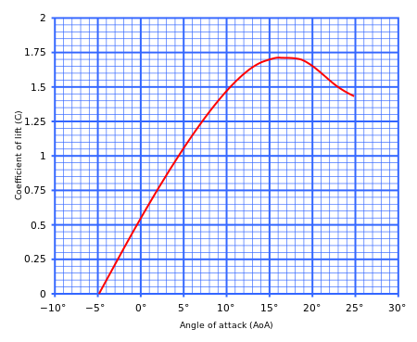
A typical curve showing section lift coefficient
versus angle of attack for a cambered aerofoil

The theoretical maximum slope is 2π, although real aerofoils deviate from this value. Once a certain angle of attack has been reached the wing will display a rapid reduction in the lift curve slope. This point is the critical angle of attack and is called stall. Stall occurs both at a positive and negative angle-of-attack. The lift at stall dictates how much wing area the aircraft must feature for a desired stalling speed.

2.3.2.2 Tail Lift and the lifts slope
The slope of lift coefficient against angle of attack for a bird’s tail (π/2AR) is small compared to that for a high aspect ratio wing (2π). High aspect ratio wings suffer flow separation and therefore stall at angles of attack over about 15°. However, low aspect ratio delta wings, like the tail of the ornithopter, shows an increase in the lift slope immediately following flow separation. As the flow separates from the leading edges large vortices form above the wing, these vortices stabilize the flow up to large angles of attack and high lift coefficients can be obtained. Flat triangular plate with an apical angle of 60° can generate a lift coefficient of about 1.3 at 20° angle of attack, and will not stall below an angle of attack of 35 degrees.
The aerodynamics of a low aspect ratio slender thin triangular wing such as the ornithopter’s tail is represented by slender lifting surface theory. Slender lifting surface theory accurately predicts aerodynamic performance at angles of attack below about 15°. Above 15° lift is generated by a detached vortex mechanism provided the flow remains stable and the lifting theory slightly underestimates the aerodynamic efficiency and performance of the tail. The low value of the lift slope means that the lift produced by the tail is insensitive to small changes in angle of attack. The ornithopter therefore has a considerable margin of safety when adjusting the tail to the incident flow. In normal flight the flow at the tail is relatively steady but in slow flight the induced velocity generated by the wings is very much higher than the flight velocity, so there may be substantial variations in the flow conditions over the tail. The low slope of lift coefficient against angle of attack means that the tail is particularly suited to providing a steady lift force under these varying flow conditions. The slender lifting surface model shows that given angles of attack, the forces generated on a tail depend on only two features of morphology; tail width and tail area. The maximum continuous span of the tail determines lifts, tail moment and induced drag.
The contribution of induced drag to total drag becomes higher at high lift coefficients. The aero- dynamic efficiency of the tail therefore increases as the lift coefficient increases. To operate at a high lift coefficient the angle of attack of the tail must be high. Together with the inclination of the incident flow at the tail induced by the wings, this may account for the relatively high angles of attack of the tail observed in slow flight. For example Tucker (1992) reports tail angles up to 20° in the Harris hawk gliding in a wind tunnel.
2.3.3 Gearing and Power Train
To move the wing and tail mechanism a series of components are involved that transmit power from the major electrical power source (the battery) to the wing. These components include the electronic speed controller (ESC), motor, servo motors, gearing system and linkages.
The electronic speed controller is an electrical device that regulates the voltage transferred from the battery to the motor depending on the control signal. This voltage regulation in turn regulates the speed of the motor.
The motor receives the battery’s power through the esc and converts it to mechanical power by the rotation of a shaft. The most common choice of motors for ornithopters are out-runner brushless motors. This is because of their relatively low weight to torque ratio. A brushless motor has higher efficiency than a brushed motor and is basically a brushed motor flipped inside out. In brushless DC motors, the permanent magnets are on the rotor, and the electromagnets are on the stator.
The speed of a brushless motor is most times greater than the actual speed required for the flapping mechanism, therefore to step it down it is passed through a gear train to get the desired speed. The gear train also serves the purpose of increasing the motor torque output to the desired output to drive the flapping mechanism; this is a result of the gear ratio.
Linkages, cranks and connecting rods are used to transmit the rotary motion of the gears to the wings. In this project, two cranks are connected to the gear system in such a way that they both rotate at the same speed but in opposite directions. Connecting rods are attached to these cranks which are primarily responsible for the up and down motion that constitute the flapping of the wings. In-line with Newton’s 3rd law of motion it was determined that the positive lift force generated by the wing flap during its downward stroke would be countered by an equivalent negative force during its upward stroke due to the fact that the parameters responsible for generating both forces are equal. The result of this finding is that the ornithopter would tend to oscillate vertically without achieving any overall lift while the weight force pulls it down. To vary the magnitude of these two forces, a wing joint is implemented.
The function of the wing joint is to reduce the wing span during the upward flap which in turn reduces the surface area on which the negative lift acts and increase the wingspan during the downward flap that increases the surface area acted upon to produce a positive lift force. There are various methods for implementing the wing joint but for the purpose of this project the wing was divided into two sections with a joint. Then one end of a linkage was connected to the mid-section of the connecting rod, while its other end is connected to the second section of the wing. As the wing descends from its maximum stroke angle the angle between the two wing sections increases as both sections tend to align linearly to increase the wing span.
2.3.4 Flight Control
Flight control of an ornithopter basically involves three basic motions namely: pitch, yaw and row which involve the motion of the ornithopter about its x, y and z axis respectively. Each of these motions can be combined with another to gain a certain movement in the ornithopter.
Ornithopter flight control systems like that of fixed wing aircrafts consists of flight control surfaces such as the flexible tailing section of the wings as well as the tail itself. The primary component for flight control for the ornithopter is the tail section i.e. the angular orientation of the tail is the determining factor to the ornithopters direction of flight. The tail is controlled by servo motors located at different sections of the ornithopter. One of the servo motors is positioned and connected in such a way that it is responsible for the upward and downward angular motion of the tail, while the second servo is positioned and connected to produce to rolling motion of the tail. The movement of the tail results in different manoeuvres of the ornithopter, these can be explained as follows: -
- If the fuselage servo pushes the linkage that connects it to the tail servo housing forward then the resulting motion is an upward motion of the tail. The result of this motion of the tail is that the centre of gravity of the ornithopter is shifted forward while the continuous fluid stream acting around the tail exerts a pressure on the tail causing a downward force at the tail and an overall positive pitching moment on the ornithopter
- If the fuselage servo pushes the linkage that connects it to the tail servo housing backward then the resulting motion is a downward motion of the tail. The result of this motion of the tail is that the centre of gravity of the ornithopter is shifted forward while the continuous fluid stream acting around the tail exerts a pressure on the tail causing an upward force at the tail and an overall negative pitching moment on the ornithopter.
- If tail servo is tilts the tail to the left of the ornithopter then the ornithopter experiences a clockwise yaw motion.
- If tail servo is tilts the tail to the right of the ornithopter then the ornithopter experiences an anticlockwise yaw motion.
2.3.5 Radio Control
The control and manoeuvring of an ornithopter basically entails the speed variation of the motor through the ESC and the control of the position and direction of the servo motors. These can be achieved with the use of radio frequency transmitter and receiver.
The radio controller works together with a receiver and a transmitter to control the ornithopter. Control signal is transmitted from the hand of the operator by pushing a lever on the controller. The movement of the lever is then converted into radio signals and sent to the appropriate channel on the receiver by the transmitter. The receiver then directs the radio signal to the appropriate component to be controlled. Below is a schematic diagram of the ornithopter radio control system.
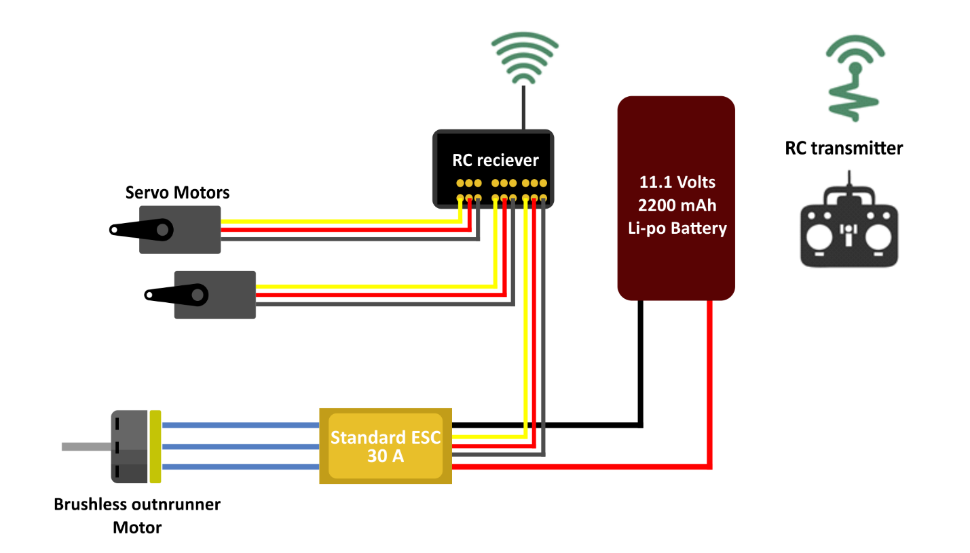These radio control components make use of radio frequency that are capable of transmitting signals over long distances of up to 200 Km, although for the purpose of this project a controller of relatively lower range is required.

2.3.6 Automation and Flight data monitoring
Ornithopter design may make use of automation to improve aerodynamic performance. Automation makes use of sensors, micro-processor and computers (such as Aduino and Rasberry pi) to improve the accuracy and efficiency of flapping and overall flight.
For optimization of flaps, these improvements are implemented by periodically adjusting the angle of attack of the wing or its outer section mid-flight. The purpose of this is to reduce the vertical drag on the wing during the upward flapping stroke, as well as optimization of generated thrust. This is accomplished with the use of a hall sensor to detect the angular position of the wing, in essence; to detect whether the wing is in its maximum upward position or downward position. As the wing approaches its maximum upward position the micro-processor instructs a servo motor at the tip of the wing to rotate at an acute angle. This process is repeated as the wing approaches its downward position, while the angle of attack is inverted or returned to its initial position.
Automation can improve flight with the addition of obstacle detection & avoidance. Implementation of obstacle detection will allow the ornithopter avoid physical obstacles during flight, such as light poles and fences. This is accomplished by the micro-processor; it collects information from the obstacle detection sensor located at the front of the ornithopter and then instructs the tail control servos to move the tail in a desired direction. This will enable the ornithopter dodge these obstacles.
Flight Data monitoring and navigation systems can be integrated into the ornithopter to further improve flight performance, as well as keeping track of its orientation in space. With the aid of an automated navigation system a gyroscope is used to improve stability or maintain a reference direction during flight. An accelerometer is also used to monitor the ornithopters flight speed & acceleration mid-flight. A camera may also be attached to record video or images during flight. Small single-board computer such as raspberry pi is used to collect data from the gyroscope, accelerometer and camera to store on a memory card. This recorded data may also be sent via a Wi-Fi connection to an android device for real-time observation.

2.4 Exergy Analysis
Kinetic energy is a form of mechanical energy, and thus it can be converted to useful work. Therefore the Exergy or work potential of the kinetic energy of an ornithopter is equal to the kinetic energy itself, regardless of environmental properties.
Considering the ornithopter as a system the work potential of energy (Exergy) in the system at a specified state is simply the maximum useful work that can be obtained from the system. The work done by the ornithopter during the process of flight depends on its initial state, final state and process path.
In an exergy analysis the initial state is specified and thus it is not a variable. The work output is maximized when the process between to specified states is executed in a reversible manner. Therefore all the irreversibility’s are disregarded when determining the work potential. Finally the system must be in the dead state at the end of the process to maximize the work output. The ornithopter is in its dead state when it is in mechanical equilibrium with its environment.

CHAPTER THREE
MATERIALS AND METHODS
3.1 METHODOLOGY
This project will be executed step by step, starting from material selection for all components. Then a design description will be drafted, after which a detailed working drawing will be produced. Once all materials have been procured the next logical step is to start construction of the ornithopter. After construction the ornithopter will be tested and its performance will be studied, with the aim of determining its exergy performance.
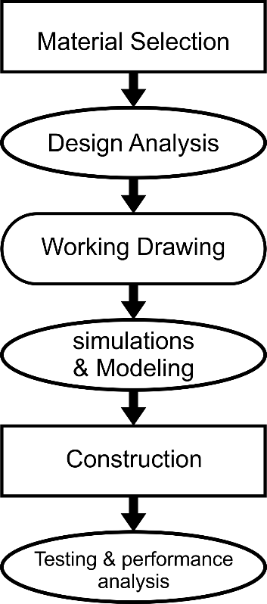

3.2 DESIGN AND MATERIAL SELECTION
3.2.1 Material Selection

COMPONENT | DESCRIPTION | MATERIAL SELECTED | REASONS FOR MATERIAL SELECTION
Fuselage |  | 3-D Printed Plastic
Wing and Tail Frame |  | 3-D Printed Plastic
Wing and Tail Covering
Gears and Gearbox |  | 3-D Printed Plastic
Joints and Fastenings
Linkages |  | 3-D Printed Plastic
Adhesives

3.2.2 Design Specifications
3.2.2.1 Weight Estimation

 | Component | Mass (Kg)
1 | Motor | 0.156
2 | Battery | 0.386
3 | Receiver | 0.041
4 | ESC | 0.032
5 | 2 Servos | 0.175
6 | Fuselage | 0.318
7 | Wings | 0.200
8 | Gears & Fasteners | 0.050
 | Total | 1.358 Kg

3.2.2.2 Lift Calculation
W = 1.358 Kg
An allowance of 40 % is added
Therefore W = 1.901 Kg, approximately 2 Kg
W = 20 Newtons
For Flight to be achieved L > W
Where L = Lift Force
L = 4 ρ ϕ $\int_{0}^{l_{e}}{{(ωr)}^{2}r ∆r}$ ……………………………………… (EQUATION 1)
Φ = flapping stroke angle = 50º
ρ = Air Density = 1.225 ${kg}/{m^{3}}$
𝞈 = flapping speed (rad/sec)
$l_{e}$ = Wing Effective length (m)
L = 40 Newtons (maximum payload of 2 kg)
Substituting known parameters into (EQUATION 1)
We have: ${ω }^{2}× {l_{e}}^{4}$ = 0.653 ………………………………… (EQUATION 2)
Desired wing shape is quarter of an ellipse.
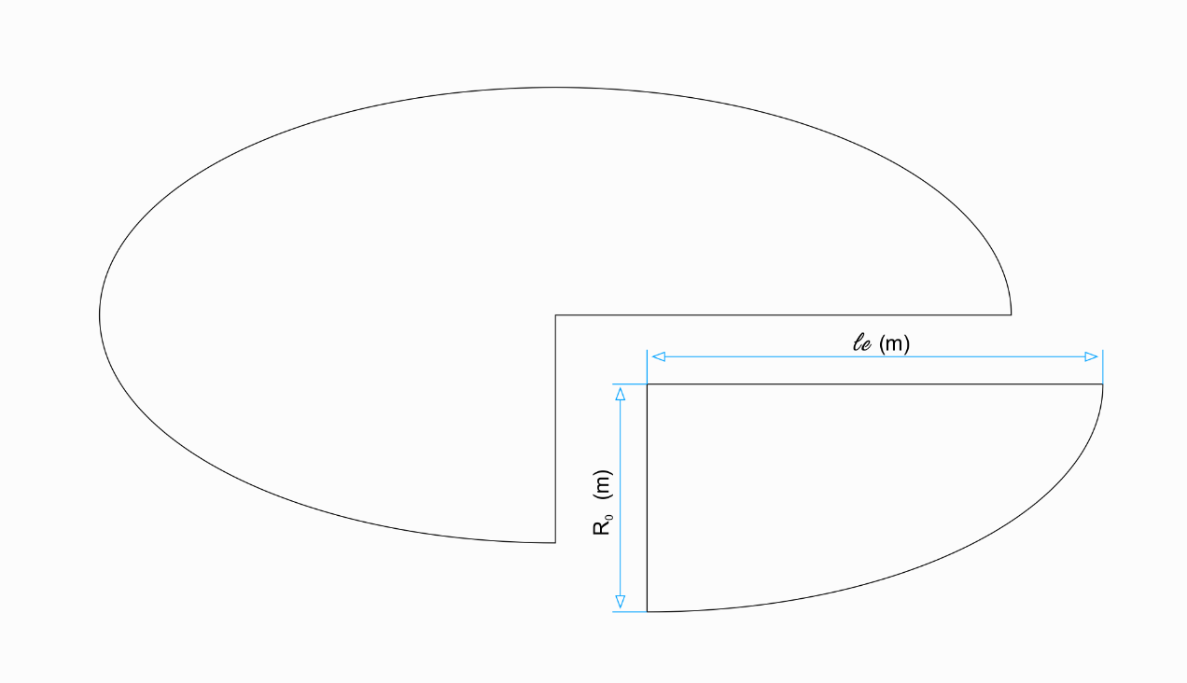
Area of Ellipse = $π × le × Ro$
Therefore, Wing Area S = $\frac{π × le × Ro}{4}$
$le=$ $\frac{S × 4}{π ×Ro}$
$R_{0}$ = 0.3 m (the length of fuselage is 0.4 m)
$l_{e}=$ $\frac{S × 4}{π ×0.3}$
$l_{e}$ = S $×$ 4.244 ……………….……………………………… (EQUATION 3)
Substituting (EQUATION 3) into (EQUATION 2)
$$ω^{2} × S^{4}=0.002$$
A graph showing the relationship between required flapping speed 𝞈, effective wing length $le$ and the wing Area S to generate lift of 40 N has been plot using the derived equation below.
$$ω^{2} × S^{4}=0.002$$
S = $\frac{π × le × Ro}{4}$ ${ (m}^{2})$ | $le=$ $\frac{S × 4}{π ×Ro}$ ($m)$ | $ω=\sqrt{\frac{0.002}{S^{4}}}$ (rad/sec)
0.10 | 0.42 | 4.47
0.12 | 0.51 | 3.10
0.14 | 0.59 | 2.29
0.16 | 0.67 | 1.75
0.18 | 0.76 | 1.38
0.20 | 0.85 | 1.18
0.22 | 0.93 | 0.92
0.24 | 1.02 | 0.78

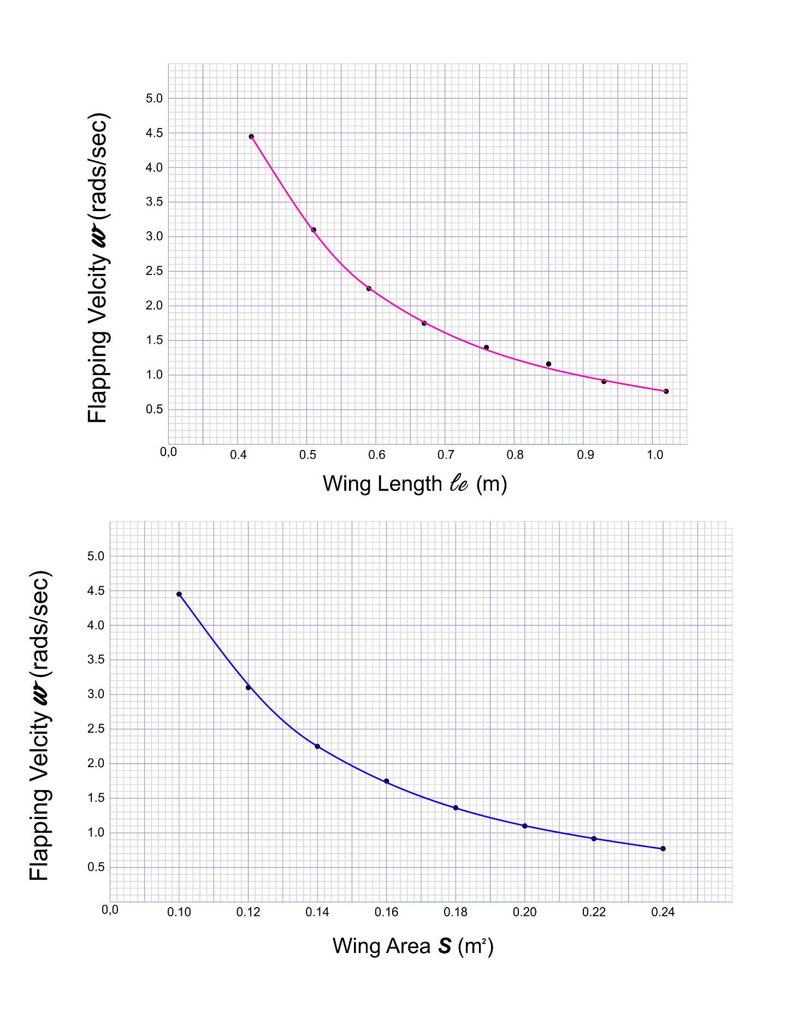
A wing area S = 0.14 $m^{2}$ and wing effective length of 0.59 m will require a flapping speed 𝞈 = 2.29 rad/sec to generate lift of 40 N.

Calculation for wing flapping speed
2.29 rad/sec = 131.2 degrees/sec
Flapping stroke angle = 50 degrees, therefore 1 flap is equivalent to 100 degrees.
No of flaps per second = 131.2 degrees/sec ÷ by 100 degrees
= 1.312 flaps/second.
3.2.2.3 Flight Control
3.2.2.4 Power, Gearing and Linkages
To achieve the flapping speed of 1.3 flaps/second; the 7500 rpm (125 rps) speed of the electric motor will be reduced to 78 rpm (1.3 rps) by a gear assembly of reduction ratio 1:96.
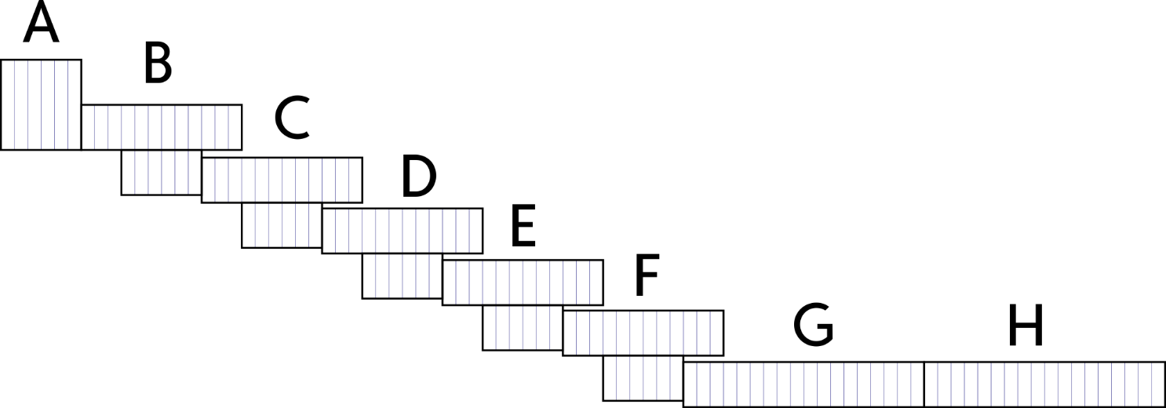
The gears have a module of 1.5
Gear module M = $pitch diameter \left(D_{p }\right)÷numberof teeth (T)$

GEAR | TYPE AND DESCRIPTION | NUMBER OF TEETH T | DIAMETER ($mm)$
A | Single gear connected to motor shaft | 12 | 18
B, C, D, E, & F | Double gear mounted in gear housing | 24 & 12 | 36
G & H | Single gear connected to cam & flapping mechanism | 36 | 54

Gear A rotates at a velocity $N_{A}$ = 7500 rpm
$\frac{N_{A}}{N_{B}}$ = $\frac{T_{B}}{T_{A}}$
$N_{G}$= $\frac{T_{A}}{T_{B}}×{\frac{T_{B}}{T_{C}}×\frac{T_{C}}{T_{D}}×\frac{T_{D}}{T_{E}}×\frac{T_{E}}{T_{F}}×\frac{T_{F}}{T_{G}}×N}_{A}$
Therefore, $N_{G }$= $\frac{12}{24}×{\frac{12}{24}×\frac{12}{24}×\frac{12}{24}×\frac{12}{24}×\frac{12}{36}×N}_{A}$
$N_{G }$= $\frac{1}{2}×\frac{1}{2}×\frac{1}{2}×\frac{1}{2}×\frac{1}{2}×\frac{1}{3}×7500$
$N_{G }$= $78.125 rpm$ (1.302 rps)
3.2.2.5 Electrical Component Estimation.
3.2.2.6 Automation
3.2.2.7 Electrical Component Selection
3.2.2.8 Table of money
3.2.2.9 Table of estimated weight vs actual weight

 | Component | Estimated Mass (Kg) | Actual Mass (Kg)
1 | Motor | 0.156 | 0.055
2 | Battery | 0.386 | 0.169
3 | Receiver | 0.041 | 0.007
4 | ESC | 0.032 | 0.032
5 | 2 Servos | 0.175 | 0.041
6 | Fuselage | 0.318 | 0.046
7 | Wings | 0.200 | 0.200
8 | Gears & Fasteners | 0.050 | 0.050
 | Total | 1.358 Kg | 1.358 Kg

3.2.2.10Stability
3.2.2.11Table of Dimensions
3.3 Working Drawing and Simulation
3.4 Fabrication and Construction

3.7 Design Calculations
Wing:
The values for maximum weight (W) of 40N, and wing length ($R_{o}$) of 0.3m were obtained from the stability and control team and were used for the following calculations:
Maximum weight (W) =Expected lift generated (L).
By actuator disc theory
$$L=4ϕρ\int^{R_{e}}{{\left(w\left(r\right)\right)}^{2}r∆r}=ϕρw^{2}{R_{e}}^{4} (1)$$
The Desired wing geometry was a quad-ellipse therefore the formula for area of a quad ellipse (A)
$$A= \frac{πR_{e}R_{o}}{4} (2)$$
Using these equations (1) and (2) and the values for The desired stroke angle $ϕ=50°$, air density$ρ=1.225$ , mathematical relationships were generated to relate major wing radius to the area of the wing and area to the angular velocity as shown below:
$$A=0.235619449×R_{e} (3)$$
$$w=\frac{0.0448641271}{A^{2}} (4)$$
Using these equations the value the wing span R_{e} was varied to get a possible range of values for area and angular velocity to produce the required lift as shown in the table below:
Table Illustrating Range of Values for Wing Span ($R_{e})$ , Area (A) and Angular Velocity (rad/s)
$$R_{e} (m)$$ | Area(m²)  $A=0.235619449×Re$ | Angular velocity (rad/s)  $$w=\frac{0.0448641271}{A^{2}}$$
0.1 | 0.023562 | 80.8122
0.2 | 0.047124 | 20.20305
0.3 | 0.070686 | 8.979134
0.4 | 0.094248 | 5.050763
0.5 | 0.11781 | 3.232488
0.6 | 0.141372 | 2.244783
0.7 | 0.164934 | 1.649229
0.8 | 0.188496 | 1.262691
0.9 | 0.212058 | 0.997682

A value for $R_{e}$ was chosen from this table to be 0.6 therefore giving a resultant area A=0.14m² and angular velocity of 2.24rad.
Angular velocity was then converted to number of flaps per second using the relation
$$Flapping speed \left(\frac{flaps}{s}\right)=w×\frac{180}{π}×\frac{1}{degrees covered per flap} (5)$$
Where $degrees covered per flap=100°$
This resulted in a flapping speed of $1.28flaps/s≈1.3 flaps/s$
To reduce the effect of tip losses during flapping, aerofoils were implemented in the wing design. The lift generated by this mechanism varies continuously during flight according to the pitch angle, coefficient of lift and velocity of the wing through air on the x-axis which tends to vary throughout controlled flight. The aerofoil generates 0N lift when the ornithopter has no lateral motion. The relation for calculating the instantaneous lift generated by the aerofoil is given as:
$L=\frac{1}{2}C_{l}ρAV^{2} (6)$
Where${ C}_{l}=Coefficient of lift$
$V=Linear velocity of the ornithopter.$

