ASSIGNMENT
Briefly explain the following interconnection networks:
1. The Crossbar Network
2. Cube Interconnection Network
3. Fat Tree Connection

1. THE CROSSBAR NETWORK

Crossbar Networks
Crossbar networks allow any processor in the system to connect to any other processor or memory unit so that many processors can communicate simultaneously without contention. A new connection can be established at any time as long as the requested input and output ports are free. Crossbar networks are used in the design of high-performance small-scale multiprocessors, in the design of routers for direct networks, and as basic components in the design of large-scale indirect networks. A crossbar can be defined as a switching network with N inputs and M outputs, which allows up to min{N, M} one-to-one interconnections without contention. Figure 1.9 shows an N × M crossbar network. Usually, M = N except for crossbars connecting processors and memory modules.
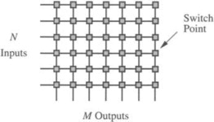
The cost of such a network is O(N M), which is prohibitively high with large N and M. Crossbar networks have been traditionally used in small-scale shared-memory multiprocessors, where all processors are allowed to access memories simultaneously as long as each processor reads from, or writes to, a different memory. When two or more processors contend for the same memory module, arbitration lets one processor proceed while the others wait. The arbiter in a crossbar is distributed among all the switch points connected to the same output. However, the arbitration scheme can be less complex than the one for a bus because conflicts in crossbar are the exception rather than the rule, and therefore easier to resolve.

2. CUBE INTERCONNECTION NETWORK
Cube: It is a 3 dimensional interconnection network. In this the PE’s are arranged in a cube structure.
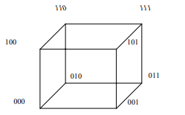

3. FAT TREE CONNECTION
Fat tree: It is a modified version of the tree network. In this network the bandwidth of edge (or the connecting wire between nodes) increases towards the root. It is a more realistic simulation of the normal tree where branches get thicker towards root. It is the more popular as compared to tree structure, because practically the more traffic occurs towards the root as compared to leaves, thus if bandwidth remains the same the root will be a bottleneck causing more delay. In a tree this problem is avoided because of higher bandwidth.
