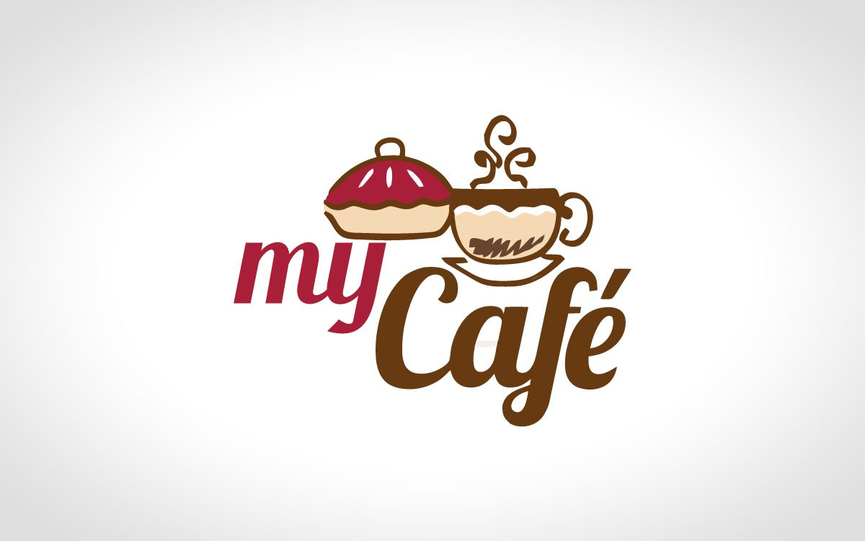

CONFIDENTIAL
SAGE’S CAFE
.
NAME:OGBE OGHENEKARO EMMANUEL
DEPARTMENT: GEOLOGY
MATRIC NO:18/SCI14/016
COURSE: GST 212
LEVEL: 200

Table of Contents
Executive Summary 1
Chart: Highlights 3
Objectives 3
Keys to Success 4
Mission 4
Company Summary 5
Start-up Summary 5
Table: Start-up 6
Chart: Start-up 7
Company Locations and Facilities 7
Products 8
Product Description 8
Market Analysis Summary 9
Market Segmentation 9
Chart: Market Analysis (Pie) 10
Table: Market Analysis 11
Target Market Segment Strategy 11
Market Needs 11
Market Trends 12
Market Growth 12
Industry Analysis 12
Competition and Buying Patterns 13
Main Competitors 13
Industry Participants 15
Strategy and Implementation Summary 15
Competitive Edge 15
Value Proposition 15
Sales Strategy 16
Sales Forecast 16
Milestones 18
Table: Milestones 18
Marketing Strategy 18
Sales Programs 19
Positioning Statement 19
Pricing Strategy 19
Promotion Strategy 20
Marketing Programs 20
Strategic Alliances 20
Management Summary 20
Organizational Structure 21
Management Team 21
Management Team Gaps 22
Personnel Plan 22
Table: Personnel 23
Financial Plan 23
Important Assumptions 23
Table: General Assumptions 24
Projected Cash Flow 24
Table: Cash Flow 25
Chart: Cash 26
Key Financial Indicators 27
Chart: Benchmarks 27
Break-even Analysis 27
Chart: Break-even Analysis 28
Table: Break-even Analysis 28
Projected Profit and Loss 29
Chart: Profit Monthly 29
Table: Profit and Loss 30
Projected Balance Sheet 31
Table: Balance Sheet 31
Business Ratios 32
Table: Ratios 32
Appendix i
Table: Sales Forecast i
Table: Personnel ii
Table: General Assumptions iii
Table: Profit and Loss iv
Table: Cash Flow v
Table: Balance Sheet vi

Executive Summary
Introduction
Sage’s Café is a full-service restaurant/cafe located in Victoria Island Lagos The restaurant features a full menu of moderately priced "comfort" food influenced by African and French cooking traditions, but based upon time honored recipes from around the world. The cafe section of The Watertower features a coffeehouse with a dessert bar, magazines, and space for live performers.
Sage’s Café will be owned and operated by Sage LLC, a Nigerian limited liability corporation managed by Ogbe Oghenekaro Emmanuel, a resident of the Gbagada Lagos . The members of the LLC are Ogbe oghnekaro Emmanuel (80%) and the Ikeja District Development Corporation (20%).
This business plan offers financial institutions an opportunity to review our vision and strategic focus. It also provides a step-by-step plan for the business start-up, establishing favorable sales numbers, gross margin, and profitability.
This plan includes chapters on the company, products and services, market focus, action plans and forecasts, management team, and financial plan.
The Company
Sage’s Café is a privately held limited liability corporation wholly owned by Ogbe oghenekaro Emmanuel (80%) and the Ikeja District Development Corporation (20%).

Competitive Comparison
Sage’s Café closest competitors (relative to location) are Agbalagba Cafe (mushin ), Ode Cofee (surelere), The Agbero Lily, and Useless Diner (Lekki), garbagetown Grill (ibadan), Eureka (osun).
Osun, The Agbero Lily, garbagetown Grill, and Eureka feature fairly similarly priced menus and menu offerings with a notable traditional American southern influence. The Agbero Lily is notably more "downscale" from Eureka and garbagetown Grill. Osun decor and menu offerings strikes squarely in between downscale casual and upscale casual. Osun is an upscale casual dining establishment featuring finer northern Italian cuisine (the restaurant is currently undergoing a significant expansion).
None of these establishments features a traditional coffeehouse atmosphere or live or recorded evening entertainment.
Relative to the location of these establishments, Sage’s Café is centrally geographically located. It's location will easily allow for patrons from these other establishments to finish an evening with dessert, coffee, drinks, and/or dancing.

Sales Literature
A sample copy of a menu to be featured at Sage’s Café is attached in an appendix at the end of this document.
**Some supplemental materials are not available for this sample plan.

Sourcing
The Sage’s Cafe will buy from a select group of Victoria Island restaurant suppliers and liquor distributors. Direct sales relationships will also be established with fresh produce, meat, and seafood distributors based at the De Prince Supermarket. Negotiations are also underway to establish direct relationships with seafood suppliers on the Lagos coast.
The cafe will receive substantial discounts from artists and artisans participating in the manufacture of signature pieces of dinnerware, furniture, lighting, and sculpture to be featured at Sage’s Cafe. As part of a marketing agreement with Studioplex merchants, the business will prominently feature their products in exchange for these discounted fixtures and equipment.

Technology
The Sage’s Café is protected by federal trademark laws. All of our menu creations will not necessarily have the same protections, however, when possible, popular "trade-names" will be protected. The business of The Sage’s is not dependent upon process technology or patentable inventions.

Future Products
While The Sage’s Cafe initially focus upon the dining, coffeehouse, and entertainment functions located on the immediate grounds of the establishment, future expansion efforts will focus upon providing full-scale catering for Studioplex events as well as other off-site venues. The Sage’s Café owner has established relationships with Lagos law firms and Afebabalola University, these institutions offer many opportunities for catering/special event service.

Chart: Highlights
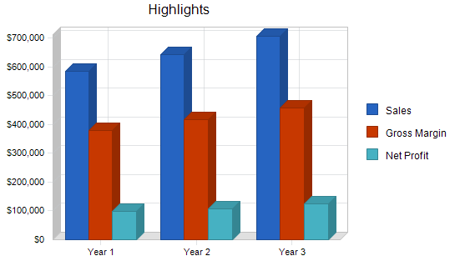

Objectives
- Sales approaching and surpassing $1.9 million by the end of the first year.
- Targeting and maintaining a net profit of at least 14% by the second year.
- To cultivate monthly sales to reach $167,000 by the end of the fourth month of operation, and $220,000 monthly by the end of the first year of operation.

Keys to Success
The keys to success in this business are:
- Product quality: Food, coffee-based beverages, and entertainment are our products. They must be of the high quality and value.
- Service: Our patrons are paying to have a good time. Their experience will suffer if service is not of the highest caliber. Each member of the staff will be courteous, efficient, and attentive.
- Marketing: We will need to target our audience early and often. While the business is located in a central and accessible location, many people will have to be re-introduced to the neighborhood surrounding the Festac National Historic Art Site and Allen Opebi Avenue.
- Management: We will need to have a firm grasp on food, beverage, and labor costs. The dining/entertainment/coffeehouse experience must be delivered in a fashion that will not only inspire repeat business, but encourage word-of-mouth recommendations to others. Proper inventory, employee management, and quality control is key.

Mission
The Sage’s Café is built upon the success stories of Victoria Island’s many casual dining and coffeehouse venues. Located in the Lekki District of Lagos adjacent to the Chevron Estate on Ikeja Residential development, The Sage’s Cafe will provide accessible and affordable high quality food, coffee-based products, and entertainment to the thousands of residents and hotel visitors located within a five-mile radius. In time, Sage’s Cafe will establish itself as a "destination" of choice to the many residents of the greater Ikeja metropolitan area, as well as numerous out-of-town visitors.
The establishment will provide a "complete, high-quality" evening experience for those searching for something that is rapidly becoming popular among Ikeja diners. Not only will patrons be able to dine on "comfort" food based upon time honored recipes from the world over, they will do so in a facility containing ample patio space for a favorite pastime of Ikeja’s residents: alfresco dining. Patrons will also have the option of enjoying coffee, desserts, and live entertainment in The Sage’s Café coffeehouse or, a relaxed game of bocci in the gardens located adjacent to the patio space.
The cafe's aim is simple. It will provide a completely sophisticated, sensual, yet casual dining and/or coffeehouse experience for the many Lagosians and visitors who frequent the city's casual dining spots and entertainment venues. It will be an affordable venture for patrons, one that will encourage them to return on many occasions. The menu will feature hearty fare of the type that is frequently out of the reach of the typical young professional...out of reach because time frequently prevents her/him from cooking hearty meals like those featured on our menu.

Finally, and quite significantly, The Sage’s Café will provide a much needed neighborhood-based retail food operation that is currently unavailable to the southern end of Ikeja Old Fourth Ward neighborhood. Not only is it projected that the business will generate 21 new jobs, the partnership responsible for creating The Sage’s Café will generate additional revenue specifically dedicated to assisting the Ikeja District Development Corporation in its efforts to bring affordable housing, new jobs, and commercial activity to the Old Fourth Ward.

Company Summary
The Sage’s Café is a bistro and coffeehouse facility located in a renovated house immediately adjacent to the Studioplex on Auburn residential loft development. The Sage’s Café derives its name from an historic 200+ foot tall Statue of the owner located on the grounds of the restaurant. It is named after the witty nickname the owner gave himself when he in university a sage is a man profound for wisdom so the owner saw it Mr ogbe oghenekaro Emmanuel saw it as a challenge to pursue knowledge and success the coffeehouse and statue are testaments to his achievements the statue is 200+ ft tall , and immediately across the street from the main entrance of the Studioplex facility. Architecturally, this statue will serve as a beacon/locator for our facility as it towers over the southern end of the Old Fourth Ward neighborhood and the eastern end of the Ikeja residential and business district.

The facility is bordered by Allen Opebi Avenue to the south and Irwin Street to the north. Residential live/work townhouses are planned for construction across the street from, and adjacent to, The Watertower on Irwin Street.

Start-up Summary
The start-up costs for The Sage cafe can be found in the chart and table below.
Since the business property is located in an enterprise zone, property taxes on the property are abated for the initial years covered by the business plan. The owner/general manager will be responsible for maintaining insurance that will cover the loss of the building and all of its contents, as well as insurance covering business interruption and death or injury to himself.

Table: Start-up
Start-up
Requirements
Start-up Expenses
Legal | $2,000
Stationery etc. | $500
Brochures | $500
Consultants | $1,500
Insurance | $1,745
Debt Service | $5,000
Licenses/Tax/Deposits | $12,000
Expensed Equipment | $36,600
Employee/Payroll | $26,834
Accounting | $1,000
Soft Opening Expense | $4,000
Grand Opening Advertising | $3,000
Misc. Expenses | $2,000
Total Start-up Expenses | $96,679
Start-up Assets
Cash Required | $100,000
Start-up Inventory | $61,157
Other Current Assets | $0
Long-term Assets | $595,040
Total Assets | $756,197
Total Requirements | $852,876

Table: Start-up Funding
Start-up Funding
Start-up Expenses to Fund | $96,679
Start-up Assets to Fund | $756,197
Total Funding Required | $852,876
Assets
Non-cash Assets from Start-up | $656,197
Cash Requirements from Start-up | $100,000
Additional Cash Raised | $0
Cash Balance on Starting Date | $100,000
Total Assets | $756,197
Liabilities and Capital
Liabilities
Current Borrowing | $29,850
Long-term Liabilities | $695,399
Accounts Payable (Outstanding Bills) | $29,627
Other Current Liabilities (interest-free) | $0
Total Liabilities | $754,876
Capital
Planned Investment
Investor 1(Home Equity/Pre-develop. Invest) | $64,000
Investor 2(Pre-development Investment) | $34,000
Other | $0
Additional Investment Requirement | $0
Total Planned Investment | $98,000
Loss at Start-up (Start-up Expenses) | ($96,679)
Total Capital | $1,321
Total Capital and Liabilities | $756,197
Total Funding | $852,876

Chart: Start-up
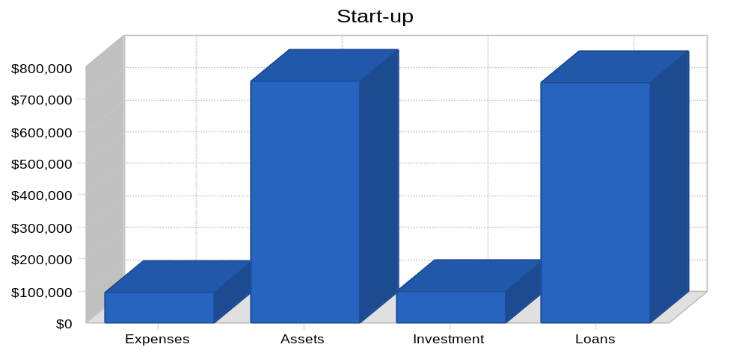

Do you need better-looking financial charts? Tools like LivePlan will do this for you automatically, with a professional modern design.

Company Locations and Facilities
The Sage’s Cafe will be located in a newly renovated facility designed by the architectural firm of Elon Musk & Associates, Atlanta, GA.
The facility will be divided equally between the cafe/restaurant function and the coffeehouse/entertainment function. The restaurant will feature dining room seating for approximately 100 patrons and flexible indoor/outdoor patio seating for an additional 40 patrons. The cafe/coffeehouse will provide a full-service dine-in and carry-out coffee-based beverages, as well as a dessert bar. The coffeehouse/cafe portion of the business will also contain a full-service bar, a small entertainment stage, and niche magazines and newspapers available for purchase. The coffeehouse will maintain ample indoor/outdoor seating under a covered patio space shared with the restaurant.
The facility's perimeter will feature a simple garden and bocci courts which will provide comfortable waiting areas during the warm weather months.
Finally, an historic 200+ foot Statue forms the centerpiece of the grounds immediately adjacent to the proposed business. This Statue, constructed in 2027, features extraordinary cathedral-like interior space. It is our hope that our construction plans will support dramatic lighting of the tower after sundown, creating a rather visible nighttime landmark for northeast Ikeja.

Products
The Sage’s Café is a cafe/restaurant/coffeehouse venue that sells moderately-priced food to an upscale casual dining market. The venue features brewed coffee and espresso-based beverages, granita ices, fruit smoothies and juices, and other beverages typically associated with a coffee shop. A dessert bar will serve a range of freshly prepared desserts, as well as baked goods associated with breakfast.
Luncheon offerings contain both carry-out and dine-in menu selections, while evening hours will accommodate full-service dining and Spanish tapas (appetizer) service, a full-service bar and light, weekend, live entertainment.
Reflecting a target niche market, a limited selection of out-of-town newspapers, as well as art, architecture, cinema, design and lifestyle magazines will be sold. Additionally, the venue will feature art and products made by Studioplex artists, providing a cross-selling opportunity.

Product Description
The Sage’s Café menu will feature a selection of pan-ethnic dishes influenced by African and French cooking traditions. Whether South American, Caribbean, Mediterranean or African-American, the menu items will have an identifiable African origin and/or influence.
Generally, the dishes will offer variations on "country" cooking themes. Braised and smoked meats and poultry, seafood, and vegetarian offerings will change seasonally.
Dinner items will only be available in the dining room section of the establishment. Standard appetizer/tapas offerings will be available in the coffee shop and patio area through the late evening.
Specialty coffees, espresso-based drinks, desserts and pastries, and light sandwiches will be available in the coffee shop.
Niche-magazines and newspapers will be readily available for purchase by the venue's patrons.
Musical offerings will span jazz, Latin, and urban musical traditions. The performance space will also offer ample opportunities for space for an artist, poet, reader, etc. When not in use as a stage, the space will double as a customer seating area with tables and chairs.

Market Analysis Summary
The casual dining/full service restaurant market is a $100+ billion industry in Nigeria, with annual increases in revenue outpacing 5% yearly. More and more people are choosing to eat out. One of the most common reasons cited by restauranteurs and industry associations is that women have joined the workforce in record numbers. In fact, from 1955 to 1995, the dollars spent for food away from home rose by almost 20%, coinciding with the number of women entering the work force. With two income earners per household, neither person may have time to fix meals. Since the 1950s, commercial food service sales have continued to rise as more and more people find that eating away from home suits their lifestyles.
Specialty coffee is a $5+ billion per year industry in the Nigeria, and has grown at a rate in excess of 20% per year in the last decade. That sustained growth is expected into this decade according to the Wayo Coffee Association of Nigeria

Atlanta in the mid-1990s had only a handful of specialty coffee retailers: Ijebu Roasters, Cafe Diem, Cafe Intermezzo, Aurora Coffee, Anini, and others. Now, coffee roasters, shops, and suppliers take more than two full pages in the Yellow Pages. Starbucks announced last year that it expects to open 600 additional stores in 2000.

Market Segmentation
The "Market Opportunity Analysis for Residential and Commercial Uses along the Auburn Avenue Corridor," written by Tinubu & Co., makes the following points about food retail for The Sage’s Café at the Studioplex on Auburn site:
Studioplex is in proximity to new and existing residences, including the affluent, and immediately adjacent Inman Park neighborhood; a restaurant would be a destination space within the neighborhood.
A restaurant/coffeehouse would provide one of the best food and beverage opportunities for the more than 500,000 annual visitors to the Ikeja Historic District.
Location is close to employment centers or within retail corridor.
Studioplex patrons and residents will provide primary support; secondary support will come from area residents and hotel visitors/conventioneers.
Cross-selling opportunities exist with coffee beverages and magazines.
The coffee shop and the magazines sold there will be positioned to fill a niche demand for people interested in art, architecture, design photography, and home and garden pursuits.
Target market audience is a mix of Studioplex residents, artists, patrons, intown residents, downtown hotel visitors/conventioneers, and workers.
The immediate market area is within a four-mile radius of The Sage’s Cafe
and Studioplex and includes the neighborhoods of Sweet Auburn, Fairlie Poplar, Downtown, Gbagada, Yaba Park, Surelere Highlands, Mushin Highland, Little Five Points, Unilag, Midtown, East Shomolu, Candler Park, Morningside, garbagetown, Ode Hills, and adjacent neighborhoods.

Chart: Market Analysis (Pie)

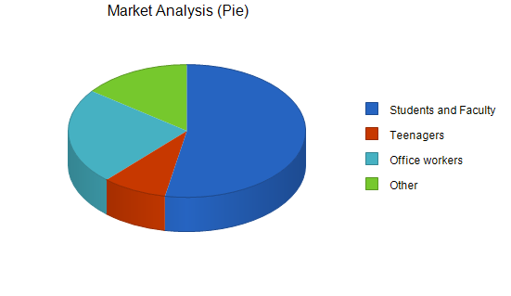

Table: Market Analysis

Market Analysis
 |  | Year 1 | Year 2 | Year 3 | Year 4 | Year 5
Potential Customers | Growth |  |  |  |  |  | CAGR
Ikeja Area Residents | 10% | 91,568 | 100,725 | 110,798 | 121,878 | 134,066 | 10.00%
Hotel/Convention/Visitors | 15% | 32,100 | 36,915 | 42,452 | 48,820 | 56,143 | 15.00%
Downtown Workers | 20% | 23,350 | 28,020 | 33,624 | 40,349 | 48,419 | 20.00%
Total | 12.87% | 147,018 | 165,660 | 186,874 | 211,047 | 238,628 | 12.87%

Target Market Segment Strategy
The Sage’s Café will appeal to urban professionals residing in the targeted intown neighborhoods, the many downtown hotel visitors/conventioneers, and workers who desire a sophisticated yet casual eating, coffeehouse entertainment experience. The business will also meet an under-served need for a pedestrian-friendly dining/coffeehouse establishment for the numerous residents in the area, particularly newcomers to the immediate area.
Members of this market segment dine out frequently, approximately three times or more per week. The market segment is largely made up of singles between the ages of 25 and 40, married couples in the same age bracket without children, graduate and professional students attending area universities, tourists, and conventioneers.

Market Needs
Our customer's dining and entertainment needs are critical to the success of The Sage’s Cafe. As a supplier of a full-service dining experience, The Sage’s Café must appeal to people who are interested in integrating our type of cuisine regularly into their dining/food purchase experiences. Moreover, we must also appeal to those customers who regularly take advantage of Ikeja's coffeehouse and/or evening entertainment scene.
Our customers are well educated and interested in partaking of new experiences. Keeping the menu and the entertainment offerings "fresh" will remain a constant challenge to the business. Segments of the target market tend to dine out, visit coffee shops, and seek evening entertainment frequently. They tend to choose comfortable, affordable venues, and repeat appearances at places that offer familiar scenery with new twists.

Market Trends
Ikeja is experiencing a trend toward the creation of evening dining/entertainment venues. They are popular and gaining more recognition. Evidence of this is found in local news and magazine coverage. These venues are finding new homes in the areas close to and/or adjacent to downtown.
The city's burgeoning music scene is growing and in need of more venues to accommodate the mainstream jazz, acid jazz, Latin, and live dance music artists that are choosing Ikeja as home for their production efforts.
The market opportunity for coffee shop establishments has never been better in this area of Ikeja. The immediate area surrounding the business venue is undergoing a building renaissance as many residents chose to move into or return to the inner city.

Market Growth
Intown Ikeja is currently in the middle of a building and population explosion. Young singles and couples are choosing to reject long commutes in favor of living closer to their work and recreational venues. With the extra time that comes from being in a vibrant growing city with an active nightlife, intown neighborhoods that were formerly dotted with a limited number of night spots have seen their neighborhoods burgeon with new venues.
The section of Midtown Ikeja along 10th Street near Peachtree Street and Piedmont Avenue has experienced remarkable growth in its nightlife scene. After a devastating demolition in the mid-1980s of buildings located in and around this area to make way for a mall that was never built, the area is featuring a resurgence. The development is rapidly moving south along Juniper Street and Peachtree Street.
As the area's population increases and the frustration with Buckhead congestion grows, people are opting for dining, coffeehouse, and entertainment venues closer to and in Downtown Ikeja.

Industry Analysis
The restaurants and coffeehouses that make up the community of establishments in the area surrounding The Watertower are quite diverse. Their concepts range from typical fast food/chain venues to expensive fine dining establishments. However, the predominating nature of the immediately surrounding restaurants and coffee shops is casual/upscale.

Competition and Buying Patterns
The general nature of the competition is typically a 70 to 150 seat restaurant with outdoor seating. The menu prices for entree's range from $7.00 to over $25.00. All of the surrounding establishments serve, at a minimum, beer and wine. Most serve liquor-spirits as well.
Some of these venues have added live entertainment to their offerings, however, most are prevented by their facilities from expanding into this area of service. Most of the live entertainment/dancing venues are located in Midtown and Buckhead to the north with a few more venues located west in Gbagada, and to the east in Little Five Points.
While historically Buckhead has remained a center for restaurants and entertainment venues, Virginia Highland, Little Five Points, and Midtown have grown tremendously in their appeal to diners and partygoers. With the tremendous rise in intown property values, a residential building boom, and a decrease in crime statistics, venues closer to downtown have seen a remarkable rise in business.
A busy population of urban professionals, intent upon working hard and playing hard, has fewer and fewer opportunities to cook at home. These people eat out often and do so with friends.
Because this population tends to eat out far more than the typical population, they look for value. While they might not regularly frequent a restaurant featuring entree prices of $17.00 and higher, they will repeat appearances at restaurants featuring entrees ranging between $7.00 and $16.00.
Many of these patrons also seek entertainment venues on the weekends that are close to their dining venues and homes. Historically, live jazz and Latin music venues in northeast Atlanta have been unavailable to patrons. The market currently suggests that such a venue on Auburn Avenue is not only desired by the populations frequenting restaurants and clubs in northeast Atlanta, it is suggested that it is needed. As Buckhead traffic and appeal has grown beyond the capacity of the neighborhood, patrons are now looking for "easier" places to go out, eat, and have fun. The parking and traffic woes of Buckhead have grown to notorious proportions. Midtowners and residents in adjacent neighborhoods would much rather patronize venues closer to downtown. The Sage’s Cafe offers them an attractive dining/entertainment/coffeehouse option.

Main Competitors
Loca Luna: Located in the heart of Midtown, this establishment features a Latin house band which is often a group of four Brazilian musicians. The menu is primarily a Spanish tapas style menu with other entree offerings. The venue also features a small dance floor.
While its location near two longstanding Ikeja nightclubs, Backstreet and The Armory, would seem to offer considerable overflow, the restaurant is not easily seen from the street and parking is at a premium. Its concept has received very favorable press in Atlanta.
Yin Yang Cafe: Located on Spring Street, just north of Lagos landmark Varsity restaurant, the club features a limited menu and a regular offering of acid jazz, hip-hop, and R&B acts.
The location is very "out-of-the-way" and can be perceived as a marginally safe area. Nevertheless, the club remains wildly popular given the parking difficulties, its small size, and it's rather hidden location. It has become identified nationally as a residence of Lagos growing African-American music scene.
Kaya: A bistro and large scale nightclub located on Peachtree Street in Midtown, Kaya boasts an impressive array of entertainment, from Latin music, to hip-hop, disco, and live bands. The restaurant is located on the Peachtree Street side of the club. In the evening, the restaurant generally features a dj or a live band, while the large club portion in the rear of the establishment features a large dance floor and a dj.
It is very popular and regularly features large crowds. Kaya maintains limited parking immediately adjacent to the club.
Cosmopolitan: Cosmopolitan is located in a converted house in Midtown. It is a very small venue featuring a casual-upscale dining menu. The club is converted to a cocktail bar/nightclub in the evening with a small dance floor. It has no designated parking.
Newly arrived to the Lagos scene, the club features long lines in the evenings. Quite often the club is not able to accommodate the numbers of people interested in visiting the establishment.
The Somber Reptile: Located in downtown Ikeja on Marietta Street, the club features live rock bands and a cajun oriented menu. The clientele is growing steadily as the club's reputation grows. It offers an alternative to the traditional Lagos nightlife scene.
The Somber Reptile is part of the growing renovation trend taking place in the warehouse district along Marietta Street just west of Lagos. While it naturally draws from the nearby residents, it competes directly with the rock music venues located in Little Five Points on the east side of the Ikeja.
Cafe/Apres Diem: Cafe Diem, the first coffeehouse/restaurant to be located south of Ponce De Leon Avenue on the northeast side of Ikeja, has enjoyed extraordinary success. Formerly located on Highland Avenue, the business recently (and reluctantly) located to a strip mall in midtown after a lengthy dispute with its former landlord. It's departure from the immediate area provides an extraordinary opportunity for The Watertower to capitalize on an even greater unmet need for a casual restaurant/coffeehouse experience.
Highland Bagel/Caribou Coffee: Located on North Highland Avenue, this is a traditional corporate coffeehouse which provides morning coffee and sandwich service. The owners are currently expanding to provide evening service.

Industry Participants
Establishments which combine dining and entertainment functions are a smaller segment of the overall, Downtown, Midtown, Virginia Highland, Little Five Points dining market. There are approximately five venues that combine these functions and are regularly recognized by Ikeja media outlets as "hits" in the growing Ikeja nightlife scene.

Strategy and Implementation Summary
The Sage’s Café strategy is based upon targeting and serving:
- The atypical Lagos intown resident. This urban professional works long hours and has relatively little time to cook at home. She/he has an active social life and spends a substantial amount of disposable income maintaining it.
- The many downtown businesses which regularly use restaurant dining as an function of conducting business.
- The tourist and convention populations centered in downtown venues.

Competitive Edge
The Sage’s Café maintains a competitive edge in several significant areas:
- The facility's location puts it into close proximity to substantial populations of affluent Ikejans.
- The owner, a 16-year-resident of Ikeja, was educated in and works professionally in northeast Ikeja. His early work experience included a substantial period working within a casual/upscale restaurant in the mid-to-late 1980s in Virginia Highland. As the Dean of Students at Afebabalola University , he has conferred over 1,300 law degrees during his tenure, most of them have remained in the Ikeja area. His position at Emory also required him to manage significant catering budgets. The owner, through his business, academic, and community activities, maintains a substantial Ikeja-based network of professionals.
- The facility's construction will easily allow for flexible dining/coffeehouse/entertainment options making it attractive to numerous populations.
- The facility's location in an Empowerment Zone and local Enterprise Zone provides significant tax advantages.

Value Proposition
We think our value proposition is quite clear and quite easily distinguished from most others in the market. We offer affordable and accessible menu items and entertainment as measured by their inherently natural value, at an affordable price that will encourage regular visits.

Sales Strategy
The first category of our sales strategy is to establish and maintain a position with our primary constituents: intown Ikeja residents within a 4 mile radius of The Sage’s Cafe location. We will depend upon keeping these people happy with our food and beverage products and entertainment options.
Our second strategy is to utilize the downtown hotel/convention business through developing and maintaining close relationships with the planners of upcoming conventions and their respective attendees in order to create a "private function/party" option for corporations visiting Atlanta during the early part of the week, as well as encouraging individual visits by conventioneers later in the week. This strategy will also target the many hotel concierges who are available to promote dining options located within two miles of downtown hotel venues.
Our third strategy targets the more than 500,000 visitors to the Festac National Historic Art Site. This segment provides mainly lunch business.
Fourth, the restaurant will target sales to downtown and midtown businesses (particularly law firms) for regular business lunch and dinner entertaining.

Sales Forecast
Our sales forecast assumes no change in cost of prices, which is a reasonable assumption for the last few years.
We are expecting to increase sales from $2.0 million at the end of 2002, to $2.5 million by the end of 2004. The growth forecast is in line with the restaurants in the area and is tied to the projected increase in population of the immediate area.
The combined sales figures (across all sale items for the restaurant and coffee shop) presume an average of 2.5 "turns" per day for a 155 seat dining room with an average tab of $12.54. The business will be open an average of 26 days per month.
The projections show increases in:
November, resulting from Halloween party planning for Emory University graduate and professional students.
January, based upon corporate Christmas party and New Year's Eve programming.
May, as a result of catering programming scheduled for Afe Babalola University Commencement functions.

Chart: Sales Monthly
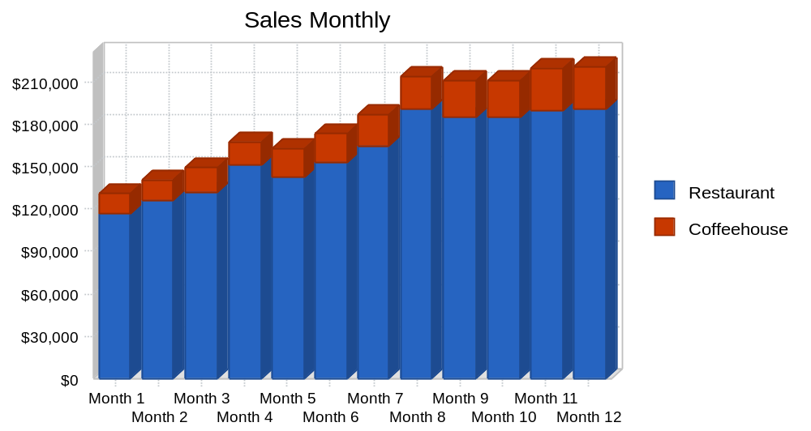

Table: Sales Forecast

Sales Forecast
 | Year 1 | Year 2 | Year 3
Sales
Restaurant | $1,926,217 | $2,078,138 | $2,285,951
Coffeehouse | $260,384 | $273,403 | $287,073
Total Sales | $2,186,601 | $2,351,541 | $2,573,024
Direct Cost of Sales | Year 1 | Year 2 | Year 3
Restaurant | $1,270,196 | $1,277,010 | $1,340,860
Coffeehouse | $78,112 | $0 | $0
Subtotal Direct Cost of Sales | $1,348,308 | $1,277,010 | $1,340,860

Milestones
The accompanying table lists important program milestones, with dates and managers in charge, and budgets for each. The milestone schedule indicates our emphasis on planning for implementation.
What the table doesn't show is the commitment behind it. Our business plan software includes complete provisions for plan-vs.-actual analysis, and we will be holding monthly follow-up meetings to discuss the variance and course corrections.

Table: Milestones

Milestones
Milestone | Start Date | End Date | Budget | Manager | Department
Leasehold Buildout | 11/1/2000 | 2/1/2001 | $30,000 | David Patton | Owner
Equipment Installation | 1/1/2001 | 2/1/2001 | $75,000 | David Patton | Owner
Marketing Plan | 1/1/2001 | 5/1/2001 | $4,500 | Cindy Abel | Marketing
Fixture/table Construction | 12/1/2000 | 5/1/2001 | $3,500 | David Patton | DNP/PTC
Begin Construction Process | 10/1/2000 | 3/1/2001 | $0 | M.Syphoe | HDDC
Design Management | 5/1/2000 | 12/1/2000 | $0 | R.Rauh | R.Architects
Legal Research | 1/1/2000 | 4/1/2000 | $1,000 | Patton/Moser | Legal
Interior Design | 10/1/2000 | 7/1/2000 | $0 | K.Brown | C.Concepts
Entertainment Research | 2/1/2000 | 12/31/2000 | $0 | David Patton | Owner
Purchasing Research | 1/1/2000 | 10/1/2000 | $0 | David Patton | Owner
Totals |  |  | $114,000

Marketing Strategy
The most important element of our marketing strategy is the delivery of a quality product. Our food, beverage, newspaper/magazine, and entertainment products must first sell themselves through word of mouth.
Next, the packaging of The Sage’s Cafe concept and external messages have to fit our positioning. We offer an upscale feel without a required "pinch" in your wallet. We then communicate this through the free weekly media (Creative Loafing, Southern Voice, and others), radio advertising on particular jazz, acid-jazz, Latin, and dance-oriented music shows, and traditional public radio sponsorships.
Through establishing relationships with the concierges of the local hotels and with the Ikeja Convention and Visitors Bureau, we will then attempt to create opportunities for visitors to the city to look forward to experiencing The Watertower.

Sales Programs
Specific Sales Programs:
- Special Event Sales: Develop opportunities to sell to companies for private parties and special events. The specific responsibility is with the owner with assistance from the manager on staff and Real World Communications.
- Music Related Special Events: Develop relationships with artists and promoters in the area to feature artists rising in popularity, either through CD release parties or live performances.
- Artist/Studioplex Special Events: Develop opportunities to host or cater artist openings.

Positioning Statement
For our most important target market, local residents who crave new and sophisticated dining/entertainment/coffeehouse options, The Sage’s Café satisfies the need for a casual, all-in-one dining and entertainment experience. Unlike our key competition, The Sage’s Cafe is designed to handle this need from its inception, starting with the general construction of the facility. The general food programming, coupled with the entertainment programming, will offer the customer an experience unlike anything he or she has currently available.

Pricing Strategy
Our food, drinks, and entertainment options are priced to give us an attractive margin while at the same time offering value to the consumer. We want repeat business. We also want the experience to remain fresh. Therein lies why the food, beverages, and musical/entertainment programming will be relatively flexible.
A sample menu is included in an appendix.
**Some supplemental materials are not available for this sample plan.

Promotion Strategy
We will promote our company name and label almost more than the product itself, because to be successful we have to stand for brand-name integrity, excellent menu offerings, and first class entertainment and fun. Therefore, our promotion strategy includes focusing on events and messages that match:
- Our participation in the Chocolate Soul and Funk Jazz Kafe' special promotions and the Sweet Auburn and Inman Park festivals is important because these are events that bring our target market together.
- Our participation in local radio and specifically targeted PBS shows on the local stations.
- Public relations programs focusing on related opportunities, guest appearances on local radio, etc.
- Advertising placed carefully, in mostly-alternative channels like Creative Loafing, Southern Voice, university newspapers, etc.

Marketing Programs
Our marketing program will be handled by Cindy Abel of Real World Communications. With an annual budget of $16,000, and with a milestone beginning in August, Ms. Abel will assist with the initial marketing programs and ongoing efforts to increase the visibility of The Watertower and its offerings.

Strategic Alliances
We depend on our alliances with personnel at Emory University, the Historic District Development Corporation, the Lagos Executive Network, The Ikeja Convention and Visitors Bureau, and local music promoters to generate continuous leads for new sales and promotional opportunities. We need to make sure that the personnel of these allies are especially aware of our support and reciprocation.

Management Summary
The Watertower is owned by a limited liability corporation including Ogbe Oghenekaro Emmanuel and the Festac Historic District Development Corporation. Mr. Ogbe will also operate as general manager/managing partner. Crucial employees include an additional manager who will assist in maintaining and reviewing operations of the restaurant and the entertainment venue/bar, and a chef who will manage kitchen operations.
Additionally, an assistant manager/senior server and a sous-chef/line cook will perform secondary management functions.
Part-time personnel will be hired to handle bartending, serving, and dishwashing functions.

Organizational Structure
The Sage’s Café is owned by Ogbe Oghenekaro Emmanuel (80%) and the Ikeja District Development Corporation (20%). Mr. Ogbe who will also operate as general manager/managing partner.
An additional manager (to be hired) will assist in maintaining and reviewing operations of the restaurant and the entertainment venue/bar.
A chef (to be hired) will manage kitchen operations and be crucial to maintaining food inventory stability and assistance in menu development.
An assistant manager/senior server (to be hired) who will be a salaried employee, will provide regular table service as well as assistance to the manager and the general manager.
A sous-chef/line cook (to be hired) will perform secondary management functions in the kitchen as well as provide assistance to the chef in main kitchen/cooking functions.
Part-time personnel will be hired to handle bartending, serving, and dishwashing functions.
The marketing, and accounting function will be handled by independent contractors/consultants.

Management Team
Ogbe E Oghenekaro - Owner and General Manager: Mr. Ogbe worked for 4 years as the Dean of Students for Afebablola University . While working at ABUAD, he was responsible for special event planning and catering, particularly related to student centered events. Mr. Ogbe is the Chairman of the Board of Directors of the Ikeja District Development Corporation, an organization devoted to the redevelopment of the properties and neighborhood surrounding Festac National Historic Art Site and Preservation District. He is also a member of the Advisory Board for the Ikeja Executive Network, a 1,000+ member business organization in Ikeja, and the past Chairman of the Board of Directors for Fulton County Court Appointed Special Advocates. Prior to his position at Emory, Mr. Ogbe worked as an attorney for a Cincinnati, Lagos-based law where he specialized in litigation and small business development. Mr. Ogbe received his law degree from the University of Lagos in 1991 and his undergraduate degree from Emory University in 1988. Mr. Ogbe put himself through college working in a casual dining establishment in the Virginia Highland neighborhood in the late 1980s.
The following potential managers are under consideration for employment
Nicolas Godebert - Chef: Mr. Godebert is currently the Executive Chef of the Chanteclair Restaurant, St. Martin, F.W.I. He has been in this position since 1997. Prior to this appointment, he was the sous-chef at Dessirier Restaurant, Paris, France and the sous-chef for the Raphael Hotel Restaurant, Paris, France. He received his apprenticeship and cooking school certificate from the Sous l'Olivier Restaurant and the Ecole de Paris des Metiers de la Table in 1993, respectively.

Cristina Brito - Manager: Ms. Brito, currently a food and beverage supervisor for the Westin Atlanta North hotel, received her start in the hotel and restaurant business in Recife-PE/ Brazil. At the Mar Hotel, she was responsible for the sales and marketing of a five-star establishment. She maintained extensive contact with corporate clients, thus requiring her to speak English, French, Italian, and Portuguese fluently. Ms. Brito has extensive experience in Ikeja’s catering industry dating from 1988, as well as experience as a chef.

Management Team Gaps
The management team will have to partially rely upon outside contractors/consultants for both the marketing and accounting functions.
The management team is still in the early stages of formation. Nicolas Godebert and Cristina Brito are under heavy consideration. Cristina Brito is currently working as a consultant on many issues facing the establishment of The Watertower's start-up.

Personnel Plan
The personnel plan calls for hiring 5 full-time salaried employees at start-up. Part time barristas/bartenders will have to be hired to manage approximately 135 hours of operation per week, servers/waiters will have to be hired for approximately 203 hours of operation per week, and dishwashers will have to be hired to handle approximately 62 hours of operation per week.
Any additional hires will be part time and devoted to the expansion of any catering function, as well as increased capacity/operation of a private party function.
Employee salaries are as follows:
Position | Salary
Owner/General Manager | $39,900
Chef | $30,000
Manager | $28,000
Sous-chef/Line Cook | $23,000
Assistant Mgr/Senior Server | $14,560 + Tips
Barristas/Bartenders | $7/Hour
Servers | $3/Hour + Tips
Dishwashers/Bussers | $6/Hour

Table: Personnel

Personnel Plan
 | Year 1 | Year 2 | Year 3
Owner/Manager | $39,996 | $39,996 | $39,996
Employees | $282,012 | $282,012 | $282,012
Total People | 21 | 21 | 21
Total Payroll | $322,008 | $322,008 | $322,008

Financial Plan
We want to finance growth mainly through cash flow. We recognize that this means we will have to grow more slowly than we might like.
The most important indicator in our case is inventory turnover. We have to make sure that food inventory turnover stays at approximately four turns per month, or we risk loss through spoilage.
We do not want to let our average collection days get above 45 under any circumstances. This could cause a serious problem with cash flow, because our working capital situation is tight. Most credit sales will be via credit and debit cards. We do have plans to initiate direct billing for law firms and other businesses conducting regular visits.
We must target a net profit of 14% at the least, and hold marketing costs to no more than one to three percent of gross sales.

Important Assumptions
The financial plan depends on important assumptions, most of which are shown in the following table. The key underlying assumptions are:
- We assume a slow-growth economy, without major recession.
- We assume of course that there are no unforeseen changes in technology to make equipment immediately obsolete.
- We assume access to equity capital and financing sufficient to maintain our financial plan as shown in the tables.

Table: General Assumptions

General Assumptions
 | Year 1 | Year 2 | Year 3
Plan Month | 1 | 2 | 3
Current Interest Rate | 12.25% | 12.25% | 12.25%
Long-term Interest Rate | 6.75% | 6.75% | 6.75%
Tax Rate | 25.42% | 25.00% | 25.42%
Other | 0 | 0 | 0

Projected Cash Flow
We expect to manage cash flow over the next three years with minimal new investment required over the first two years. It is our expectation that revenue beyond projected sales will be invested in retiring long-term debt early.

Table: Cash Flow

Pro Forma Cash Flow
 | Year 1 | Year 2 | Year 3
Cash Received
Cash from Operations
Cash Sales | $2,186,601 | $2,351,541 | $2,573,024
Subtotal Cash from Operations | $2,186,601 | $2,351,541 | $2,573,024
Additional Cash Received
Sales Tax, VAT, HST/GST Received | $0 | $0 | $0
New Current Borrowing | $0 | $0 | $29,559
New Other Liabilities (interest-free) | $0 | $0 | $0
New Long-term Liabilities | $0 | $0 | $0
Sales of Other Current Assets | $0 | $0 | $0
Sales of Long-term Assets | $0 | $0 | $0
New Investment Received | $0 | $0 | $0
Subtotal Cash Received | $2,186,601 | $2,351,541 | $2,602,583
Expenditures | Year 1 | Year 2 | Year 3
Expenditures from Operations
Cash Spending | $322,008 | $322,008 | $322,008
Bill Payments | $1,633,772 | $1,666,553 | $1,783,297
Subtotal Spent on Operations | $1,955,780 | $1,988,561 | $2,105,305
Additional Cash Spent
Sales Tax, VAT, HST/GST Paid Out | $0 | $0 | $0
Principal Repayment of Current Borrowing | $23,160 | $26,435 | $0
Other Liabilities Principal Repayment | $0 | $0 | $0
Long-term Liabilities Principal Repayment | $27,430 | $29,329 | $31,339
Purchase Other Current Assets | $0 | $0 | $0
Purchase Long-term Assets | $0 | $0 | $0
Dividends | $0 | $0 | $0
Subtotal Cash Spent | $2,006,370 | $2,044,325 | $2,136,644
Net Cash Flow | $180,231 | $307,216 | $465,939
Cash Balance | $280,231 | $587,446 | $1,053,385

Chart: Cash
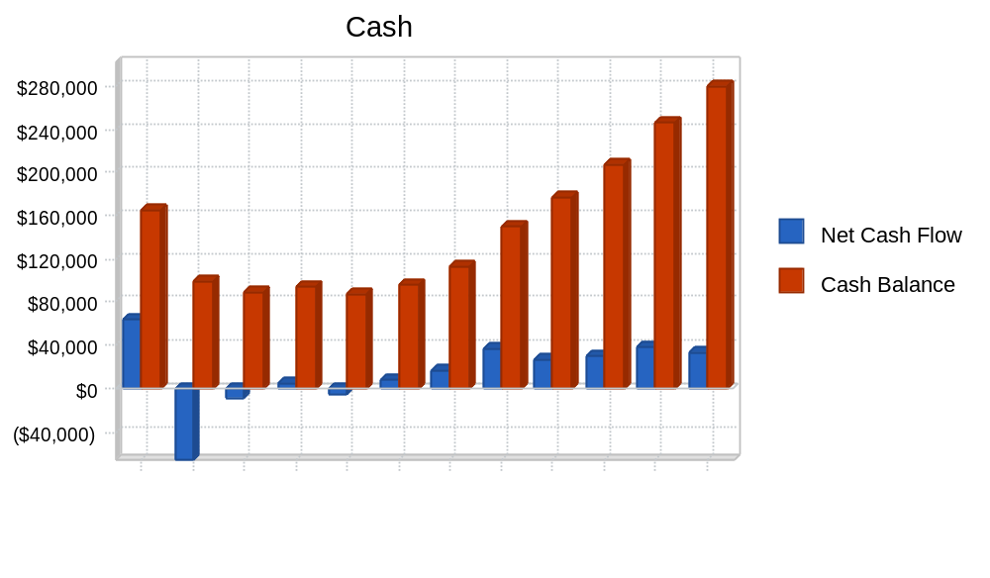

Key Financial Indicators
The most important indicators in our case are are daily seating "counts" and weekly sales numbers. We must also make sure that we are turning our inventory rapidly so as to avoid food spoilage.
We must target net profit/sales figures toward the 14% level with gross margins never dipping below 38%. Marketing costs should never exceed three percent of sales.

Chart: Benchmarks
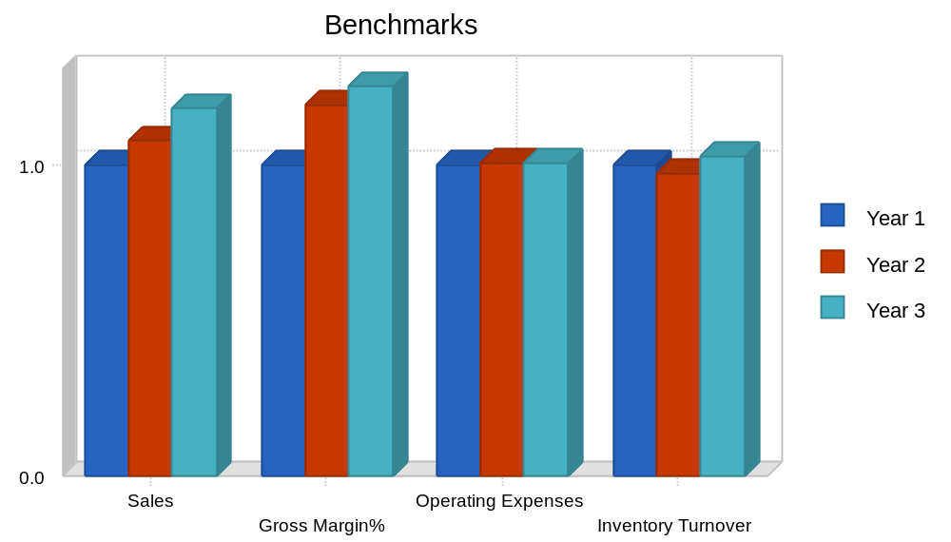

Break-even Analysis
The Break-even Analysis shows that The Sage’s Cafe has a good balance of fixed costs and sufficient sales strength to remain healthy. Our break-even point is $106,101 on sales averaging $12.54 per patron. This break-even position is achieved on a monthly fixed cost of $57,873 and and per unit/patron variable cost of $5.70.

Chart: Break-even Analysis
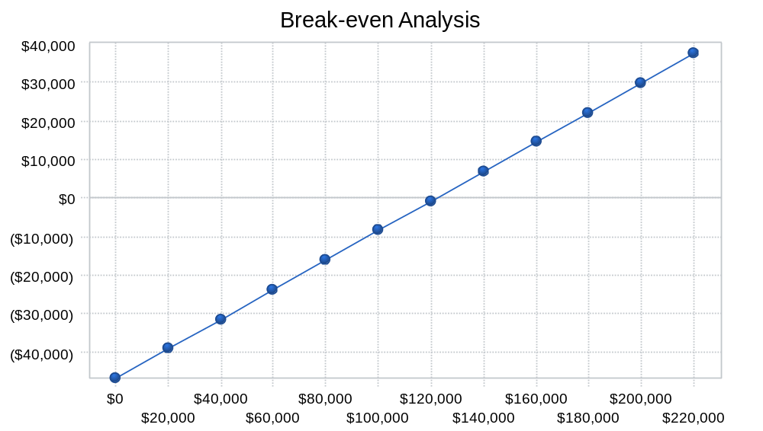

Table: Break-even Analysis

Break-even Analysis
Monthly Revenue Break-even | $122,179
Assumptions:
Average Percent Variable Cost | 62%
Estimated Monthly Fixed Cost | $46,841

Projected Profit and Loss
We expect income to approach $2.1 million for calendar year 2002. It should increase to $2.57 million by the end of the years covered in this plan.

Chart: Profit Monthly
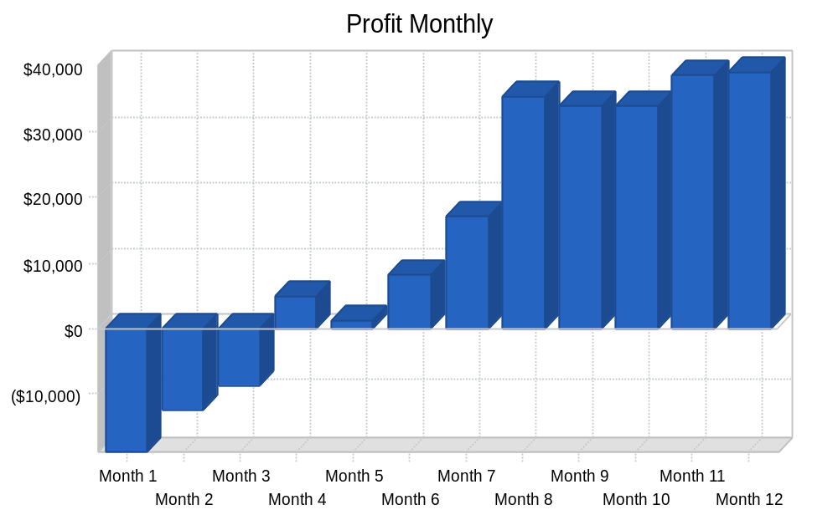

Table: Profit and Loss

Pro Forma Profit and Loss
 | Year 1 | Year 2 | Year 3
Sales | $2,186,601 | $2,351,541 | $2,573,024
Direct Cost of Sales | $1,348,308 | $1,277,010 | $1,340,860
Other | $0 | $0 | $0
Total Cost of Sales | $1,348,308 | $1,277,010 | $1,340,860
Gross Margin | $838,293 | $1,074,531 | $1,232,164
Gross Margin % | 38.34% | 45.69% | 47.89%
Expenses
Payroll | $322,008 | $322,008 | $322,008
Sales and Marketing and Other Expenses | $80,800 | $80,800 | $80,800
Depreciation | $6,900 | $6,900 | $6,900
Leased Equip/Van/Dispensing Systems | $12,600 | $12,600 | $12,600
Utilities | $24,000 | $24,000 | $24,000
Insurance | $20,940 | $22,000 | $23,000
Other Taxes | $24,000 | $24,000 | $24,000
Payroll Taxes | $70,842 | $70,842 | $70,842
Other | $0 | $0 | $0
Total Operating Expenses | $562,090 | $563,150 | $564,150
Profit Before Interest and Taxes | $276,203 | $511,381 | $668,014
EBITDA | $283,103 | $518,281 | $674,914
Interest Expense | $48,095 | $43,298 | $41,442
Taxes Incurred | $55,675 | $117,021 | $159,254
Net Profit | $172,433 | $351,062 | $467,318
Net Profit/Sales | 7.89% | 14.93% | 18.16%

Need to create your own financial tables? Tools like LivePlan will do this for you automatically.

Projected Balance Sheet
As shown in the Balance Sheet, we expect a healthy growth in net worth from approximately $172,000 at the end of 2002 to almost $1 million by the end of the plan period.

Table: Balance Sheet
Pro Forma Balance Sheet
 | Year 1 | Year 2 | Year 3
Assets
Current Assets
Cash | $280,231 | $587,446 | $1,053,385
Inventory | $129,671 | $110,869 | $129,058
Other Current Assets | $0 | $0 | $0
Total Current Assets | $409,902 | $698,316 | $1,182,443
Long-term Assets
Long-term Assets | $595,040 | $595,040 | $595,040
Accumulated Depreciation | $6,900 | $13,800 | $20,700
Total Long-term Assets | $588,140 | $581,240 | $574,340
Total Assets | $998,042 | $1,279,556 | $1,756,783
Liabilities and Capital | Year 1 | Year 2 | Year 3
Current Liabilities
Accounts Payable | $149,628 | $135,844 | $147,533
Current Borrowing | $6,690 | ($19,745) | $9,814
Other Current Liabilities | $0 | $0 | $0
Subtotal Current Liabilities | $156,318 | $116,099 | $157,347
Long-term Liabilities | $667,969 | $638,640 | $607,301
Total Liabilities | $824,287 | $754,739 | $764,648
Paid-in Capital | $98,000 | $98,000 | $98,000
Retained Earnings | ($96,679) | $75,754 | $426,817
Earnings | $172,433 | $351,062 | $467,318
Total Capital | $173,754 | $524,817 | $992,135
Total Liabilities and Capital | $998,042 | $1,279,556 | $1,756,783
Net Worth | $173,754 | $524,817 | $992,135

Business Ratios
Business ratios for the years of this plan are shown below. Industry profile ratios based on the Standard Industrial Classification (SIC) code 5812, Eating Places, are shown for comparison. The ratios show a plan for balanced, healthy growth.

Table: Ratios
Ratio Analysis
 | Year 1 | Year 2 | Year 3 | Industry Profile
Sales Growth | n.a. | 7.54% | 9.42% | 7.60%
Percent of Total Assets
Inventory | 12.99% | 8.66% | 7.35% | 3.60%
Other Current Assets | 0.00% | 0.00% | 0.00% | 35.60%
Total Current Assets | 41.07% | 54.57% | 67.31% | 43.70%
Long-term Assets | 58.93% | 45.43% | 32.69% | 56.30%
Total Assets | 100.00% | 100.00% | 100.00% | 100.00%
Current Liabilities | 15.66% | 9.07% | 8.96% | 32.70%
Long-term Liabilities | 66.93% | 49.91% | 34.57% | 28.50%
Total Liabilities | 82.59% | 58.98% | 43.53% | 61.20%
Net Worth | 17.41% | 41.02% | 56.47% | 38.80%
Percent of Sales
Sales | 100.00% | 100.00% | 100.00% | 100.00%
Gross Margin | 38.34% | 45.69% | 47.89% | 60.50%
Selling, General & Administrative Expenses | 30.51% | 30.77% | 29.62% | 39.80%
Advertising Expenses | 0.73% | 0.68% | 0.62% | 3.20%
Profit Before Interest and Taxes | 12.63% | 21.75% | 25.96% | 0.70%
Main Ratios
Current | 2.62 | 6.01 | 7.51 | 0.98
Quick | 1.79 | 5.06 | 6.69 | 0.65
Total Debt to Total Assets | 82.59% | 58.98% | 43.53% | 61.20%
Pre-tax Return on Net Worth | 131.28% | 89.19% | 63.15% | 1.70%
Pre-tax Return on Assets | 22.86% | 36.58% | 35.67% | 4.30%
Additional Ratios | Year 1 | Year 2 | Year 3
Net Profit Margin | 7.89% | 14.93% | 18.16% | n.a
Return on Equity | 99.24% | 66.89% | 47.10% | n.a
Activity Ratios
Inventory Turnover | 10.91 | 10.62 | 11.18 | n.a
Accounts Payable Turnover | 11.72 | 12.17 | 12.17 | n.a
Payment Days | 28 | 32 | 29 | n.a
Total Asset Turnover | 2.19 | 1.84 | 1.46 | n.a
Debt Ratios
Debt to Net Worth | 4.74 | 1.44 | 0.77 | n.a
Current Liab. to Liab. | 0.19 | 0.15 | 0.21 | n.a
Liquidity Ratios
Net Working Capital | $253,583 | $582,217 | $1,025,096 | n.a
Interest Coverage | 5.74 | 11.81 | 16.12 | n.a
Additional Ratios
Assets to Sales | 0.46 | 0.54 | 0.68 | n.a
Current Debt/Total Assets | 16% | 9% | 9% | n.a
Acid Test | 1.79 | 5.06 | 6.69 | n.a
Sales/Net Worth | 12.58 | 4.48 | 2.59 | n.a
Dividend Payout | 0.00 | 0.00 | 0.00 | n.a

Appendix

Table: Sales Forecast

Sales Forecast
 |  | Month 1 | Month 2 | Month 3 | Month 4 | Month 5 | Month 6 | Month 7 | Month 8 | Month 9 | Month 10 | Month 11 | Month 12
Sales
Restaurant | 0% | $116,330 | $126,271 | $132,163 | $150,898 | $142,787 | $153,458 | $164,320 | $190,700 | $184,871 | $184,871 | $189,120 | $190,428
Coffeehouse | 0% | $14,525 | $14,525 | $16,800 | $16,800 | $19,800 | $19,800 | $22,770 | $22,770 | $26,185 | $26,185 | $30,112 | $30,112
Total Sales |  | $130,855 | $140,796 | $148,963 | $167,698 | $162,587 | $173,258 | $187,090 | $213,470 | $211,056 | $211,056 | $219,232 | $220,540
Direct Cost of Sales |  | Month 1 | Month 2 | Month 3 | Month 4 | Month 5 | Month 6 | Month 7 | Month 8 | Month 9 | Month 10 | Month 11 | Month 12
Restaurant |  | $101,350 | $102,363 | $103,386 | $105,419 | $104,420 | $105,850 | $106,908 | $108,850 | $107,350 | $107,350 | $108,100 | $108,850
Coffeehouse |  | $4,357 | $4,357 | $5,040 | $5,040 | $5,940 | $5,940 | $6,831 | $6,831 | $7,855 | $7,855 | $9,033 | $9,033
Subtotal Direct Cost of Sales |  | $105,707 | $106,720 | $108,426 | $110,459 | $110,360 | $111,790 | $113,739 | $115,681 | $115,205 | $115,205 | $117,133 | $117,883

Table: Personnel

Personnel Plan
 |  | Month 1 | Month 2 | Month 3 | Month 4 | Month 5 | Month 6 | Month 7 | Month 8 | Month 9 | Month 10 | Month 11 | Month 12
Owner/Manager | 0% | $3,333 | $3,333 | $3,333 | $3,333 | $3,333 | $3,333 | $3,333 | $3,333 | $3,333 | $3,333 | $3,333 | $3,333
Employees | 0% | $23,501 | $23,501 | $23,501 | $23,501 | $23,501 | $23,501 | $23,501 | $23,501 | $23,501 | $23,501 | $23,501 | $23,501
Total People |  | 21 | 21 | 21 | 21 | 21 | 21 | 21 | 21 | 21 | 21 | 21 | 21
Total Payroll |  | $26,834 | $26,834 | $26,834 | $26,834 | $26,834 | $26,834 | $26,834 | $26,834 | $26,834 | $26,834 | $26,834 | $26,834

Table: General Assumptions

General Assumptions
 |  | Month 1 | Month 2 | Month 3 | Month 4 | Month 5 | Month 6 | Month 7 | Month 8 | Month 9 | Month 10 | Month 11 | Month 12
Plan Month |  | 1 | 2 | 3 | 4 | 5 | 6 | 7 | 8 | 9 | 10 | 11 | 12
Current Interest Rate |  | 12.25% | 12.25% | 12.25% | 12.25% | 12.25% | 12.25% | 12.25% | 12.25% | 12.25% | 12.25% | 12.25% | 12.25%
Long-term Interest Rate |  | 6.75% | 6.75% | 6.75% | 6.75% | 6.75% | 6.75% | 6.75% | 6.75% | 6.75% | 6.75% | 6.75% | 6.75%
Tax Rate |  | 30.00% | 25.00% | 25.00% | 25.00% | 25.00% | 25.00% | 25.00% | 25.00% | 25.00% | 25.00% | 25.00% | 25.00%
Other |  | 0 | 0 | 0 | 0 | 0 | 0 | 0 | 0 | 0 | 0 | 0 | 0

Table: Profit and Loss

Pro Forma Profit and Loss
 |  | Month 1 | Month 2 | Month 3 | Month 4 | Month 5 | Month 6 | Month 7 | Month 8 | Month 9 | Month 10 | Month 11 | Month 12
Sales |  | $130,855 | $140,796 | $148,963 | $167,698 | $162,587 | $173,258 | $187,090 | $213,470 | $211,056 | $211,056 | $219,232 | $220,540
Direct Cost of Sales |  | $105,707 | $106,720 | $108,426 | $110,459 | $110,360 | $111,790 | $113,739 | $115,681 | $115,205 | $115,205 | $117,133 | $117,883
Other |  | $0 | $0 | $0 | $0 | $0 | $0 | $0 | $0 | $0 | $0 | $0 | $0
Total Cost of Sales |  | $105,707 | $106,720 | $108,426 | $110,459 | $110,360 | $111,790 | $113,739 | $115,681 | $115,205 | $115,205 | $117,133 | $117,883
Gross Margin |  | $25,148 | $34,076 | $40,537 | $57,239 | $52,227 | $61,468 | $73,351 | $97,789 | $95,851 | $95,851 | $102,099 | $102,657
Gross Margin % |  | 19.22% | 24.20% | 27.21% | 34.13% | 32.12% | 35.48% | 39.21% | 45.81% | 45.41% | 45.41% | 46.57% | 46.55%
Expenses
Payroll |  | $26,834 | $26,834 | $26,834 | $26,834 | $26,834 | $26,834 | $26,834 | $26,834 | $26,834 | $26,834 | $26,834 | $26,834
Sales and Marketing and Other Expenses |  | $7,900 | $6,500 | $7,900 | $6,500 | $6,500 | $6,500 | $6,500 | $6,500 | $6,500 | $6,500 | $6,500 | $6,500
Depreciation |  | $575 | $575 | $575 | $575 | $575 | $575 | $575 | $575 | $575 | $575 | $575 | $575
Leased Equip/Van/Dispensing Systems |  | $1,050 | $1,050 | $1,050 | $1,050 | $1,050 | $1,050 | $1,050 | $1,050 | $1,050 | $1,050 | $1,050 | $1,050
Utilities |  | $2,000 | $2,000 | $2,000 | $2,000 | $2,000 | $2,000 | $2,000 | $2,000 | $2,000 | $2,000 | $2,000 | $2,000
Insurance |  | $1,745 | $1,745 | $1,745 | $1,745 | $1,745 | $1,745 | $1,745 | $1,745 | $1,745 | $1,745 | $1,745 | $1,745
Other Taxes |  | $2,000 | $2,000 | $2,000 | $2,000 | $2,000 | $2,000 | $2,000 | $2,000 | $2,000 | $2,000 | $2,000 | $2,000
Payroll Taxes | 22% | $5,903 | $5,903 | $5,903 | $5,903 | $5,903 | $5,903 | $5,903 | $5,903 | $5,903 | $5,903 | $5,903 | $5,903
Other |  | $0 | $0 | $0 | $0 | $0 | $0 | $0 | $0 | $0 | $0 | $0 | $0
Total Operating Expenses |  | $48,007 | $46,607 | $48,007 | $46,607 | $46,607 | $46,607 | $46,607 | $46,607 | $46,607 | $46,607 | $46,607 | $46,607
Profit Before Interest and Taxes |  | ($22,859) | ($12,531) | ($7,470) | $10,632 | $5,620 | $14,861 | $26,744 | $51,182 | $49,244 | $49,244 | $55,492 | $56,050
EBITDA |  | ($22,284) | ($11,956) | ($6,895) | $11,207 | $6,195 | $15,436 | $27,319 | $51,757 | $49,819 | $49,819 | $56,067 | $56,625
Interest Expense |  | $4,185 | $4,154 | $4,122 | $4,090 | $4,058 | $4,026 | $3,993 | $3,960 | $3,927 | $3,893 | $3,860 | $3,826
Taxes Incurred |  | ($8,113) | ($4,171) | ($2,898) | $1,635 | $390 | $2,709 | $5,688 | $11,805 | $11,329 | $11,338 | $12,908 | $13,056
Net Profit |  | ($18,931) | ($12,514) | ($8,695) | $4,906 | $1,171 | $8,126 | $17,063 | $35,416 | $33,987 | $34,013 | $38,724 | $39,168
Net Profit/Sales |  | -14.47% | -8.89% | -5.84% | 2.93% | 0.72% | 4.69% | 9.12% | 16.59% | 16.10% | 16.12% | 17.66% | 17.76%

Table: Cash Flow
Pro Forma Cash Flow
 |  | Month 1 | Month 2 | Month 3 | Month 4 | Month 5 | Month 6 | Month 7 | Month 8 | Month 9 | Month 10 | Month 11 | Month 12
Cash Received
Cash from Operations
Cash Sales |  | $130,855 | $140,796 | $148,963 | $167,698 | $162,587 | $173,258 | $187,090 | $213,470 | $211,056 | $211,056 | $219,232 | $220,540
Subtotal Cash from Operations |  | $130,855 | $140,796 | $148,963 | $167,698 | $162,587 | $173,258 | $187,090 | $213,470 | $211,056 | $211,056 | $219,232 | $220,540
Additional Cash Received
Sales Tax, VAT, HST/GST Received | 0.00% | $0 | $0 | $0 | $0 | $0 | $0 | $0 | $0 | $0 | $0 | $0 | $0
New Current Borrowing |  | $0 | $0 | $0 | $0 | $0 | $0 | $0 | $0 | $0 | $0 | $0 | $0
New Other Liabilities (interest-free) |  | $0 | $0 | $0 | $0 | $0 | $0 | $0 | $0 | $0 | $0 | $0 | $0
New Long-term Liabilities |  | $0 | $0 | $0 | $0 | $0 | $0 | $0 | $0 | $0 | $0 | $0 | $0
Sales of Other Current Assets |  | $0 | $0 | $0 | $0 | $0 | $0 | $0 | $0 | $0 | $0 | $0 | $0
Sales of Long-term Assets |  | $0 | $0 | $0 | $0 | $0 | $0 | $0 | $0 | $0 | $0 | $0 | $0
New Investment Received |  | $0 | $0 | $0 | $0 | $0 | $0 | $0 | $0 | $0 | $0 | $0 | $0
Subtotal Cash Received |  | $130,855 | $140,796 | $148,963 | $167,698 | $162,587 | $173,258 | $187,090 | $213,470 | $211,056 | $211,056 | $219,232 | $220,540
Expenditures |  | Month 1 | Month 2 | Month 3 | Month 4 | Month 5 | Month 6 | Month 7 | Month 8 | Month 9 | Month 10 | Month 11 | Month 12
Expenditures from Operations
Cash Spending |  | $26,834 | $26,834 | $26,834 | $26,834 | $26,834 | $26,834 | $26,834 | $26,834 | $26,834 | $26,834 | $26,834 | $26,834
Bill Payments |  | $35,544 | $175,815 | $127,186 | $132,308 | $137,495 | $134,078 | $139,478 | $145,029 | $152,660 | $149,153 | $149,821 | $155,206
Subtotal Spent on Operations |  | $62,378 | $202,649 | $154,020 | $159,142 | $164,329 | $160,912 | $166,312 | $171,863 | $179,494 | $175,987 | $176,655 | $182,040
Additional Cash Spent
Sales Tax, VAT, HST/GST Paid Out |  | $0 | $0 | $0 | $0 | $0 | $0 | $0 | $0 | $0 | $0 | $0 | $0
Principal Repayment of Current Borrowing |  | $1,824 | $1,843 | $1,861 | $1,880 | $1,900 | $1,919 | $1,939 | $1,958 | $1,978 | $1,999 | $2,019 | $2,040
Other Liabilities Principal Repayment |  | $0 | $0 | $0 | $0 | $0 | $0 | $0 | $0 | $0 | $0 | $0 | $0
Long-term Liabilities Principal Repayment |  | $2,221 | $2,223 | $2,243 | $2,257 | $2,268 | $2,281 | $2,292 | $2,305 | $2,317 | $2,328 | $2,341 | $2,354
Purchase Other Current Assets |  | $0 | $0 | $0 | $0 | $0 | $0 | $0 | $0 | $0 | $0 | $0 | $0
Purchase Long-term Assets |  | $0 | $0 | $0 | $0 | $0 | $0 | $0 | $0 | $0 | $0 | $0 | $0
Dividends |  | $0 | $0 | $0 | $0 | $0 | $0 | $0 | $0 | $0 | $0 | $0 | $0
Subtotal Cash Spent |  | $66,423 | $206,715 | $158,124 | $163,279 | $168,497 | $165,112 | $170,543 | $176,126 | $183,789 | $180,314 | $181,015 | $186,434
Net Cash Flow |  | $64,432 | ($65,919) | ($9,161) | $4,419 | ($5,910) | $8,146 | $16,547 | $37,344 | $27,267 | $30,742 | $38,217 | $34,106
Cash Balance |  | $164,432 | $98,513 | $89,352 | $93,771 | $87,861 | $96,007 | $112,553 | $149,897 | $177,164 | $207,907 | $246,124 | $280,231

Table: Balance Sheet

Pro Forma Balance Sheet
 |  | Month 1 | Month 2 | Month 3 | Month 4 | Month 5 | Month 6 | Month 7 | Month 8 | Month 9 | Month 10 | Month 11 | Month 12
Assets | Starting Balances
Current Assets
Cash | $100,000 | $164,432 | $98,513 | $89,352 | $93,771 | $87,861 | $96,007 | $112,553 | $149,897 | $177,164 | $207,907 | $246,124 | $280,231
Inventory | $61,157 | $116,278 | $117,392 | $119,269 | $121,505 | $121,396 | $122,969 | $125,113 | $127,249 | $126,726 | $126,726 | $128,846 | $129,671
Other Current Assets | $0 | $0 | $0 | $0 | $0 | $0 | $0 | $0 | $0 | $0 | $0 | $0 | $0
Total Current Assets | $161,157 | $280,710 | $215,905 | $208,621 | $215,276 | $209,257 | $218,976 | $237,666 | $277,146 | $303,890 | $334,632 | $374,970 | $409,902
Long-term Assets
Long-term Assets | $595,040 | $595,040 | $595,040 | $595,040 | $595,040 | $595,040 | $595,040 | $595,040 | $595,040 | $595,040 | $595,040 | $595,040 | $595,040
Accumulated Depreciation | $0 | $575 | $1,150 | $1,725 | $2,300 | $2,875 | $3,450 | $4,025 | $4,600 | $5,175 | $5,750 | $6,325 | $6,900
Total Long-term Assets | $595,040 | $594,465 | $593,890 | $593,315 | $592,740 | $592,165 | $591,590 | $591,015 | $590,440 | $589,865 | $589,290 | $588,715 | $588,140
Total Assets | $756,197 | $875,175 | $809,795 | $801,936 | $808,016 | $801,422 | $810,566 | $828,681 | $867,586 | $893,755 | $923,922 | $963,685 | $998,042
Liabilities and Capital |  | Month 1 | Month 2 | Month 3 | Month 4 | Month 5 | Month 6 | Month 7 | Month 8 | Month 9 | Month 10 | Month 11 | Month 12
Current Liabilities
Accounts Payable | $29,627 | $171,581 | $122,781 | $127,721 | $133,032 | $129,435 | $134,653 | $139,937 | $147,688 | $144,165 | $144,647 | $150,046 | $149,628
Current Borrowing | $29,850 | $28,026 | $26,183 | $24,322 | $22,442 | $20,542 | $18,623 | $16,684 | $14,726 | $12,748 | $10,749 | $8,730 | $6,690
Other Current Liabilities | $0 | $0 | $0 | $0 | $0 | $0 | $0 | $0 | $0 | $0 | $0 | $0 | $0
Subtotal Current Liabilities | $59,477 | $199,607 | $148,964 | $152,043 | $155,474 | $149,977 | $153,276 | $156,621 | $162,414 | $156,913 | $155,396 | $158,776 | $156,318
Long-term Liabilities | $695,399 | $693,178 | $690,955 | $688,712 | $686,455 | $684,187 | $681,906 | $679,614 | $677,309 | $674,992 | $672,664 | $670,323 | $667,969
Total Liabilities | $754,876 | $892,785 | $839,919 | $840,755 | $841,929 | $834,164 | $835,182 | $836,235 | $839,723 | $831,905 | $828,060 | $829,099 | $824,287
Paid-in Capital | $98,000 | $98,000 | $98,000 | $98,000 | $98,000 | $98,000 | $98,000 | $98,000 | $98,000 | $98,000 | $98,000 | $98,000 | $98,000
Retained Earnings | ($96,679) | ($96,679) | ($96,679) | ($96,679) | ($96,679) | ($96,679) | ($96,679) | ($96,679) | ($96,679) | ($96,679) | ($96,679) | ($96,679) | ($96,679)
Earnings | $0 | ($18,931) | ($31,445) | ($40,140) | ($35,234) | ($34,063) | ($25,937) | ($8,874) | $26,542 | $60,529 | $94,542 | $133,266 | $172,433
Total Capital | $1,321 | ($17,610) | ($30,124) | ($38,819) | ($33,913) | ($32,742) | ($24,616) | ($7,553) | $27,863 | $61,850 | $95,863 | $134,587 | $173,754
Total Liabilities and Capital | $756,197 | $875,175 | $809,795 | $801,936 | $808,016 | $801,422 | $810,566 | $828,681 | $867,586 | $893,755 | $923,922 | $963,685 | $998,042
Net Worth | $1,321 | ($17,610) | ($30,124) | ($38,819) | ($33,913) | ($32,742) | ($24,616) | ($7,553) | $27,863 | $61,850 | $95,863 | $134,587 | $173,754

