NAME: LAWAL AMINAT TEMITOPE
MATRIC NO.: 17/MHS01/177
LEVEL: 300
DEPARTMENT: MEDICINE AND SURGERY
COURSE CODE: PHS 305
COURSE TITLE: NEUROPHYSIOLOGY
QUESTION 1:
PHYSIOLOGY OF SLEEP
Sleep is a naturally recurring state of mind and body, characterized by altered consciousness, relatively inhibited sensory activity, reduced muscle activity and inhibition of nearly all voluntary muscles during rapid eye movement (REM) sleep and reduced interactions with surroundings. It is distinguished from wakefulness by a decreased ability to react to stimuli, but more reactive than a coma or disorders of consciousness, with sleep displaying very different and active brain patterns.
Sleep occurs in repeating periods, in which the body alternates between two distinct modes: REM sleep and non-REM sleep. Although REM stands for “rapid eye movement”, this mode of sleep has many other aspects, including virtual paralysis of the body. A well-known feature of sleep is the dream, an experience recounted in narrative form, which resembles waking life while in progress but which usually can later be distinguished as fantasy. During sleep, most of the body’s systems are in an anabolic state, helping to restore the immune, nervous, skeletal and muscular systems which are vital systems that maintain mood, memory, cognitive function and play a large role in the function of the endocrine and immune systems.
The internal circadian clock promotes sleep daily at night. The most pronounced physiological changes in sleep occur in the brain. The brain uses significantly less energy during sleep than it does when awake, especially during non-REM sleep.
Sleep increases the sensory threshold. This means that sleeping persons perceive fewer stimuli but can generally still respond to loud noises and other salient sensory events. During slow-wave sleep, humans secrete bursts of growth hormone. All sleep, even during the day, is associated with the secretion of prolactin.
REM AND NON-REM SLEEP
Sleep is divided into two broad types; non-rapid eye movement (non-REM or NREM) and rapid eye movement (REM) sleep. Non- REM and REM sleep are so different that physiologists identify them as distinct behavioral states.
Non- REM sleep occurs first and after a transitional period is called slow-wave sleep or deep sleep. During this phase, body temperature and heart rate fall, and the brain uses less energy.
REM sleep, also known as paradoxical sleep, represents a smaller portion of total sleep time. It is the main occasion for dreams or nightmares and is associated with desynchronized and fast brain waves, eye movements, loss of muscle tone and suspension of homeostasis.
The sleep cycle of alternate NREM and REM sleep takes an average of 90 minutes, occurring 4-6 times in a good night’s sleep. The American Academy of Sleep Medicine (AASM) divides NREM into three stages: N1, N2 AND N3, the last of which is also called delta sleep or slow-wave sleep. There is a greater amount of deep sleep (stage N3) earlier in the night while the proportion of REM sleep increases in the two cycles just before natural awakening.
AWAKENING: Awakening can mean the end of sleep or simply a moment to survey the environment and readjust body position before falling back asleep. Sleepers typically awaken soon after the end of a REM phase or sometimes in the middle of REM. Internal circadian indicators typically bring about awakening and the end of the sleep cycle. Awakening involves heightened electrical activation in the brain, beginning with the thalamus and spreading throughout the cortex.
TIMING: Sleep timing is controlled by the circadian clock (Process C), sleep-wake homeostasis (Process S) and to some extent by individual will.
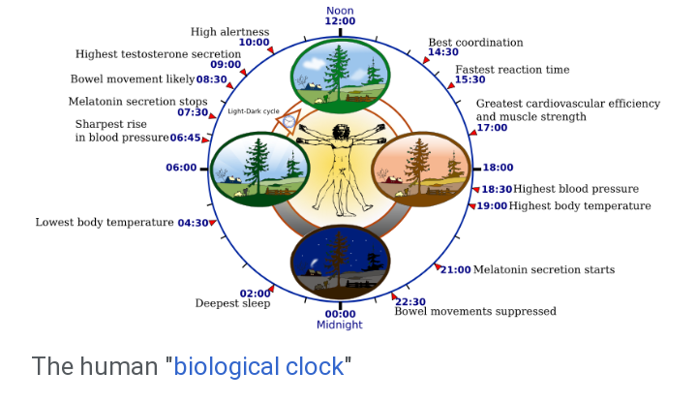
CIRCADIAN CLOCK
Sleep timing depends greatly on hormonal signals from the circadian clock or Process C, a complex neurochemical system which uses signals from an organism’s environment to recreate an internal day-night rhythm. The suprachiasmatic nucleus, a brain area directly above the optic chiasm, is presently considered the most important nexus for this process.
The circadian pacemaker in the suprachiasmatic nucleus has a direct neural connection to the pineal gland, which releases the hormone, melatonin at night. Cortisol levels rise throughout the night, peak in the awakening hours and diminish during the day. Circadian prolactin secretion begins in the late afternoon, especially in women, and peaks in the middle of the night. Circadian rhythm exerts some influence on the nighttime secretion of growth hormone.
The internal circadian clock is profoundly influenced by changes in light, since these are main clues about what time it is. Exposure to even small amounts of light during the night can suppress melatonin secretion and increase body temperature and wakefulness.
PROCESS S: The longer an organism is awake, the more it feels a need to sleep (sleep debt). This driver of sleep is referred to as Process S. The balance between sleeping and waking is regulated by a process called homeostasis. Induced or perceived lack of sleep is called sleep deprivation.
Process S is driven by the depletion of glycogen and accumulation of adenosine in the forebrain. Sleep deprivation tends to cause slower brain waves in the frontal cortex, shortened attention span, higher anxiety, impaired memory and a grouchy mood.
One neurochemical indicator of sleep debt is adenosine, a neurotransmitter which inhibits many of the bodily processes associated with wakefulness. Adenosine levels increase in the cortex and basal forebrain during prolonged wakefulness and decrease during the sleep-recovery period, potentially acting as a homeostatic regulator of sleep. Coffee and caffeine temporarily block the effect of adenosine, prolong sleep latency and reduce total sleep time and quality.
IDEAL DURATION OF SLEEP: Human sleep needs vary by age and amongst individuals. Sleep is considered to be adequate when there is no daytime sleepiness or dysfunction.
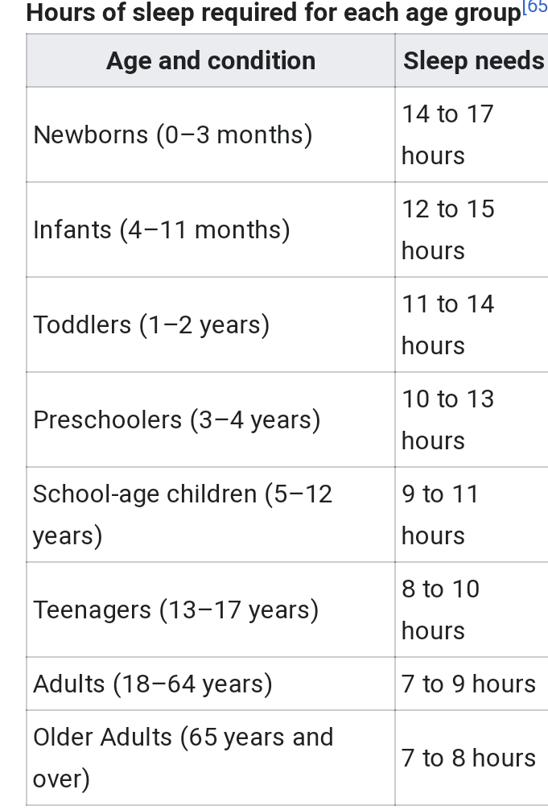
FUNCTION OF SLEEP
- RESTORATION: The human organism physically restores itself during sleep, healing itself and removing metabolic wastes which build up during periods of activity. This restoration takes place mostly during slow-wave sleep, during which body temperature, heart rate and brain oxygen consumption decrease.
- MEMORY: It has been widely accepted that sleep must support the formation of long-term memory and generally increasing previous learning and experiences recalls. However, its benefit seems to depend on the phase of sleep and type of memory.
DISORDERS OF SLEEP
- INSOMNIA: Insomnia is a general term for difficulty falling asleep and/or staying asleep. Insomnia is the most common sleep problem, with many adults reporting occasional insomnia and 10-15% reporting a chronic condition. Insomnia can have many different causes, including psychological stress, a poor sleep environment, an inconsistent sleep schedule or excessive mental or physical stimulation in the hours before bedtime. It is often treated through behavioral changes like keeping a regular sleep schedule, avoiding stimulating or stressful activities before bedtime and cutting down on stimulants such as caffeine. The sleep environment may be improved by installing heavy drapes to shut out all sunlight and keeping computers, televisions and work materials out of the sleeping area. Exercise also improves sleep.
- OBSTRUCTIVE SLEEP APNEA: It is a condition in which major pauses in breathing occur during sleep, disrupting the normal progression of sleep and often causing other more severe health problems. Apneas occur when the muscles around the patient’s airway relax during sleep, causing the airway to collapse and block the intake of oxygen. As oxygen levels in the blood drop, the patient then comes out of deep sleep in order to resume breathing. When several of these episodes occur per hour, sleep apnea rises to a level of seriousness that may require treatment.
QUESTION 2:
ROLE OF BASAL GANGLIA IN COORDINATING MOVEMENT
The basal ganglia or basal nuclei are a group of subcortical nuclei, of varied origin, in the brains of vertebrates, including humans, which are situated at the base of the forebrain and top of the midbrain. They are strongly interconnected with the cerebral cortex, thalamus, brainstem as well as several other brain areas. The basal ganglia are associated with a variety of functions including; control of voluntary motor movements, procedural learning, habit learning, eye movements, cognition and emotion.
The main components of the basal ganglia, as defined functionally, are the stratium, consisting of both the dorsal stratium (caudate nucleus and putamen) and the ventral striatum (nucleus accumbens and olfactory tubercle), the globus pallidus, the ventral pallidum, the substantia nigra and the subthalamic nucleus.
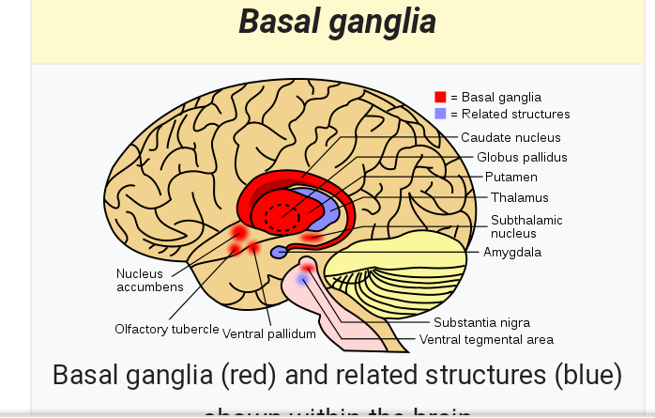
EYE MOVEMENTS
One important function of the basal ganglia is its role in controlling eye movements. Eye movement is influenced by an extensive network of brain regions that converges on a midbrain area called the superior colliculus.
The superior colliculus receives a strong inhibitory projection from the basal ganglia, originating in the substantia nigra pars reticulata (SNr). Neurons in the SNr usually fire continuously at high rates but at the onset of an eye movement; they pause, thereby releasing the superior colliculus from inhibition. Eye movements of all types are associated with “pausing” in the SNr. Neurons in some parts of the caudate nucleus also show activity related to eye movements. Since the great majority of caudate cells fire at very low rates, this activity almost always shows up as an increase in firing rate. Thus, eye movements begin with activation in the caudate nucleus, which inhibits the SNr via the direct GABAergic projections, which in turn disinhibits the superior colliculus.
CLINICAL ANATOMY
- PARKINSON’S DISEASE: Parkinson’s disease results from loss of dopaminergic innervation (loss of the nigrostriatal connection) to the striatum and other basal ganglia structures. It is also referred to as Parkinsonism or Paralysis agitans (shaking palsy). The condition is characterized by rigidity (increased muscle tone), which leads to a stooped posture, a slow shuffling gait, difficulty in speech and a mask like face. It is believed to be due to degenerative changes in the striatum and the substantia nigra.
- CEREBRAL PALSY: People with cerebral palsy have various motor problems, such as spasticity, paralysis and even seizures. Spasticity is a condition in which some muscles are abnormally stiff and as a result interfere with normal movement. This is the reason for the unusual hand and arm positions seen in some people with cerebral palsy. Causes may include fetal infection, environmental toxins or lack of oxygen.
- TREMOR: This is an abnormal movement in which there is involuntary shaking of the hand, head or other parts of the body. Usually, the basal ganglia, cerebellum and the subthalamic nucleus are involved. However, intention tremor is also seen in disorders of the cerebellum, in which case, the tremor comes when the individual tries to perform a voluntary movement.
- ATHETOSIS: Athetosis is a symptom characterized by slow, involuntary, convoluted, writhing movements of the fingers, hands, toes and feet and in some cases, arms, legs, neck and tongue. Lesions to the brain are most often the direct cause of the symptoms, particularly to the corpus striatum. This symptom does not occur alone and is often accompanied by the symptoms of cerebral palsy, as it is often a result of this physical disability. Treatments for athetosis are not very effective, and in most cases are simply aimed at managing the uncontrollable movement, rather than the cause itself.

