REPORT
ON

CORONA VIRUS PANDEMIC AND THE EFFECTS OF THE LOCKDOWN AND RESTRICTION OF MOVEMENT ON NIGERIANS

BY
ADEYELU TEMITOPE OPEMIPO
16/ENG01/023

IN PARTIAL FUFILLMENT OF THE REQUIREMENT FOR THE AWARD OF THE BACHELOR OF ENGINEERING (B.ENG) DEGREE IN CHEMICAL ENGINEERING

26TH JULY 2020

The coronavirus disease of 2019 (COVID-19) pandemic gripped the world with a shock, thereby overwhelming the health system of most nations. The World Health Organization (WHO) declared the novel human coronavirus disease (COVID-19) outbreak, which began in Wuhan, China on December 8, 2019, a Public Health Emergency of International Concern (PHEIC) on January 30, 2020. Following this WHO declaration, the Coronavirus Preparedness Group was constituted on January 31 in Nigeria (a country with 36 states and a Federal Capital Territory [FCT]). WHO categorized Nigeria as one of the 13 high-risk African countries with respect to the spread of COVID-19. Nigeria is also among the vulnerable African nations, given the weak state of the healthcare system. In Africa, there are still communities without healthcare facilities, apart from the scarcity of health workers. The projection is that Africa could bear the final burden of the COVID-19 pandemic if the countries do not institute effective measures to combat the pandemic. Sociologically, the pandemic has caused global social disruption by limiting global social relations. The idea of “social distancing” negates regular social interaction, which is the bedrock of human society. A contagious disease of global health importance also disrupts the usual norms of close physical contacts since the disease transmits through contact with individuals who already contracted the disease. COVID-19 deglobalizes the world in terms of human migration with airports shut, and social events (sports, festivals and the like) postponed indefinitely. The "stay-at-home" campaign and proscription of (large) social gatherings mean that social interaction has been limited.
With 1.39 million coronavirus cases and 79,382 deaths globally, the world continues to battle the COVID-19 pandemic. Even before the outbreak, the outlook for the world economy—and especially developing countries like Nigeria—was fragile, as global GDP growth was estimated to be only 2.5 percent in 2020. While many developing countries have recorded relatively fewer cases—Nigeria currently has 238 confirmed cases and 5 deaths as of this writing—the weak capacity of health care systems in these countries is likely to exacerbate the pandemic and its impact on their economies.
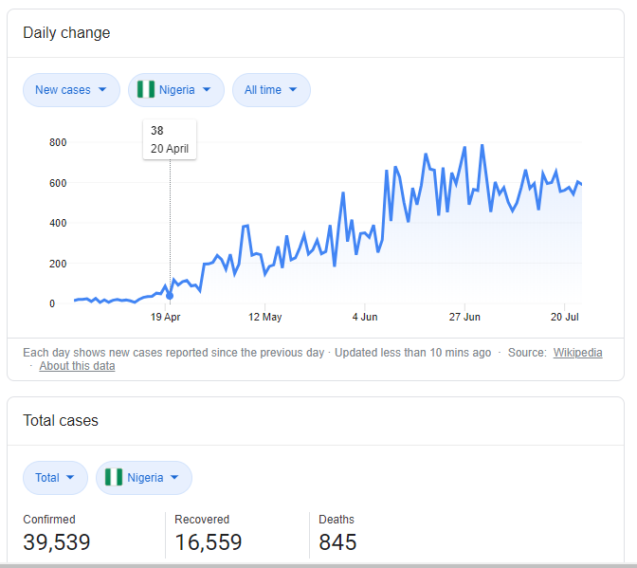
Figure 1: Statistics on the COVID-19 Pandemic in Nigeria as at 24th July 2020
Figure 1 shows that in Nigeria there has been about 39,539 cases which about 16,559 people have recovered and unfortunately 845 people have died. Before the pandemic, the Nigerian government had been grappling with weak recovery from the 2014 oil price shock, with GDP growth tapering around 2.3 percent in 2019. In February, the IMF revised the 2020 GDP growth rate from 2.5 percent to 2 percent, as a result of relatively low oil prices and limited fiscal space. Relatedly, the country’s debt profile has been a source of concern for policymakers and development practitioners as the most recent estimate puts the debt service-to-revenue ratio at 60 percent, which is likely to worsen amid the steep decline in revenue associated with falling oil prices. These constraining factors will aggravate the economic impact of the COVID-19 outbreak and make it more difficult for the government to weather the crisis.

