Lawoyin Joyce O.
17 /MHS01/178
MEDICINE AND HEALTH SCIENCES
NEUROPHYSIOLOGY
PHYSIOLOGY OF SLEEP.

SLEEP :
  - Loss of wakefulness
  - A fundamental function for physical and mental health
  - Not loss of consciousness; only a“shift”
  - An unconscious state which can be in part modified by sensory stimulations

Reticular Formation (Reticular activating system)
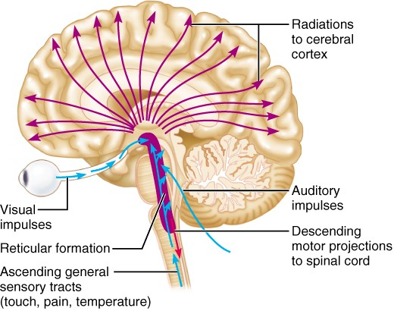

Arousal,Reward system Motor systems, reward, cognition, endocrinecontrol

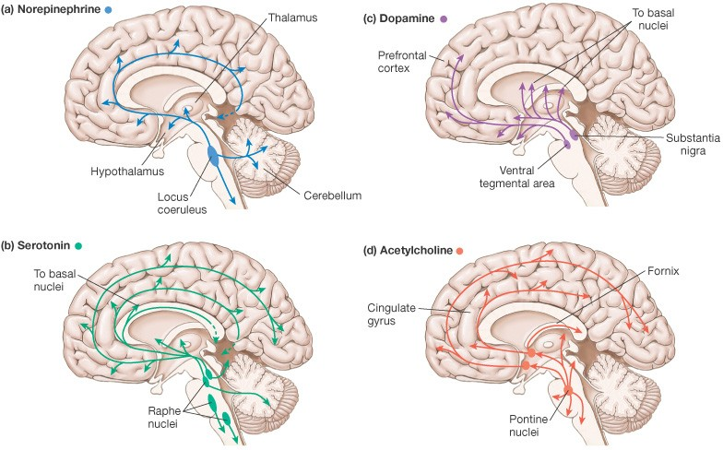

Mood, satiety, body temperature, introversion; pain inhibition .. Learning, short-term memory, arousal, reward

SLEEP CENTRES

Areas causing sleep when stimulated:

Raphe nuclei in lower pons and medulla
  - Targets (efferents): Reticular formation, thalamus, neocortex, hypothalamus, limbic system, dorsal roots of spinal cord
  - Neurotransmitter: Serotonin(5HT)

- *“Medullary synchronization area” innuc. tractus solitariuslevel:
- May stimulate the Raphenuclei?

*Diencephalic sleep areas:
- Rostral of hypothalamus, especially the suprachiasmaticarea
- Intralaminar and anterior thalamicnuclei

Basal forebrain sleeparea:
1. Preoptic area and Brocaʼs diagonal band.
*low freq stimulation (8/s) leads to sleep; while high freq. causes to wake up

Some Factors Known To Interfere With Sleep:
- Adenosine - Inhibits the specific cholinergic neurons of RAS which stimulates the cortex
- PgD2-Increases tendency to sleep when released from medial preoptic area of hypothalamus
- PgE2-wakefulness

IL-1
- Δ-sleep inducing factor
- Muramil Peptide
- Rythmic stimulation of mechanoreceptors(10 Hz or lower)

PHASES OF SLEEP

- Slow-wave sleep(NonREM):
  - Phase1-4
- Paradoxal/desynchronized sleep (REM- Rapid Eye Movements)

Slow-Wave (NONREM) Sleep
  - Entrance to sleep
  - Takes appr. 90 minutes with 5-20 minutes intervals
  - Peripheral vessel tone and vegetative body functions decrease
  - Muscle tone decreases
  - 10-30% decrease in blood pressure, respiration rate and basal metabolism
  - Spinal reflexes can be elicited but stretch (deep tendon) reflexes are absent.
  - Dreams cannot be remembered
  - Theta and delta waves in EEG
  - Duration and frequency decrease with age
  - Has 4 different stages

Phase 1
- Transition period between wakefulness and sleep; takes approximately 1-15minutes.
  - Eyes closed and relaxed...
  - Light sleep, hallucination-likevisions...
  - α(alpha) waves weaken, slower θ(delta)waves emerge.

Phase 2
    - First stage of the real sleep; takes about 20 minutes...
    - Sleep spindles: 12-14 Hz sharp waves appear for 1-2seconds...
    - Slow eye movements...
    - Hard to awaken...
    - Fragments of dreams?

Phase 3

  - Half-way deep sleep
  - Body temperature and blood pressure decreases
  - Harder to awaken
  - Low frequency δ(theta)waves
  - Sleep spindles are decreased
  - No slow eye movements

Phase 4
  - Deepest sleep; takes about 30-40mins.
  - δ(theta) wavespredominate
  - Most reflexes are intact; muscle tone slightly decreased
  - Sleep-walking; sleep-talking; snoring and bedwetting generally occurs at this stage.

REM SLEEP
    - 5-30 minutes with 90minute-intervals
    - Active dreaming (dreams are remembered)
    - Active body movements
    - More difficult to wake up with sensory stimulations
    - Waking up in the morning generally coincides with the last REM period.
    - Decrease in muscle tone (except respiratory and eye muscles)
    - Irregularity in heart and respiration rate.
    - 20% increase in brain metabolism

  - Atonia in neck muscles
  - Rapid eye movements
  - Beta waves in EEG
=paradoxal sleep, =desynchronized sleep

Possible causes of REMsleep
  - ACh neurons in rostral Reticular formation
    - Lateral tegmentum→lateral geniculate body→ cortex:
= Ponto-geniculo-occipital spikes in EEG

Characteristics of REM and Non-REM Sleep

Non-REM
SlowEEG
REM (Paradoxical)EEG similar to awake person

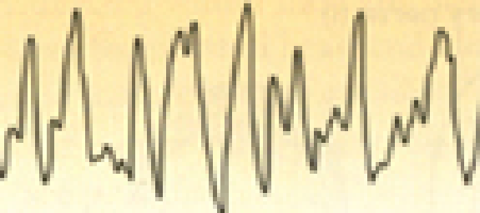
Muscular activity No movement Dreaming rare Dreaming common Easilyawakened Hardtoarouseeasily 80% of sleep time 20% of sleeptime

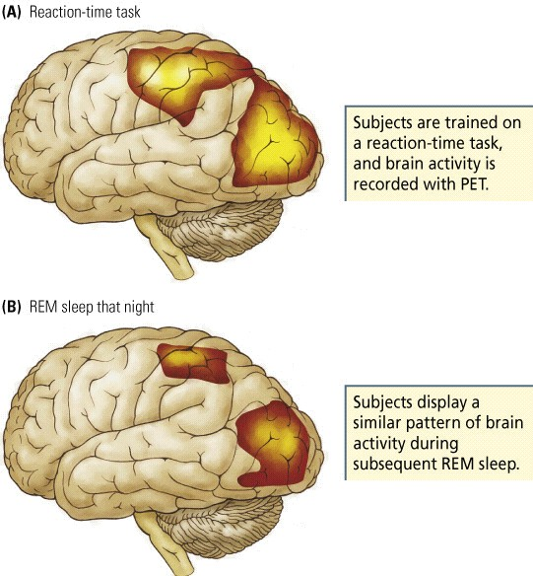

PHYSIOLOGICAL EFFECTS OF SLEEP
Sleep,
    - Helps the maintenance of normal activity level of CNS.
    - Helps to maintain the “balance” between the different parts of the CNS.
    - Increased sympathetic activity and muscle tone during the awake period decreases with sleep...

    - Body temperature drops, energy loss decreases
    - Growth hormone and cortisol secretion
    - Phosphate excretion from kidneys increase
    - Melatonin secretion increases
    - Skin and tissue repair

Sleep across life span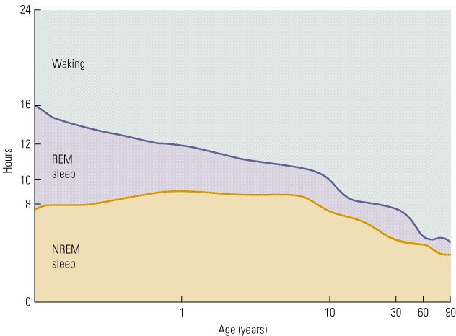

Sleep disorders
  - Insomnia
    - Disturbances in sleep onset or maintenance
  - Fatal Familial Insomnia
    - Unable to sleep, emotional instability, hallucinations, stupor- coma and death

SLEEP DEPRIVATION

- Prolonged wakefulness may result in irritability, confusion and psychotic symptoms
- Fatigue, prostration,depression...
- Unability to direct attention
- Hypersensitivity to pain
- Visceral problems including anorexia and distruption of excretion
- Defects in skin repair
  - Collagen fibres loose their flexibility and may display color changes

    - Confusion
    - Paranoia
    - Affective disorders
    - Decrease in motor performance
    - Memory consolidation impairments?
    - Loss of balance
    - Decreased immune efficiency
    - Work, traffic and home accidents!

SLEEP DISORDERS

  - Parasomnias
    - Sleep walking (somnanbulism), talking,etc..
  - Behavioral
  - disorders in REMsleep
    - Excess motor activity in REM.
  - Narcolepsy
  - Restless leg syndrome
    - Reccurrent leg movements like shaking or withdrawal- extension
  - Sleep paralysis
    - Unable to move for a couple of minutes right after sleep onset or after wake up.

Obstructive Sleep Apnea Syndrome
    - Collapse in the upper airways, interruption of respiration,snoring...
    - May cause restlessness and daysleep
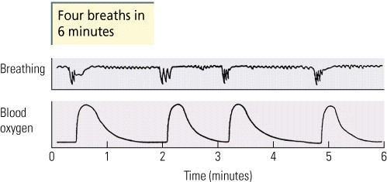
2. Basal ganglia: Direct and indirect pathway of movement
The direct pathway of movement is a neuronal circuit within the central nervous system (CNS) through the basal ganglia which facilitates the initiation and execution of voluntary movement. It works in conjunction with the indirect pathway of movement.
The indirect pathway of movement is a neuronal circuit through the basal ganglia and several associated nuclei within the central nervous system (CNS) which helps to prevent unwanted muscle contractions from competing with voluntary movements. It operates in conjunction with the direct pathway of movement.

