NAME: SUOWARI OYINEBI PASCHELIA
MATRIC NUMBER: 17/MHS01/299
DEPARTMENT: MEDICINE AND SURGERY
NEUROPHYSIOLOGY ASSIGNMENT
- Discuss the physiology of sleep
- Discuss the role of basal ganglia in coordinating movement
ANSWERS
- PHYSIOLOGY OF SLEEP
Sleep refers to a state of unconsciousness from which the individual can be aroused by sensory or other stimuli. When asleep, an individual is not aware of the environment and is unable to perform activities that require consciousness. During sleep, the stimulus pulse transfer becomes less frequent between the reticular formation and cerebral cortex.
Sleep is a brain process; it is often described as a reversible state in which an individual has little or no response to environmental stimuli. Regardless of whether sleep is conceptualized as a process or as a state, it is multidimensional—that is, sleep is not just one process (or state); there are different kinds of sleep. Each type of sleep has its own regulatory mechanisms and presumably different functions. For example, selective deprivation of one type of sleep leads to preferential recovery of that type of sleep when sleep is permitted. The different types of sleep can be thought of as different overall organizational states of the nervous system, some involving increased brain activity and some involving decreased brain activity.
TYPES AND STAGES OF SLEEP
Sleep is of two types: non-REM sleep and REM sleep, which alternate in a sleep cycle:
- Non-REM sleep: Non-REM sleep, i.e. non-rapid eye movement sleep is also known as slow wave sleep (SWS), because in this type of sleep brain waves are very slow. In normal adults, sleep mostly begins with non-REM sleep. It is rest type of sleep which a person experiences during first hour of sleep after having been kept awake for many hours. The non-REM sleep alternates with REM sleep during the sleep cycle.
When an individual from the state of quiet rest with eyes closed enters the state of non-REM sleep the consciousness is reduced. The non-REM sleep also known as slow-wave sleep progresses in an orderly way from light to deep sleep in four stages as:
- Stage 1 of non-REM sleep (stage of very light sleep): EEG pattern in this stage is characterized by low amplitude mixed frequency activity. There is still considerable sensitivity to sensory stimuli. However, the mild to moderate stimuli are often unable to produce a full arousal
- Stage 2 of non-REM sleep (stage of light sleep): It is characterized by the appearance of sleep spindles. These are bursts of α-like 10–14 Hz, 50 μV waves, which periodically interrupt the α rhythm .Auditory stimuli during this phase readily evoke the K-complexes in the EEG. They also occur spontaneously during this stage. The K-complex consists of one or two high-voltage waves followed by a brief 14 Hz activity.
- Stage 3 of non-REM sleep (moderate deep sleep): It is characterized by an EEG that display high amplitude slow (0.5–2 Hz) waves called δ waves.
- Stage 4 of non-REM sleep (deep sleep): produces EEG pattern dome-like very slow, large waves called δ waves. Thus, the characteristic of deep sleep is a pattern of rhythmic slow waves, indicating marked synchronization
- REM sleep: REM sleep (rapid eye movement sleep) is also called ‘fast wave (desynchronized) sleep, or ‘paradoxical sleep’ or ‘dream sleep’ or ‘deepest sleep’. In adults, the REM sleep follows non-REM sleep.
In a normal night of sleep, bouts of REM sleep lasting 5 to 30 minutes usually appear on the average every 90 minutes. When the person is extremely sleepy, each bout of REM sleep is short and may even be absent. Conversely, as the person becomes more rested through the night, the durations of the REM bouts increase. REM sleep has several important characteristics:
- It is an active form of sleep usually associated with dreaming and active bodily muscle movements.
- The person is even more difficult to arouse by sensory stimuli than during deep slow-wave sleep, and yet people usually awaken spontaneously in the morning during an episode of REM sleep.
- Muscle tone throughout the body is exceedingly depressed, indicating strong inhibition of the spinal muscle control areas.
- Heart rate and respiratory rate usually becomes irregular, which is characteristic of the dream state.
- Despite the extreme inhibition of the peripheral muscles, irregular muscle movements do occur. These are in addition to the rapid movements of the eyes.
- The brain is highly active in REM sleep, and overall brain metabolism may be increased as much as 20 percent. The electroencephalogram (EEG) shows a pattern of brain waves similar to those that occur during wakefulness. This type of sleep is also called paradoxical sleep because it is a paradox that a person can still be asleep despite marked activity in the brain.
SLEEP CYCLE
In a normal adult individual, the average sleep period of about 7–8 h is divided into about 5 cycles during which non-REM sleep and REM sleep alternate with each other. There is an orderly progression of sleep states and stages during a typical sleep cycle.
The average duration of each sleep cycle is about 90 min (range 70–120 min). Duration of different sleep stages is different in different cycles:
- Duration of non-REM sleep which is about 85 min (out of total 90 min) in first cycle decreases progressively in the next sleep cycles.
- About 25% of entire sleep period is passed in REM sleep
- Duration of REM sleep, which is about 5 min (out of total 90 min) in first cycle increases progressively in the next cycle.
- Duration of deeper stages (3 and 4) of non-REM sleep is maximum during first cycle and then decreases progressively and may even disappear altogether from the later cycles.
- Duration of second stage of non-REM sleep increases progressively from first cycle onwards and may even occupy most of the non-REM portion of the later cycles. About 50% of the entire sleep period is spent in second stage of non-REM sleep.
- As morning approaches, the individual may be periodically awaken during later sleep cycles.
SLEEP DISORDERS
- Narcolepsy: it is a chronic neurological disorder caused by the brain’s inability to regulate sleep–wake cycles normally in which there is a sudden loss of voluntary muscle tone (cataplexy), an eventual irresistible urge to sleep during daytime, and possibly also brief episodes of total paralysis at the beginning or end of sleep. Narcolepsy is characterized by a sudden onset of REM sleep, unlike normal sleep which begins with NREM, slow-wave sleep.
- Obstructive sleep apnea (OSA): It is the most common cause of daytime sleepiness due to fragmented sleep at night. Breathing ceases for more than 10 s during frequent episodes of obstruction of the upper airway (especially the pharynx) due to reduction in muscle tone. The apnea causes brief arousals from sleep in order to reestablish upper airway tone. Snoring is a common patient complaint. There is actually not a reduction in total sleep time, but individuals with OSA experience a much greater time in stage 1 NREM sleep (from an average of 10% of total sleep to 30–50%) and a marked reduction in slow-wave sleep (stages 3 and 4 NREM sleep). The pathophysiology of OSA includes both a reduction in neuromuscular tone at the onset of sleep and a change in the central respiratory drive.
Sleepwalking (somnambulism), bed-wetting (nocturnal enuresis), and night terrors are referred to as parasomnias, which are sleep disorders associated with arousal from NREM and REM sleep.

- ROLE OF BASAL GANGLIA IN COORDINATING MOVEMENT
The basal ganglia (or basal nuclei) are a group of nuclei of varied origin in the brains of vertebrates that act as a cohesive functional unit. It refers to a group of subcortical nuclei within the brain responsible primarily for motor control, as well as other roles such as motor learning, executive functions, emotional behaviors, and play an important role in reward and reinforcement, addictive behaviors and habit formation. They are situated at the base of the forebrain and are strongly connected with the cerebral cortex, thalamus, and other brain areas.
The basal ganglia are associated with a variety of functions, including voluntary motor control, procedural learning relating to routine behaviors or habits such as bruxism and eye movements, as well as cognitive and emotional functions.

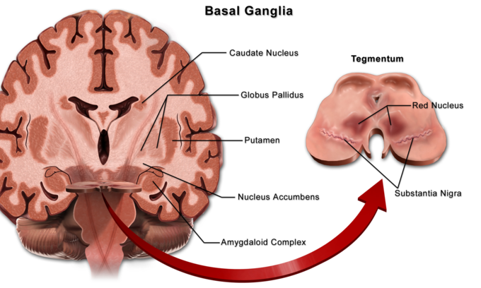
The input to the basal ganglia is from the motor cortex; the output to the cortex is through the thalamus. A complex series of interactions between components of the basal ganglia and associated structures leads to this output, which then regulates the level of excitation in the motor cortex. These interactions form an indirect pathway that inhibits cortical excitation and a direct pathway that is excitatory. The balance of these opposing pathways is responsible for coordinating smooth movement and maintenance of posture.
Neurons in the basal ganglia, like those in the lateral portions of the cerebellar hemispheres, discharge before movements begin. This observation, plus careful analysis of the effects of diseases of the basal ganglion in humans and the effects of drugs that destroy dopaminergic neurons in animals, have led to the idea that the basal ganglia are involved in the planning and programming of movement or, more broadly, in the processes by which an abstract thought is converted into voluntary action. They influence the motor cortex via the thalamus, and the corticospinal pathways provide the final common pathway to motor neurons. In addition, GPi projects to nuclei in the brain stem, and from there to motor neurons in the brain stem and spinal cord. The basal ganglia, particularly the caudate nuclei, also play a role in some cognitive processes. Possibly because of the interconnections of this nucleus with the frontal portions of the neocortex, lesions of the caudate nuclei disrupt performance on tests involving object reversal and delayed alternation. In addition, lesions of the head of the left but not the right caudate nucleus and nearby white matter in humans are associated with a dysarthric form of aphasia that resembles Wernicke aphasia.
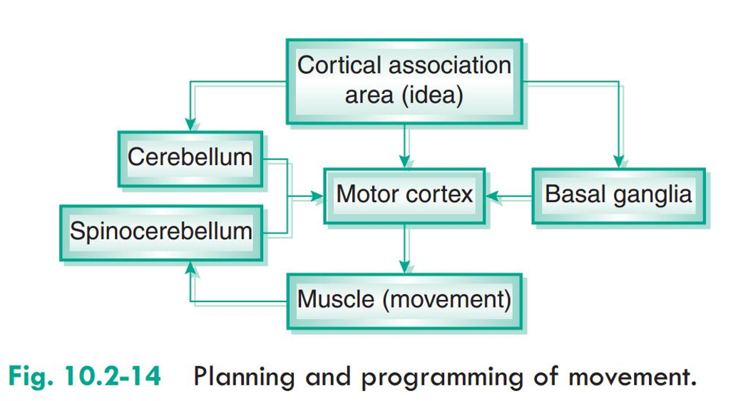

The greatest source of insight into the functions of the basal ganglia has come from the study of two neurological disorders, Parkinson’s disease and Huntington’s disease. For both of these disorders, the nature of the neural damage is well-understood and can be correlated with the resulting symptoms.
Parkinson’s disease involves the major loss of dopaminergic cells in the substantia nigra. Huntington’s disease involves the massive loss of medium spiny neurons in the striatum. The symptoms of the two diseases are virtually opposite: Parkinson’s disease is characterized by a gradual loss of the ability to initiate movement, whereas Huntington’s disease is characterized by an inability to prevent parts of the body from moving unintentionally.
It is noteworthy that, although both diseases have cognitive symptoms, especially in their advanced stages, the most salient symptoms relate to the ability to initiate and control movement. Thus, both are classified primarily as movement disorders.

