- The zener diode is the simplest types of voltage regulator and the point at which a zener diode breaks down or conducts is called the “Zener Voltage” ( Vz ). The Zener diode is like a general-purpose signal diode consisting of a silicon PN junction. When biased in the forward direction it behaves just like a normal signal diode passing the rated current, but as soon as a reverse voltage applied across the zener diode exceeds the rated voltage of the device, the diodes breakdown voltage is reached at which point a process called Avalanche Breakdown occurs in the semiconductor depletion layer and a current starts to flow through the diode to limit this increase in voltage.
i.
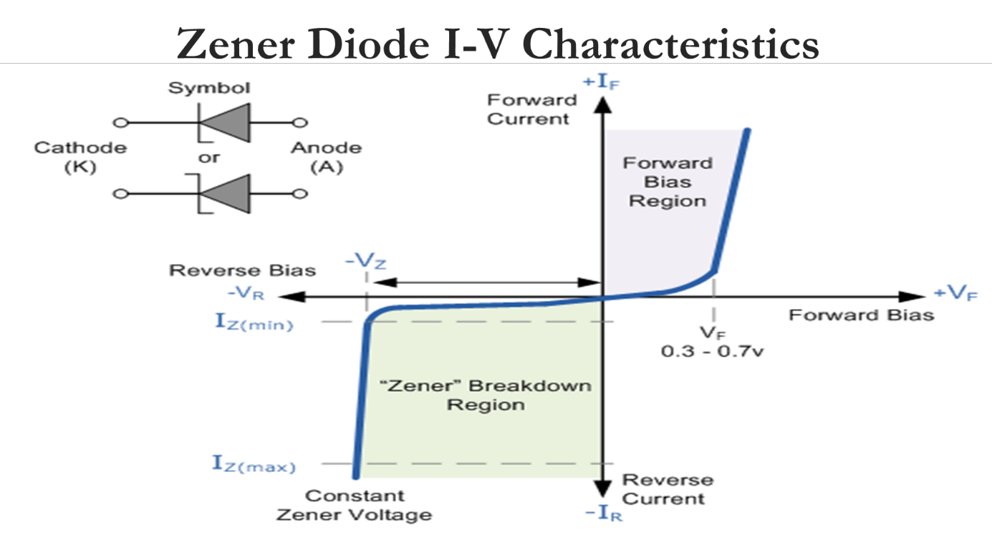

ii.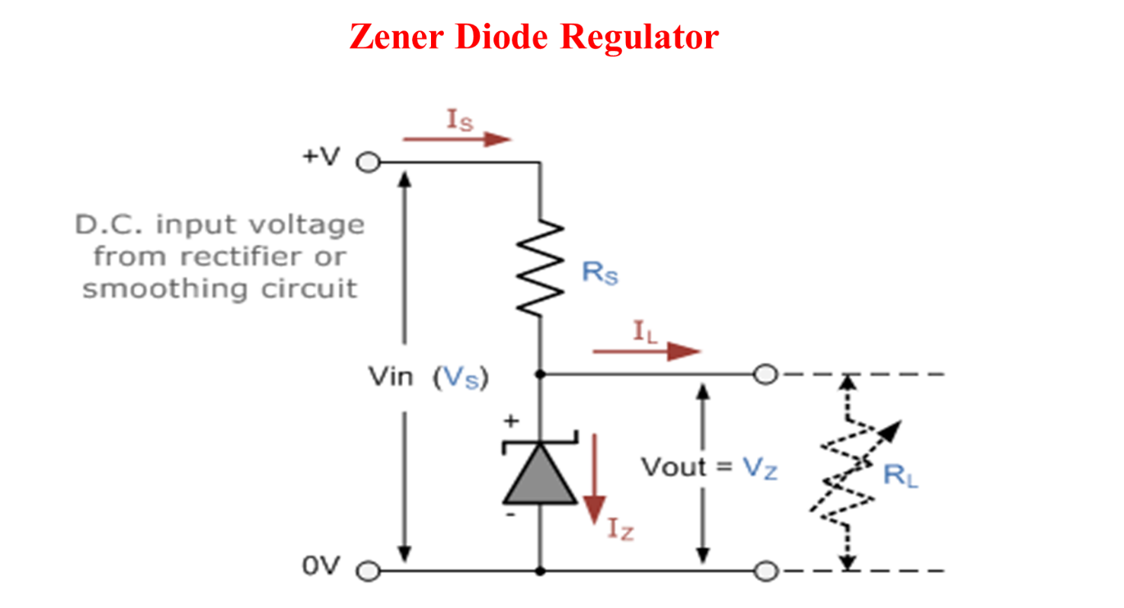
- Power = 5w
Max current = 500Ma
Max current = watts/voltage
Voltage = watts/max current
V = 5w/500Ma
V = 10v

R_{S} = V_{S} – V_{z}/I_{Z}
R_{s} = 20v – 10v/500mA
R_{s} = 0.02ohms

I_{L} = V_{Z}/R_{L}
I_{L} = 10v/500ohms
I_{L} = 2mA

