OMEREJI EZE AMOS
17/SCI01/067
SOLUTIONS
- The goal or objective of computability theory is to determine which problems, or classes of problems, can be solved in each model of computation. It is also concerned with the classification of problems by difficulty

WHILE

The complexity of a problem or the objective of complexity theory is to describe whether a problem can be solved using algorithms, and how much resources (in form of time and space) it will take to solve a problem algorithmically

2. Computability theory deals primarily with the question of whether a problem is
solvable at all on a computer. The statement that the halting problem cannot be
solved by a Turing machine is one of the most important results in computability
theory, as it is an example of a concrete problem that is both easy to formulate and
impossible to solve using a Turing machine. Much of computability theory builds on
the halting problem result.
Complexity Theory is part of the theory of computation dealing with the resources
required during computation to solve a given problem. The most common resources
are time (how many steps does it take to solve a problem) and space (how much
memory does it take to solve a problem). Other resources can also be considered,
such as how many parallel processors are needed to solve a problem in parallel.
Complexity theory differs from computability theory, which deals with whether a
problem can be solved at all, regardless of the resources required.

3.
I) A set is a group or collection of related objects or numbers, considered as an entity unto
itself. Examples include the set of all students in a school, the set of cars in a parking lot.
(ii) power set of any set S is the set of all subsets of S, including the empty set and S
itself, variously denoted as P(S),(S). Eg If S is the set {x, y, z}, then the subsets
of S are
•{}
•{x}
•{y}
•{z}
•{x, y}
•{x, z}
•{y, z}
•{x, y, z}

and hence the power set of S is {{}}, {x}, {y}, {z}, {x, y}, {x, z}, {y, z}, {x, y, z}}
(iii) members of a set: elements that makes up a set. For example, {x,y,z} are the elements in set S.
(iv) Subset: is a set A is a subset of a set B, or equivalently B is a superset of A, if A is contained in B. That is, all elements of A are also elements of B. A and B may be equal.
(v) Proper subset : A proper subset of a set A is a subset of A that is not equal to A. In other words, if B is a proper subset of A, then all elements of B are in A but A contains at least one element that is not in B.
(vi) Infinite set: set is said to be an infinite set whose elements cannot be listed if it has an unlimited (i.e. uncountable) by the natural number 1, 2, 3, 4, ………… n.
(vii) Finite set: a finite set is a set that has a finite number of elements. Informally, a finite set is a set which one could in principle count and finish counting.
(viii) Unordered pair: is a set of the form {a, b}, i.e. a set having two elements a and b with no particular relation between them.
(ix) Union of a set: The u un ni io on n of two s se et ts s A and B is the s se et t of elements which are in A, in B, or in both A and B.
For example, if A = {1, 3, 5, 7} and B = {1, 2, 4, 6, 7} then A ∪
B = {1, 2, 3, 4, 5, 6, 7}.
(x) Intersection of a set: i in nt te er rs se ec ct ti io on n of two sets A and B, denoted by A ∩ B, is the
set containing all elements of A that also belong to B (or equivalently, all elements
of B that also belong to A). For example, The intersection of the sets {1, 2, 3} and {2,
3, 4} is {2, 3}.
(xi) Complement of a set: refers to elements not in A. When all sets under consideration are considered to be subsets of a given set U, the absolute compliment of A is the set of elements in U but not in A.
(xii) Difference of a set: The difference of two sets, written A - B is the set of all
elements of A that are not elements of B. The difference operation, along with union and intersection, is an important and fundamental set theory operation.
(xiii) Symmetric difference of a set : is the s set of elements which are in either of the sets and not in their intersection.

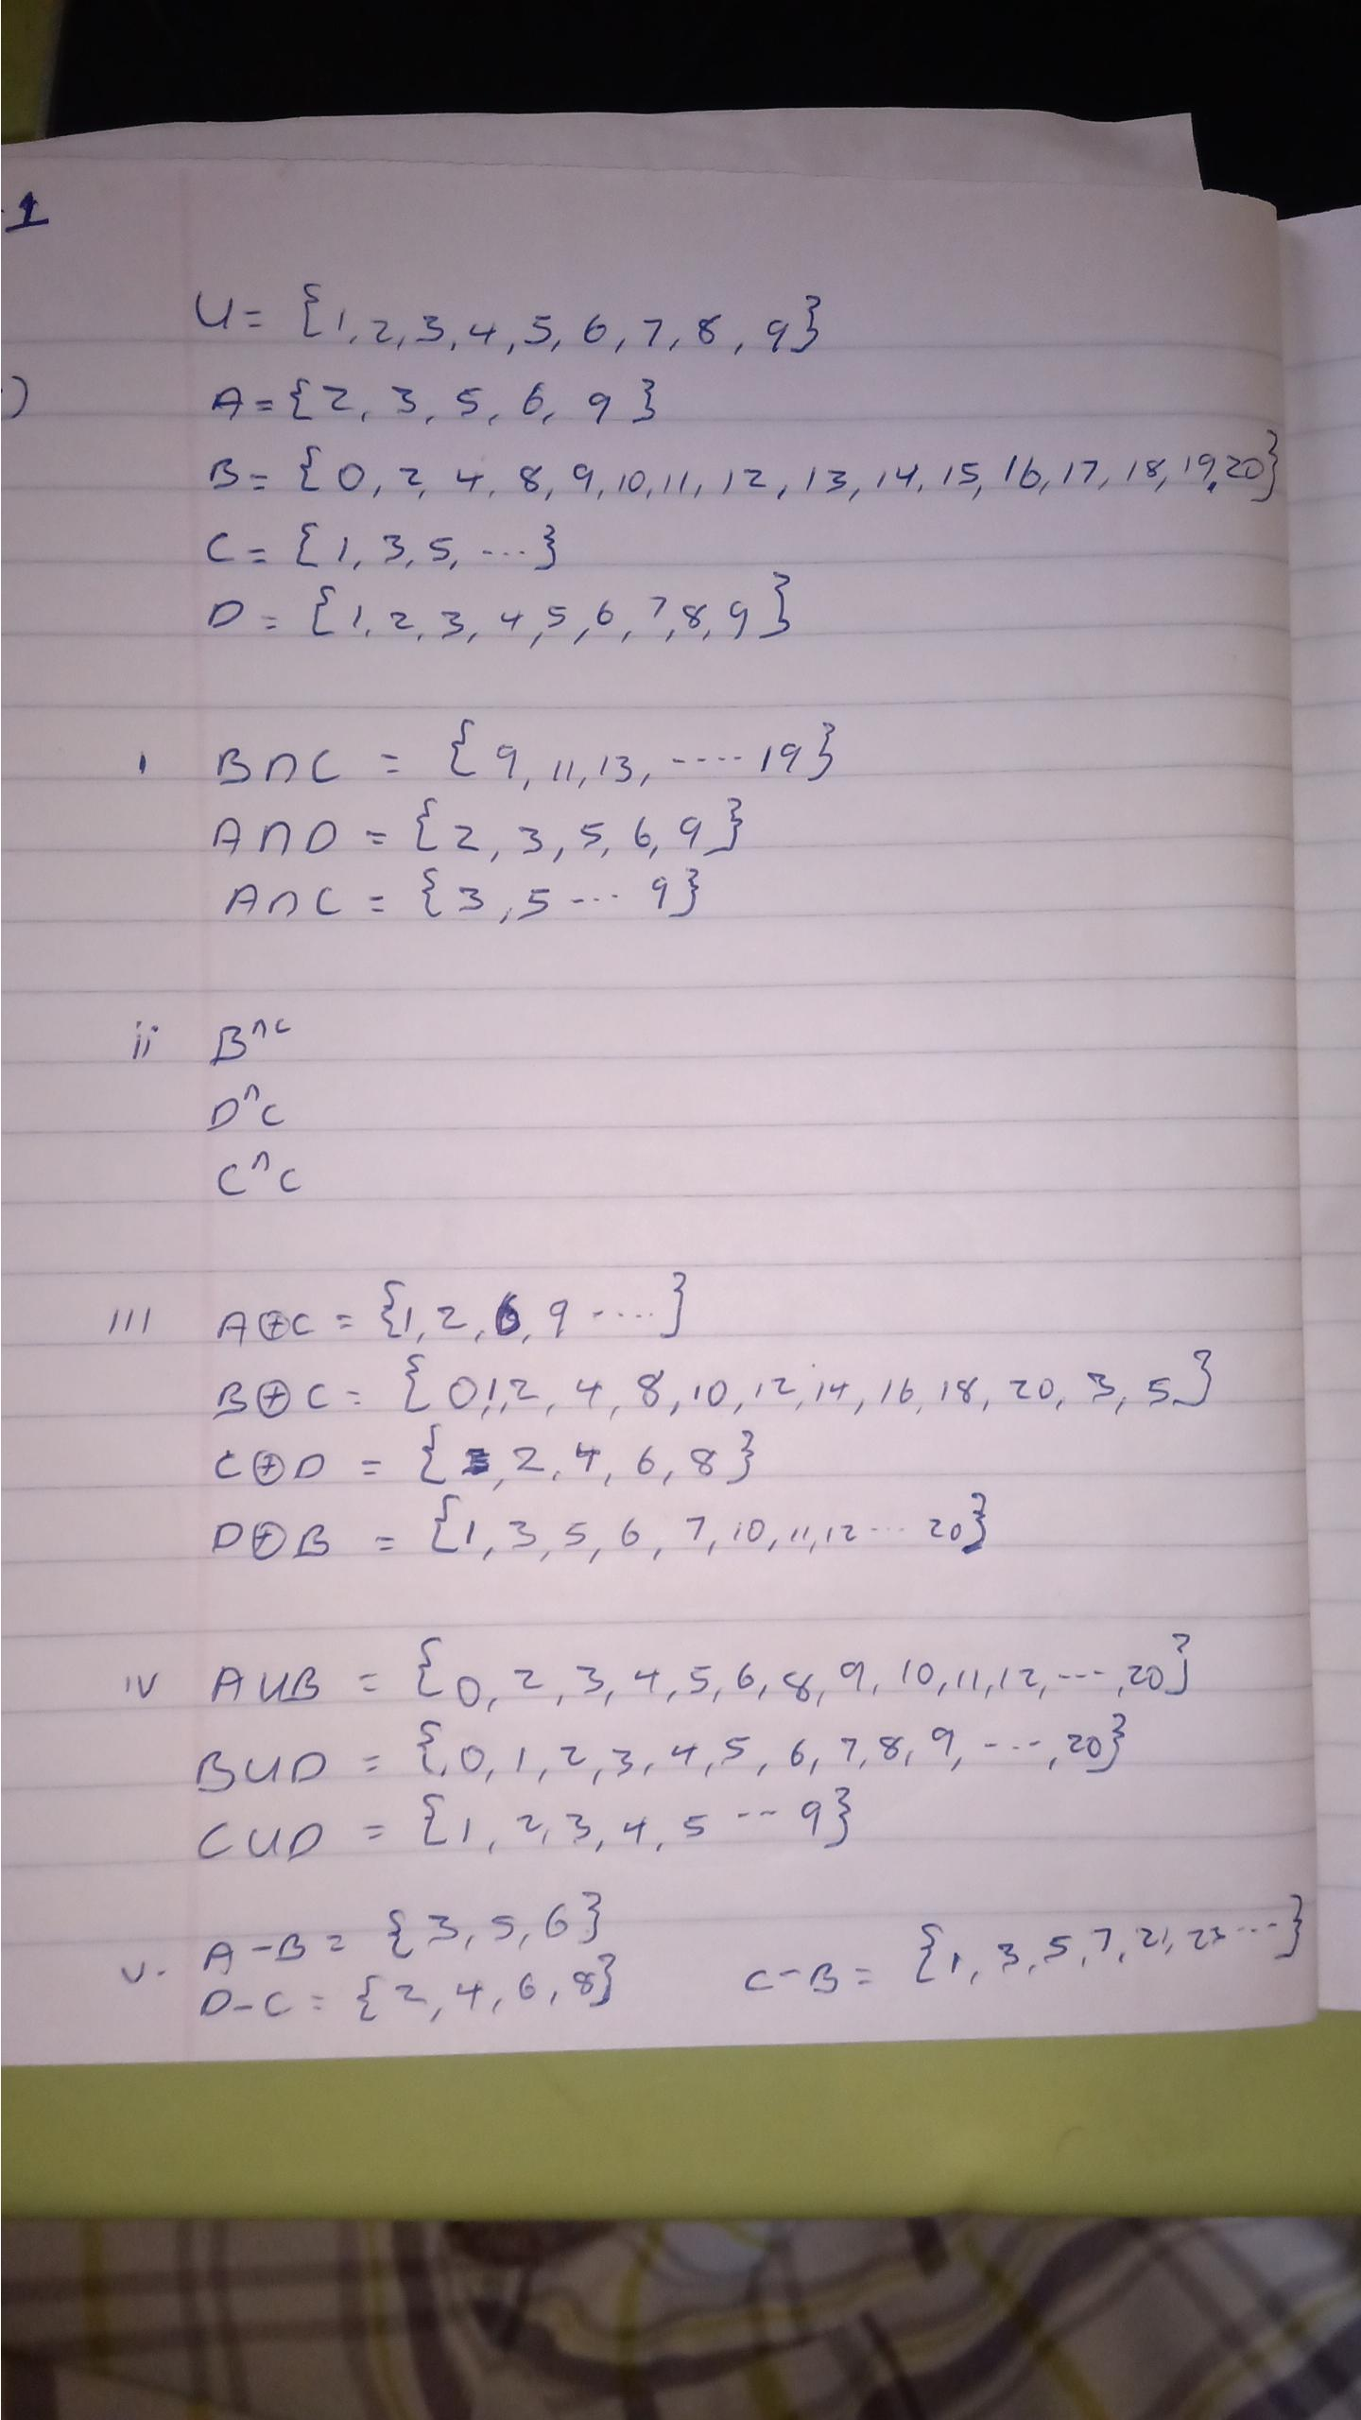
4.

5. An alphabet is a finite non-empty set. The elements of an alphabet are called
the letters or symbols of the alphabet.
(ii) Words: Suppose a set A is finite and A is viewed as a character set or an alphabet. Then a finite sequence over A is called a string or word
(iii) Length of words: Length of a word is denoted as |w| and is defined as the
number of positions for the symbol in the string.
(iv) Substring: is a contiguous sequence of characters within a string.
(v) Initial segment: initial segment is often referred to as the set of strictly preceding elements.
(vi) Concatenation of strings:
Let w1 and w2 be two strings then w1w2 denotes their concatenation w. The
concatenation is formed by making a copy of w1 and followed by a copy of w2.
For example w1 = xyz, w2 = uvw
then w = w1w2 = xyzuvw
(vii) Language: A language is a set of strings, chosen from some Σ* or we can say- ‘ ‘A
language is a subset of Σ* ‘ ‘. A language which can be formed over ‘ Σ ‘ can
be finite or infinite.

6. A = {a,c,e,i,o,n,t}
v = concatenation
u = catetioncona
(i) the length of v= 13
(ii) reverse string u= anocnoitetac
(iii) concatenate v and u= concatenationcatetioncona
(iv) substring of m if m=cacontatione
∑0={λ}
∑1= { c,a,c,o,n,t,a,t,I,o,n,e}
∑2= {ca,ac,co,on,nt,ta,at,ti,io,on,ne}
∑3= {cac,aco,con,,ont,tat,tio,ion,one}
∑4={caco,acon,cont,onta,tati,atio,ione}
∑5={cacon,acont,conta,ontat,ntati,tatio,ation,tione}
∑6={cacont,aconta,contat,ontati,ntatio,tation,atione}
∑7={caconta,acontat,contati,ontatio,ntation,tatione}
∑8={cacontat,acontati,contatio,notation,ntatione}
∑9={cacontati,acontatio,contation,ontatione,}
∑10={cacontatio,acontation,contatione}
∑11={cacontation,acontatione}
∑12={cacomtatione}
∑= { λ,c,a,c,o,n,t,a,t,I,o,n,e, ca,ac,co,on,nt,ta,at,ti,io,on,ne, cac,aco,con,,ont,tat,tio,ion,one, caco,acon,cont,onta,tati,atio,ione, cacon,acont,conta,ontat,ntati,tatio,ation,tione,cacont,aconta,contat,ontati,ntatio,tation,atione,caconta,acontat,contati,ontatio,ntation,tatione, cacontat,acontati,contatio,notation,ntatione, cacontati,acontatio,contation,ontatione, cacontatio,acontation,contatione, cacontation,acontatione, cacomtatione}

7. substring of s={abracaba}
(i) ∑0={λ}
∑1={a,b,r,a,c,a,b,a}
∑2={ab,br,ra,ca,ab,ba}
∑3={abr,bra,rac,aca,cab,aba}
∑4={abar,brac,raca,acab,caba}
∑5={abrac,braca,racab,acaba}
∑6={abraca,bracab,racaba}
∑7= {abracab,bracaba}
∑8={abracaba}
∑= { λ, a,b,r,a,c,a,b,a, ab,br,ra,ca,ab,ba, abr,bra,rac,aca,cab,aba, abar,brac,raca,acab,caba, abrac,braca,racab,acaba, abraca,bracab,racaba, abracab,bracaba, abracaba}

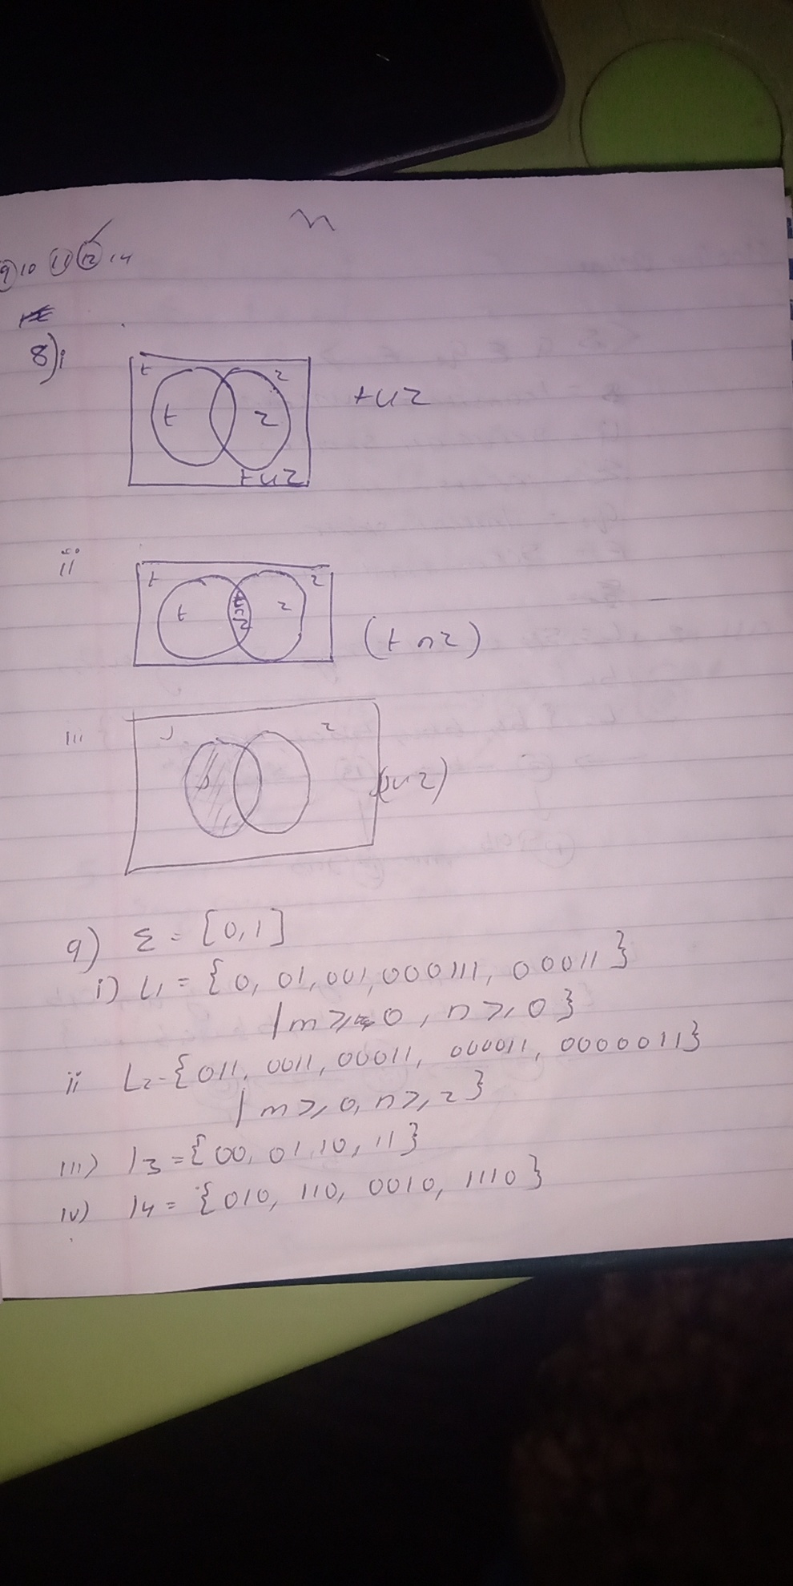
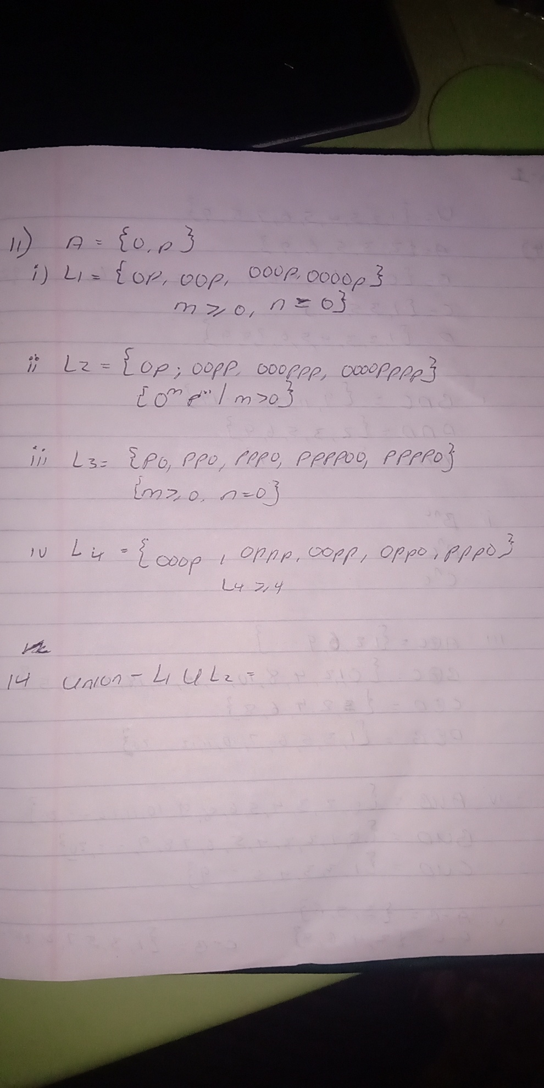

12. i. {b^n a| n>0} : consist of words that end with one or more b's eg ba, bba, bbbba
ii. { a^n ab^m | n≥0,m>0} : consist of words starting with 0 or more a's followed by one a and one or more b's
Eg. aab,ab,abb
iii. { b^n b^m a^m | n≥0,m≥0} : consist of words starting with 0 or more b's followed by 0 or more b's and ending with 0 or more a's
E.g bba, bbbaa
iv. {ab, abb, aab, aaa, abbb,.....}: Consist of words starting with one or more a's and ending with 0 or more b's.

13. {b^n a^m b^p|n>0,m>=0,p>=0}
(ii) {b^n a b^m|n>0,m>=0}
(iii) { b^n|n>0}
(iv) {a^n b^m| n>0,m>0}

