NAME:OLAOYE,OLUFUNBI JOSEPHINE
MATRIC NUMBER:17/SCI05/009
COURSE TITLE:GENETIC ENGINEERING AND MOLECULAR BIOLOGY
COURSE CODE:MCB 310
ASSIGNMENT TITLE: NUCLEIC ACID PROCESSING AND BLOTTING TECHNIQUES
Answers
1a Purine synthesis
Adenine and guanine are the two nucleotides classified as purines. There are two pathways of synthesis of purine nucleotides:
- De Novo synthesis pathway, and
- Salvage pathway.
De Novo synthesis pathway
The major site of purine synthesis is in the liver. Synthesis of the purine nucleotides begins with 5-Phosphoribosyl-1-pyrophosphate (PRPP) and leads to the first fully formed nucleotide, inosine 5-monophosphate (IMP). It is then converted to either AMP or GMP.
Steps involved
- Ribose 5-phosphate(of carbohydrate metabolism) is the starting material. It reacts with ATP to form 5-Phosphoribosyl-1-pyrophosphate (PRPP).
- Glutamine transfers its amide nitrogen to PRPP to replace pyrophosphate and produce 5-phosphoribosylamine. The amine group that has been placed on carbon 1 of the sugar becomes nitrogen 9 of the ultimate purine ring. This is the commitment and rate-limiting step of the pathway.
- Phosphoribosylamine reacts with glycine in the presence of ATP to form glycinamide ribosyl 5-phosphate or glycinamide ribotide (GAR).
- N10-formyltetrahydrofolate donates the formyl group and the product formed is formylglycinamide ribosyl 5-phosphate.
- Glutamine transfers the second amino group to produce formylglycinamide ribosyl 5-phosphate
- The imidazole ring of the purine is closed in an ATP dependent reaction to yield aminoimidazole ribosyl 5-phosphate
- Incorporation of co2(carboxylation) occurs to yield aminoimidazole carboxylate ribosyl 5-phosphate
- Aspartate condenses with the aminoimidazole carboxylate ribosyl 5-phosphate to form aminoimidazole 4-succinylcarboxamide ribosyl 5-phosphate.
- Adenosuccinatelyase cleaves off the fumarate and only the amino group of aspartate is retained to yield aminoimidazole 4-carboxamide ribosyl 5-phosphate.
- N10-formyltetrahydrofolate donates one carbon moiety to produce 5-formaminoimidazole 4-carboxamide ribosyl 5-phosphate
- The final reaction catalyzed by cyclohydrolase leads to ring closure with an elimination of water molecule.
- The product obtained is inosine 5-monophosphate (IMP), the parent purine nucleoetide from which other purine nucleotides can be synthesiszed.
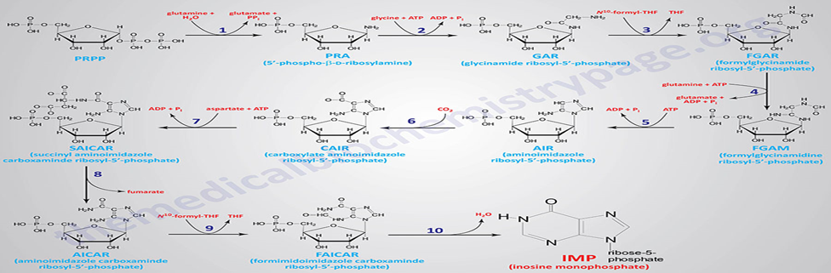
Figure 1:De novo purine nucleotide synthesis pathway
Formation of AMP and GMP
Synthesis of AMP
Inosine monophosphate (IMP) is the immediate precursor for the formation of AMP and GMP
- Removal of the carbons of aspartate as fumarate leaves the nitrigen behind as the 6-amino group of the adenine ring.
- Aspartate condenses with IMP in the presence of GTP to produce adenylsuccinate which on cleavage, forms AMP.

Synthesis of GMP
- IMP undergoes NAD+ dependent dehydrogenation to form xanthosine monophosphate(XMP).
- Glutamine then transfers amide nitrogen to xanthosine monophosphate (XMP) to produce GMP.
The monophosphates are readily converted to the di- and tri-phosphates.

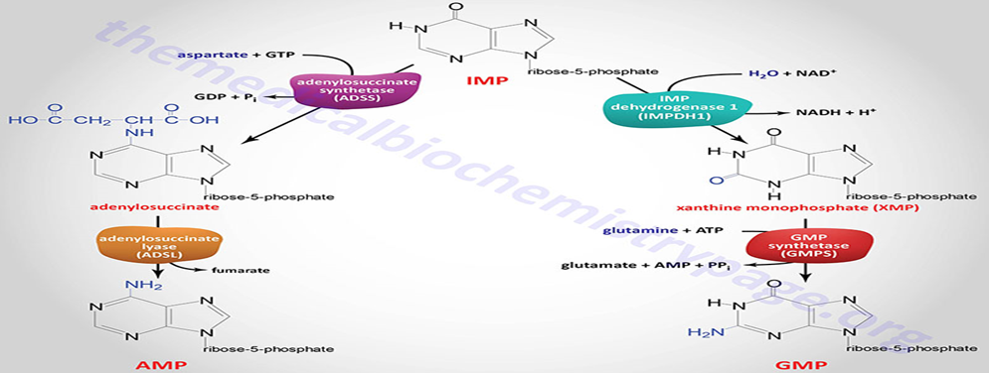
Figure 2: Synthesis of AMP and GMP from IMP.
Salvage pathway of purine synthesis
A salvage pathway is a pathway in which nucleotides are synthesized from intermediates in the degradative pathway for nucleotides.
Free purine bases, derived from the turnover of nucleotides or from the diet, can be attached to PRPP to form purine nucleoside monophosphates. Two salvage enzymes with different specificities recover purine bases. Adenine phosphoribosyltransferase catalyzes the formation of adenylate.
Hypoxanthine-guanine phosphoribosyltransferase (HGPRT) catalyzes the formation of guanylate as well as inosinate (inosine monophosphate, IMP), a precursor of guanylate and adenylate.
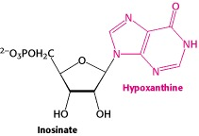
ATP stimulates production of GTP, while GTP stimulates production of ATP. This cross regulation keeps the relative amounts of ATP and GTP the same. Excess of either nucleotide could increase the likelihood of DNA mutations, where the wrong purine nucleotide is inserted.
Lesch–Nyhan syndrome is caused by a deficiency in hypoxanthine-guanine phosphoribosyltransferase or HGPRT, the enzyme that catalyzes the reversible reaction of producing guanine from GMP. This is a sex-linked congenital defect that causes overproduction of uric acid along with mental retardation, spasticity, and an urge to self-mutilate.

1b Pyrimidine synthesis
Pyrimidine nucleotides include cytidine, uridine, and thymidine. The synthesis of any pyrimidine nucleotide begins with the formation of uridine. Synthesis of the pyrimidines is less complex than that of the purines, since pyrimidine molecules are simpler than purines. In pyrimidine synthesis, the ring is completed before being linked to ribose-5-phosphate.
Steps involved
- Pyrimidine synthesis begins with the synthesis carbamoyl phosphate (synthesized in the cytosol of those tissues capable of making pyrimidines highest in spleen, thymus, GItract and testes). With the hydrolysis of two ATPS,bicarbonate and amide nitrogen of glutamine combine to form carbamoyl phosphate.
- Carbamoyl phosphate condenses with aspartate in the presence of aspartate transcarbamylase to yield N-carbamylaspartate
- By elimination reaction, the carbamylaspartate is converted to a ring compound dihydroorotate
- Dihydroorotate is dehydrogenated to form orotate
- Orotate reacts with PRPP to produce orotidine-5’-monophosphate (OMP),
- (OMP) is subsequently decarboxylated to UMP (uridine-monophosphate)
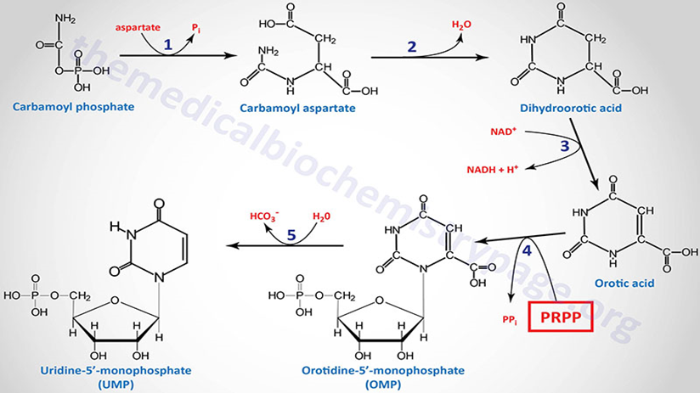
Figure 3: Synthesis of UMP from carbamoyl phosphate
- UMP is converted to UTP two ATP molecules are required.
- CTP (cytidine-triphosphate) is synthesized by the amination of UTP by the enzyme CTP synthase.( In animals amino group is donated by glutamine and in bacteria amino group is donated by ammonia)
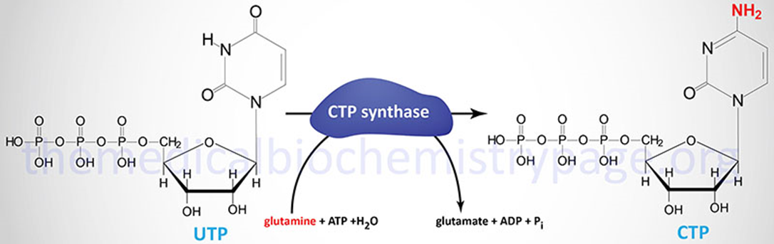
Figure 4: Synthesis of CTP from UTP.
ATP, a purine nucleotide, is an activator of pyrimidine synthesis, while CTP, a pyrimidine nucleotide, is an inhibitor of pyrimidine synthesis. This regulation helps to keep the purine/pyrimidine amounts similar, which is beneficial because equal amounts of purines and pyrimidines are required for DNA synthesis.
Deficiencies of enzymes involved in pyrimidine synthesis can lead to the genetic disease Orotic aciduria which causes excessive excretion of orotic acid in the urine.

C Nucleotides to deoxynucleotides conversion
Nucleotides are initially made with ribose as the sugar component, which is a feature of RNA. DNA, however, requires deoxyribose, which is missing the 2'-hydroxyl (-OH group) on the ribose. Uracil does not appear (normally) as a base in DNA; instead thymine (5-methyluracil) appears. The reaction to remove this -OH is catalyzed by ribonucleotide reductase. This enzyme converts NDPs (nucleoside-diphosphate) to dNDPs (deoxynucleoside-diphosphate). The nucleotides must be in the diphosphate form for the reaction to occur.
A base diphosphate (BDP) is reduced at the 2' position of the ribose portion using the protein, thioredoxin and the enzyme nucleoside diphosphate reductase. Thioredoxin has two sulfhydryl groups which are oxidized to a disulfide bond during the process. In order to restore the thioredoxin to its reduced form so that it can be reused, thioredoxin reductase and NADPH are required. The primary pathway for the synthesis of the deoxynucleotides involves the association of the redox reactions of thioredoxin and thioredoxin reductase. However, the glutaredoxin, glutathione, and glutathione reductase pathway does serve as an important component of the overall deoxynucleotide synthesis process.
Thymine Synthesis
Thymine is formed by methylating deoxyuridine monophosphate (dUMP) rather than by the reduction at the C 2' position of a nucleoside diphosphate that would correspond to TDP. Although UTP is needed for RNA production, dUTP is not needed for DNA production and, in fact, if there were appreciable amounts of dUTP in the cell, there would be many substitution errors of dUTP for dTTP. That is the reason for the following roundabout way that thymine is produced.
dUTP is hydrolyzed in the presence of dUTP diphosphohydrolase to dUMP and pyrophosphate. The dUMP is then methylated at C 5 on the pyrimidine ring to produce dTMP, which is then rephosphorylated to dTTP.

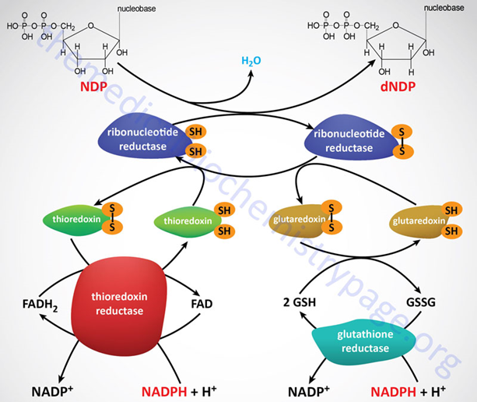
Figure 5: Nucleotide to deoxynucleotide conversion

2 Differences between a bioreactor and fermentor
Bioreactor is the vessel that facilitates various types of biochemical reactions whereas the fermentor is the vessel that facilitates fermentation. Bioreactor and fermentor are closed systems that carry out biochemical reactions; Fermentor is a type of bioreactor. The key difference between bioreactor and fermentor is that bioreactors generally carry out any type of biochemical reactions while fermentors only carry out fermentation. Thus, fermentors will only produce acids such as lactic acid and alcohols. Therefore, we use only the fermentative microbes in fermentors. In contrast, bioreactors are capable of producing varied products such as pharmaceuticals, drugs and proteins. Thus, both are vital in the industry for mass production of compounds.
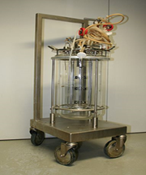 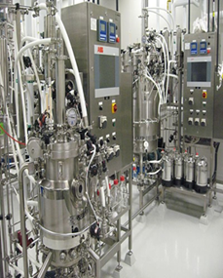
Figure 6: fermentor Figure 7: Bioreactor
The table below describes these the differences between bioreactor and fermentor differences as a side by side comparison.
Table 1: differences between bioreactor and fermentor
 | Bioreactor | Ferementor
Definition | Bioreactor is a closed vessel that facilitates different types of biochemical raeactions. | Fermentor is a type of bioreactor that is specialized only to carry out fermentataion.
Type of reaction | Any type of biochemical reaction | Only fermentation
Types of designs | Can be packed, bed, fluidized bed,IVFR or Air lift bioreactor | Can be batch, fed batch or continuous.
Types of products | Metabolites such as pharmateuticals, drugs, peptides,antibodies,vaccines and amino acids | Only acids and alcohols.
Type of living organisms involved | Unicellular microbes, plants and animal cells. | Only fermentative miicrobes
Oxygen requirement | Can operate under both aerobic and anaerobic conditions | Only anaerobic
Substrates used | Various types of substrates can be used based on the desired reaction | Glucose or glucose containing compounds are used.
Doubling time | Doubling time is long(14,17 or 24hours) | Doubling time is 20 minutes
Purpose | Can either be used to produce a cell mass or a particular metabolite. | Used to produce a etabolie
Metabolites produced | Can produce secondary metabolites | Can only produce primary metabolites
Volume | Volume can be up to several litres | Volume can be up to 2litres
Viral Infections | Bioreactors tend to be infected by viruses | fermentors generally are not infected by viruses.

3 Amino acid synthesis
Amino acid synthesis is the set of biochemical processes (metabolic pathways) by which the amino acids are produced. Different organisms vary greatly in their ability to synthesize the 20 amino acids. Whereas most bacteria and plants can synthesize all 20, mammals can synthesize only about half of them. Those that are synthesized in mammals are generally those with simple pathways. These are called non- essential amino acids and are so termed because they be made by our bodies – this is in contrast to essential amino acids while conditional amino acids are only vital during specific times, such as periods of illness or stress.
All amino acids are derived from intermediates in glycolysis, the citric acid cycle, or the pentose phosphate pathway .Nitrogen enters these pathways by way of glutamate and glutamine.
Ways in which amino acids could be synthesized
- Reduction of N2 to NH4.
- Transamination.
- Synthesis of amino acids by metabolic precursors.
- Commercial Synthesis of amino acids
Reduction of N2 to NH4: It is the first step during synthesis of amino acids, in which reduction of N2 TO NH4 takes place. The conversion of nitrogen to ammonia is a reduction reaction which is exergonic in nature .Biological fixation of nitrogen is carried out by a highly conserved complex of proteins called nitrogenase complex. Glutamine is synthesized from NH4+ and glutamate, and asparagine is synthesized similarly. Asparagine is synthesized through one of two known pathways. In bacteria, an asparagine synthetase combines aspartate and ammonia. However, in mammals, the aspartate gets its amino group from glutamine.

Transmination : A chemical reaction that transfers an amino group to a ketoacid to form new amino acids. This pathway is responsible for the deamination of most amino acids. This is one of the major degradation pathways which convert essential amino acids to nonessential amino acids (amino acids that can be synthesized de novo by the organism). Transamination is accomplished by enzymes called transaminases or aminotransferases.
For example; α-ketoglutarate acts as the predominant amino-group acceptor and produces glutamate as the new amino acid.
Aminoacid + α-ketoglutarate ↔ α-keto acid + Glutamate
Glutamate's amino group, in turn, is transferred to oxaloacetate in a second transamination reaction yielding aspartate.
Glutamate+ oxaloacetate ↔ α- ketoglutarate + aspartate
Aminotransfer reaction between an amino acid and an alpha-keto acid Keto acids (also called oxo acids or oxoacids) are organic compounds that contain a carboxylic acid group and a ketone group.
Synthesis of amino acids by metabolic precursors: All the 20 protein amino acids are derived from intermediates in glycolysis, citric acid cycle or the pentose phosphate pathway Nitrogen enters these pathways by way of glutamate and glutamine.
A useful way to organize the amino acid biosynthetic pathways is to group them into families corresponding to the metabolic precursor of each amino acid. This approach is used in the detailed descriptions of these pathways presented below.
- α-Ketoglutarates: glutamate, glutamine, proline, arginine
- Erythrose 4-phosphate and phosphoenolpyruvate: phenylalanine, tyrosine, and tryptophan
- Ribose 5-phosphates: histidine
- Oxaloacetate/aspartate: lysine, asparagine, methionine, threonine, and isoleucine
- Ribose 5-phosphates: histidine
- 3-Phosphoglycerates: serine, glycine, cysteine
- Pyruvate: alanine, valine, and leucine
Commercial Synthesis of amino acids: The commercial production of amino acids usually relies on mutant bacteria that overproduce individual amino acids using glucose as a carbon source. Some amino acids are produced by enzymatic conversions of synthetic intermediates. 2-Aminothiazoline-4-carboxylic acid is an intermediate in the industrial synthesis of L-cysteine for example. Aspartic acid is produced by the addition of ammonia to fumarate using a lyase

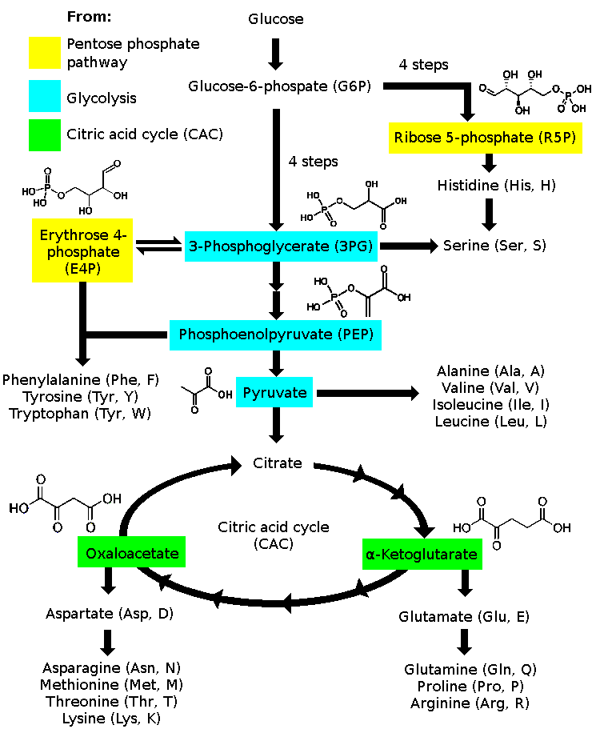
Figure 8: Amino acid synthesis overview
References
- Amino acid synthesis. Retrieved from https://library.med.utah.edu/NetBiochem/pupyr/pp.htm
- Amino acid synthesis. Retrieved from https://en.wikipedia.org/wiki/Amino_acid_synthesis#/media/File:Amino_acid_biosynthesis_overview.png
- Biosynthesis and catabolism of nucleic acids. Retrieved from https://themedicalbiochemistrypage.org/biosynthesis-and-catabolism-of-nucleic-acids/
- Nucleotides. Retrieved from https://homepages.rpi.edu/~bellos/nucleotides.htm
- Nucleotides. Retrieved from https://en.wikipedia.org/

