NAME: USMAN MUSTAPHA A.
DEPARTMENT: MECHANICAL
MATRIC NO: 17/ENG06/087
LEVEL: 300L
TITLE: ASSIGNMENT 2

ANSWER TO THE QUESTIONS

Q1. Explain these two types of friction: Dry friction and Fluid friction
Ans:
- Dry friction:
This is the force that opposes one solid surface sliding across another solid surface. Dry friction always opposes the surfaces sliding relative to one another and can have the effect of either opposing motion or causing motion in bodies. Dry friction is subdivided into static friction (between non-moving surfaces,) and kinetic friction (between moving surfaces). Examples include: Pulling a wagon, pushing a box across the floor, a vase sitting on a table, riding a bike.

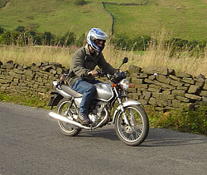
Figure 1: dry friction
- Fluid friction:
This is the force that resists motion either within the fluid itself or of another medium moving through the fluid. There is internal friction, which is a result of the interactions between molecules of the fluid, and there is external friction, which refers to how a fluid interacts with other matter. Examples include: Swimming – swimmer’s body and surface of water, greasing a squeaky door hinge.
Air resistance is an example of fluid friction caused by the particles that make up air. It causes a falling object to slow down.

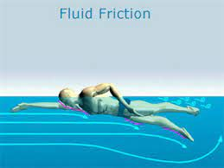
Figure 2: fluid friction

Note: Fluid friction is usually “less” than sliding friction. Lubricants change sliding friction to fluid friction. Lubricants are slippery substances.

Q2. Explain the following types of machines:
- Wedges
- Square threaded – screw
- Journal bearings
Ans:
- Wedges:
A wedge is a triangular shaped tool, and is a portable inclined plane (or two inclined planes joined together to form a triangle that moves) and one of the six classical simple machines. It can be used to separate two objects or portions of an object, lift up an object, or hold an object in place. It functions by converting a force applied to its blunt end into forces perpendicular (normal) to its inclined surfaces. It is thick on one end and tapers to a thin or sharp edge on the other end.
A wedge maybe attached to a handle to make it easier for use. Examples include: knives, nails, axes.

- Square threaded – screw:
The square thread form is a common screw thread form, used in high load applications such as leadscrew and jackscrew. It gets its name from the square cross-section of the thread. It is the lowest friction and most efficient thread form, but it is difficult to fabricate.
The greatest advantage of square threads is that they have a much higher intrinsic efficiency. The greatest disadvantage is the difficulty in machining such a thread.

- Journal bearings:

These are one of the most common types of hydrodynamic bearings. Their primary purpose is to support a rotating shaft. They are used in various subsystems in engines and power trains, for example for support of both crankshaft and camshaft. They are also used in the rocker shaft of rocker-arm valve train systems.
Journal or sleeve bearings make use of a pressure wedge of fluid that forms between the rotating shaft and the bearing. The portion of the shaft supported by the bearing is called the journal and is usually hardened for wear-resistance.

