NAME: BADASERAYE OGHENETEGA PAUL
MATRIC NO: 18/ENG06/074
COURSE: MECHANICS OF MACHINES
ANSWERS
QUESTION 1
Explain these two types of friction; dry friction and fluid friction and give practical examples.
Friction is the force resisting the relative motion of solid surfaces, fluid layers, and material elements sliding against each other
Dry friction is the force that opposes one solid surface sliding across another solid surface. Dry friction always opposes the surfaces sliding relative to one another and can have the effect of either opposing motion or causing motion in bodies. The most commonly used model for dry friction is coulomb friction. This type of friction can further be broken down into static friction and kinetic friction. These two types of friction are illustrated in the diagram below. First imagine a box sitting on a surface. A pushing force is applied parallel to the surface and is constantly being increased. A gravitational force, a normal force, and a frictional force are also acting on the box.
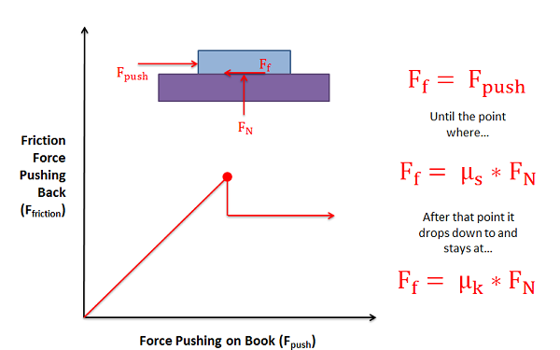

- static friction: The friction applies when the object is stationary.
- Kinetic friction: This is the frictional resistive force that acts on an object a long as it is in motion.

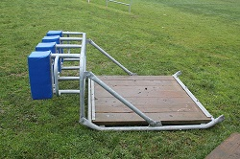
PRACTICAL EXAMPLES

Dry friction occurs between the bottom of this training sled and the grassy field. The dry friction would oppose the motion of the sled along the field in this case

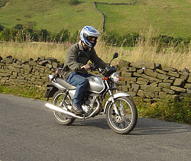
Dry friction occurs between the tires and the road for this motorcycle. The dry friction force for this motorcycle is what allows it to accelerate.

2.Fluid friction :describes the friction between layers of a viscous fluid that are moving relative to each other. Fluid friction occurs between fluid layers that are moving relative to each other. This internal resistance to flow is named viscosity. In everyday terms, the viscosity of a fluid is described as its “thickness”.
All real fluids offer some resistance to shearing and therefore are viscous. It is helpful to use the concept of an inviscid fluid or an ideal fluid that offers no resistance to shearing and so is not viscous.

PRACTICAL EXAMPLE.
- If there is a wet surface between two thin glass plates, you will notice that plates get stuck and the bottom plate doesn’t fall when you hold only the top one.
- When any object is dropped in a fluid, the extent of splash is depended on the fluid friction of that particular fluid.
- You find lighter dust particles move fast on the surface of a flowing river. This is due to the high-velocity gradient at the top layer of water due to lower dynamic fluid friction at that layer.

QUESTION 2
Explain the following types of machines;
- Wedges
- Square-Threaded Screws
- Journal Bearings

a. Wedges: Wedge, in mechanics, device that tapers to a thin edge, usually made of metal or wood, and used for splitting, lifting, or tightening, as to secure a hammer head onto its handle. Along with the lever, wheel and axle, pulley, and screw, the wedge is considered one of the five simple machines
b. Square-Threaded Screws: This is a common screw thread form used in high load application such as leadscrew and jack screws. It is the lowest friction and most efficient thread form.
c. Journal Bearings: A journal bearing is a shaft or journal rotating in a bearing. The shaft rotates in the bearing with a layer of lubricant separating the two parts. Because journal bearings are designed to reduce load friction, they are often used when the load is light and the motion is continuous.

