DIDAM LORRETA ZUGWAI
17/ENG06/021
MECHANICAL ENGINEERING
MEE 312
QUESTION 1
Friction is the resistance to motion of one object moving relative to another. It is not a fundamental force, like gravity or electromagnetism. Instead, scientists believe it is the result of the electromagnetic attraction between charged particles in two touching surfaces.
- Dry friction is the force that opposes one solid surface sliding across another solid surface. Dry friction always opposes the surfaces sliding relative to one another and can have the effect of either opposing motion or causing motion in bodies.
It is also a force that opposes the relative lateral motion of two solid surfaces in contact.
Dry friction is motion if two solid surfaces in contact. Dry friction is divided into static and kinetic friction. Static friction is between non-moving surfaces and Kinetic friction is between moving surfaces. An example of dry friction is when a person is riding a bicycle and presses the brakes, the rough edges on the brake pads rub against the bicycle rim and it ends up slowing down the rim.
The most commonly used model for dry friction is coulomb friction. This type of friction can further be broken down into static friction and kinetic friction. These two types of friction are illustrated in the diagram below. First imagine a box sitting on a surface. A pushing force is applied parallel to the surface and is constantly being increased. A gravitational force, a normal force, and a frictional force are also acting on the box.
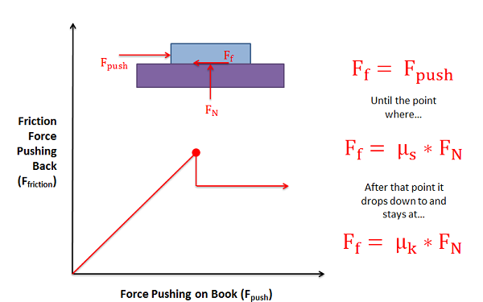As the pushing force increases, the static friction force will be equal in magnitude and opposite in direction until the point of impending motion. Beyond this point, the box will begin to slip as the pushing force is greater in magnitude than the kinetic friction force opposing it.
Static friction occurs prior to the box slipping and moving. In this region the friction force will be equal in magnitude and opposite in direction to the pushing force itself. As the magnitude of the pushing force increases so does the magnitude of the friction force.
If the magnitude of the pushing force continues to rise, eventually the box will begin to slip. As the box begins to slip the type of friction opposing the motion of the box changes from static friction to what is called kinetic friction. The point just before the box slips is known as impending motion. This can also be thought of as the maximum static friction force before slipping. The magnitude of the maximum static friction force is equal to the static coefficient of friction times the normal force existing between the box and the surface. This coefficient of friction is a property that depends on both materials and can usually be looked up in tables.
Kinetic friction occurs beyond the point of impending motion when the box is sliding. With kinetic friction, the magnitude of the friction force opposing motion will be equal to the kinetic coefficient of friction times the normal force between the box and the surface. The kinetic coefficient of friction also depends upon the two materials in contact, but will almost always be less than the static coefficient of friction.
.
There are two types of dry friction, static and kinetic. <<<<Static friction is friction between two solid objects that are not moving relative to each other. Static friction can prevent an object from sliding down a sloped surface. One example is when static friction prevents a car tire from slipping of a road as it still moves. Even though the tire is moving, the pattern from the tire is in contact with the surface (road).
<<<<< Kinetic friction is when two objects are moving relative to each other. The two objects contact and work together. One example is when a sled slides down a smooth ice surface which causes less friction to the sled and the ice surface.
- Fluid friction occurs between fluid layers that are moving relative to each other. This internal resistance to flow is named viscosity. In everyday terms, the viscosity of a fluid is described as its “thickness”.
All real fluids offer some resistance to shearing and therefore are viscous. It is helpful to use the concept of an inviscid fluid or an ideal fluid that offers no resistance to shearing and so is not viscous.
EXAMPLE OF FLUID FRICTION
If there is a wet surface between two thin glass plates, you will notice that plates get stuck and the bottom plate doesn’t fall when you hold only the top one.
- When any object is dropped in a fluid, the extent of splash is depended on the fluid friction of that particular fluid.
- You find lighter dust particles move fast on the surface of a flowing river. This is due to the high-velocity gradient at the top layer of water due to lower dynamic fluid friction at that layer.
QUESTION 2
  - A wedge is a triangular shaped tool, and is a portable inclined plane, and one of the six classical simple machines. It can be used to separate two objects or portions of an object, lift up an object, or hold an object in place. It functions by converting a force applied to its blunt end into forces perpendicular (normal) to its inclined surfaces. The mechanical advantage of a wedge is given by the ratio of the length of its slope to its width
  - The square thread form is a common screw thread form, used in high load applications such as leadscrews and jackscrews. It gets its name from the square cross-section of the thread According to Bulapari (2004),
  - Journal bearings are known as a type of fluid film bearings in which the surfaces in contact (or the mating surfaces) - the journal and the sleeve (bearing), are completely separated by a layer of fluid lubricant.
In a simpler language, a Journal Bearing is an example of the fluid film bearing which is made up of a stationary bearing (or shell) and a freely rotating journal having an interposed lubricant between the clearance existing between the bearing and journal. The lubricant can either be a solid, liquid or gas.The main advantage of this type of Bearing is the ability of the interposed lubricant to help reduce frictional resistance and wear and in some cases to carry away the heat generated in the bearing.
CLASSIFICATION OF JOURNAL BEARING
Journal Bearing is broadly classified into two main types. These are:
- Hydrodynamic Journal Bearing
- Hydrostatic Journal Bearing

