NAME: ADAH EMMANUEL .O
COURSE: MECHANICS OF MACHINE II (MEE 312)
MATRIC NO: 17/ENG06/001
ASSIGNMENT II
1.) It is generally considered that in engineering application problem, there are no perfectly frictionless surfaces. Explain these two types of friction; dry friction and fluid friction and give practical examples.
DRY FRICTION;
Dry friction, also called Coulomb friction, occurs when unlubricated surfaces of two solids are in contact and slide or tend to slide from each other. If lubricant separates these two surfaces, the friction created is called lubricated friction. The two types of dry friction are 'static friction' between non-moving surfaces, and kinetic friction (sometimes called sliding friction or dynamic friction) between moving surfaces.
PRACTICAL EXAMPLES
a) Lighting a matchstick: We strike a matchstick against a rough surface to create friction. The matchstick lights up due to the heating effect of friction.
b) Brushing your teeth to remove particles: Sticky particles get stuck on our teeth and are very difficult to be removed. The brushing action allows us to overcome the frictional force of the particles and get them removed.
c) Rubbing of hands to produce heat: Friction always has a heating effect associated with it. Rubbing of hands causes heat due to friction which can keep our hands warm for some time.
FLUID FRICTION;
Fluid friction occurs when layers of two viscous fluids moves at different velocities. The relative velocity between layers causes frictional forces between fluid elements, thus, no fluid friction occurs when there is no relative velocity.
PRACTICAL EXAMPLES
a) Resistance experienced by swimmer in water
b) Lubrication can reduce friction between two solid surfaces due to fluidic friction. Friction in solids is generally greater than friction in fluids.
c) Friction of water in river with riverbed which is an important factor in flooding
Also note that the reason honey is thicker than water, Is because honey moves slower compared to water. It is because the molecules in any fluid face an internal friction called viscosity, and this is what we call as thickness or resistance to flow. Hence the molecules in honey move at a slower pace as compared to water and eventually honey seems as thicker than water.

2.) Explain the following types of machines;
Wedges
Square-Threaded Screws
Journal Bearings

a) WEDGES;

A wedge is a simple machine used to separate two objects, or portions of objects, through the application of force. A wedge is made up of two inclined planes. These planes meet and form a sharp edge. This edge can split things apart. Wedges are used as either separating or holding devices.#
Examples of wedges are: knives, axes, forks and nails.
Wedge, in mechanics, device that tapers to a thin edge, usually made of metal or wood, and used for splitting, lifting, or tightening, as to secure a hammer head onto its handle. Along with the lever, wheel and axle, pulley, and screw, the wedge is considered one of the five simple machines.

b) SQUARE-THREADED SCREWS;

The square thread form is a common screw thread form, used in high load applications such as leadscrews and jackscrews. It gets its name from the square cross-section of the thread. It is the lowest friction and most efficient thread form, but it is difficult to fabricate.

Square threaded screws are used as a power screw. It is the most efficient design (low friction), the easiest to analyse, but the most difficult to machine. Acme threads are also used as power screws. They are much easier to machine but only have about 70% of the efficiency of a square threaded screw.
Advantages & Disadvantages
The greatest advantage of square threads is that they have a much higher intrinsic efficiency than trapezoidal threads (Acme or metric trapezoidal). Due to the lack of a thread angle there is no radial pressure, or bursting pressure, on the nut. This also increases the nut life.
The greatest disadvantage is the difficulty in machining such a thread. The single-point cutting tools or taps and dies used to cut the thread cannot have efficient rake and relief angles (because of the square form), which makes the cutting slow and difficult. Square threads also cannot carry as much load as a trapezoidal thread, because the root of the square thread is smaller. Also, there is no way to compensate for wear on the nut, so it must be replaced when worn out

c) Journal Bearings;

The portion of the shaft which is in actual contact with the bearing is known as journal. For every machine and engine, it is necessary to have a provision for the support of rotating shaft. Such support is called bearing. In other words, the shaft must be supported through bearing. Simple bearing has been shown in Figs. 8.11(a) and 8.11(b).
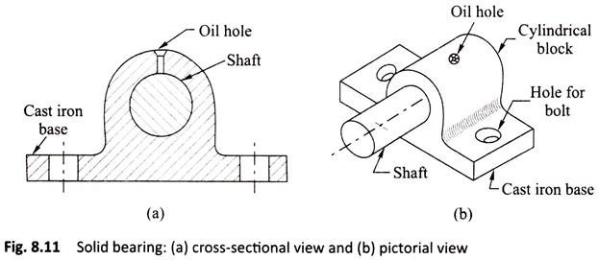
To avoid frictional resistance which opposes rotation between the journal and the inner face of the bearing, proper lubrication of the bearing is required. Proper lubrication keeps the smooth running of shaft which causes less power loss, less heat production, and also less noise production.

