IKON SAMUEL OSCAR
17/ENG06/045
MECHANICAL ENGINEERING
300 LEVEL
MEE 312 ASSIGNMENT 2
1. Explain dry friction and fluid friction
a. DRY FRICTION
Dry friction is the force that opposes one solid surface sliding across another solid surface. It always opposes the surfaces sliding relative to one another and can have the effect of either opposing motion or causing motion in bodies. Dry friction occurs at the interface between two bodies in relative motion with contact. The friction force opposes the relative velocity direction and depends on the normal force that acts on the body.
b. FLUID FRICTION
Fluid friction is the force that resists motion either within the fluid itself or of another medium moving through the fluid. There is internal friction, which is a result of the interactions between molecules of the fluid, and there is external friction, which refers to how a fluid interacts with other matter.

Examples of Fluid Friction
- If there is a wet surface between two thin glass plates, you will notice that plates get stuck and the bottom plate doesn’t fall when you hold only the top one.
- When any object is dropped in a fluid, the extent of splash is depended on the fluid friction of that particular fluid.
- You find lighter dust particles move fast on the surface of a flowing river. This is due to the high-velocity gradient at the top layer of water due to lower dynamic fluid friction at that layer.

2. Explain the following machines
a) Wedges: A wedge is an inclined plane and it is one of the six simple machine. To make work easier you have to apply input force on an object. Two types of wedges is a single and a two back two back wedge. A wedge splits things in half. If you increased the distance, you decreased the effort or if you decreased the distance, you increased the effort.
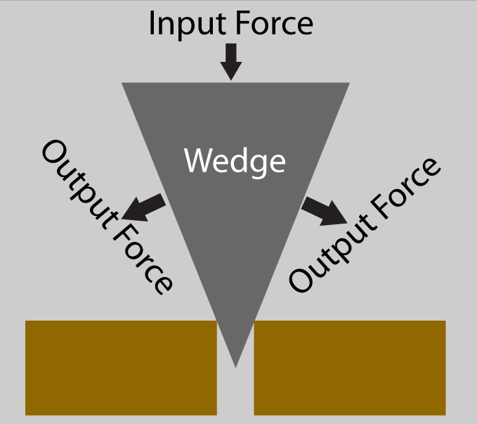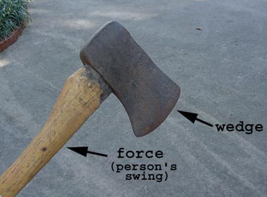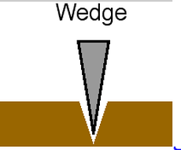
b) Square threaded screws: The square thread form is a common screw thread form, used in high load applications such as leadscrews and jackscrews.
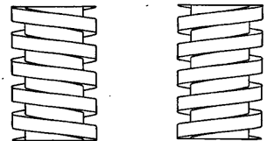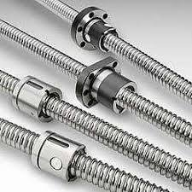
c) Journal bearings: Journal bearings are one of the most common types of hydrodynamic bearings. Their primary purpose is to support a rotating shaft. They are used in various sub-systems in engines and power trains, for example for support of both crankshaft and camshaft. They are also used in the rocker shaft of rocker arm valve train systems. Journal bearings usually operate in hydrodynamic regime of lubrication as the generated pressures are low compared with those experienced by ball and rolling element bearings, gears and cam-follower pairs. Unlike these counterforming pairs, where the area of contact is very small, the journal conforms reasonably well to the bearing bushing (but not completely), allowing a wedge shape to form a film, drawn into the contact. Thus, a large area of contact results in generated lubricant pressures which are typically at least an order of magnitude less than those in concentrated counterforming contacts. These are usually from a few to tens of MPa, which are insufficient to cause localised deformation of surfaces in contact unlike elastohydrodynamic conditions in the rolling element bearings and cam-followers. The film thickness is also of the order of a few to several micrometres unlike a few tenths to a couple of micrometre in ball and rolling element bearings.
