NAME: ADEBIYI OLUMUYIWA DANIEL
MATRIC N0: 17/ENG06/106
DEPARTMENT: MECHANICAL ENGINEERING
MEE 312: ASSIGNMENT 2

QUESTION 1
It is generally considered that in engineering application problem, there are no perfectly frictionless surfaces. Explain these two types of friction; dry friction and fluid friction and give practical examples.
ANSWER
What is friction
Friction is the resistance to motion of one object moving relative to another. It is not a fundamental force, like gravity or electromagnetism. Instead, scientists believe it is the result of the electromagnetic attraction between charged particles in two touching surfaces.
Frictional force is the calculable effort (in Newton) that opposes the motion of a moving body.

Dry Friction?
Dry friction is the force that opposes one solid surface sliding across another solid surface. Dry friction always opposes the surfaces sliding relative to one another and can have the effect of either opposing motion or causing motion in bodies.
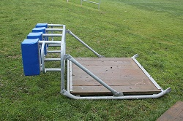Dry friction occurs between the bottom of this training sled and the grassy field. The dry friction would oppose the motion of the sled along the field in this case. Image by Avenue CC-BY-SA 3.0 | 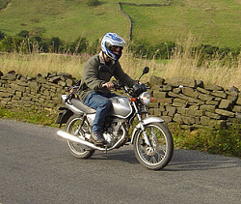Dry friction occurs between the tires and the road for this motorcycle. The dry friction force for this motorcycle is what allows it to accelerate.
The most commonly used model for dry friction is coulomb friction. This type of friction can further be broken down into static friction and kinetic friction. These two types of friction are illustrated in the diagram below. First imagine a box sitting on a surface. A pushing force is applied parallel to the surface and is constantly being increased. A gravitational force, a normal force, and a frictional force are also acting on the box.
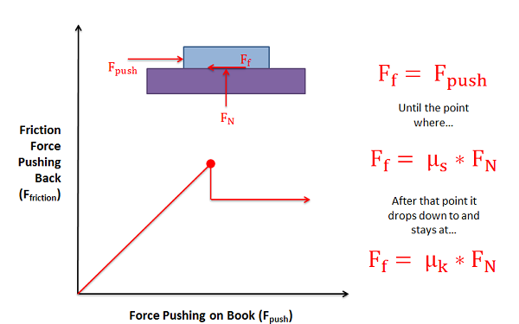

What is fluid friction?
Fluid friction refers to the resistance of fluid between different fluid surfaces in contact or a body in contact with fluid.
Examples:
Swimming – swimmer’s body and surface of water Greasing a squeaky door hinge – now the 2 hinge parts are sliding across a fluid (the grease)

QUESTION TWO
Explain the following types of machines;
Wedges
Square-Threaded Screws
Journal Bearings

WEDGE
A wedge is a simple machine that consists of two inclined planes, giving it a thin end and thick end. Force is applied to the thick end of the wedge, and the sloping sides of the wedge apply force to the object, cutting it or splitting it apart.
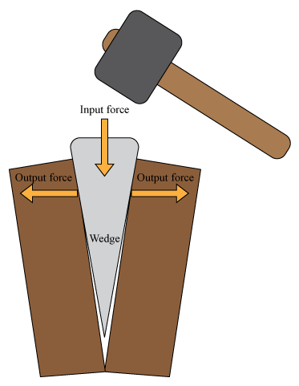
A knife is another example of a wedge. In the Figure below, a knife is being used to chop tough pecans. The job is easy to do with the knife because of the wedge shape of the blade. The very thin edge of the blade easily enters and cuts through the pecans.
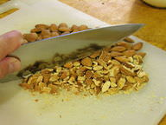

Mechanical Advantage Of A Wedge
The mechanical advantage of a simple machine is the factor by which it multiplies the force applied to the machine. It is the ratio of the output force to the input force. A wedge applies more force to the object (output force) than the user applies to the wedge (input force), so the mechanical advantage of a wedge is greater than 1. A longer, thinner wedge has a greater mechanical advantage than a shorter, wider wedge. With all wedges, the trade-off is that the output force is applied over a shorter distance, so force may need to be applied to the wedge repeatedly to push it through the object.

Square-Threaded Screws

A screw thread, often shortened to thread, is a helical structure used to convert between rotational and linear movement or force. A screw thread is a ridge wrapped around a cylinder or cone in the form of a helix, with the former being called a straight thread and the latter called a tapered thread.

Journal Bearings
Journal or plain bearings consist of a shaft or journal which rotates freely in a supporting metal sleeve or shell. There are no rolling elements in these bearings. Their design and construction may be relatively simple, but the theory and operation of these bearings can be complex.
This article concentrates on oil and grease-lubricated full fluid film journal bearings; but first a brief discussion of pins and bushings, dry and semilubricated journal bearings, and tilting-pad bearings.
Low-speed pins and bushings are a form of journal bearing in which the shaft or shell generally does not make a full rotation. The partial rotation at low speed, before typically reversing direction, does not allow for the formation of a full fluid film and thus metal-to-metal contact does occur within the bearing. Pins and bushings continually operate in the boundary lubrication regime.
These types of bearings are typically lubricated with an extreme pressure (EP) grease to aid in supporting the load. Solid molybdenum disulfide (moly) is included in the grease to enhance the load-carrying capability of the lubricant.
Many outdoor construction and mining equipment applications incorporate pins and bushings. Consequently, shock loading and water and dirt contamination are often major factors in their lubrication.

