NAME: EDEM ETORO-ABASI ANIEDI
MATRIC NUMBER: 19/SCI03/009
DEPARTMENT: BIOCHEMISTRY
COURSE CODE: BCH 202
COURSE TITLE: GENERAL BIOCHEMISTRY II

ASSIGNMENT

- What are plasmalogens?
Plasmalogens are a class of glycerol phospholipids which contain a vinyl-ether and ester bond at the sn-1 and sn-2 position, respectively in the glycerol backbone. They constitute 20% of the total mass of phospholipids in humans, mainly as membrane structures components.

- Name and draw 3 examples of plasmalogens.

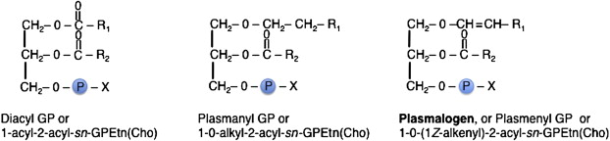

- Give 2 differences between plasmalogens and phosphogylcerides.

- Phosphoglycerides are types of membrane lipids while plasmalogens are types of phosphoglycerides.
- Plasmalogens have one of their fatty acids replaced by an aldehyde connected by an unsaturated ether linkage while phosphoglycerides do not.

