NAME: EDEM ETOR-ABASI ANIEDI
MATRIC NUMBER: 19/sci03/009
DEPARTMENT: BIOCHEMISTRY
ASSIGNMENT
1. Vitamins are organic compounds required in the diet in small amounts to perform specific biological functions in an organism. There are 13 essential vitamins and they are classified into two broad groups based on their solubilities; fat soluble vitamins and water-soluble vitamins.
Fat soluble vitamins are apolar hydrophobic compounds that can only be absorbed sufficiently when there is normal fat absorption. They are soluble in fat are absorbed by the body via the intestinal tract. They are stored in body fats and cannot be readily excreted in urine. The fat-soluble vitamins include; Retinol, Tocopherol, Cholecalciferol, Phylloquinone and Menaquinone (vitamins A, E, D and K respectively).
Water soluble vitamins are polar hydrophilic compounds that are easily absorbed by the body. They cannot be stored in the body and are easily lost in urine so they must be continually supplied in the diet. They are nontoxic. The water-soluble vitamins include Thymine, Riboflavin, Niacin, Pantothenic acid, Pyridoxamine, Biotin, Folic acid, Cobalamin (these are the vitamin B complex; B₁, B₂, B₃, B₅, B₆, B₇, B₉, B₁₂ respectively) and Ascorbic acid (vitamin C).
Vitamins have diverse biochemical functions. Vitamin A acts as a regulator of cell and tissue growth and differentiation. Vitamin D provides hormone- like function, regulating mineral metabolism for bones and other organs. The B complex vitamins function as enzyme cofactors(coenzymes) or precursors for them. They in general are essential for normal growth and development.
2. Role of coenzymes in metabolism: Water soluble vitamins serve as coenzymes or are precursors to coenzymes. These coenzymes serve various roles in metabolism in cells. Vitamin C also known as ascorbic acid is an antioxidant, helps regulate the immune system and is needed in the manufacture of collagen and norepinephrine. Vitamin B₁ also known as thiamine or its cofactor form, thiamine diphosphate (TPP) is a cofactor for oxidative decarboxylation both in the Kerb’s cycle and in converting pyruvate to acetyl-CoA (an important molecule used in the citric acid cycle of metabolism).
3. Nomenclature of nucleotide, nucleoside and nucleic acid.
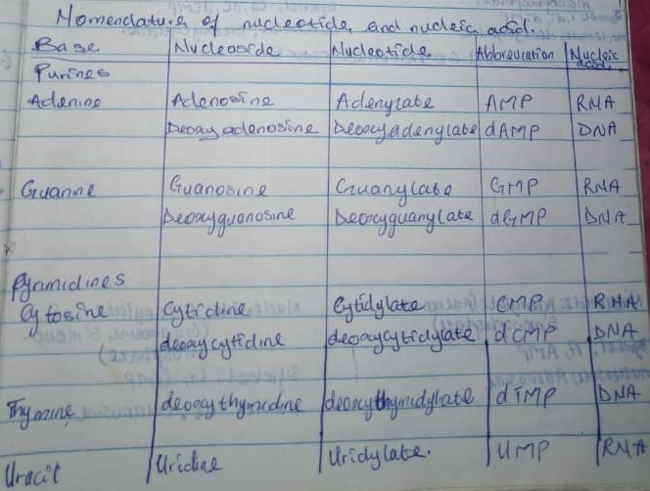
4. Role of vitamin A in vision: The biochemical function of vitamin A in the visual system is an event that occurs in the cycle known as the rhodopsin cycle or Wald’s visual cycle. The retina contains two types of receptor cells; cones which are specialized for colored and detailed vision in bright light and contains iodopsin and rods which specializes in visual activity in dim light and contains rhodopsin.
Light waves striking these receptors produce chemical changes which in turn gives rise to nerve impulses. Visual activity of rod cells is dependent on their content of photosensitive pigment called rhodopsin also known as visual purple which is a conjugated protein. It contains opsin as its apoprotein and retinal as its prosthetic group. Retinal present in rhodopsin is 11 cis retinal. The aldehyde group of 11 cis retinal is bound to € NH₂ group of lysine of opsin. Rhodopsin has a light absorbing property due to polyene group of 11 cis retinal.
When light falls on rhodopsin, it splits into opsin and all trans retinal in a series of events. It first forms Photo rhodopsin, Batho rhodopsin, then, Lumirhodopsin and then finally Metarhodopsin 1,2 & 3. Finally, metarhodopsin gets split into opsin and all trans retinal. At this stage, the eye becomes less sensitive to light. The formation of the initial excited form of rhodopsin, Batho rhodopsin, occurs within Pico seconds of illumination. There is then a series of conformational changes leading to the formation of metarhodopsin 3 which initiates a guanine nucleotide amplification cascade and then the nerve impulses. All trans retinal is inactive in the synthesis of rhodopsin. It is therefore converted to 11 cis retinal which takes place in the following way;
(i). All trans retinal may be isomerized by retinal isomerase to its 11 cis retinal in presence of blue light. This combines with opsin to regenerate rhodopsin and complete the visual cycle. However, the conversion of all trans retinal to 11 cis retinal is incomplete. Therefore, most of the all trans retinal is transported to the liver and converted to all trans retinal by retinol dehydrogenase.
(ii). First, the all trans retinal is converted to all trans retinol by an NADH dependent retinal reductase and all trans retinol from the blood is then isomerized to 11 cis retinol.
(iii). 11 cis retinol is then converted to 11 cis retinal by retinol dehydrogenase in the presence of NAD⁺.
(iv). Now, 11 cis retinal which is active can combine with opsin to form back rhodopsin in the dark. Thus, the visual process involves continual removal of the active cis retinol from blood into retina. The key to initiation of the visual cycle is the availability of the 11 cis retinal, and hence, vitamin A.
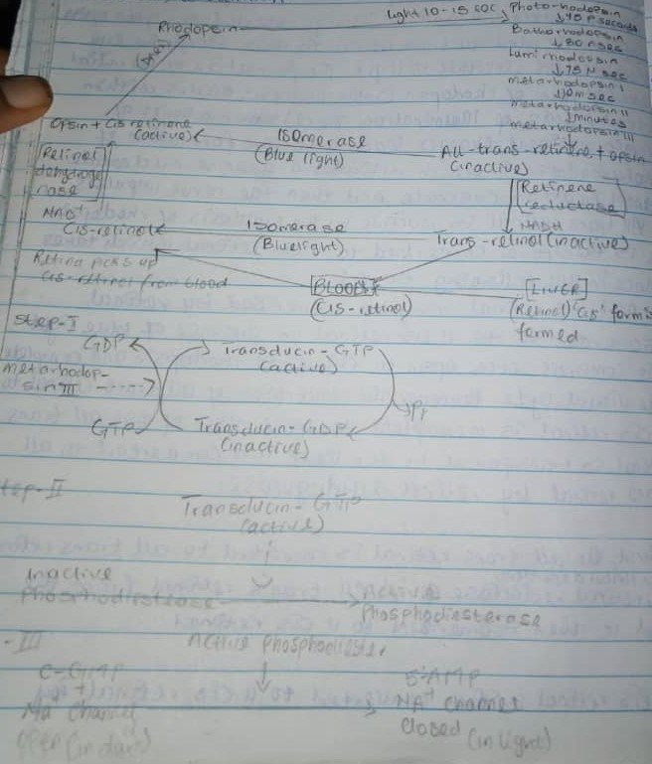
5. When are person shifts from bright light to dim light, rhodopsin stores are depleted and vision is impaired. However, within a few minutes, known as dark adaptation time, rhodopsin is synthesized and vision is improved.
When exposed to light, the color of rhodopsin changes from red to yellow by a process called bleaching. This occurs in a few milliseconds and many unstable intermediates are formed during the process.
6. The skin is responsible for producing vitamin D. During exposure to sunlight, UV radiation penetrates into the epidermis and photolyzes provitamin D3(cholecalciferol). Cholecalciferol is hydroxylated at the 25th position to give 25-hydroxycholecalciferol (25-OH D3) by a specific hydroxylase present in the liver. 25-hydroxycholecalciferol is the major storage and circulatory form of vitamin D. the kidney possesses a specific enzyme 25-hydroxycholecalciferol(calcitriol)1-hydroxylase which hydroxylates 25-hydroxycholecalciferol at position 1 to produce 1,25-hydroxycholecalciferol(1,25-DHCC). 1,25-DHCC contains 3 hydroxyl groups (1,3,25 carbon) hence referred to as calcitriol. Both the hydroxylase enzymes (of the liver and kidney) require cytochrome P4SO, NADPH and molecular oxygen for the hydroxylation process.
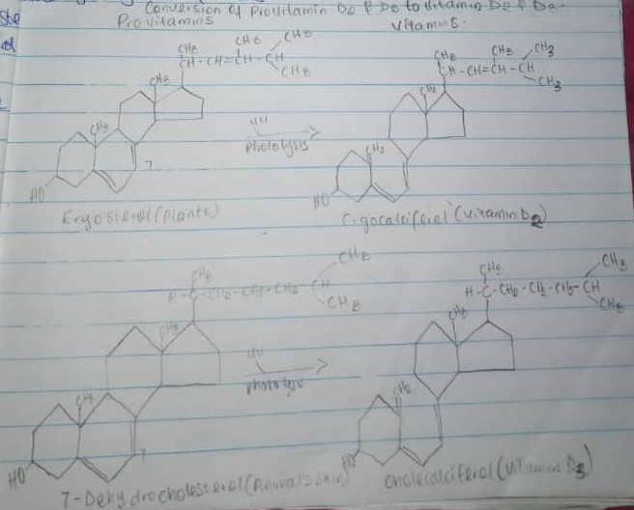
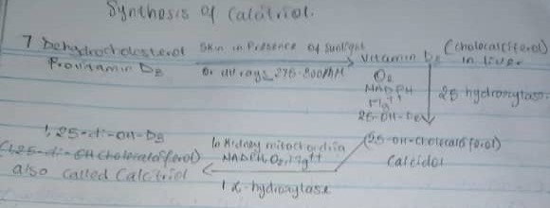
7. Acid hydrolysis cleaves susceptible purine N-glycosyl bonds in both DNA and RNA. When RNA is boiled in dilute acid, adenine and guanine are released, leaving an “apurinic acid” which maybe further hydrolyzed to a mixture of pyrimidine nucleotide. The pyrimidines are more resistant to acid hydrolysis. Significant hydrolysis of RNA can be obtained by treatment with 1N Hcl at 100ºC for 1 hour. In the depurination reactions, the N-glycosyl linkage between a purine base and deoxyribose is cleaved. The protonation of N-3 and N-7 of guanine promotes hydrolysis. If repair mechanism does not repair the purine nucleotide, a point mutation will result in the next round of DNA replication. Alkali hydrolysis of RNA produces a mixture of 2’ and 3’ nucleotides of cyclic 2’ and 3’- monophosphate intermediates. These are further hydrolyzed by alkali which attacks either one or two P-O-C linkages, to yield a mixture of 2’ and 3’ nucleoside monophosphates. DNA on the other hand, is not readily hydrolyzed by dilute alkali because it lacks the 2’ hydroxyl group and therefore, cannot form the necessary 2’, 3’-cyclic monophosphate intermediates.
8.The double helix structure of DNA was proposed by James Watson and Francis Crick in 1958. They demonstrated that the structure of DNA was a spiral of two DNA strands, each containing a long chain of monomer nucleotides, wound around each other. According to their findings, DNA replicated itself by separating into individual strands, each of which became the template for a new double helix. The elucidation of DNA structure is considered a milestone in the era of the modern biology.
9.
Properties | DNA | RNA
Sugar moiety | Deoxyribose | Ribose
Nitrogenous Base | Adenine, Guanine, Cytosine, Thymine | Adenine, Guanine, Cytosine, Uracil
Pairing | Adenine pairs with Thymine | Adenine pairs with Uracil
Number of strands | Two strands | Single strand
Alkali action | Cannot be hydrolyzed by alkali | Can be hydrolyzed by alkali
Propagation | Self-replicating | Synthesized from DNA

10. Functions of Nucleotides
(i) They are activated precursors of DNA and RNA.
(ii) They are required for activation of intermediates in many biosynthetic pathways e.g. UDP-glucose and CDP-diacylglycerol are precursors for glycogen and phosphoglyceride synthesis.
(iii) Nucleotides of adenine acts as a carrier of methyl group in the form of S-adenosylmethionine (SAM).
(iv) ATP, an adenine nucleotide, is a universal currency of energy in the biological systems.
(v) GTP is involved in protein biosynthesis as a source of energy.
(vi) Adenine nucleotides are components of three major coenzymes, NAD⁺, FAD⁺, CoA.
(vii) Nucleotides are metabolic regulators e.g. C-AMP and C-GMP.
(viii) Cyclic AMP, formed from ATP in a reaction catalyzed by adenylyl cyclase, is a common second messenger produced in response to hormones and other chemical signals.

